SPACE-TO-FARM INTELLIGENCE PLATFORM
Full Technical Architecture & Build Document
TerraTech × PJTAU — AI-Driven Crop Monitoring & Advisory System
Version 1.0 | Prepared for Engineering Build & Technical Review

Table of Contents

1. Executive Summary
This document is the complete technical build specification for the Space-to-Farm Intelligence Platform (TerraTech x PJTAU). It consolidates system architecture, data flow, workflows, user roles, API design, data security, and the AI/ML training strategy — including the practical plan for training models before PJTAU field data exists, using public datasets and historical satellite backtesting as a bootstrap, with a defined upgrade path once PJTAU's real outbreak logs, farm boundaries, and field photos are supplied.
This document is intended for: engineering leads scoping the build, the AI/ML team designing training pipelines, and PJTAU technical reviewers evaluating scientific validity.

1.1 Key Design Principles
- Day-1 readiness without local data: models are bootstrapped on public datasets and historical satellite imagery; PJTAU data fine-tunes rather than trains from zero.
- Every farmer-facing advisory is gated by a deterministic PJTAU Package-of-Practice (PoP) rule — raw model probability is never sent directly to a farmer.
- All-weather coverage: Sentinel-1 SAR is the primary signal during monsoon (Kharif) cloud cover; Sentinel-2 optical supplements when skies are clear.
- Offline-first field operations: the Flutter staff app runs Edge AI (TensorFlow Lite) so on-device pest classification works without connectivity.
- Security and data protection are designed in from Sprint 1, not retrofitted — relevant given this is a government/university-facing system handling farmer PII.

2. System Architecture
The platform follows a modular, microservices-based architecture hosted on AWS, organized into six layers: Presentation, API Gateway, Microservices, AI/ML Inference, Data, and Ingestion. Each layer is independently scalable and containerized via Docker/Kubernetes (EKS).
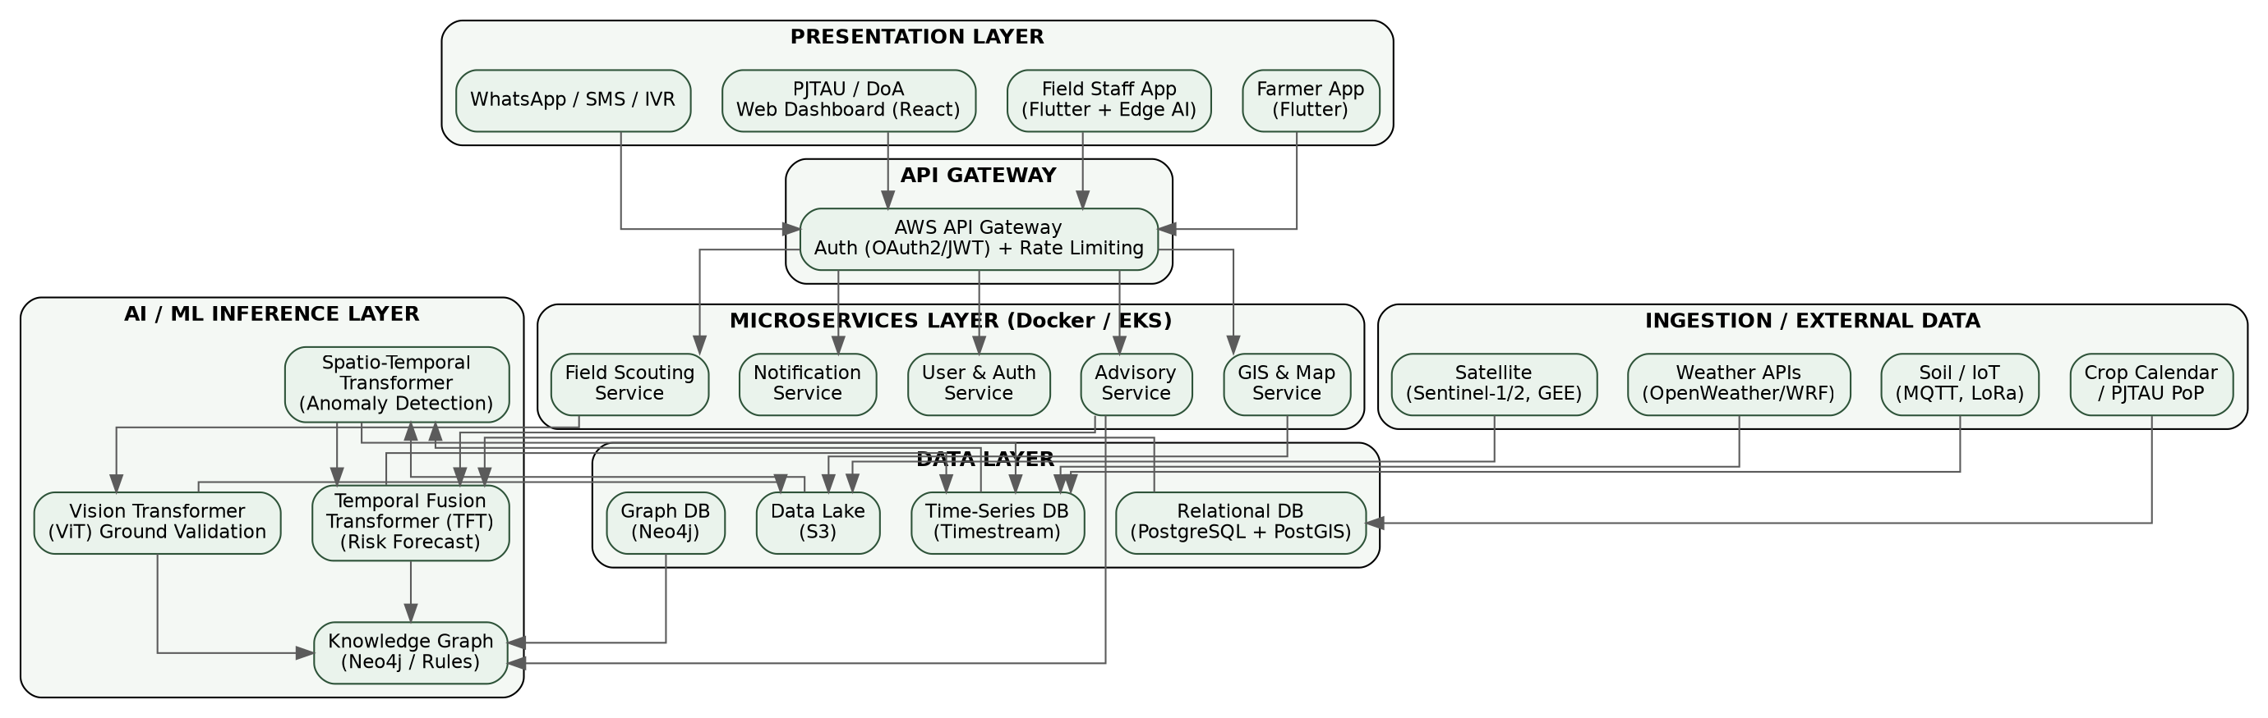
Figure 1. Full-stack system architecture, presentation layer through external data ingestion.

2.1 Layer Responsibilities
Layer | Responsibility | Key Components
Presentation | User-facing interfaces across web, mobile, and low-bandwidth channels | Farmer App, Staff App, PJTAU/DoA Dashboard, WhatsApp/SMS/IVR
API Gateway | Single entry point: auth, rate limiting, routing | AWS API Gateway, OAuth2.0/JWT
Microservices | Independently deployable business logic | Advisory, Field Scouting, User & Auth, Notification, GIS & Map
AI/ML Inference | Model serving for anomaly, risk, and image classification | Spatio-Temporal Transformer, TFT, ViT, Knowledge Graph/Rules
Data | Persistent storage, tuned per access pattern | S3 (lake), Timestream (time-series), PostgreSQL+PostGIS (relational/geo), Neo4j (graph, optional)
Ingestion / External | Pulls third-party and sensor data on schedule | Copernicus/Sentinel via GEE, Weather APIs, IoT/MQTT, Crop Calendar/PoP

2.2 Why This Architecture
- Microservices over monolith: Advisory, Scouting, and GIS services scale independently — GIS load (heavy spatial queries) won't starve the Notification service during an alert storm.
- Time-series DB separate from relational: NDVI/weather data is high-frequency, append-heavy, and queried by time range — Timestream is purpose-built for this; PostgreSQL stays focused on farmer/farm/crop-calendar records.
- Google Earth Engine as compute-side processing: avoids downloading petabytes of raw satellite tiles; only final per-polygon index values are pulled into AWS, keeping egress and storage costs low.

3. Data Flow Diagram
This traces a single advisory end-to-end: from satellite pass to farmer notification to the feedback loop that improves the models over time.
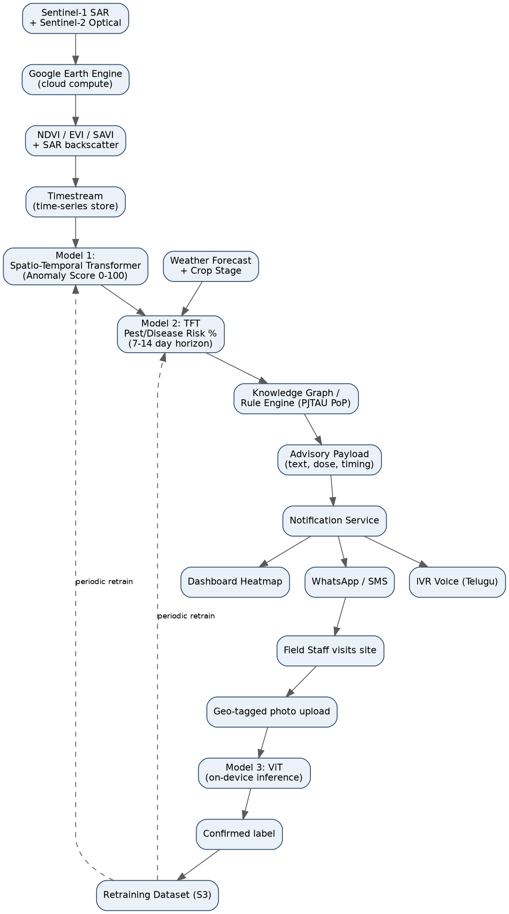
Figure 2. End-to-end data flow: ingestion → anomaly detection → risk forecasting → advisory → delivery → feedback loop.

3.1 Step-by-Step Description
- Step 1: Ingestion: Sentinel-1 SAR + Sentinel-2 optical pulled via Google Earth Engine; weather and crop-stage data pulled in parallel.
- Step 2: Preprocessing: cloud masking, NDVI/EVI/SAVI computation, SAR backscatter statistics; written to Timestream.
- Step 3: Model 1 (Spatio-Temporal Transformer): flags anomalies against the learned seasonal baseline; outputs a 0–100 anomaly score.
- Step 4: Model 2 (TFT): fuses the anomaly score with weather forecast and crop growth stage to output a pest/disease risk probability per pest class, 7–14 days ahead.
- Step 5: Knowledge Graph / Rule Engine: looks up the matching PJTAU PoP rule and generates the exact advisory text and dosage — only if risk probability clears the confidence gate (0.85 default).
- Step 6: Delivery: advisory pushed via WhatsApp, IVR (Telugu), and the PJTAU/DoA dashboard heatmap, in parallel.
- Step 7: Ground truth: field staff visit, capture a geo-tagged photo; Model 3 (ViT) classifies it on-device (offline-capable); the confirmed label is queued for periodic retraining of Models 1 and 2.

4. Operational Workflow
This shows the conditional logic and decision gates the system applies before any advisory reaches a farmer — including how false positives are filtered at two separate checkpoints (the risk threshold, and field-staff visual confirmation).
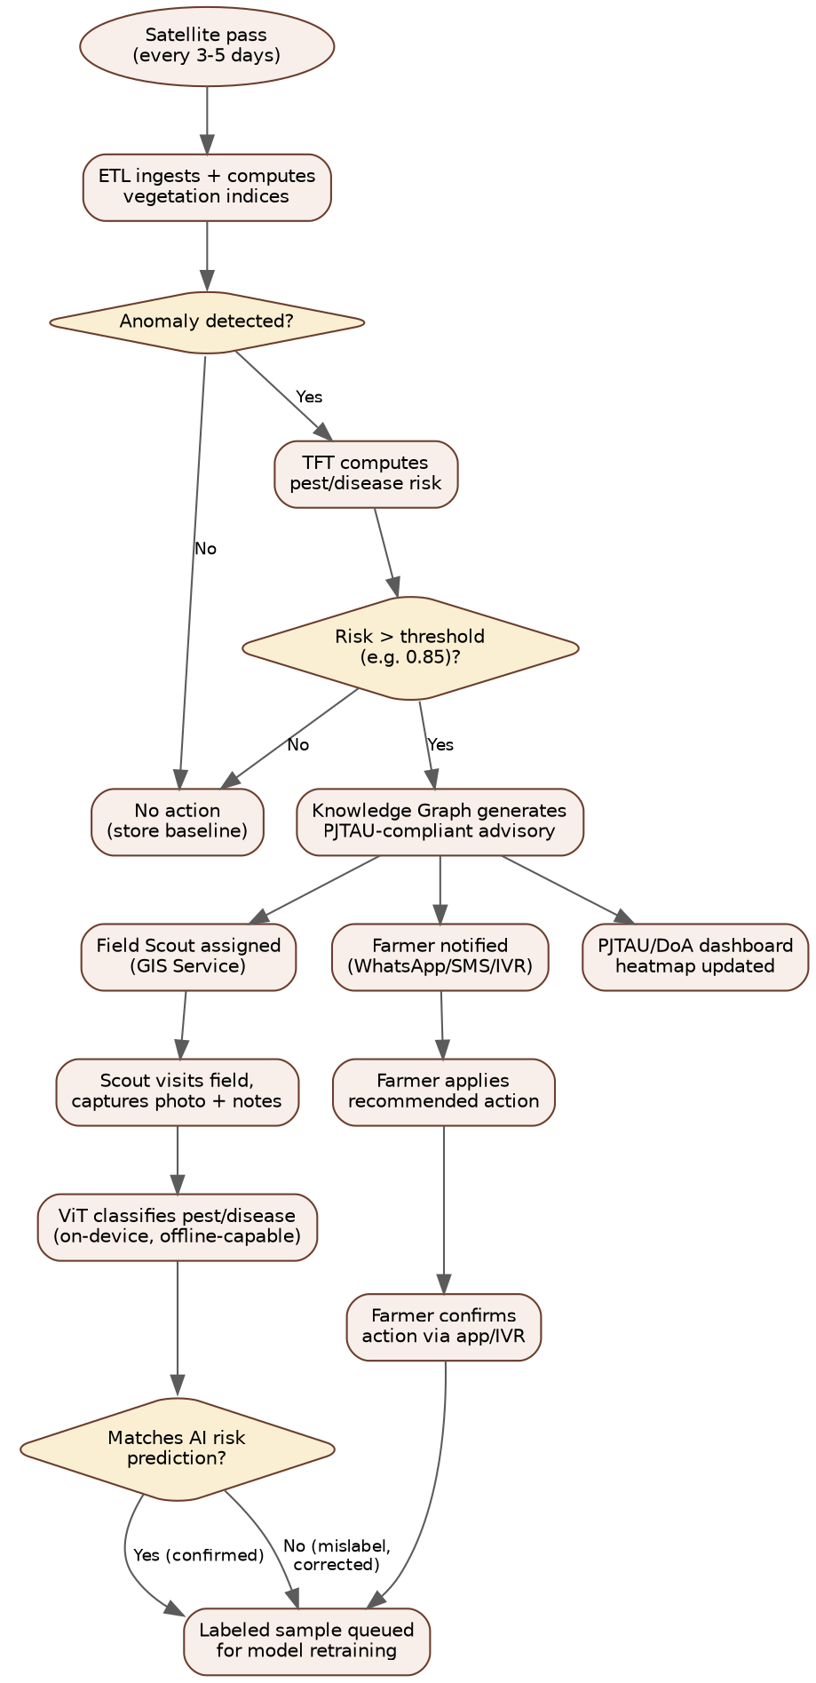
Figure 3. Decision workflow from satellite pass to confirmed/retrained outcome.

4.1 Validation Gates
Gate | Threshold / Logic | Purpose
Anomaly detection | Forecast error exceeds calibrated baseline | Filters normal seasonal variation from genuine stress signals
Risk confidence | TFT output probability ≥ 0.85 | Prevents low-confidence model output from reaching farmers as an alert
PoP rule match | Knowledge Graph must return a matching rule | Guarantees scientific validity — no advisory is generated without a PJTAU-approved basis
Field validation | Staff photo + ViT classification | Ground-truths the alert before/alongside farmer notification; closes the feedback loop

5. Users, Roles & Responsibilities
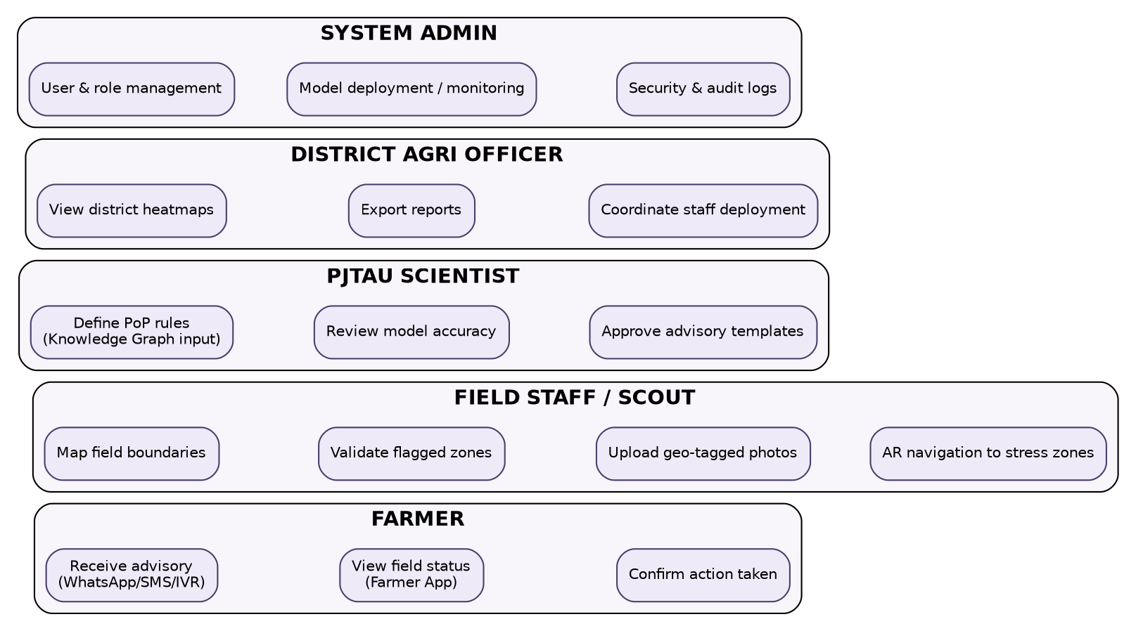
Figure 4. Primary user roles and their core responsibilities in the system.

5.1 Role Definitions & Access Levels
Role | Primary Responsibilities | System Access | Channel
Farmer | Receive advisories; view field status; confirm action taken | Read-only, own farm(s) only | Farmer App, WhatsApp, SMS, IVR
Field Staff / Scout | Map field boundaries; validate flagged zones; upload geo-tagged photos; AR navigation to stress zones | Read/write, assigned villages/zones | Staff App (offline-first)
PJTAU Scientist | Author/approve PoP rules; review model accuracy; sign off advisory templates | Read/write, Knowledge Graph + model dashboards | Web Dashboard
District Agriculture Officer (DAO) | View district heatmaps; export reports; coordinate staff deployment | Read-only district scope, export rights | Web Dashboard
System Administrator | User & role management; model deployment/monitoring; security and audit logs | Full system access (RBAC root) | Admin Console

5.2 Role-Based Access Control (RBAC) Model
Access is enforced at the API Gateway and re-validated at each microservice (defense in depth, not gateway-only trust). Roles map to scopes embedded in the JWT issued at login:
{
"sub": "user_8841",
"role": "field_staff",
"scope": ["scouting:read", "scouting:write", "photos:upload"],
"zone_access": ["zone_07", "zone_12"],
"exp": 1718900000
}

Each microservice independently checks `role` + `scope` + `zone_access` against the requested resource before executing — a compromised or misissued token for one role cannot silently gain another role's data access purely through a gateway misconfiguration.

6. API Specification
REST/JSON over HTTPS (TLS 1.3), versioned under /api/v1/. GraphQL is exposed for the dashboard's complex/nested heatmap queries; WebSockets carry real-time alert pushes to the dashboard. All endpoints require a Bearer JWT except /auth/* and /health.

6.1 Core Endpoints
Method | Endpoint | Description | Auth Scope
POST | /api/v1/auth/login | Issue JWT for farmer/staff/PJTAU/DAO/admin | public
POST | /api/v1/farms | Register a farm boundary (GeoJSON) | scouting:write
GET | /api/v1/farms/{farm_id} | Retrieve farm metadata + boundary | scouting:read
GET | /api/v1/predict/anomaly?farm_id= | Model 1 inference: anomaly score | internal/advisory:read
GET | /api/v1/predict/pest-risk?farm_id= | Model 2 inference: pest risk probabilities | internal/advisory:read
POST | /api/v1/advisory/generate | Trigger Knowledge Graph rule lookup + advisory generation | advisory:write
GET | /api/v1/advisory/{farm_id}/history | Advisory history for a farm | advisory:read
POST | /api/v1/scouting/photo | Upload geo-tagged field photo (multipart) | photos:upload
POST | /api/v1/notify/dispatch | Send advisory via WhatsApp/SMS/IVR | internal/notify:write
GET | /api/v1/dashboard/heatmap?district= | District-level stress heatmap (GeoJSON) | dashboard:read
GET | /api/v1/dashboard/report/export | Exportable PDF/CSV report | dashboard:export

6.2 Sample Request/Response
POST /api/v1/advisory/generate
Request:
{
"farm_id": "farm_telangana_0192",
"crop": "cotton",
"stage": "flowering",
"pest": "bollworm",
"risk_probability": 0.91,
"humidity": 82
}

Response (200 OK):
{
"status": "OK",
"advisory_text": "Apply Neem oil 5% or Profenofos @ 2ml/liter within 3 days.",
"dosage": "2ml/liter",
"confidence": 0.91,
"source_pop_reference": "PJTAU PoP Cotton 2024, Sec 4.2"
}

6.3 API Standards
- Rate limiting: 100 req/min per token (farmer/staff), 1000 req/min (internal services), enforced at API Gateway.
- Versioning: breaking changes increment the path version (/v1 → /v2); old versions supported for 6 months minimum.
- Errors: RFC 7807 Problem Details JSON format — machine-parseable error type, title, status, and detail.
- Idempotency: POST /scouting/photo and /notify/dispatch require an Idempotency-Key header to prevent duplicate sends on retry.
- Documentation: OpenAPI 3.0/Swagger spec auto-generated from FastAPI route definitions; published at /docs in non-prod, gated in prod.

7. Data Security & Data Protection
This is a government/university-facing system handling farmer PII (phone numbers, GPS-tagged field locations, photos), so security is treated as a Sprint 1 deliverable, not a late-stage audit item.

7.1 Security Controls
Control Area | Implementation
Authentication | OAuth2.0 + JWT, short-lived access tokens (15 min) + refresh tokens; MFA required for PJTAU/DAO/Admin roles
Authorization | RBAC enforced at API Gateway AND independently at each microservice (defense in depth)
Encryption in transit | TLS 1.3 everywhere; certificate pinning on mobile apps
Encryption at rest | AES-256 for S3, RDS, Timestream; AWS KMS-managed keys with rotation
Secrets management | AWS Secrets Manager / HashiCorp Vault — no secrets in code, env files, or container images
Network isolation | Private VPC subnets for databases; microservices reachable only via internal service mesh, not public internet
Vulnerability management | SAST (SonarQube) + DAST (OWASP ZAP) in CI/CD; dependency scanning (Dependabot/Snyk)
Audit logging | Immutable audit trail (who accessed what farmer/farm data, when) — required for government data-sharing compliance
Mobile device security | SQLite local cache encrypted at rest (SQLCipher); biometric/PIN app lock optional for staff devices

7.2 Data Protection & Privacy
- Applicable regulation: India's Digital Personal Data Protection Act (DPDP) 2023 — farmer phone numbers, location data, and photos qualify as personal data requiring lawful basis, purpose limitation, and a defined retention/deletion policy.
- Consent: farmers consent at onboarding to data collection and advisory delivery channels (WhatsApp/SMS/IVR); consent is recorded with a timestamp and version of the consent text shown.
- Data minimization: field photos are geo-tagged at farm-polygon precision, not exact farmer home address; only PJTAU-relevant agronomic fields are collected.
- Data residency: AWS ap-south-1 (Mumbai) region for all farmer/farm data to satisfy any data-localization expectations from government stakeholders.
- Right to erasure: a farmer/FPO can request account and data deletion; deletion cascades across PostgreSQL, S3 photo storage, and Timestream within a defined SLA (e.g., 30 days), with anonymized aggregate stats retained for research per the PJTAU data-sharing agreement.
- Third-party data sharing: DoA/PJTAU API access is read-only, scoped to district-level aggregates by default — raw farmer-identifiable records require a separate, logged authorization.
- Breach response: incident response runbook with notification timelines aligned to DPDP Act requirements; Prometheus/Grafana alerting on anomalous access patterns (e.g., bulk export of farmer records).

8. AI/ML Architecture & Training Strategy (No PJTAU Data Yet)
The core challenge: the pilot must be demonstrably functional before PJTAU's historical outbreak logs, real farm boundaries, and field-labeled photos are available. The strategy is a 3-stage bootstrap — each stage has a defined confidence level and an explicit upgrade path once PJTAU data lands.

8.1 Stage 1 — Historical Backtesting (Model 1: Spatio-Temporal Transformer)
Source: Google Earth Engine, 5 years of Sentinel-1/Sentinel-2 history, pulled for ~100+ known Telangana coordinates (e.g., public KVK/Krishi Vigyan Kendra farm locations as a starting set, replaced by real PJTAU GeoJSON once supplied). This is real Telangana signal, not synthetic — confidence: HIGH.
The model is trained self-supervised: predict the next satellite pass's NDVI/EVI/SAVI/SAR values from the recent window; large forecast error becomes the anomaly score. No labels are required for this stage.

8.2 Stage 2 — Transfer Learning (Model 3: ViT) + Heuristic Cold-Start (Model 2: TFT)
Vision Transformer (ViT): fine-tuned on PlantVillage (~54,000 labeled leaf images, 38 disease/pest classes) and TERRA-REF (maize/cotton stress imagery). This gives ~75–85% baseline visual classification accuracy on Day 1 — confidence: MEDIUM.
Pest Risk Forecaster (TFT) — important correction from earlier drafts: PlantVillage cannot pretrain the TFT, because it is static leaf imagery with no time-series or weather structure. There is no public dataset that matches Telangana pest-outbreak time-series conditions. Instead, the TFT is cold-started on heuristic labels derived from published agronomic thresholds (ICAR/PJTAU PoP literature) — e.g., "high humidity + flowering stage + NDVI drop ⇒ elevated bollworm risk." This is explicitly a low-confidence prior, and its output is never shown to a farmer without passing through the deterministic Knowledge Graph/PoP rule gate (see Section 4.1).

8.3 Stage 3 — PJTAU Fine-Tuning (Continuous, Post Field-Data Arrival)
- Re-run Stage 1 against PJTAU's real farm GeoJSON boundaries (replacing the placeholder KVK coordinate set).
- Fine-tune the TFT on PJTAU's real historical outbreak logs — this becomes the primary training signal, replacing the heuristic cold-start labels.
- Fine-tune the ViT further on field-staff-labeled Telangana photos collected via the in-app feedback loop, closing the domain gap to local pest variants and phone camera conditions.
- A scheduled retraining job (Airflow DAG) triggers once a minimum number of new labeled samples (e.g., 200) accumulate in S3 since the last retrain.

8.4 What to Tell PJTAU Reviewers
"Our anomaly detection model is trained on five years of real Telangana satellite history via historical backtesting — not synthetic data. Our pest/disease image classifier starts from global public datasets (PlantVillage, TERRA-REF) for baseline visual recognition. Our risk-forecasting model starts from a conservative, literature-derived rule prior, and every advisory it could trigger is still checked against your official Package of Practices before reaching a farmer — so even at Day 1, no advisory bypasses PJTAU's scientific guidance. As the pilot progresses and your outbreak logs and field-labeled photos accumulate, all three models continuously fine-tune toward the >90% accuracy targets."

8.5 Model Validation & Accuracy Targets
Model | Day-1 Confidence | Target by Pilot Mid-Point | Validation Method
Model 1: Anomaly Detection | High (real historical data) | AUC > 0.92 | Held-out historical period + field-staff confirmation
Model 2: TFT Risk Forecast | Low (heuristic prior) | Precision > 90%, Recall > 85% | PJTAU outbreak log backtesting once available
Model 3: ViT Validation | Medium (PlantVillage transfer) | Precision > 93% | Field-staff-confirmed photo labels, 3-tier validation

9. Advanced Technology Stack
Layer | Technology | Notes
Cloud | AWS (EKS, S3, RDS, Timestream, Lambda) | Primary cloud; Terraform-managed IaC
Satellite Processing | Google Earth Engine, Copernicus API, Planet API | Cloud-side index computation avoids raw tile downloads
AI/ML Frameworks | PyTorch, PyTorch Lightning, TensorFlow Lite, HuggingFace, timm | timm provides pretrained ViT backbones
Geospatial | GDAL, Rasterio, GeoPandas, PostGIS, QGIS | Index computation + spatial indexing for 6,000+ farm polygons
Backend | Python (FastAPI) for ML inference; Node.js (NestJS) for high-concurrency APIs | Split by workload type, not arbitrary
Databases | PostgreSQL+PostGIS, Timestream, Neo4j (optional), Redis | Neo4j introduced only once PoP relationships are genuinely multi-hop
Frontend | React.js, Mapbox GL JS, Tailwind CSS | RBAC-gated dashboard views per role
Mobile | Flutter, SQLite (SQLCipher), TensorFlow Lite, Firebase Cloud Messaging | Offline-first; on-device Edge AI inference
Notifications | Twilio (IVR/SMS), WhatsApp Business API | Multilingual (Telugu) templates
DevOps | Docker, Kubernetes (EKS), GitHub Actions, Terraform, Prometheus, Grafana | Full CI/CD with SAST/DAST gates
Security | OAuth2.0/JWT, AWS KMS, Secrets Manager, SQLCipher | See Section 7 for full control list

10. AI/ML Implementation — Code Modules
The following modules are provided as complete, runnable Python files (attached alongside this document). Each includes a smoke test using synthetic data so the pipeline can be verified before real satellite/PJTAU data is wired in.
File | Purpose
sentinel_processing.py | Sentinel-1 SAR + Sentinel-2 optical ingestion via Google Earth Engine. Computes NDVI/EVI/SAVI and SAR VV/VH backscatter, fuses both sources with forward-fill to bridge monsoon cloud gaps.
spatio_temporal_transformer.py | Model 1: self-supervised Transformer-encoder forecaster over multi-variate satellite time-series. Forecast error → 0–100 anomaly score.
temporal_fusion_transformer.py | Model 2: TFT-style architecture (Gated Residual Networks + temporal self-attention) for pest/disease risk classification. Includes the heuristic cold-start labeling function (Section 8.2).
vision_transformer.py | Model 3: ViT-B/16 fine-tuning pipeline (head-only → top-block fine-tune), plus ONNX → TensorFlow Lite export for offline on-device inference in Flutter.
advisory_rule_engine.py | Knowledge Graph / rule-engine facade with a Postgres-backed default implementation and an optional Neo4j backend behind the same interface (Section 9, design note).
train_on_public_data.py | Orchestrates the full 3-stage bootstrap pipeline (Section 8) end-to-end, from historical backtesting through PJTAU fine-tuning once real data is supplied.

10.1 Module: sentinel_processing.py (excerpt)
Computes NDVI/EVI/SAVI from Sentinel-2 and VV/VH backscatter from Sentinel-1, then fuses both into one time-indexed feature table:
def compute_vegetation_indices(image: ee.Image) -> ee.Image:
ndvi = image.normalizedDifference(["B8", "B4"]).rename("NDVI")
evi = image.expression(
"2.5 * ((NIR - RED) / (NIR + 6 * RED - 7.5 * BLUE + 1))",
{"NIR": image.select("B8"), "RED": image.select("B4"), "BLUE": image.select("B2")},
).rename("EVI")
savi = image.expression(
"((NIR - RED) / (NIR + RED + 0.5)) * 1.5",
{"NIR": image.select("B8"), "RED": image.select("B4")},
).rename("SAVI")
return image.addBands([ndvi, evi, savi])

def fuse_optical_sar(s2_df, s1_df):
# Forward-fills short gaps left by cloud cover using SAR as backup signal
merged = s2.join(s1, how="outer", lsuffix="_s2", rsuffix="_s1")
return merged.sort_index().ffill(limit=5).reset_index()
Full file: see sentinel_processing.py (attached).

10.2 Module: spatio_temporal_transformer.py (excerpt)
class SpatioTemporalTransformer(pl.LightningModule):
"""Forecasts next satellite-pass indices; forecast error = anomaly score."""

def forward(self, x):
h = self.pos_encoding(self.input_proj(x))
h = self.encoder(h)
return self.output_proj(h[:, -1:, :])

@torch.no_grad()
def anomaly_score(self, x, y_true):
pred = self(x)
raw_score = (pred - y_true).pow(2).squeeze(1).mean(dim=-1)
return 100 * (1 - torch.exp(-5.0 * raw_score)) # squash to 0-100
Full file: see spatio_temporal_transformer.py (attached).

10.3 Module: temporal_fusion_transformer.py (excerpt)
def heuristic_pest_labels(df: pd.DataFrame) -> pd.Series:
"""Cold-start labels from published agronomic thresholds — NOT PlantVillage.
Review with a PJTAU entomologist before production use."""
label = pd.Series("none", index=df.index)
bollworm_mask = (
(df["crop_type"] == "cotton") & (df["crop_stage_encoded"] == 3) &
(df["humidity"] > 75) & (df["anomaly_score"] > 50)
)
label[bollworm_mask] = "bollworm"
return label
Full file: see temporal_fusion_transformer.py (attached).

10.4 Module: vision_transformer.py (excerpt)
def train_vit(data_dir, cfg):
model = build_model(cfg).to(device)
freeze_backbone(model) # Stage A: head-only
# ... train head ...
unfreeze_top_blocks(model, n_blocks=2) # Stage B: fine-tune
# ... train end-to-end at low LR with cosine schedule ...

def export_to_tflite(pt_checkpoint, cfg, ...):
# PyTorch -> ONNX -> TF SavedModel -> TFLite (int8 quantized)
# Brings ~25-40MB model down to ~8-12MB for offline mobile inference
Full file: see vision_transformer.py (attached).

10.5 Module: advisory_rule_engine.py (excerpt)
class AdvisoryEngine:
CONFIDENCE_THRESHOLD = 0.85

def generate_advisory(self, crop, stage, pest, risk_probability, humidity=None):
if risk_probability < self.CONFIDENCE_THRESHOLD:
return None # below confidence gate -- no farmer-facing alert
rule = self.backend.query(crop=crop, stage=stage, pest=pest, humidity=humidity)
if rule is None:
return {"status": "NO_POP_MATCH", "message": "Escalate to PJTAU for manual review."}
return {"status": "OK", "advisory_text": rule.advisory_text, ...}
Full file: see advisory_rule_engine.py (attached).

10.6 Module: train_on_public_data.py (orchestration excerpt)
# Stage 1: real Telangana signal, no labels needed
stage1_historical_backtesting(geojson_dir="data/telangana_sample_boundaries")

# Stage 2: public-dataset transfer learning + heuristic cold-start
stage2_transfer_learning(plantvillage_dir="data/plantvillage")

# Stage 3: once PJTAU supplies real data
stage3_pjtau_finetune(pjtau_data_dir="/path/to/pjtau_export")
Full file: see train_on_public_data.py (attached).

11. Public Datasets Used for Pre-PJTAU Training
Dataset | Used For | Notes
Sentinel-1 (Copernicus, ESA) | SAR backscatter — Model 1 historical backtesting | Free, 5+ years history via Google Earth Engine
Sentinel-2 (Copernicus, ESA) | NDVI/EVI/SAVI — Model 1 historical backtesting | Free, 10m resolution, cloud-masked
PlantVillage | ViT pretraining — leaf disease/pest classification | ~54,000 labeled images, 38 classes; verify license terms for commercial/production redistribution
TERRA-REF | ViT pretraining — maize/cotton stress imagery | Public research dataset
ICAR / PJTAU published PoP literature | Heuristic TFT cold-start rule thresholds | Not a trained dataset — used to derive if-then rule priors; requires PJTAU sign-off
OpenWeatherMap / IMD | Weather features for TFT | Historical + forecast humidity, temperature, rainfall
Caveat: dataset licenses should be re-verified before production/commercial deployment — academic-use datasets like PlantVillage may carry redistribution or commercial-use restrictions that need confirming with the dataset maintainers.

