Decision Tree Exercise

# Contracting (6 points)

A car manufacturing company is considering the brown-field renovation of one of its former manufacturing facilities. As part of this program, the body painting line requires very urgent and specialized revamping, which is made particularly complex due to the unavailability of the original as-built drawings.

As the car manufacturer’s Project Manager charged with the responsibility of contracting out the painting line renovation project, please propose a suitable contract organization, payment scheme and award methodology.

# Project monitoring (6 points)

The team of SA Gold Mine was tasked to sink a 2,000 meter deep ventilation shaft, and then to excavate room for a station at the bottom of the shaft. The approved plan was to sink the shaft within 20 months at a cost of 65,000 R per meter of shaft depth (R =South Africa RAND, R1 = US $0.1244). For the station at the bottom, 30,000 cubic meter of rock would have to be excavated within 3 months at a cost of R700 per cubic meter. The plan assumed a straight line value progress over time.

After the work had begun, the scope of the project was changed to include excavation for a new station halfway down the shaft with a volume of 20,000 cubic meters (Figure below).

It was agreed that the additional work had to be done at the same excavation rate as the bottom station, but due to softer rock than the bottom one, the team agreed on the cost of R500 per cubic meter.

Because of space and resources available, the new station cannot be performed simultaneously to the other tasks. Currently, after 13 months from inception of work, the shaft has reached a depth of 1,400 meters below surface and the new halfway station is completed. The actual cost at this time is R90 million.

Your executive management has requested an earned value report as well as time and cost estimates at completion.

Ventilation shaft

Bottom station

New station

## Small Project (6 points)

Pretend to be working as a Project Manager for a construction company that has been awarded by a Utility Company the contract to build a new hydropower station.

You are asked to prepare a Project Charter including a project plan. Please make your educated guess to provide information included in all sections of a standard Project Charter.

The plant section is represented in the figure above.

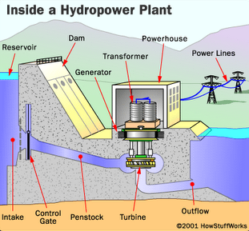

The scope of work is composed of the following tasks and associated durations and cost, when performed by one team of workers:

|  |  |  |  |  |
| --- | --- | --- | --- | --- |
|  | **Task** | **Predecessor** | **Duration (months)** | **Cost (k€)** |
| 1 | Dam (basement) |  | 6 | 2,000 |
| 2 | Dam (reservoir and elevation) | 1, 3 | 4 | 1,500 |
| 3 | Penstock and outflow | 1 | 1 | 500 |
| 4 | Control gate | 1, 2, 3 | 2 | 350 |
| 5 | Turbine | 1, 2, 3 | 3 | 1,200 |
| 6 | Generator | 5, 8 | 1 | 850 |
| 7 | Transformer | 6, 8 | 1 | 450 |
| 8 | Powerhouse | 2 | 2 | 900 |
| 9 | Power lines to backbone interface |  | 3 | 1,000 |

You have no more than 2 teams to be used (maximum available units). All tasks can be performed by 1 or more teams (if you make use of more than 1 team to perform a single task, please consider no loss of productivity. For example: 1 team takes 2 months; 2 teams take 1 month).

1. **Time scheduling (6 points)**

Suppose you are given the responsibility of managing a project to develop a new product. The venture requires the effort of a large project team to execute various activities. Your understanding is that the activities will involve different level of risk that is likely to affect the success of your project.

A precedence matrix of the macro-activities of the project is given in the chart below:

|  |  |  |  |
| --- | --- | --- | --- |
| **Activity** | **Predecessor** | **Duration [months]** | **Deadline** |
| Concept | - | 6 | *September 30th* |
| Market study | - | 3 | .............. |
| Engineering | Basic design | 3 | .............. |
| Prototyping | Engineering | 1 | .............. |
| Production line installation | Market study | 3 | .............. |
| Production start-up | Prototyping;  Prod. line installation | 2 | .............. |
| Advertising preparation | Market study | 2 | .............. |
| Advertising campaign | Advertising preparation | 1 | .............. |

Assume the project will start on April 1st this year. You are requested to assign finish dates to each activity so that your project team will be committed to meet precise deadlines (to this end please keep on filling in the “Deadline” column blanks). Please justify your reasoning.

1. **Monitoring (6 points)**

Assume that your company is a large multinational consulting firm engaged in a complex project to redesign and implement major organizational changes for one of its most important customers: “ComCast”. Today, February 20th 2020, you are hired as the new Project Manager to replace the one that quit the company. The project, to last 8 months, was originally scheduled according to the Gantt chart below:

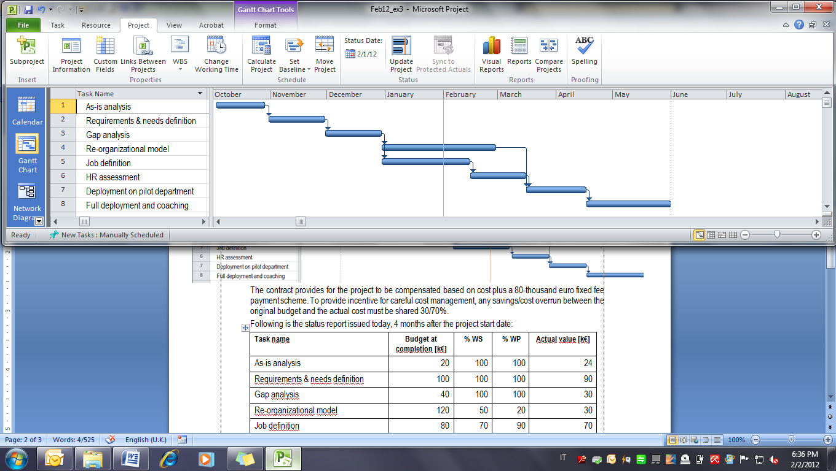

The contract signed with ComCast provides for the project to be compensated based on a cost plus €300,000 fixed fee payment scheme. Liquidated damages of €3,300 are due for each calendar day of delayed completion of the project.

You have just been mailed the following status report which records data as per January 31st:

|  |  |  |  |  |
| --- | --- | --- | --- | --- |
| **Task name** | **Budget at completion [k€]** | **% WS** | **% WP** | **Actual value [k€]** |
| As-is analysis | 20 | 100 | 100 | 24 |
| Requirements & needs definition | 100 | 100 | 100 | 90 |
| Gap analysis | 40 | 100 | 100 | 30 |
| Re-organizational model | 120 | 50 | 20 | 30 |
| Job definition | 80 | 70 | 90 | 70 |
| HR assessment | 90 | 0 | 0 | 0 |
| Deployment on pilot department | 30 | 0 | 0 | 0 |
| Full deployment and coaching | 50 | 0 | 0 | 0 |
| *TOTAL* | *530* |  |  | *244* |

Today you receive a call from your C.E.O. who wants to be informed about the current performance, estimated completion date, and reasonable estimate of the final profit that your company will net at the end of the project. What would you answer?

1. **(6 points)**

A real estate development company is considering building a recreational facility on a public plot of land. Based on current estimates, the required investment to design and construct the facility is $20million. The facility will assure a $2,000,000 annual post-tax income. The local government proposes two alternate schemes:

1. buy the perpetual real estate property for $10million;
2. sign a 30-year long BOT concession contract. In this case the government does not charge any payment, but the property must be transferred back at the end of the concession period.

The real estate company will fund the project by seeking to minimize the equity investment. Based on such consideration, which solution would you suggest?

Please consider the following information:

* Free risk rate 2%
* Market beta 1.5
* Market risk premium 8%
* Cost of Equity 14%
* Cost of debt 8%
* Non-deductible interest, no inflation

Feel free to make any additional assumption you may need.

1. **Bidding (6 points)**

In a lowest price bid to implement a large software development project, you have to calculate the fixed price. Your corporate policy requires a 10% mark-up charged on top of all cost to compute the price.

Overhead cost and interest on capital are worth 30k€/week.

A 120k€/week time penalty will be charged for any delay that the project would experience out of the specified contract baseline of 42 weeks.

The activities required to implement the project are given in the table below. Some activities can be crashed by one or more weeks down to a shortest crashed duration. The project includes the software integration with an ERP system subproject developed by the client who promises completion within 26 weeks.

There is 50% chance that the ‘System setup’ activity may take 4 weeks longer if some issues will incur with no direct cost impact (risk may impact under either normal or crashed duration).

|  |  |  |  |  |  |  |  |
| --- | --- | --- | --- | --- | --- | --- | --- |
|  | **Task** | **Predecessor** | **Normal duration [weeks]** | **Normal direct cost [k€]** |  | **Shortest crashed duration**  **[weeks]** | **Weekly crashing curve slope[k€/week]** |
| A | User needs and specs design |  | 8 | 300 |  |  |  |
| B | Software development | A | 10 | 500 | Can be crashed | 8 | 20 |
| C | Hardware procurement | A | 8 | 300 |  |  |  |
| D | System setup | B, C | 6 | 200 | Can be crashed | 2 | 100 |
| E | Pre-test | D | 4 | 100 |  |  |  |
| F | Integration with ERP | E, H | 10 | 600 | Can be crashed | 6 | 50 |
| G | Final test | F | 4 | 100 |  |  |  |
| H | ERP subproject developed by client |  | 26 |  |  |  |  |

1. **Decision making (6 points)**

Your company is considering whether to bid or not to bid on the following project. If the bidder can complete the project within 20 weeks, it will receive a bonus of $25,000. But if the project delays beyond 23 weeks, it must pay a penalty of $5,000. What would you recommend?

|  |  |  |  |
| --- | --- | --- | --- |
| Task (AOA) | Optimistic duration [weeks] | Most likely | Pessimistic duration |
| 1-2 | 5 | 11 | 11 |
| 1-3 | 10 | 10 | 10 |
| 1-4 | 2 | 5 | 8 |
| 2-6 | 1 | 7 | 13 |
| 3-6 | 4 | 4 | 10 |
| 3-7 | 4 | 7 | 16 |
| 3-5 | 2 | 2 | 14 |
| 4-5 | 0 | 6 | 12 |
| 5-7 | 2 | 8 | 14 |
| 6-7 | 1 | 4 | 7 |

Normal distribution table at the following page.

