Decision Tree Exercise

# Initiating - Decision making (6 points)

## Problem

Your pizza business is earning net revenues of €120 per year.Current overhead is €50 per year.

You have some savings to be used for expansion of your business.

You have the choice between either putting up a new shop of your pizza business in a city further away or, more simply, setting up a small shop, a point of sale, in a nearby town.

If you set up a new shop there are the following probabilities for the economy in the far city:

* does well: 37%
* remains the same: 29%
* does bad: 34%

Correspondingly the net revenues will be:

* does well:
  + the shop has a probability of being a hit of 71% and your business net revenues will be €400
  + the shop otherwise will be comparable to your existing and your business net revenues will be €240
* remains the same: additional net revenues of €85
* does bad: additional net revenues of €25

If you set up a small shop nearby there are equal probabilities that the economy will do well, bad or will remain the same.

* If you take the latter decisions net revenues will be:
* does well: increase your business net revenues by 70%
* remains the same:
  + 62% probability of your business net revenues of €166
  + 38% probability of your business net revenues of €146
* does bad: increase your business net revenues by 30%

The additional overhead of running the new shop is €30 per year, while running the small point of sale will increase your business overhead by 30%.

If you decide to do nothing consider the following chances: 70% your business will be as usual and 30% probability that your turnover and net sales will decrease by 40%. On the other hand you'll leave your business savings in a saving account that will earn you €15 by year, decreasing your business overhead.

**What will you decide?**

## **Solution**

### By excel

Prepare a workbook like the example 8.3.1_decision_tree.xlsx

you should obtain a computation like this:

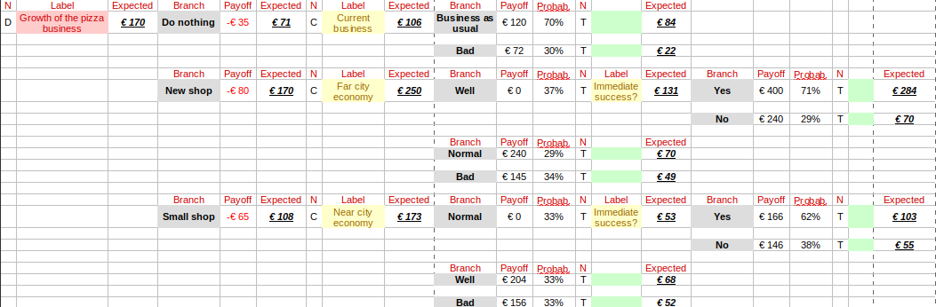

### By Silver Decisions

Goto <http://silverdecisions.pl/>.

Run a new decision tree.

The result should be:

