FINAL EXAMINATION – January 2010

## name:

Scope of work: four exercises + one small project

# Project Performance with System Dynamics (3 points)

Following is the interview to a project manager that shows a typical behaviour of project performance:

“*I have experienced that whenever a project falls behind schedule, the relationship with the customer gets worse so that the long time spent on conflict resolution generates even more delay and makes the morale of my project team go down with consequent reduced productivity.*

*Any time pressure I put on top of my team to recover productivity has unfortunately an even more negative effect on the morale of the guys. Unfortunately, the consequence is a longer and longer project with very low customer satisfaction!“*

You are demanded to depict the above problem by making use of influence diagram graphical representation (Causal Loop Mapping).

# Contract Definition (4 points)

The Sands Hotel organization has bought a casino a block off the famous boardwalk in Atlantic City, New Jersey. The facility requires renovation and improvement works. While most of the well-known profitable casinos in town benefit from boardwalk frontage, this one is not visible from the well-trafficked strip.

To achieve profitability, Sands realizes that the project to renovate the casino building needs a high-attracting architecture and upscale quality to draw a significant numbers of patrons from the boardwalk. Also, it is mandatory to open the new facility by the next summer touristic peak period

Suppose to be the Sands project manager facing the problem of defining the contract organization. What would you suggest with regard to the delivery system, the payment scheme and the award method to take on?

# Probabilistic Scheduling (5 points)

A project to develop a new manufacturing facility requires executing the following tasks:

|  |  |  |  |  |
| --- | --- | --- | --- | --- |
| **TASK** | **optimistic duration [weeks]** | **most likely duration [weeks]** | **pessimistic duration [weeks]** | **PREDECESSOR** |
| Basic design | 4 | 8 | 12 |  |
| Detailed design | 9 | 12 | 18 | basic design |
| Procurement | 24 | 26 | 40 | basic design |
| Civil works erection | 12 | 14 | 22 | detailed design |
| Assembly of production line | 12 | 16 | 20 | procurement; civil works erection |
| Testing | 3 | 4 | 8 | assembly of production line |

You are requested to indicate the probability of completing the project within 60 weeks?

NORMAL DISTRIBUTION TABLE

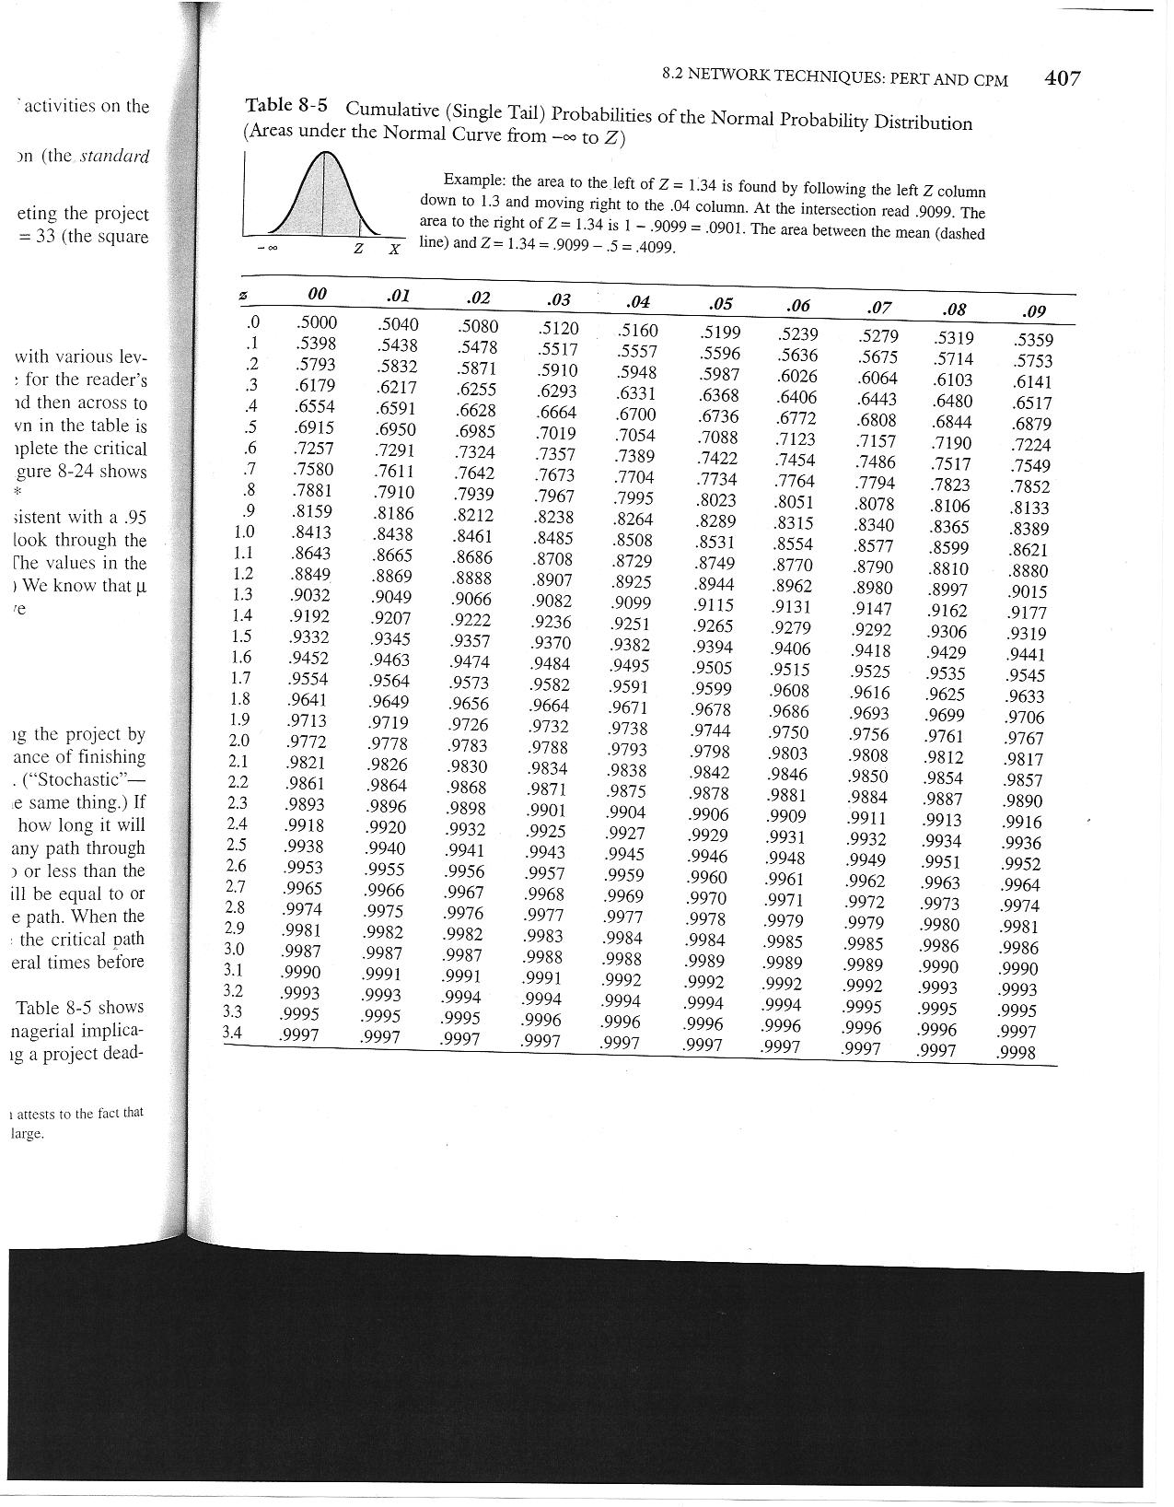

# Contract Management (5 points)

Assume to be part of a software development and IT service providing company. You are the project manager of a project to develop a custom business software solution for one of your corporate clients.

The contract deadline is 10 months. The software development contract provides for the project to be compensated based on cost plus a 150,000 euro fixed fee payment scheme. To provide incentive for careful cost management, any savings between the original budget and the actual cost must be shared equally.

Following is the status report issued today, 7 months after the project start date:

|  |  |  |  |  |
| --- | --- | --- | --- | --- |
| **Task name** | **Budget at completion [k€]** | **% WS** | **% WP** | **Actual value [k€]** |
| Feasibility analysis | 20 | 100 | 100 | 18 |
| System design | 100 | 100 | 100 | 90 |
| Functional specs | 40 | 100 | 90 | 32 |
| Development | 240 | 90 | 80 | 180 |
| Testing | 80 | 70 | 50 | 36 |
| Pilot test | 90 | 20 | 10 | 8 |
| Deployment site A | 30 | 0 | 0 | 0 |
| Deployment site B | 20 | 0 | 0 | 0 |
| *TOTAL* | *620* |  |  | *364* |

Today you receive a call from Susan Smith, your client’s representative manager, that forces you to release the project savings for her to reinvest in additional project upgrades soon. How much money would you release as project savings to both satisfy your customer and protect yourself?

.

## Small Project (7 points)

Pretend to be the project manager challenged with executing the construction portion of a wastewater treatment plant project to serve a small town.

You are asked to plan and schedule the project, calculate the total duration by identifying the critical path, plot the diagram of assignment of the “Team” resource, and determine an approximate contingency budget.

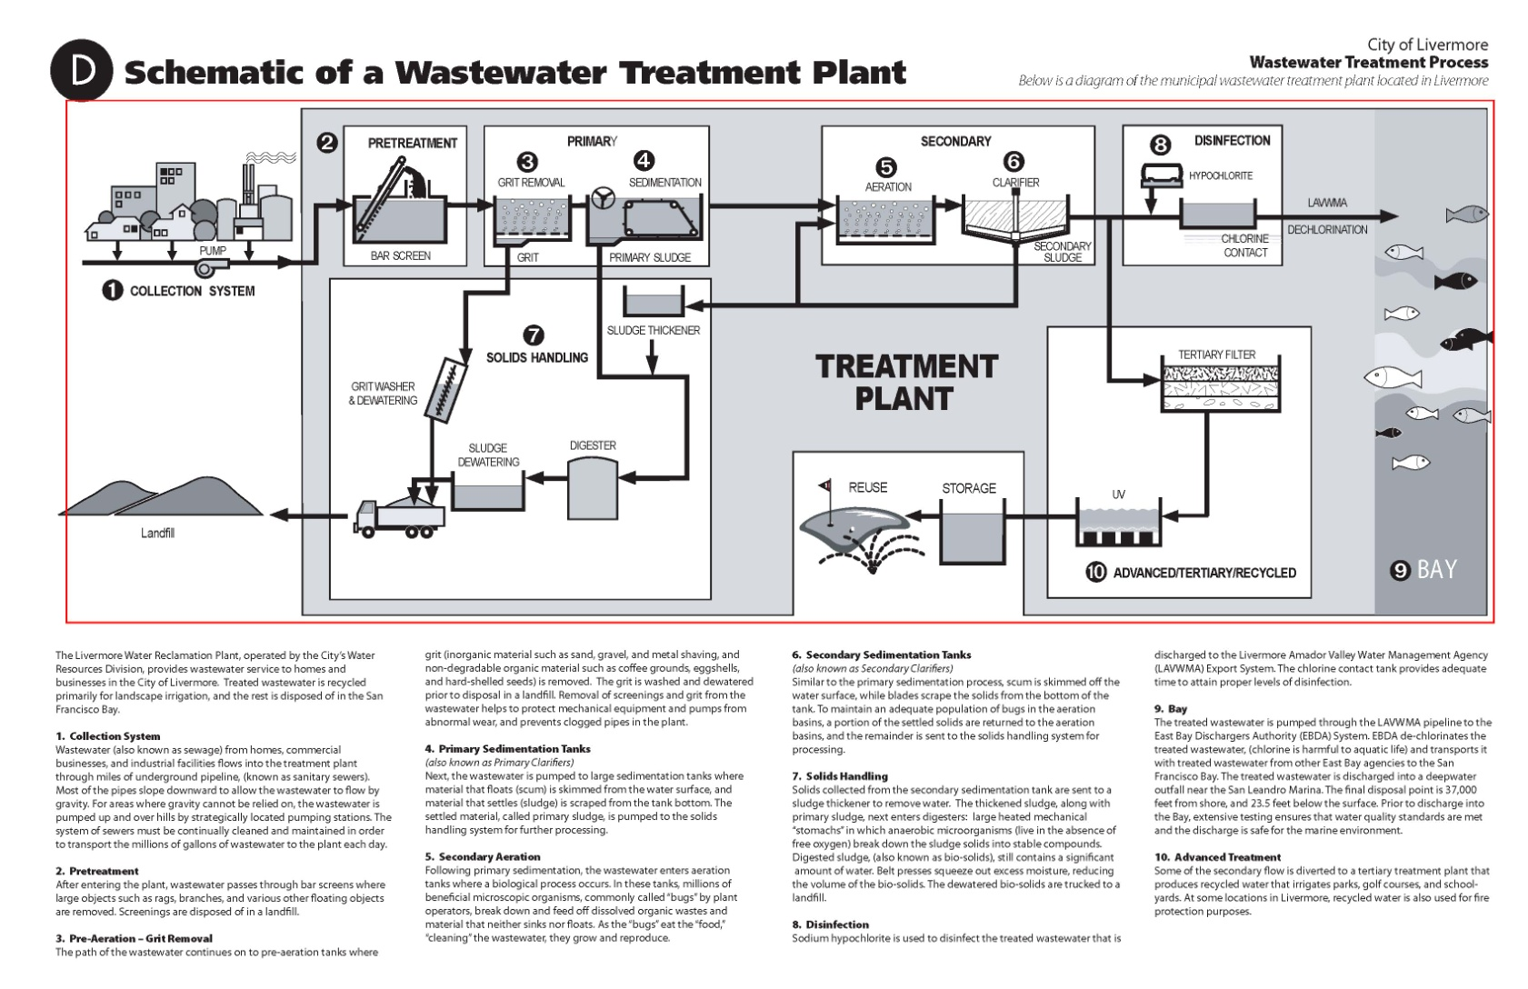

Below are the durations of each individual task, when performed by one team. Before constructing the pools/tanks it is necessary to prepare the corresponding field areas. Three is the maximum number of available teams of construction workers. All tasks can be performed by 1 or more teams without loosing productivity (i.e.: 1 team takes 2 months; 2 teams take 1 month).

|  |  |
| --- | --- |
| **Task** | **Duration** |
| Pre-treatment field | 1 month |
| Bar screen pool | 2 months |
| Primary field | 2 months |
| Grit removal tank | 1 month |
| Sedimentation tank | 2 months |
| Secondary field | 2 months |
| Aeration tank | 1 months |
| Clarifier tank | 2 months |
| Disinfection systems | 4 months |
| Solids handling systems | 4 months |
| Tertiary filter, UV and storage for reuse systems | 3 months |
| Connecting piping and interface systems | 8 months |