FINAL EXAMINATION – February 7th, 2012

## name:

Scope of work: four exercises

# Time scheduling (6 points)

Suppose you are given the responsibility of managing a complex project to develop a new product. The venture requires the effort of a large project team to execute various activities. Your understanding is that the activities will involve different level of risk that is likely to affect the success of your project.

A precedence matrix of the macro-activities of the project is given in the chart below:

|  |  |  |  |
| --- | --- | --- | --- |
| **Activity** | **Predecessor** | **Duration [months]** | **Deadline** |
| Concept | - | 6 | *September 30th* |
| Market study | - | 3 | .............. |
| Engineering | Basic design | 3 | .............. |
| Prototyping | Engineering | 1 | .............. |
| Production line installation | Market study | 3 | .............. |
| Production start-up | Prototyping;  Prod. line installation | 2 | .............. |
| Advertising preparation | Market study | 2 | .............. |
| Advertising campaign | Advertising preparation | 1 | .............. |

Assume the project will start on April 1st this year. You are requested to assign finish dates to each activity so that your project team will be committed to meet precise deadlines (to this end please keep on filling in the “Deadline” column blanks). Please justify your deadlines with computations and brief comment.

# Resource-based Scheduling (6 points)

The activities and requirements for analysts and programmers for the ABC project are as follows:

|  |  |  |  |  |  |  |  |
| --- | --- | --- | --- | --- | --- | --- | --- |
| Activity | J | M | V | Y | L | Q | Z |
| Predecessor | - | J | M | V | J | L | Y, Q |
| Duration (weeks) | 6 | 4 | 6 | 8 | 2 | 8 | 2 |
| Analysts | 8 | 5 | 3 | 2 | 5 | 3 | 5 |
| Programmers | 3 | 4 | 2 | 3 | 3 | 2 | 3 |

You are requested to:

1. draw the network and compute the total duration assuming infinite resources.
2. suppose the maximum weekly availability is 8 analysts and 5 programmers. Can activities be scheduled without delaying the project duration computed without limitations?

# Monitoring (6 points)

Assume that your company is a large multinational consulting firm, which is engaged in a difficult project to redesign and implement major organizational changes for one of its most important customers: “GlobalCom”. Today, February 7th 2012, you are appointed Project Manager to replace the one that quit the company. The project, to last 8 months, was scheduled according to the chart below.

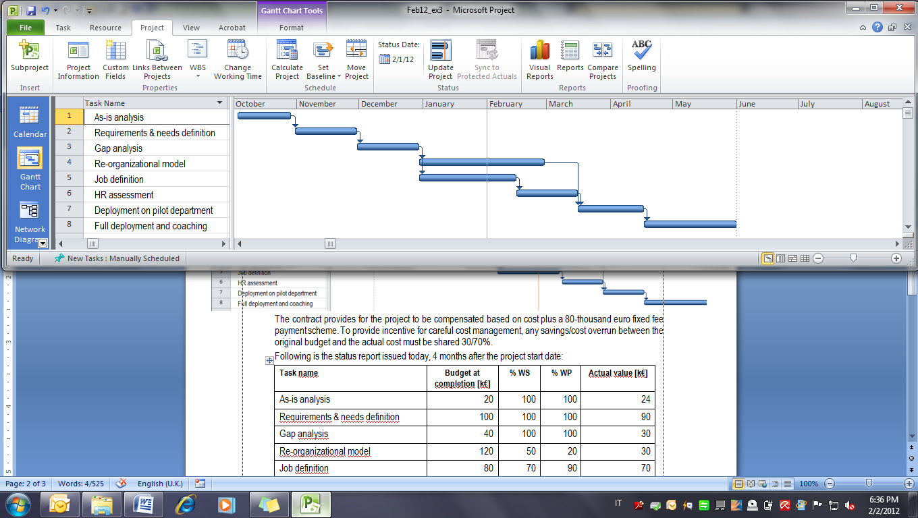

The contract signed with GlobalCom provides for the project to be compensated based on cost plus €300,000 fixed fee payment scheme. Liquidated damages of 100,000/month are due in case of delay. Overhead cost is €10,000 per month.

You have just been mailed the following status report which records data as per January 31st:

|  |  |  |  |  |
| --- | --- | --- | --- | --- |
| **Task name** | **Budget at completion [k€]** | **% WS** | **% WP** | **Actual value [k€]** |
| As-is analysis | 20 | 100 | 100 | 24 |
| Requirements & needs definition | 100 | 100 | 100 | 90 |
| Gap analysis | 40 | 100 | 100 | 30 |
| Re-organizational model | 120 | 50 | 20 | 30 |
| Job definition | 80 | 70 | 90 | 70 |
| HR assessment | 90 | 0 | 0 | 0 |
| Deployment on pilot department | 30 | 0 | 0 | 0 |
| Full deployment and coaching | 50 | 0 | 0 | 0 |
| *TOTAL* | *530* |  |  | *244* |

Today you receive a call from your C.E.O. that wants to be informed the current performance, estimated completion date, and reasonable estimate of the final profit that your company will net at the end of the project. What would you answer?

# Case (5 points)

Bev-Pak Inc. is planning to start a €50-million investment to build a new beverage container plant with total capacity of 2 billion cans produced per year. Bev-Pak is expecting Coca-Cola and PepsiCo. to buy cans over 5 years of operations, with expected annual revenue of €18millions, and operations costs no greater than €2millions per year.

Assuming you are the Bev-Pak project manager, please advise on the following issues:

1. suggest the most suitable contract organization to implement the project;
2. determine the funding scheme for the facility investment;
3. assess the present value of the project investment.

Please consider the following assumptions, and feel free to make any additional hypotheses, if necessary:

annual interest rate on debt capital 7%, cost of equity 11%, marginal corporate tax rate 40%.