FINAL EXAMINATION – July 4th, 2013

Duration **1.5hrs**

## name:

# Contract definition (4 points)

As property owner of a piece of land, an electric utility company is willing to construct a new power station. The basic design prepared by an independent reputable engineering company is completed, and preliminary authorizations, permits, and local community’s consensus have been obtained under the conditions that the project will assure maximum environmental quality, and that appointed local bodies will have the right to make changes to meet the requirements.

Suppose to be the appointed project manager facing the problem of defining the project contract. What would you suggest with regard to the delivery system, the payment scheme and the award method?.

# Scheduling (6 points)

Given the following precedence matrix, calculate the total duration and the criticality index of all paths.

|  |  |  |
| --- | --- | --- |
| Task | Duration | Predecessor |
| 1 | 10 days |  |
| 2 | 6 days | 1 |
| 3 | 5 days | 1 |
| 4 | 8 days | 2; 5 |
| 5 | 5 days | 3 |
| 6 | 15 days | 2 |
| 7 | 10 days | 5; 6 |

.

# Project Monitoring (6 points)

A project, with a total budgeted cost of $24,000 and expected total duration of 6 weeks, has been developing according to the Earned Value chart below:

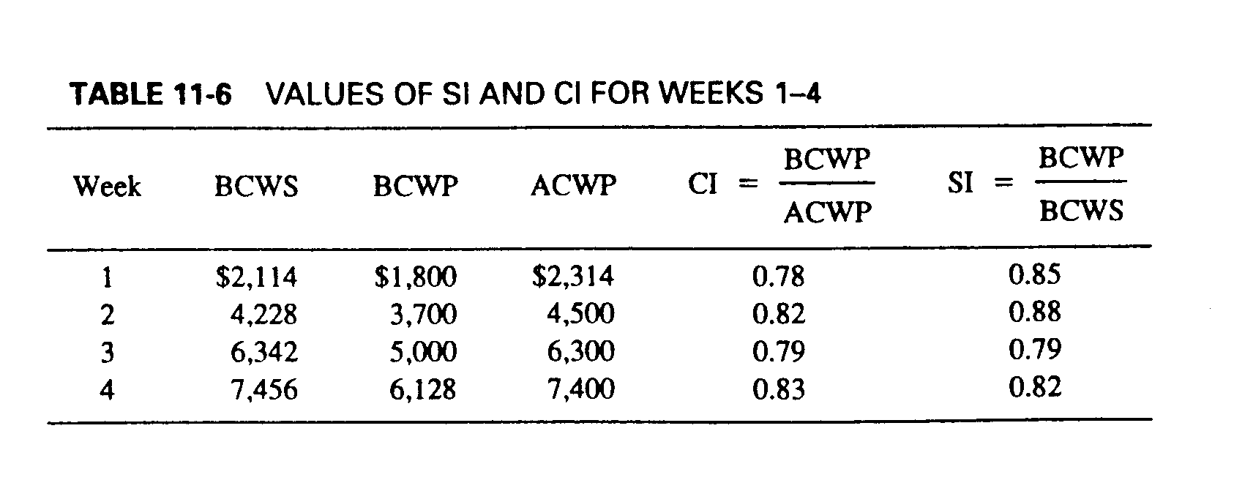

What is the project performance at the current time (week 4)?

Please also forecast both cost EAC and the actual completion date. Please consider to take into account for past performance trends.

# Small project (6 points)

Pretend to be the project manager of a project to construct a coal-fired power station. Coal-fired units produce electricity by burning coal in a boiler to heat water to produce steam. The steam, at tremendous pressure, flows into a turbine, which spins a generator to produce electricity. The steam is cooled, condensed back into water, and returned to the boiler to start the process over.

You are asked to plan and budget the project, define the network schedule, calculate the total duration by identifying the critical path, and plot the resource diagram for the resource “team”.

Coal storage and conveyor belt system

stack

The plant section is represented in the figure above.

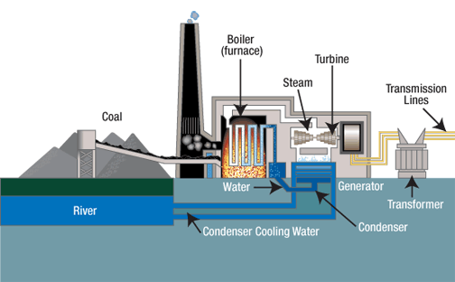

The scope of work is composed of the following tasks and associated durations and cost, when performed by one team:

|  |  |  |  |
| --- | --- | --- | --- |
| **Task** | **Predecessor** | **Duration (months)** | **Cost (k€)** |
| Stack | Boiler | 1 | 100 |
| Coal storage and conveyor belt system |  | 3 | 1200 |
| Cooling water piping |  | 4 | 200 |
| Boiler |  | 3 | 300 |
| Steam turbine |  | 2 | 800 |
| Generator | Steam turbine | 2 | 400 |
| Transformer |  | 1 | 250 |
| Transmission lines | transformer | 3 | 350 |

You have no more than 2 teams to be used (maximum available units). All tasks can be performed by 1 or more teams (if you make use of more than 1 team to perform a single task, please consider a no loss of productivity. For example: 1 team takes 2 months; 2 teams take 1 month).