FINAL EXAMINATION – February 24th, 2014

## name:

# Small Project (7 points)

Pretend to be the Project Manager of a hydropower plant project. You are asked to plan the scope of work, prepare a budget, define the network schedule, calculate the total duration by identifying the critical path, and plot the resource diagram for the resource “Team of workers”.

The plant section is represented in the figure above.

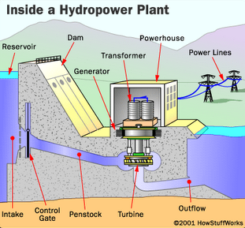

The scope of work is composed of the following tasks and associated durations and cost, when performed by one Team of workers:

|  |  |  |  |  |
| --- | --- | --- | --- | --- |
|  | **Task** | **Predecessor** | **Duration (months)** | **Cost (k€)** |
| 1 | Dam (basement) |  | 6 | 2,000 |
| 2 | Dam (reservoir and elevation) | 1, 3 | 5 | 1,500 |
| 3 | Penstock and outflow | 1 | 2 | 600 |
| 4 | Control gate | 1, 2, 3 | 2 | 300 |
| 5 | Turbine | 1, 2, 3 | 3 | 1,100 |
| 6 | Generator | 5, 8 | 1 | 950 |
| 7 | Transformer | 6, 8 | 1 | 400 |
| 8 | Powerhouse | 2 | 4 | 950 |
| 9 | Power lines to backbone interface |  | 3 | 1,100 |

You have no more than 2 Teams to be used (maximum available units). All tasks can be performed by 1 or more teams (if you make use of more than 1 team to perform a single task, please consider having no loss of productivity. For example: 1 team takes 2 months; 2 teams take 1 month).

# Monitoring (8 points)

Following is the original schedule of a sales campaign project, with total budgeted cost of $3.4mil and 12 months BC.

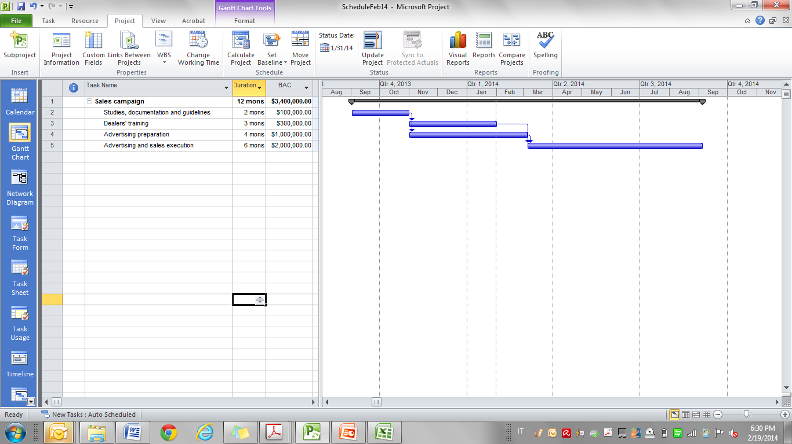

Below is also provided a status report just recorded as per January 31, 2014.

|  |  |  |  |  |
| --- | --- | --- | --- | --- |
|  | **BAC** | **BCWS** | **ACWP** | **BCWP** |
| Studies, documentation and guidelines | 100,000 | 100,000 | 120,000 | 100,000 |
| Dealers’ training | 300,000 | 300,000 | 220,000 | 180,000 |
| Advertising preparation | 1,000,000 | 750,000 | 930,000 | 900,000 |
| Advertising and sales execution | 2,000,000 | - | - | - |

Assume you are the project manager. When would you set the revised advertising and sales execution start date, if you assume that a delayed start may result in losing sales worth $2millions per month?

Would you also revise the original budget? If yes, how much would be the revised budgeted cost?

# Probabilistic scheduling (7 points)

Consider the activities described in the chart below, where a, m, and b are given in weeks.

Please note that a and b are estimates at the 95 percent level.

|  |  |  |  |  |
| --- | --- | --- | --- | --- |
| Activity | Predecessor | a | m | b |
| A |  | 2 | 4 | 6 |
| B |  | 2 | 2 | 3 |
| C |  | 4 | 8 | 10 |
| D | A | 4 | 6 | 7 |
| E | A, B | 7 | 9 | 12 |
| F | D, E | 1 | 2 | 3 |
| G | C | 2 | 3 | 4 |

What is the probability of ending the project before week 17?

NORMAL DISTRIBUTION TABLE

