FINAL EXAMINATION – September 2014

## name:

# Scheduling (6 points)

The following table gives information on a project (T in days; C in €1,000).

|  |  |  |  |  |  |
| --- | --- | --- | --- | --- | --- |
| **TASK** | **predecessor** | **T normal** | **C normal** | **T crashed** | **C crashed** |
| **A** |  | 6 | 10 | 2 | 38 |
| **B** |  | 4 | 12 | 4 | 12 |
| **C** |  | 4 | 18 | 2 | 36 |
| **D** | A | 6 | 20 | 2 | 40 |
| **E** | B, D | 3 | 30 | 2 | 33 |
| **F** | C | 10 | 10 | 6 | 50 |
| **G** | E, F | 6 | 20 | 2 | 100 |

If overhead costs are €20,000 per day, what is the optimal duration?

# Project monitoring (6 points)

The team of SA Gold Mine was tasked to sink a 2,000 meter deep ventilation shaft, and then to excavate room for a station at the bottom of the shaft. The approved plan was to sink the shaft within 20 months at a cost of 65,000 R per meter of shaft depth (R =South Africa RAND, R1 = US $0.1244). For the station at the bottom, 30,000 cubic meter of rock would have to be excavated within 3 months at a cost of R700 per cubic meter. The plan assumed a straight line value progress over time.

After the work had begun, the scope of the project was changed to include excavation for a new station halfway down the shaft with a volume of 20,000 cubic meters (Figure below).

It was agreed that the additional work had to be done at the same excavation rate as the bottom station, but due to softer rock than the bottom one, the team agreed on the cost of R500 per cubic meter.

Because of space and resources available, the new station cannot be performed simultaneously to the other tasks. Currently, after 13 months from inception of work, the shaft has reached a depth of 1,400 m below surface and the new halfway station is completed. The actual cost at this time is R90 million.

You are requested an earned value report as well as time and cost estimates at completion by your executive management.

Ventilation shaft

Bottom station

New station

## Small Project (6 points)

Pretend to be the project manager of a project to construct a new hydroelectric power station. You are asked to plan the project, define the network schedule, calculate the total duration by identifying the critical path, plot the usage profile for the resource “team”, and identify the project risks.

The system is represented in the figure above.

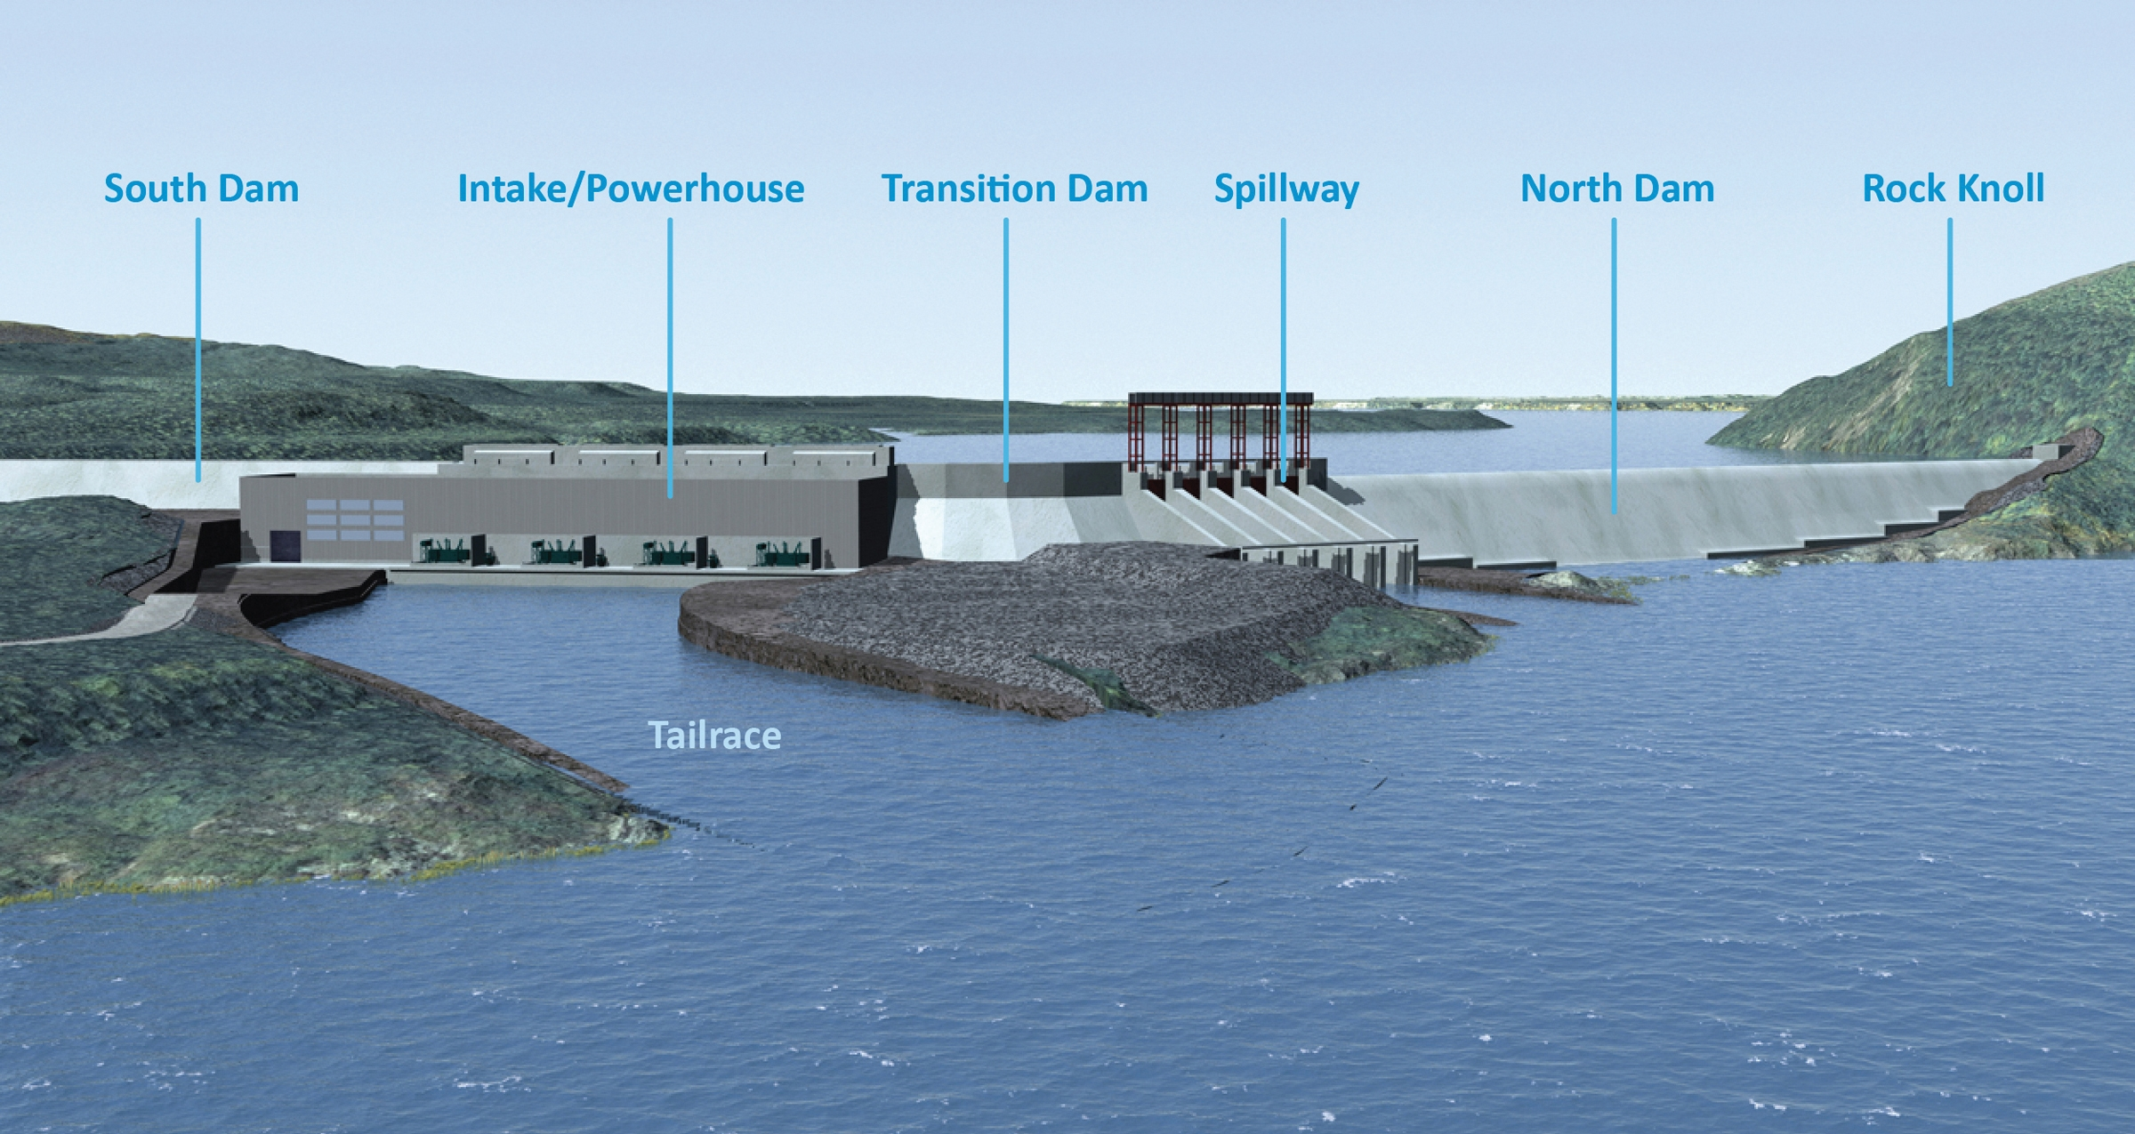

The scope of work includes the following tasks and associated durations, when performed by one team:

South dam 5 months

Transition dam 3 months

North dam 9 months

Intake/powerhouse

Powerhouse building 12 months

Turbines 4 months

Generator 3 months

Spillway 12 months

Tailrace 4 months

You have no more than 3 teams to be used (maximum available units). All tasks can be performed by 1 or more teams (if you make use of more than 1 team to perform a single task, please consider a no loss of productivity. For example: 1 team takes 2 months; 2 teams take 1 month)

# Project Funding (4 points)

Determine the approximate mix of equity and debt sources of fund (debt leverage) required to finance a 10 million € B.O.T. project. The project is supposed to be operated over 10 year, with 1 million € annual expected cash flow (before repayment of debt interest and principal to the bank).

Assume that both cost of equity and cost of debt are 10% and that annual principal is 1/10 of initial debt funds. Fell free to make other reasonable financial assumptions, if required.