FINAL EXAMINATION – February 25th, 2015 – 11:00-12:30

## name:

# Monitoring (8 points)

Consider a pharmaceutical project to develop and launch a new drug compound by end of current year 2015. The EV report as per Dec 31st, 2014 is given in the chart below with figures expressed in $ amounts.

Based on estimates at completion, you are requested to propose a revised budget that minimizes the cost impact of current performance. Please consider that any delay of the project would result in loosing sales by as much as $50,000/month.

|  |  |  |  |  |  |  |
| --- | --- | --- | --- | --- | --- | --- |
| **BCWS** | sem 1, 2013 | sem 2, 2013 | sem 1, 2014 | sem 2, 2014 | sem 1, 2015 | sem 2, 2015 |
| Component identification | 200,000 | 90,000 |  |  |  |  |
| Preclinical test |  | 50,000 | 200,000 |  |  |  |
| Clinical program |  |  |  | 260,000 | 200,000 |  |
| Launch |  |  |  |  |  | 100,000 |
| Marketing and legal support |  | 10,000 | 30,000 | 50,000 | 100,000 |  |
| Prj mng support | 30,000 | 30,000 | 30,000 | 30,000 | 30,000 | 30,000 |
| Corporate overhead | 100,000 | 100,000 | 100,000 | 100,000 | 100,000 | 100,000 |
|  |  |  |  |  |  |  |
| **ACWP** | sem 1, 2013 | sem 2, 2013 | sem 1, 2014 | sem 2, 2014 | sem 1, 2015 | sem 2, 2015 |
| Component identification | 190,000 | 130,000 |  |  |  |  |
| Preclinical test |  | 60,000 | 220,000 | 40,000 |  |  |
| Clinical program |  |  |  | 170,000 |  |  |
| Launch |  |  |  |  |  |  |
| Marketing and legal support |  | 10,000 | 30,000 | 50,000 |  |  |
| Prj mng support | 30,000 | 30,000 | 30,000 | 30,000 |  |  |
| Corporate overhead | 100,000 | 100,000 | 100,000 | 100,000 |  |  |
|  |  |  |  |  |  |  |
| **BCWP** | sem 1, 2013 | sem 2, 2013 | sem 1, 2014 | sem 2, 2014 | sem 1, 2015 | sem 2, 2015 |
| Component identification | 180,000 | 110,000 |  |  |  |  |
| Preclinical test |  | 40,000 | 180,000 | 30,000 |  |  |
| Clinical program |  |  |  | 160,000 |  |  |
| Launch |  |  |  |  |  |  |
| Marketing and legal support |  | 10,000 | 30,000 | 50,000 |  |  |
| Prj mng support | 30,000 | 30,000 | 30,000 | 30,000 |  |  |
| Corporate overhead | 100,000 | 100,000 | 100,000 | 100,000 |  |  |

# Decision making (6 points)

Your company is considering whether to bid or not to bid on the following project. If the bidder can complete the project within 20 weeks, it will receive a bonus of $25,000. But if the project delays beyond 23 weeks, it must pay a penalty of $5,000. What would you recommend?

|  |  |  |  |
| --- | --- | --- | --- |
| Task (AOA) | Optimistic duration [weeks] | Most likely | Pessimistic duration |
| 1-2 | 5 | 11 | 11 |
| 1-3 | 10 | 10 | 10 |
| 1-4 | 2 | 5 | 8 |
| 2-6 | 1 | 7 | 13 |
| 3-6 | 4 | 4 | 10 |
| 3-7 | 4 | 7 | 16 |
| 3-5 | 2 | 2 | 14 |
| 4-5 | 0 | 6 | 12 |
| 5-7 | 2 | 8 | 14 |
| 6-7 | 1 | 4 | 7 |

Normal distribution table

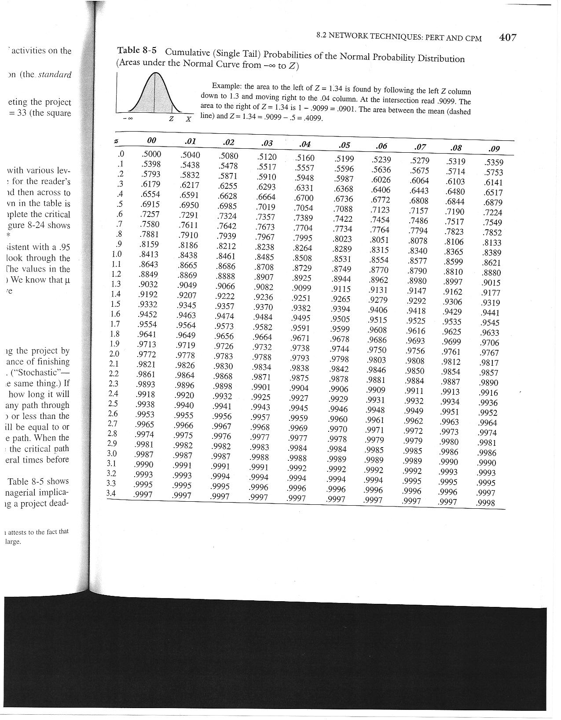

# Small project (8 points)

Pretend to be the Proposal Manager charged with bidding a turn-key fixed-price tender to build a liquefied natural gas (LNG) regasification terminal, as represented in the below figure. As part of the bid documents, you are asked to provide for: 1. WBS and CBS 2. Schedule, 3. Resource graph for the “Team” assignment, 4. Assessment of a risk contingency (please consider no more than 3 major risks), 5. Price computation

Assume that Price = 1.2*(direct cost + overhead cost + risk contingency + interest); where overhead daily cost is 10,000€ and annual interest rate on negative bank account balance is 10% (no interest on positive balance). No advanced payment is agreed upon the contract.

The project scope of work includes several independent components:

* One (1) unloading dock
* Three (3) LNG storage tanks
* A flare (1)
* A boil off gas compressor (1)
* A regaseifier (1)
* A high pressure pump (1)
* Two (2) open rack vaporisers
* A metering station (1)
* Lines/pipes system (all including unloading lines, sea water line, etc.) (1 system)

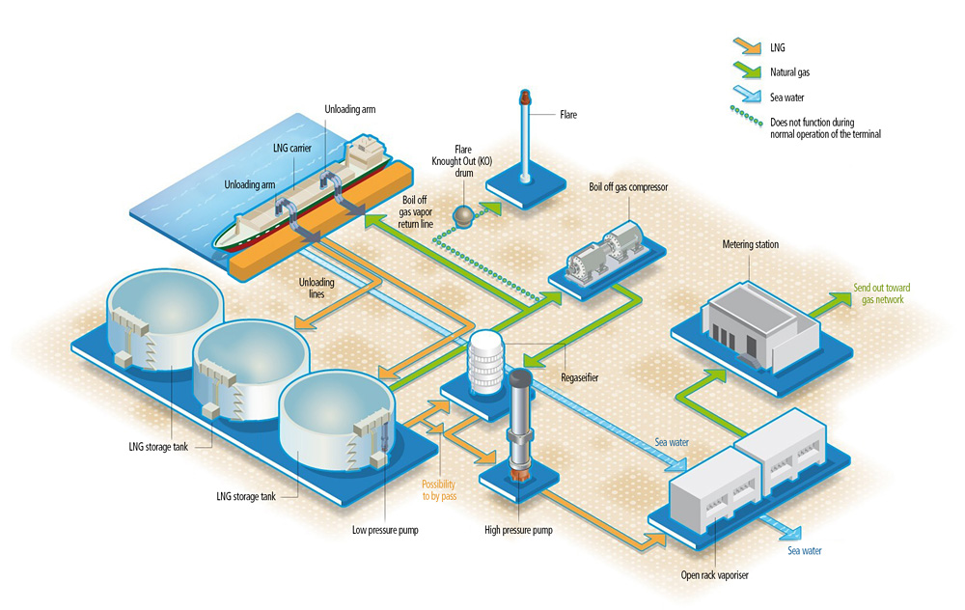

Below are the durations of each task, when performed by one team. You have no more than 3 teams available. All tasks can be performed by one or more teams (if you make usage of more than 1 team to perform a single task, please consider no loss of productivity. For example: 1 team takes 2 months; 2 teams take 1 month).

|  |  |  |
| --- | --- | --- |
| Task | Duration [months] | Cost [k€] |
| Unloading dock | 6 | 12,000 |
| LNG storage tank | 4 | 5,000 |
| Flare | 5 | 6,000 |
| Boil off gas compressor | 4 | 4,500 |
| Regasefeier | 7 | 10,500 |
| High pressure pump | 5 | 9,000 |
| Open rack vaporizer | 4 | 3,500 |
| Metering station | 6 | 3,000 |
| Lines/pipes system | 12 | 6,000 |