FINAL EXAMINATION – June 16th, 2015

Duration 1h40’

## name:

# Scheduling (8 points)

Assume you are Project Manager of a project to develop a new product.

Information on the major phases is given in the below chart.

|  |  |  |  |  |
| --- | --- | --- | --- | --- |
| Activity | Predecessor | Duration [months] | Risk score [1-10] | Deadline date |
| Basic design | - | 6 | 8 | December 31st |
| Market study | - | 3 | 8 |  |
| Engineering | Basic design | 3 | 10 |  |
| Prototyping | Engineering | 1 | 5 |  |
| Production line installation | Market study | 3 | 4 |  |
| Production start-up | Prototyping;  Prod. line installation | 2 | 6 |  |
| Advertising preparation | Market study | 2 | 2 |  |
| Advertising campaign | Advertising preparation | 1 | 2 |  |

Assume the project will start on July 1st this year and assign finish dates to each phase so that your project team will be responsible for meeting precise deadlines (to this end please fill in the “Deadline” column blanks and justify your answers with appropriate computations).

# Financing (6 points)

A PPP project to build, operate for 30 years, and transfer back a new pay toll road has an estimated capital expenditure of €5billions. The SPV has expected annual revenue of €0.7bln, annual O&M costs of €0.1bln and annual general expenses of 0.1mln€.

Annual interest rate on debt is 5%. Tax on income rate is 33%.

Revenue risk is considered to be quite low because the governmental granting authority will pay for a shadow toll if the traffic level would not reach the estimated annual revenue.

Determine the approximate suitable debt to equity ratio for the project investment.

# Monitoring (8 points)

Assume you work for a consulting firm engaged in a complex project to redesign and implement major organizational changes for one of its most important customers: Voltas Inc.

Today, June 16th 2015, you are freshly appointed Project Manager in replacement of the one that just quit the company. The project, to last 9 months, was scheduled according to the chart below with start date on February 1st 2015.

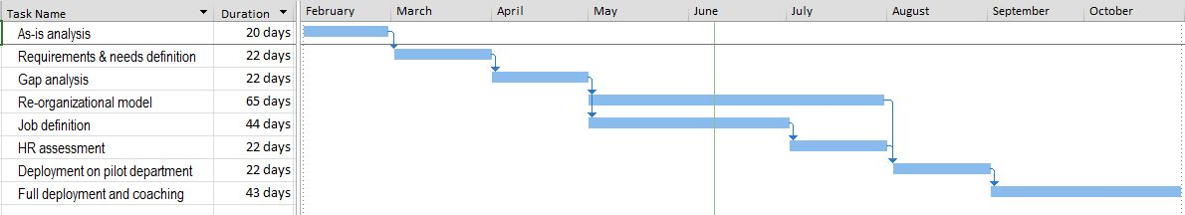

The contract signed with Voltas provides for the project to be compensated based on a cost plus €495,000 fixed fee scheme. Liquidated damages of €50,000/month are due in case of any delay. Overhead cost, for as much as €20,000 per month, is not going to be reimbursed since any compensation is supposed to be included in the fixed fee.

You have just been mailed the following status report that records data as per May 31st 2015.

|  |  |  |  |  |
| --- | --- | --- | --- | --- |
| **Task name** | **Budget at completion [k€]** | **% WS** | **% WP** | **Actual value [k€]** |
| As-is analysis | 20 | 100 | 100 | 24 |
| Requirements & needs definition | 100 | 100 | 100 | 90 |
| Gap analysis | 40 | 100 | 100 | 30 |
| Re-organizational model | 120 | 50 | 20 | 30 |
| Job definition | 80 | 70 | 90 | 70 |
| HR assessment | 90 | 0 | 0 | 0 |
| Deployment on pilot department | 30 | 0 | 0 | 0 |
| Full deployment and coaching | 50 | 0 | 0 | 0 |
| *TOTAL* | *530* |  |  | *244* |

Today you receive a call from your C.E.O. that wants to be informed the current performance, estimated completion date and reasonable estimate of the final profit that your company will net at the end of the project. What would you answer?