FINAL EXAMINATION – January 29th, 2016 – 11:00-12:45

## name:

# Monitoring (8 points)

As the Contractor’s Project Manager for an ongoing project to construct and sell a shopping mall, you are approached by your client who wants to know if the shopping mall will open by the contract deadline of September 30st, 2016 and what could be the estimated price she will pay.

What would you answer?

The payment conditions agreed upon the contract are as follows:

* Estimated target cost: €10millions
* Fixed Fee: €1.5million
* Share of cost savings/overruns: 70% client/30% contractor
* GMP: €14millions
* Contract deadline: September 30th, 2016
* Time penalty: €35,000 per week (please consider 1 month = 4 weeks)

As per Dec 31st, 2015 the actual value spent is €7,110,000 and the following data report is available.



# Scheduling (6 points)

Consider the data about project activities given in the table below.

Schedule the work and indicate the resource-critical path.

|  |  |  |  |
| --- | --- | --- | --- |
| Activity | Predecessor(s) | Duration [days] | Resources |
| A | - | 2 | John |
| B | A | 3 | Sue |
| C | - | 3 | Sue, John |
| D | C | 2 | Al |
| E | D, J | 3 | Sue, Al |
| F | E, B | 2 | John |
| G | F | 2 | Ann |
| H | - | 4 | Sue |
| J | H | 2 | Al |

# Small project (8 points)

Pretend to be the Project Manager for a project to construct a hydropower plant. Description.

You are asked to plan the project, draw the network schedule, calculate the total duration by identifying the critical path, plot the usage profile for the resource “team of technicians” and accounting for a draft contingency budget.

The plant section is represented in the figure above.

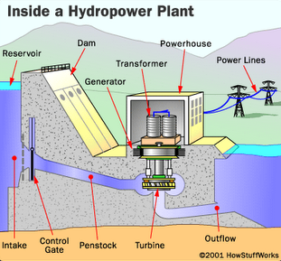

The scope of work is composed of the following tasks and associated durations and cost, when performed by one team of workers:

|  |  |  |  |  |
| --- | --- | --- | --- | --- |
|  | **Task** | **Predecessor** | **Duration (months)** | **Cost (k€)** |
| 1 | Dam (basement) |  | 6 | 2,000 |
| 2 | Dam (reservoir and elevation) | 1, 3 | 6 | 1,500 |
| 3 | Penstock and outflow | 1 | 2 | 500 |
| 4 | Control gate | 1, 2, 3 | 4 | 500 |
| 5 | Turbine | 1, 2, 3 | 2 | 1,200 |
| 6 | Generator | 5, 8 | 2 | 1,000 |
| 7 | Transformer | 6, 8 | 2 | 500 |
| 8 | Powerhouse | 2 | 6 | 1,000 |
| 9 | Power lines to backbone interface |  | 2 | 1,000 |

You have no more than 3 teams to be used (maximum available units). All tasks can be performed by one or more teams (if you make use of more than 1 team to perform a single task, please consider no loss of productivity. For example: 1 team takes 2 months; 2 teams take 1 month)