FINAL EXAMINATION

## name:

# Contracting (7 points)

The Freight Forwarding & Distribution Co. (FF&D) is willing to award Best Co. the contract for the logistical on-line system project. The project consists of designing, fabricating, and installing a transport, storage, and database system for automatic placement, storage and retrieval of standardized shipping containers.

Best Co. has strong engineering and project management expertise, but does not have comprehensive competence and capacity to install the total scope of work, thus requiring the help of other companies in the tasks of computer software and robotics installation.

FF&D faces strict budget requirements, but a few risks challenge the ceiling budget. On the one hand, the steel component of the supply is a large portion of the project and steel is known to be a price-fluctuating commodity. On the other hand, the system design may be subject to changes as far as technology may change from the point in time the basic design was developed to the one Best Co. will detail the system engineering and install the system.

You are demanded to define the contract organization and associated payment scheme.

# Project Scheduling (8 points)

The following project network and associated costs are given below (time in days, cost in €1,000).



|  |  |  |  |  |
| --- | --- | --- | --- | --- |
| Activity | Normal duration | Normal cost | Crashed duration | Crashed cost |
| A | 6 | 6 | 3 | 9 |
| B | 9 | 9 | 5 | 12 |
| C | 3 | 4.5 | 2 | 7 |
| D | 5 | 10 | 2 | 16 |
| E | 2 | 2 | 2 | 2 |
| F | 4 | 6 | 1 | 10 |
| G | 8 | 8 | 5 | 10 |

What is the optimal project duration and associated budgeted cost?

# Small Project (7 points)

Pretend to be the project manager of a project to construct a hydropower plant. Description.

You are asked to plan the project, define the network schedule, calculate the total duration by identifying the critical path, and plot the usage profile for the resource “team of technicians”.

The plant section is represented in the figure above.

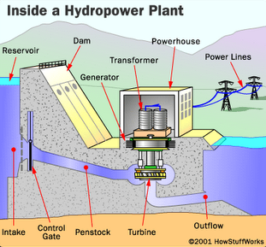

The scope of work is composed of the following tasks and associated durations and cost, when performed by one team of workers:

|  |  |  |  |  |
| --- | --- | --- | --- | --- |
|  | **Task** | **Predecessor** | **Duration (months)** | **Cost (k€)** |
| 1 | Dam (basement) |  | 6 | 2,000 |
| 2 | Dam (reservoir and elevation) | 1, 3 | 4 | 1,500 |
| 3 | Penstock and outflow | 1 | 1 | 500 |
| 4 | Control gate | 1, 2, 3 | 2 | 350 |
| 5 | Turbine | 1, 2, 3 | 3 | 1,200 |
| 6 | Generator | 5, 8 | 1 | 850 |
| 7 | Transformer | 6, 8 | 1 | 450 |
| 8 | Powerhouse | 2 | 2 | 900 |
| 9 | Power lines to backbone interface |  | 3 | 2,000 |

You have no more than 2 teams to be used (maximum available units). All tasks can be performed by 1 or more teams (if you make use of more than 1 team to perform a single task, please consider to have no loss of productivity. For example: 1 team takes 2 months; 2 teams take 1 month).