FINAL TEST – February 9th, 2017

## name:

# Monitoring (6 points)

Assume your company is a large multinational consulting firm, which is engaged in a project to design and deploy major organizational changes for one of its clients: “TelCo”. Today, February 9th 2017, you take up as the new Project Manager. The project, to last 8 months, was scheduled according to Gantt chart below.

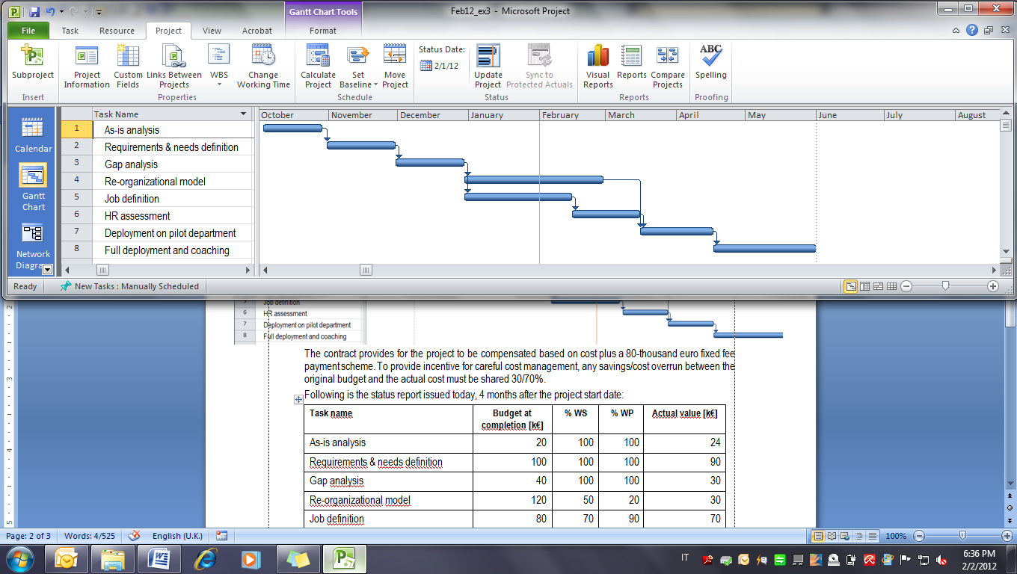

The contract provides for cost to be reimbursed based plus a €200,000 fixed fee payment scheme. Liquidated damages of 25,000/week (please consider 1 month = 4 weeks) are due in case of delay. Overhead cost is €2,000 per week.

You have just received the following project status report, which records data as per January 31st:

|  |  |  |  |  |
| --- | --- | --- | --- | --- |
| **Task name** | **BAC [k€]** | **% WS** | **% WP** | **ACWP [k€]** |
| As-is analysis | 20 | 100 | 100 | 24 |
| Requirements & needs definition | 100 | 100 | 100 | 90 |
| Gap analysis | 40 | 100 | 100 | 30 |
| Re-organizational model | 120 | 50 | 20 | 30 |
| Job definition | 80 | 70 | 90 | 70 |
| HR assessment | 90 | 0 | 0 | 0 |
| Deployment on pilot department | 30 | 0 | 0 | 0 |
| Full deployment and coaching | 50 | 0 | 0 | 0 |
| *TOTAL* | *530* |  |  | *244* |

Today you receive a call from your boss that wants to be informed about the current performance, estimated completion date, and reasonable estimate of the final profit that your company will net at the end of the project. What would you answer?

# Resource-based Scheduling (6 points)

The activities and requirements for analysts and programmers for a hypothetical project are as follows:

|  |  |  |  |  |  |  |  |
| --- | --- | --- | --- | --- | --- | --- | --- |
| Activity | J | M | V | Y | L | Q | Z |
| Predecessor | - | J | M | V | J | L | Y, Q |
| Duration (weeks) | 6 | 4 | 6 | 8 | 2 | 8 | 2 |
| Analysts | 8 | 5 | 3 | 2 | 5 | 3 | 5 |
| Programmers | 3 | 4 | 2 | 3 | 3 | 2 | 3 |

You are requested to:

1. draw the network and compute the total duration assuming unlimited resources.
2. suppose the maximum weekly availability is 8 analysts and 5 programmers. Can activities be scheduled without delaying the project duration computed with unlimited resources?

# Case (6 points)

The consumer packaging company Packs Co. is planning to start a €40-million investment to build a new packaging production facility with total capacity of 3 billion packaging items produced per year. Packs entered into long term takeoff agreements with P&G and Unilever that will buy their packaging items over 6 years of operations for €12millions. Packs is projecting operations&maintenance cost no greater than €2millions per year.

Assuming you are Packs’s Project Manager. Please advise on the following issues:

1. suggest the most suitable contract organization to implement the project;
2. determine the funding scheme for the facility investment;
3. assess the present value of the project investment.

Please consider the following assumptions, and feel free to make any additional hypotheses, if necessary:

annual interest rate on debt capital 5%, cost of equity 12%, income tax rate 30%.