FINAL EXAMINATION – September 2017

## name:

Scope of work: four exercises + one small project

# Monitoring (6 points)

Following is the original bar schedule of a project to implement a software solution. (Specs is predecessor to HW & SW, which are in turn predecessors to Test).

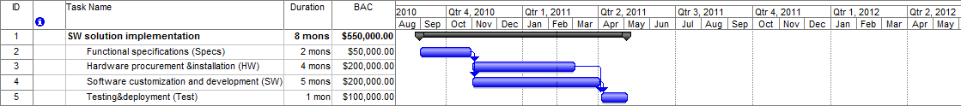

Below is also provided a status report just recorded on January 31, 2011.

|  |  |  |  |  |
| --- | --- | --- | --- | --- |
|  | **BAC** | **BCWS** | **ACWP** | **BCWP** |
| Functional specifications (Specs) | 50,000 | 50,000 | 52,000 | 50,000 |
| Hardware procurement &installation (HW) | 200,000 | 150,000 | 112,000 | 112,000 |
| Software customization and development (SW) | 200,000 | 120,000 | 127,500 | 150,000 |
| Testing&deployment (Test) | 100,000 | - | - | - |

Assume you are the project manager of the contracting consultant challenged with estimating the worst-case completion date and cost of the project. What would you propose?

# Scheduling (6 points)

The following project activities with associated costs are given (T in days, C in $1,000). If the overhead cost is 1,500$/day, what is the optimal project duration?

|  |  |  |  |  |  |
| --- | --- | --- | --- | --- | --- |
| Activity | predecessor | T normal | T crashed | C normal | C crashed |
| A |  | 6 | 3 | 6 | 9 |
| B | A | 9 | 5 | 9 | 12 |
| C |  | 3 | 2 | 4.5 | 7 |
| D | C | 5 | 2 | 10 | 16 |
| E | D | 2 | 2 | 2 | 2 |
| F | C | 4 | 1 | 6 | 10 |
| G | F | 8 | 5 | 8 | 10 |

## Small Project (6 points)

Pretend to be the project manager of a project to construct a hydropower plant. Description.

You are asked to plan the project, define the network schedule, calculate the total duration by identifying the critical path, and plot the usage profile for the resource “team of technicians”.

The plant section is represented in the figure above.

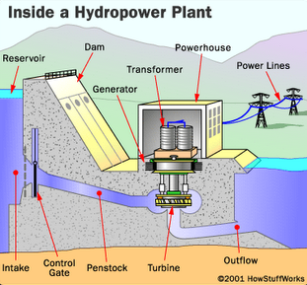

The scope of work is composed of the following tasks and associated durations and cost, when performed by one team of workers:

|  |  |  |  |  |
| --- | --- | --- | --- | --- |
|  | **Task** | **Predecessor** | **Duration (months)** | **Cost (k€)** |
| 1 | Dam (basement) |  | 6 | 2,000 |
| 2 | Dam (reservoir and elevation) | 1, 3 | 4 | 1,500 |
| 3 | Penstock and outflow | 1 | 1 | 500 |
| 4 | Control gate | 1, 2, 3 | 2 | 350 |
| 5 | Turbine | 1, 2, 3 | 3 | 1,200 |
| 6 | Generator | 5, 8 | 1 | 850 |
| 7 | Transformer | 6, 8 | 1 | 450 |
| 8 | Powerhouse | 2 | 2 | 900 |
| 9 | Power lines to backbone interface |  | 3 | 1,000 |

You have no more than 2 teams to be used (maximum available units). All tasks can be performed by 1 or more teams (if you make use of more than 1 team to perform a single task, please consider no loss of productivity. For example: 1 team takes 2 months; 2 teams take 1 month).