FINAL EXAMINATION – June 25th, 2019

## name:

Scope of work: three exercises

# Resource-based Scheduling (6 points)

The activities and requirements for analysts and programmers for the ABC project are as follows:

|  |  |  |  |  |  |  |  |
| --- | --- | --- | --- | --- | --- | --- | --- |
| Activity | J | M | V | Y | L | Q | Z |
| Predecessor | - | J | M | V | J | L | Y, Q |
| Duration (weeks) | 6 | 4 | 6 | 8 | 2 | 8 | 2 |
| Analysts | 8 | 5 | 3 | 2 | 5 | 3 | 5 |
| Programmers | 3 | 4 | 2 | 3 | 3 | 2 | 3 |

You are requested to:

1. draw the network and compute the total duration assuming infinite resources.
2. suppose the maximum weekly availability is 8 analysts and 5 programmers. Can activities be scheduled without delaying the project duration computed without limitations?

# Case (6 points)

Bev-Pak Inc. is planning to start a €50-million investment to build a new beverage container plant with total capacity of 2 billion cans produced per year. Bev-Pak is expecting Coca-Cola and PepsiCo. to buy cans over 5 years of operations, with expected annual revenue of €18millions, and operations costs no greater than €2millions per year.

Assuming you are the Bev-Pak project manager, please advise on the following issues:

1. suggest the most suitable contract organization to implement the project;
2. determine the funding scheme for the facility investment;
3. assess the present value of the project investment.

Please consider the following assumptions, and feel free to make any additional hypotheses, if necessary:

annual interest rate on debt capital 7%, cost of equity 11%, marginal corporate tax rate 40%.

# Monitoring (6 points)

Assume that your company is a large multinational consulting firm, which is engaged in a difficult project to redesign and implement major organizational changes for one of its most important customers: “GlobalCom”. Today, February 7th 2012, you are appointed Project Manager to replace the one that quit the company. The project, to last 8 months, was scheduled according to the chart below.

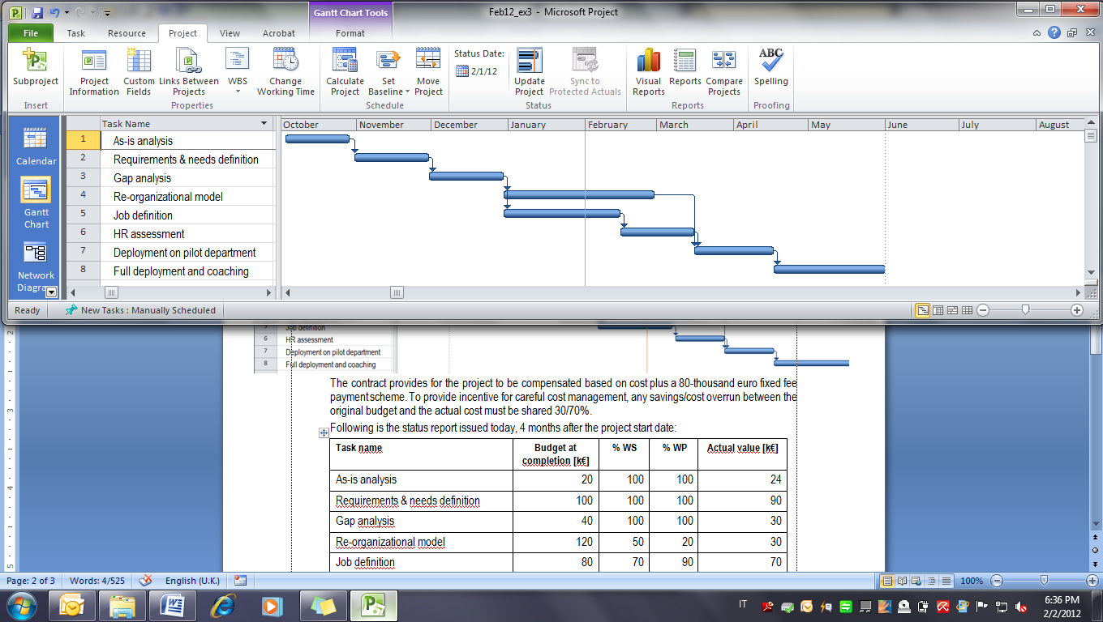

The contract signed with GlobalCom provides for the project to be compensated based on cost plus €300,000 fixed fee payment scheme. Liquidated damages of 100,000/month are due in case of delay. Overhead cost is €10,000 per month.

You have just been mailed the following status report which records data as per January 31st:

|  |  |  |  |  |
| --- | --- | --- | --- | --- |
| **Task name** | **Budget at completion [k€]** | **% WS** | **% WP** | **Actual value [k€]** |
| As-is analysis | 20 | 100 | 100 | 24 |
| Requirements & needs definition | 100 | 100 | 100 | 90 |
| Gap analysis | 40 | 100 | 100 | 30 |
| Re-organizational model | 120 | 50 | 20 | 30 |
| Job definition | 80 | 70 | 90 | 70 |
| HR assessment | 90 | 0 | 0 | 0 |
| Deployment on pilot department | 30 | 0 | 0 | 0 |
| Full deployment and coaching | 50 | 0 | 0 | 0 |
| *TOTAL* | *530* |  |  | *244* |

Today you receive a call from your C.E.O. that wants to be informed the current performance, estimated completion date, and reasonable estimate of the final profit that your company will net at the end of the project. What would you answer?