B - FINAL EXAMINATION – February 20th, 2020

## name:

# Time scheduling (6 points)

Suppose you are given the responsibility of managing a project to develop a new product. The venture requires the effort of a large project team to execute various activities. Your understanding is that the activities will involve different level of risk that is likely to affect the success of your project.

A precedence matrix of the macro-activities of the project is given in the chart below:

|  |  |  |  |
| --- | --- | --- | --- |
| **Activity** | **Predecessor** | **Duration [months]** | **Deadline** |
| Concept | - | 6 | *September 30th* |
| Market study | - | 3 | .............. |
| Engineering | Basic design | 3 | .............. |
| Prototyping | Engineering | 1 | .............. |
| Production line installation | Market study | 3 | .............. |
| Production start-up | Prototyping;  Prod. line installation | 2 | .............. |
| Advertising preparation | Market study | 2 | .............. |
| Advertising campaign | Advertising preparation | 1 | .............. |

Assume the project will start on April 1st this year. You are requested to assign finish dates to each activity so that your project team will be committed to meet precise deadlines (to this end please keep on filling in the “Deadline” column blanks). Please justify your reasoning.

# Monitoring (6 points)

Assume that your company is a large multinational consulting firm engaged in a complex project to redesign and implement major organizational changes for one of its most important customers: “ComCast”. Today, February 20th 2020, you are hired as the new Project Manager to replace the one that quit the company. The project, to last 8 months, was originally scheduled according to the Gantt chart below:

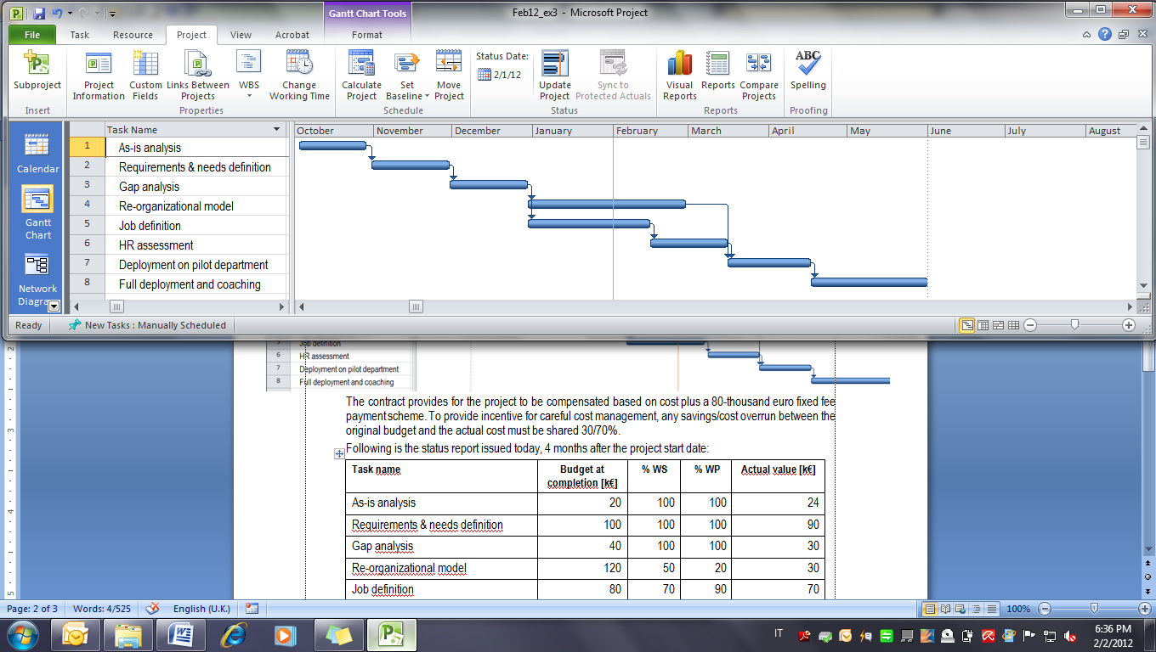

The contract signed with ComCast provides for the project to be compensated based on a cost plus €300,000 fixed fee payment scheme. Liquidated damages of €3,300 are due for each calendar day of delayed completion of the project.

You have just been mailed the following status report which records data as per January 31st:

|  |  |  |  |  |
| --- | --- | --- | --- | --- |
| **Task name** | **Budget at completion [k€]** | **% WS** | **% WP** | **Actual value [k€]** |
| As-is analysis | 20 | 100 | 100 | 24 |
| Requirements & needs definition | 100 | 100 | 100 | 90 |
| Gap analysis | 40 | 100 | 100 | 30 |
| Re-organizational model | 120 | 50 | 20 | 30 |
| Job definition | 80 | 70 | 90 | 70 |
| HR assessment | 90 | 0 | 0 | 0 |
| Deployment on pilot department | 30 | 0 | 0 | 0 |
| Full deployment and coaching | 50 | 0 | 0 | 0 |
| *TOTAL* | *530* |  |  | *244* |

Today you receive a call from your C.E.O. who wants to be informed about the current performance, estimated completion date, and reasonable estimate of the final profit that your company will net at the end of the project. What would you answer?

# Multiple choice test (6 points)

Please tick the only one right answer for each of the following questions. Each question is worth 0.5 points if correct. 0 points if the answer is not given or wrong.

1. The Project Management and his team are creating the schedule for the project to develop the policies and procedures section of the intranet. During this process, they discuss leads. Of the following examples, which is the lead?

1. The earliest the graphics for the pages can be completed without delaying the project
2. Editing content prior to completion of the Policies and Procedures section
3. The delay after the converting existing graphics to gif images

2. The project team is developing rules for reporting updates on the project. The majority of the activities are greater than two reporting periods long. Which format is best to use in this case?

A. 0/1 progress reporting

B. intermediate milestones

C. Earned value

D. Forecast reporting

3. To determine the float, which formula should you use?

1. Late start-early start (LS-ES) or late finish-late start (LF-LS)
2. Late finish-early finish (LF-EF) or late finish-late start (LF-LS)
3. Late start-early start (LS-ES) or early finish-early start (LF-LS)
4. Late finish-early finish (LF-EF) or late start-early start (LS-ES)

4. What is created in the initiating process?

1. Project scope statement, various management plans
2. Project charter, stakeholder analysis, stakeholder management plan
3. Project charter, WBS
4. Project charter, detailed schedule

5. The Project Manager is creating an estimate for building a company communication network. As the Project Manager, you have undertaken the make-or-buy decision and determined that the network should be outsourced because your company does not have the expertise. After receiving all the vendor proposals, you find that three of the proposals specify Cost Plus Fixed Fee, two other of the vendor’s specify Fixed-Price, another two specify Cost Plus Incentive Fee, and the last two specify Time and Material. Which of the proposals would present the greatest probability of loss for the seller?

1. Proposals that use Fixed Price
2. Proposals that use Cost Plus Fixed Fee
3. Proposals that use Time and Material
4. Proposals that use Cost Plus Incentive Fee

6. Management has asked to set milestones on the current project. What are the characteristics of a milestone?

1. The completion of major deliverables
2. The completion of a major event in the project
3. All the answers
4. A duration of zero

7. The Project Manager is calculating the critical path to determine the negative slack for a project that is behind schedule. Of the following, what is the most accurate statement about the critical path?

A. If ahead of schedule, a project can have negative slack

B. The critical path is the longest path on the project network diagram

C. There can only be one critical path per project

D. The least project risk occurs on the critical path

8. Project management roles not only describe project participation levels of various personnel, they also indicate responsibility. Which of the following is the most accurate description of project management roles?

1. The Project manager reports directly to the CEO
2. The Project Manager is responsible for the delivery of the results of the project, but may not always control staff
3. Functional management manages the functionality of the project
4. Senior management has ultimate control over project personnel

9. Which of the following shows the rate at which the project is progressing compared to what was planned?

1. Variance report
2. Progress measurement
3. Schedule variance
4. Schedule index

10. The contract’s expected target cost is $1120K. Actual cost is $1020K. There is a 50/50% share for any cost savings. What is the total value of the contract?

1. $1120K
2. $1050K
3. $1070K
4. $1020K

11. The Project Manager and the team created the risk register. Which of the following best describes the process they have just completed?

1. Plan Risk Responses which entails determining what will be done if risk events occur and who will be responsible for executing those actions
2. Identify Risk which entails determining what risks could occur on the project
3. Perform Qualitative Risk Analysis which entails assigning probability and impact ratings to each risk
4. Monitor and Control Risk management which entails observing project activities for risks and implementing the means to control them

12. Activity A is worth $200, is 100% complete, should have been done on day 1, and actually cost $200. Activity B is worth $75, is 90% complete, should have been done on day 2, and actually cost $120 so far. Activity C is worth $200, is 75% complete and should have been done on day 3, and has cost $175 so far. The total budget is $1,000. What is the planned value as of day 2?

1. $275.00
2. -$417.50
3. $495.00
4. -$275.00