FINAL EXAMINATION

name:

INSTRUCTIONS:
Scope of work: four exercises + one small project
Grading policy:
Exercises: 4 points each
Small project: 8 points

Contract definition
The Sands Hotel organization has bought a land to build a casino a block off the famous boardwalk in Atlantic City, New Jersey, USA. While most of the well-known profitable casinos in town benefit from boardwalk frontage, this one is not visible from the well-trafficked road.
To achieve profitability, Sands realizes that they need a high-attracting architecture and upscale quality to draw a significant numbers of patrons from the boardwalk.
Suppose to be the Sands Hotel’s project manager facing the problem of defining the contract organization. What would you suggest with regard to the delivery system, the payment scheme and the award method?

Deterministic Scheduling
A project to develop a new manufacturing plant to produce aluminum components for the automotive industry requires that a set of tasks is performed according to the following chart:

TASK duration [weeks] predecessor budget [€]
Basic design 8 80,000.00
Detailed design 12 basic design 250,000.00
Procurement 20 basic design 3,500,000.00
Civil works erection 24 detailed design 1,200,000.00
Assembly of production line 16 procurement; civil works erect. 600,000.00
Testing 4 assembly of production line 120,000.00
Project management 20 48,000.00

The project is scheduled to be started-up on September 1st, 2008.
You are requested to compute the CBS, draw the network schedule, define the critical path, and determine the project completion date.
Note: please take into account the following approximation: 4 weeks = 1 month

Risk assessment
Consider the project described in exercise 2 and the following additional information:
- the manufacturing plant is planned to be constructed in an industrial sector very close to Saint Petersburg, Russia
- in Russia the public administrative processes aimed at releasing construction permits are slow and may take from 8 to 24 weeks, once the request is submitted based on the basic design drawings
- the specifications from the owner are incomplete
- the electronic technology that is planned to be used for the new manufacturing line is quite new.
You are requested to identify possible sources of risk and quantify the risk Expected Monetary Value.
Also, please estimate the cost of any preventive actions and determine the contingency budget.

Performance analysis
Following is the performance report of a sample project.
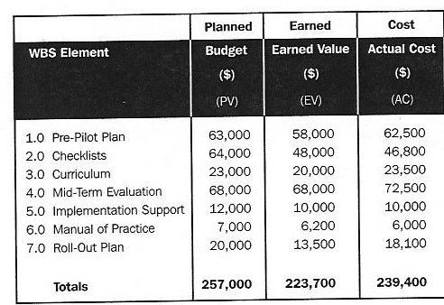
For the total project calculate: cost variance, schedule variance, cost index, schedule index. Is the project ahead/behind schedule? Is the project on budget? Please draw a graph to better show your consideration.
Also, estimate the final cost at completion.

Small project
Pretend to be the project manager of a project to construct a natural liquefied gas pipeline (NLG). You are asked to plan the project, define the network schedule, calculate the total duration by identifying the critical path and plot the usage profile for the resource “team”.
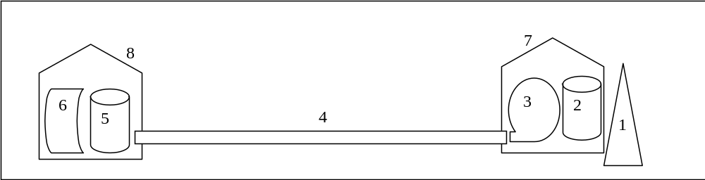
The system is represented in the figure above.
The scope of work is composed of the following tasks and associated durations, when performed by one team:
1. gas spilling well 2 months
2. liquefaction system 4 months
3. pump station 3 months
4. pipeline 9 months
5. degasification station 6 months
6. interface system 1 months
7. spilling building 2 months
8. terminal building 1 months

You have no more than 3 teams to be used (maximum available units). All tasks can be performed by 1 or more teams (if you make use of more than 1 team to perform a single task, please consider a no loss of productivity. For example: 1 team takes 2 months; 2 teams take 1 month).

