FINAL EXAMINATION

name:

INSTRUCTIONS:
Scope of exam work: four exercises + one small project
Grading policy:
Exercises: 4 points each
Small project: 8 points

Contract definition
The MiniMetro Turnback project, launched by the City of San Francisco, consists of building a pair of twin tunnels 6 meters in diameter and 600 meters long under the busiest central street of San Francisco, California, US. Major concerns are traffic disruption, business activities and tourism.
Suppose to be the owner’s project manager facing the problem of defining the contract organization. What would you suggest with regard to the delivery system, the payment scheme and the award method?

Probabilistic Scheduling
Consider the following probabilistic network schedule for a software implementation project:
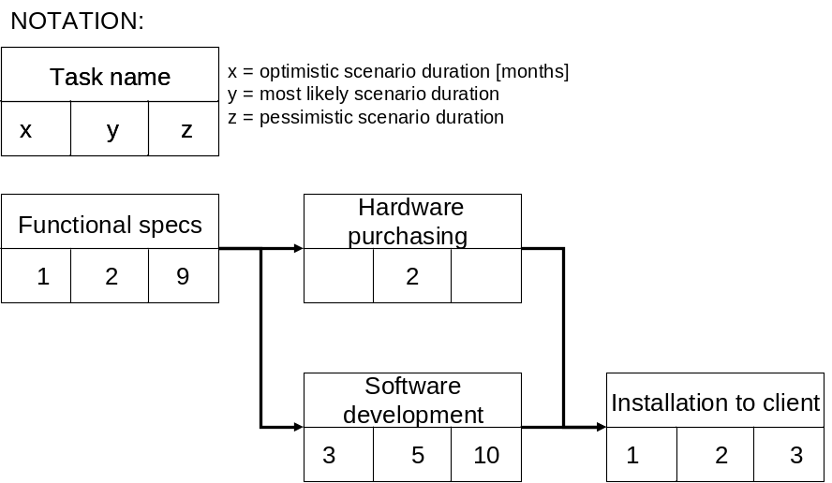
Calculate the expected (mean) duration and the probability of ending the project within the expected duration.
Which project deadline would you propose to the client if we want to have 90% of probability?

Monitoring Reporting
Following is the progress report of a sample project that is still underway after 6 months.
Task | WS | Total budget | % progress (WP) | ACWP
1 | 100% | 1.000 € | 90 % | 900 €
2 | 80% | 3.000 € | 75 % | 2.000 €
3 | 40% | 2.000 € | 50 % | 1.200 €
Calculate the cost estimate at completion.

Performance analysis
Consider the previous project, calculate the project Schedule Index (SI) and estimate the total duration of the project at completion.

Small project
Pretend to be the project manager of a project to construct a ski cableway facility. You are asked to plan the project, edit the schedule, calculate the total duration by identifying the critical path and plot the usage profile for the resource “team”.
The plant is composed of several components:
- a departure and an arrival station;
- two piles sustained by the corresponding foundations, numbered as 1 and 2;
- the cable;
- the engine system included in the departure station.

1
2
Below are the durations of each individual task, when performed by one team. You have no more than 3 teams to be used (maximum available units). All tasks can be performed by 1 or more teams (if you make use of more than 1 team to perform a single task, please consider a no loss of productivity. For example: 1 team takes 2 months; 2 teams take 1 month).

TASK DURATION
Departure station 2 months
Arrival station 3 months
Foundation 1 1 month
Pile 1 1 month
Foundation 2 1 month
Pile 2 2 months
Engine system 2 months
Cable laying 1 month

NORMAL DISTRIBUTION TABLE
