IMPLEMENTATION PLAN
Matter Masters Arena
IB MYP Science Smartboard Web Game

Vision
Create a cinematic web-based classroom competition using 3D visuals, GIFs, embedded videos, interactive simulations and live team scoring.
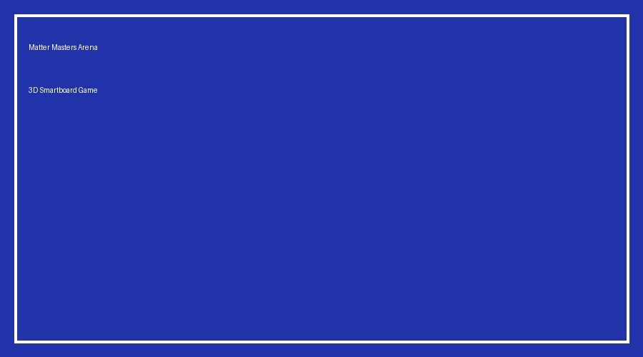
Hero screen with holographic arena and mission board.

Learning Outcomes
- Materials & particle structure
- States of matter
- Changes of state
- Water cycle
- Atoms & periodic table
- Compounds & mixtures
- Collaboration & inquiry

Game Flow
Stage | Experience | Media | Time
Intro | 3D cinematic | Video | 2 min
Mission Board | Choose challenge | Interactive | 20 min
Particle Lab | Temperature simulation | GIF+Canvas | 5 min
Water World | Animated Earth | Video | 5 min
Atom Builder | Drag particles | Simulation | 8 min
Final Arena | Boss battle | Animation | 5 min

Media Storyboards

Particle Simulator

Replace this placeholder with a looping GIF and embed a 30–60 second YouTube video in the web version.

Water Cycle
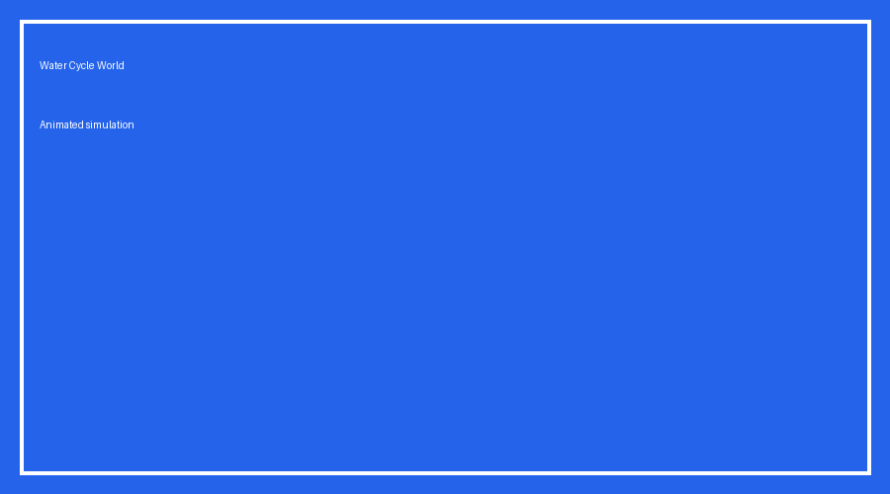
Replace this placeholder with a looping GIF and embed a 30–60 second YouTube video in the web version.

Atom Builder
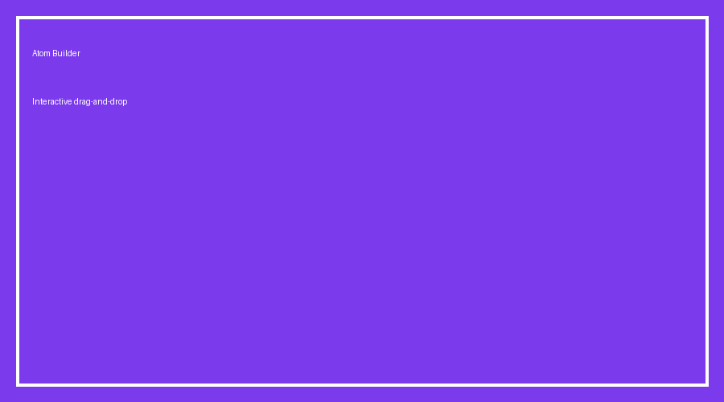
Replace this placeholder with a looping GIF and embed a 30–60 second YouTube video in the web version.

Mixture Laboratory

Replace this placeholder with a looping GIF and embed a 30–60 second YouTube video in the web version.

Required Simulations
Simulation | Interaction | Technology | Concept
Particle Physics | Temperature slider | Canvas | States
State Change | Heat/Cool | JavaScript | Energy
Water Cycle | Rain cycle | SVG | Earth
Atom Builder | Drag particles | Canvas | Atoms
Compound Creator | Combine atoms | JS | Formulae
Mixture Lab | Filter tools | Interactive | Separation

Smartboard Features
- 4-team live leaderboard
- Digital buzzer
- 60-second timer
- XP buttons
- Confetti animation
- Offline single HTML deployment

Technical Stack
HTML5 • CSS3 • JavaScript • Three.js • GSAP • SVG • Canvas • YouTube iframe

