Windows Phone 7.0 mOcean C# SDK

Developer Guide

V 2.2.0

Table of Contents

Overview 3

System requirements: 3

SDK contents: 3

Installation instructions: 3

SDK API reference: 4

AdView class members 4

Interstitial properties 7

Sample usage 8

## Overview

This document provides a description of the following:

* System requirements
* Installation Instructions
* SDK contents
* SDK API reference
* Sample of usage

### System requirements:

* Microsoft Windows Vista SP2 or Microsoft Windows 7.
* Windows Phone Developer Tools (http://go.microsoft.com/fwlink/?LinkID=189554)
* Microsoft Visual Studio 2010
* 2 Mb free disk space

### SDK contents:

Release version of library

Debug version of library in Debug directory

Samples in Samples directory

### Installation instructions:

*Installing Windows Phone Developer Tools*

Download and install *Windows Phone Developer Tools* (http://go.microsoft.com/fwlink/?LinkID=189554).

Follow installation instructions provided by Windows Phone Developer Tools. Once Tools has been installed follow to the next step to install Windows Phone mOcean C# SDK.

*Installing Windows Phone 7.0 C# SDK*

The SDK has been coded as a class library.

To add the library to a project, the developer must configure the project properties to add library reference.

Select References in Solution Explorer. Right click and choose Add Reference, locate the mOceanWindowsPhone.dll library and add it.

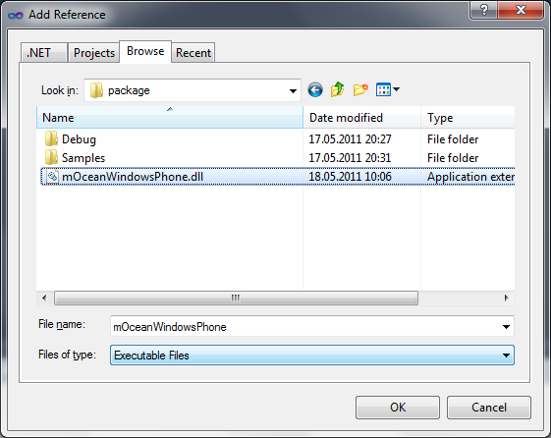

## SDK API reference:

### AdView class members

#### Setting properties of AdView

##### SetSite(int site)

The id of the publisher site.

##### SetZone(int zone)

The id of the zone of publisher site.

##### SetTest(bool test)

Setting is test mode where, if the ad code is true, the ad response is "Test MODE". (default = false)

##### SetPremium(int premium)

Filter ads by premium status (0 - non-premium, 1 - premium only, 2 - both). Can be used only by premium publishers. (default = 0)

##### SetKeywords(string keywords)

Keywords to search ad delimited by commas.

##### SetAdsType(int adsType)

Type of ads (1 - text only, 2 - image only, 3 - image and text, 6 - SMS ad). SMS will be ONLY returned in XML and should be used along with key=3.

##### SetMinSizeX(int size)

Minimal width of the ad banner to be shown.

##### SetMinSizeY(int size)

Minimal height of the ad banner to be shown.

##### SetMaxSizeX(int size)

Maximal width of the ad banner to be shown.

##### SetMaxSizeY(int size)

Maximal height of the ad banner to be shown.

##### SetBackgroundColor(Color backgroundColor)

Background color in HEX.

##### SetTextColor(Color textColor)

Determine the color of links in HEX.

##### SetCustomParameters(string customParameters)

Custom request parameters (name,value comma separated).

##### SetAdserverURL(string adServerUrl)

Url of ad server (default to <http://ads.mocean.mobi/ad>).

##### SetDefaultImage(Image defaultImage)

Image which will be shown during advertising loading if there is no advertising in a cache.

##### SetInternalBrowser(bool internalBrowser)

The flag which operates advertising opening. False - Ad opens in an external browser. True - Ad opening at internal form. (default = false)

##### SetAdvertiserId(int advertiserId)

Advertiser id (will be provided by mocean) (if both AdvertiserId and GroupCode are specified then install notification is enabled)

##### SetGroupCode(string groupCode)

Group code (will be provided by mocean) (if both AdvertiserId and GroupCode are specified then install notification is enabled)

##### SetUpdateTime(int updateTime)

Banner refresh interval (in seconds). (Banner refresh interval (in seconds). 0 - disable update.)

##### SetLatitude(string latitude)

User location latitude value (given in degrees.decimal degrees). It’s used together with ’long’ parameter. null - enable autodetect(default). "" - don't send coords to server.

##### SetLongitude(string longitude)

User location longtitude value (given in degrees.decimal degrees). It’s used together with ’lat’ parameter. null - enable autodetect(default). "" - don't send coords to server.

##### SetCountry(string country)

Country of visitor; it overrides country detected by IP. It is ISO 3166 to be used for specifying country code.

##### SetRegion(string region)

Region of visitor. ISO 3166-2 is used for United States and Canada and FIBS 10-4 is used for other countries.

##### SetCity(string city)

City of the device user (with state). For US only.

##### SetArea(string area)

Area code of a user. For US only.

##### SetMetro(string metro)

Metro code of a user. For US only.

##### SetZip(string zip)

Zip/Postal code of user (note: parameter is all caps). For US only.

##### SetCarrier(string carrier)

Carrier name.

##### SetLogger(Logger logger)

Logging object

##### SetLogLevel(Logger.LogLevel logLevel)

Log level (0 - disabled, 1 - errors only (default), 2 - errors and information messages, 3 - errors, information messages and HTTP traffic)

#### Interstitial properties

##### SetAutoCloseInterstitialTime(uint time)

auto-close interstitial time

##### SetShowCloseButtonTime(uint time)

show close button after delay

##### SetCloseButtonTextColor(Color color)

Text color

##### SetCloseButtonBackgroundColor(Color color)

Background color

##### SetCloseButtonImage(Image image)

Background image

##### SetCloseButtonPosition(ButtonPosition position)

Position of close button

##### SetCloseButtonSize(Size size)

Size of button

##### SetCloseButtonText(string text)

Text

##### SetCloseButtonTransparency(byte transparency)

Alpha level (0-255)

#### Methods

##### void Update()

Immediately update banner contents

#### Events

##### bool AdNavigateBanner(String url)

This event fired after user clicks the banner (only if InternalBrowser property has been set to True).

url - location proceeding to.

Return True if you are handled the event and do not want the control to show internal popup window.

##### void AdDownloadBegin ()

This event is fired before banner download begins.

void AdDownloadEnd()  
This event is fired after banner content fully downloaded.

##### void AdDownloadError(String error)

This event is fired after fail to download content.

## Sample usage

See Sample directory in SDK contents.

To run this sample you need Windows Phone Emulator from Windows Phone Developer Tools.

*Create banner control:*

MainPage.xaml

|  |
| --- |
| <phone:PhoneApplicationPage xmlns:my="clr-namespace:mOceanWindowsPhone;assembly=mOceanWindowsPhone">  <my:AdView Name="AdView" HorizontalAlignment="Left" VerticalAlignment="Top" Height="279" Width="480" />  …  </phone:PhoneApplicationPage> |

MainPage.xaml.cs

|  |
| --- |
| public MainPage()  {  InitializeComponent();  adView.SetSite(8061);  adView.SetZone(20249);  adView.SetAdvertiserId(1234);  adView.SetGroupCode("code");  adView.SetUpdateTime(50);  } |
|  |

-- END OF DOCUMENT --