Windows Phone 7.0 mOcean C# SDK

Developer Guide

V 1.0

Table of Contents

Overview 3

System requirements: 3

SDK contents: 3

Installation instructions: 3

SDK API reference: 4

AdViewControl class members 4

Events 8

Sample usage 9

## Overview

This document provides a description of the following:

* System requirements
* Installation Instructions
* SDK contents
* SDK API reference
* Sample of usage

### System requirements:

* Microsoft Windows Vista SP2 or Microsoft Windows 7.
* Windows Phone Developer Tools (http://go.microsoft.com/fwlink/?LinkID=189554)
* Microsoft Visual Studio 2010
* 2 Mb free disk space

### SDK contents:

Documentation - SDK documentation

Lib - SDK library files

Sample - sample MojivaPhoneSample

### Installation instructions:

*Installing Windows Phone Developer Tools*

Download and install *Windows Phone Developer Tools* (http://go.microsoft.com/fwlink/?LinkID=189554).

Follow installation instructions provided by Windows Phone Developer Tools. Once Tools has been installed follow to the next step to install Windows Phone mOcean C# SDK.

*Installing Windows Phone 7.0 C# SDK*

The SDK has been coded as a class library.

To add the library to a project, the developer must configure the project properties to add library reference.

Select References in Solution Explorer. Right click and choose Add Reference, locate the MojivaPhone.dll library and add it.

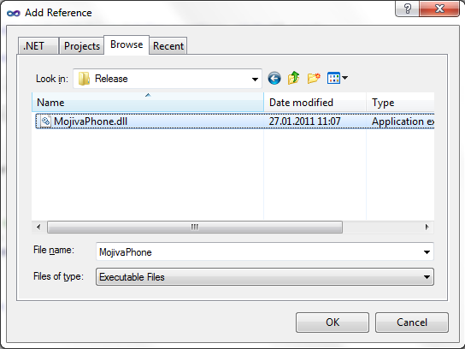

## SDK API reference:

### AdViewControl class members

#### Properties

##### String SiteId

The id of the publisher site.

##### String ZoneId

The id of the zone of publisher site.

##### bool TestModeEnabled

Setting is test mode where, if the ad code is true, the ad response is "Test MODE".

(default = false)

##### String Premium

Filter by premium (0 - disabled, 1 - non-premium, 2 - premium only, 3 - both). Can be used only by premium publishers.

(default = 0)

##### String Keywords

Keywords to search ad delimited by commas.

##### int MinSizeX

Minimal width of the ad banner to be shown.

##### int MinSizeY

Minimal height of the ad banner to be shown.

##### int MaxSizeX

Maximal width of the ad banner to be shown.

##### int MaxSizeY

Maximal height of the ad banner to be shown.

##### Color BackgroundColor

Background color in HEX.

##### Color TextColor

Determine the color of links in HEX.

##### String CustomParameters

Custom request parameters (name,value comma separated).

##### String AdServerUrl

Url of ad server (default to <http://ads.mocean.mobi/ad>).

##### Image DefaultImage

Image which will be shown during advertising loading if there is no advertising in a cache.

##### bool InternalBrowser

The flag which operates advertising opening. False - Ad opens in an external browser.

True - Ad opening at internal form.

(default = false)

##### int UpdateTime

Banner refresh interval (in seconds).

(Banner refresh interval (in seconds). 0 - disable update.)

##### String Latitude

User location latitude value (given in degrees.decimal degrees). It’s used together with ’long’ parameter. null - enable autodetect(default). "" - don't send coords to server.

##### String Longitude

User location longtitude value (given in degrees.decimal degrees). It’s used together with ’lat’ parameter. null - enable autodetect(default). "" - don't send coords to server.

##### String Country

Country of visitor; it overrides country detected by IP. It is ISO 3166 to be used for specifying country code.

##### String Region

Region of visitor. ISO 3166-2 is used for United States and Canada and FIBS 10-4 is used for other countries.

##### String City

City of the device user (with state). For US only.

##### String Area

Area code of a user. For US only.

##### String Metro

Metro code of a user. For US only.

##### String Zip

Zip/Postal code of user (note: parameter is all caps). For US only.

##### String Carrier

Carrier name.

Autodetected if not set.

##### Bool SizeRequired

If set to 1, return image size (width and height) in html.

##### String AdvertiserId

Advertiser id (will be provided by mocean)

##### String GroupCode

Group code (will be provided by mocean)

#### Interstitial properties

##### AutoCloseInterstitialTime

auto-close interstitial time

##### ShowCloseButtonTime

show close button after delay

##### CloseButtonTextColor

Text color

##### CloseButtonBackgroundColor

Background color

##### CloseButtonImage

Background image

##### CloseButtonPosition

Position of close button

##### CloseButtonSize

Size of button

##### CloseButtonText

Text

##### CloseButtonTransparency

Alpha level (0-255)

#### Methods

##### void Run()

Run the advertisement (should be called to run banner)

##### void Update()

Immediately update banner contents

## Events

##### bool AdNavigateBanner(String url)

This event fired after user clicks the banner (only if InternalBrowser property has been set to True).

url - location proceeding to.

Return True if you are handled the event and do not want the control to show internal popup window.

##### void AdDownloadBegin ()

This event is fired before banner download begins.

void AdDownloadEnd()  
This event is fired after banner content fully downloaded.

##### void AdDownloadError(String error)

This event is fired after fail to download content.

## Sample usage

See MojivaPhoneSample in SDK contents.

To run this sample you need Windows Phone Emulator from Windows Phone Developer Tools.

*Create banner control:*

MainPage.xaml

|  |
| --- |
| <phone:PhoneApplicationPage … xmlns:my="clr-namespace:MojivaPhone;assembly=MojivaPhone"  … >  …  <my:AdViewControl HorizontalAlignment="Left" Name="adViewControl" VerticalAlignment="Top" Height="279" Width="480"></my:AdViewControl>  …  </phone:PhoneApplicationPage> |

MainPage.xaml.cs

|  |
| --- |
| private void PhoneApplicationPage_Loaded(object sender, RoutedEventArgs e)  {  adViewControl.ZoneId = "9411";  adViewControl.SiteId = "6277";  adViewControl.Owner = this;  adViewControl.UpdateTime = 30;  adViewControl.AdvertiserId = "1111";  adViewControl.GroupCode = "2222";  adViewControl.Run();  } |
|  |

-- END OF DOCUMENT --