Ethereum
Ethereum is a decentralized platform that runs smart contracts: applications that run exactly as programmed without any possibility of downtime, censorship, fraud or third-party interference.
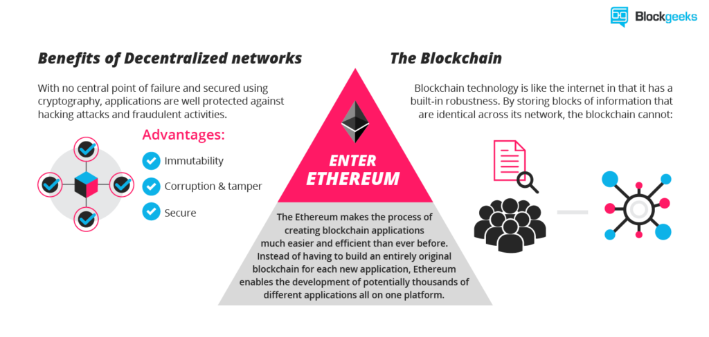
Smart contract
Smart contracts are how things get done in the Ethereum ecosystem. When someone wants to get a particular task done in Ethereum they initiate a smart contract with one or more people. Smart contracts are a series of instructions, written using the programming language “solidity”, which work on the basis of the IFTTT logic aka the IF-THIS-THEN-THAT logic. Basically, if the first set of instructions are done then execute the next function and after that the next and keep on repeating until you reach the end of the contract.
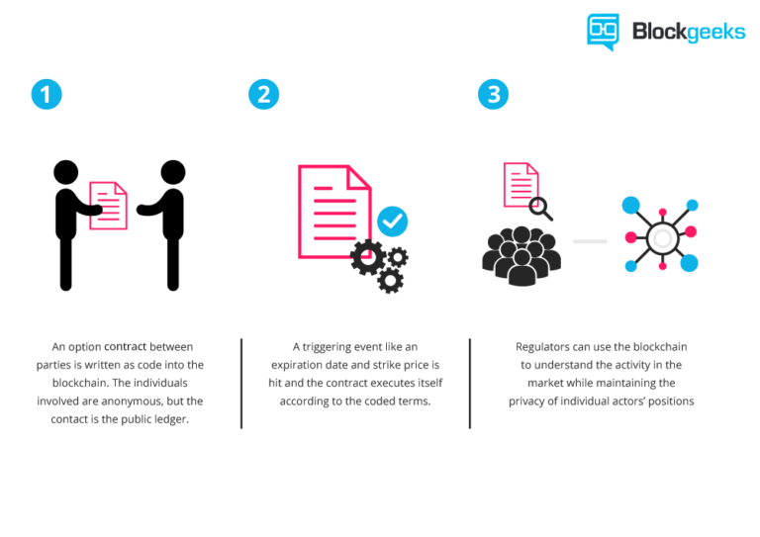
Why is it needed?
This enables developers to create markets, store registries of debts or promises, move funds in accordance with instructions and many other things that have not been invented yet, all without a middleman or counterparty risk.
Who was creator?
The project was bootstrapped via an ether presale in August 2014 it is developed by the Ethereum Foundation, with contributions across the globe.

Ether
Every single step in a smart contract is a transaction or a complex computation and would have a cost that is measured in “gas”. The price of this gas is paid by the requester in “Ether”. Ether is the currency with which everything runs in the Ethereum. When people talk about ETH and ETC they are actually talking about the value of the Ether in their respective blockchain.
Let’s check out the graph of gas prices over the years:
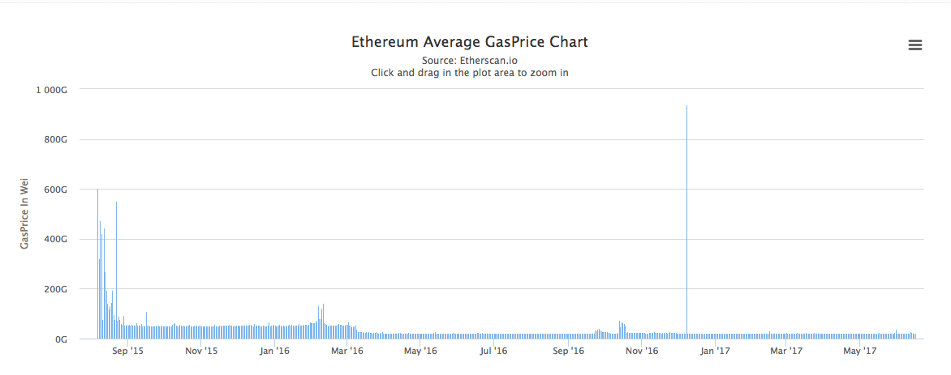

Every command has a specific gas limit which ensures that a buggy piece of code doesn’t end up depleting your entire ether wallet.
What happens when your ether supply gets depleted in the middle of the contract? If you do not have the ether required for all the gas payments, then all the transactions that have already taken place during the course will go back to the original state. But, your ether wallet will still reflect the change in balance since all transactions made in the blockchain are irreversible. In other words, you’ll lost your ether permanently.

Going forward it is very important that you have these things absolutely clear.

- Smart contracts are how things get done in Ethereum.
- Ether is the currency that is used in the Ethereum network to do anything.

What is token?

Think of Ethereum like the internet and all the DAPPS as websites that run in it. The way that happens is usually by a crowd-sale called the “ICO” (more on that later). Basically, you buy certain tokens of that DAPP in exchange of your ether.

These tokens are usually of 2 varieties:
- Usage Tokens.
- Work Tokens.

Usage Tokens
These are the tokens that act like native currency in their respective DAPPS. Golem is a pretty good example of this. If you want to use the services in Golem then you will need to pay with Golem Network Token (GNT). While these tokens have monetary value they won’t give you any particular rights or privilege within the network.
Work Token
These are the tokens that identify you as a sort of shareholder in the DAPP. Because of that, you have a say in the direction that that DAPP takes. A perfect example of this is the DAO tokens. If you were a DAO token holder then you had the right to vote on whether a particular DAPP could get funding from the DAO or not.

How To Create An Ethereum Token
The simplest way for you to create a token is simply going to Token Factory and check out their system. They have a superbly user-friendly system which you can use right away:
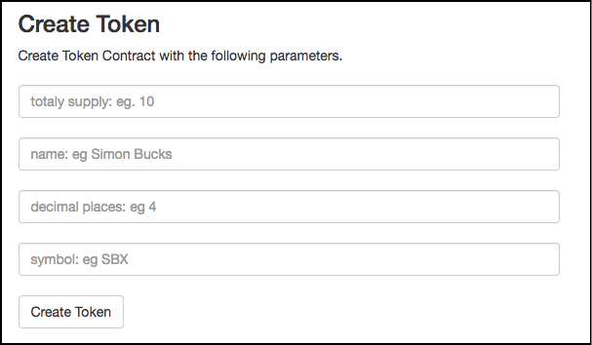
https://tokenfactory.surge.sh/#/factory
If, however you want to code your tokens from scratch then you should definitely be well versed in Solidity aka the language used to code in Ethereum.
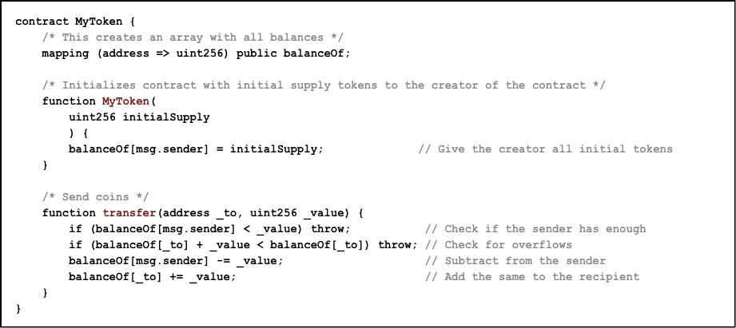
So let’s break down the code into its bare necessities. As you can see, there are three specific parts of this function:
- The mapping
- Giving the creator all the tokens.
- Transfer the token to a sender for ether.
This creates a database wherein everyone can see the balance of your tokens. Tokens like ETH itself is logged into an open ledger. Anyone can see all the balances and transactions of that particular token.

What Are ICOs?
ICOs or Initial Coin Offerings are basically crowd sales. It was created to perform following tasks:
- They have provided the simplest path by which DAPP developers can get the required funding for their project.
- Anyone can become invested in a project they are interested in by purchasing the tokens of that particular DAPP and become a part of the project themselves. (We are talking about Work Tokens here).
So, how does an ICO work?
Firstly, the developer issues a limited amount of tokens. By keeping a limited amount of tokens they are ensuring that the tokens itself have a value and the ICO has a goal to aim for. The tokens can either have a static pre-determined price or it may increase or decrease depending on how the crowd sale is going.
The transaction is a pretty simple one. If someone wants to buy the tokens they send a particular amount of ether to the crowd sale address. When the contract acknowledges that this transaction is done, they receive their corresponding amount of tokens. Since everything on Ethereum is decentralized, an ICO is considered a success if it is properly well-distributed and a majority of its chunk is not owned by one entity.
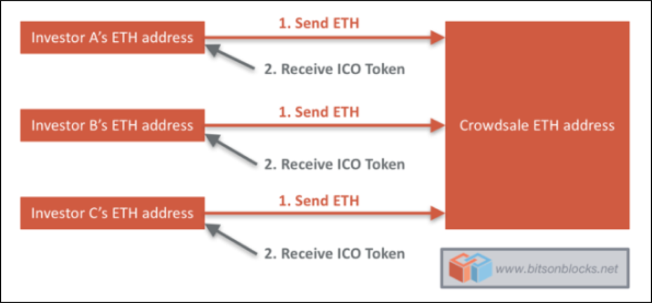

Golem
Token Cap: 1 Billion GNT
Money Raised In ICO: $8.6 million
Its essence is to build super powerful PC and CPU and you are hardly using it at night, while at the same time, halfway around the world in Philippines, an animator is desperately looking to render a high-def video.
Golem describes itself as an “Airbnb for computers”. It is essentially a peer-to-peer network which is aiming to be the world’s first decentralized supercomputer. By tapping into the Golem network you can essentially “rent out” some of the CPU power in the network and use it for your own projects.
There are 3 kinds of people in the Golem network:
- Requestors.
- Providers.
- Software Developers.
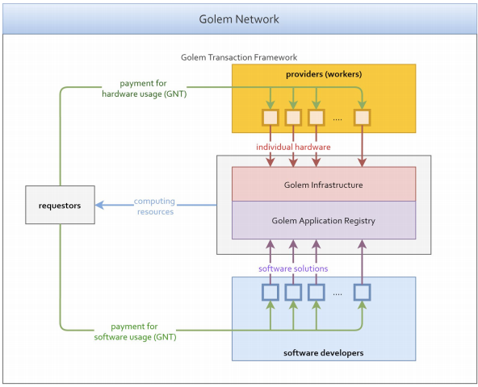
Requestors: These are people who want to access the power in the golem network. They can do so by paying with GNT (Golem Network Token).
Providers: These are people in the Golem network who are renting out their computer power. They get paid in GNT for their services.
Software Developers: These are people who are going to be uploading the software they develop into the Golem system. In case the requestors want to use their software, they will have to pay GNT to the software developers to gain access to their software and then pay the providers the required amount to rent out their computer power.
Pros
- A very interesting concept which can effectively create the world’s first decentralized super computer.
- Can give access to people living in poorer parts of the world to world-class computer machines.
- The team behind Golem is very good and proven.
- The value of GNT has been steadily rising over the last few years.
- The sandbox environment contains any potential hacks.
- Gives software developers a platform to release and showcase their software.
- Makes good use of underutilized computer equipment.

Cons
- Even though there is a way to contain any hacks, no sandbox is perfect. A bug can be exploited which can render the entire system useless.
- According to the roadmap given in their white paper, Golem will take 8 years to run at an optimal state which is too long a time.
- Potential latency issues because of over usage.

The Sandbox
There is one way that the Golem system can be exploited. Suppose a requestor rents out a provider’s hardware and uses it to run a virus code which steals all the data in that hardware or the entire system. What happens then? To counteract this issue all the transactions in Golem will be run in a sandbox environment. What does that mean? When you rent out a provider’s hardware you will be under a lot of rules which will restrict your movement. So, if you were a hacker you won’t really have the freedom to move about and do what you want.

Bancor
While you can easily exchange and buy tokens like GNT, what happens when you have tokens that nobody wants to exchange with? How do you liquidate your tokens then? This is where Bancor offers an extremely elegant solution. Bancor has come up with the idea of issuing smart tokens.

Client wallet
Ledger Nano S (Hardware Wallet)
Mist (Desktop Wallet)
MetaMask (Desktop Wallet / Chrome Extension)
MyEtherWallet (Web open source wallet / Web3)

Token standard
https://github.com/ethereum/EIPs/blob/master/EIPS/eip-20.md

How growth ethereum difficulty
https://www.coinwarz.com/difficulty-charts/ethereum-difficulty-chart

ABI decoder
https://github.com/ConsenSys/abi-decoder

Mist issue with tetstrpc
https://github.com/ethereum/mist/issues/2131

Most convenient way to interact with smart contracts
https://www.myetherwallet.com/#contracts

