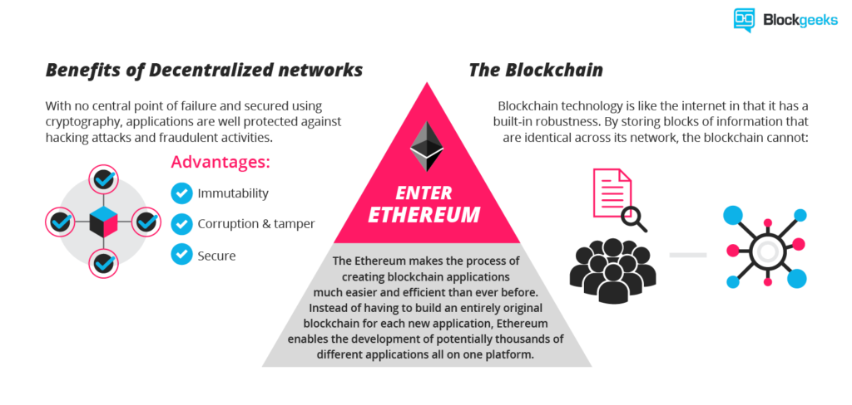
Ethereum blockchain
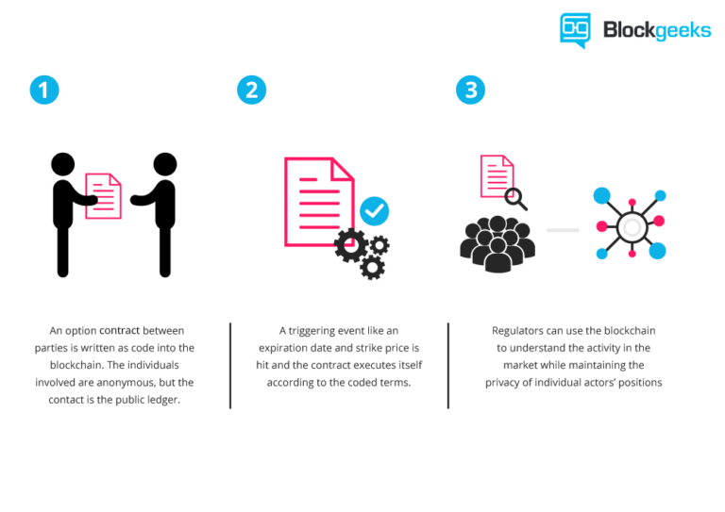
Why is it needed?
This allows developers to create markets, store registries of debts or promises, move funds in accordance with instructions and many other things that have not been invented yet, all without a middleman or counterparty risk.

Who was creator?
The project was bootstrapped via an ether presale in August 2014 it is developed by the Ethereum Foundation, with contributions across the globe.

Ether
Ethereum cryptocurrency.

Gas prices over the years:
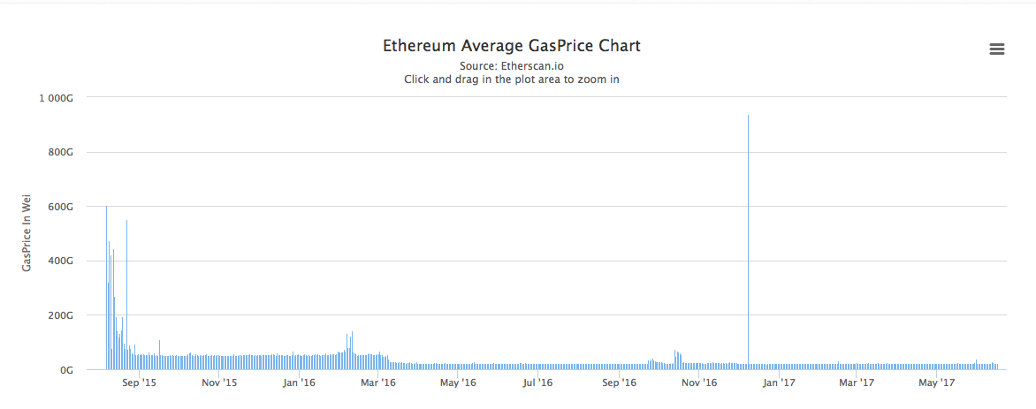

Every command has a specific gas limit which ensures that a buggy piece of code doesn’t end up depleting your entire ether wallet.

Going forward it is very important that you have these things absolutely clear.

- Smart contracts are how things get done in Ethereum.
- Ether is the currency that is used in the Ethereum network to do anything.

What is token?

Think of Ethereum like the internet and all the DAPPS as websites that run in it. The way that happens is usually by a crowd-sale called the “ICO” (more on that later). Basically, you buy certain tokens of that DAPP in exchange of your ether.

These tokens are usually of 2 varieties:
- Usage Tokens.
- Work Tokens.

Usage Tokens
These are the tokens that act like native currency in their respective DAPPS.
Work Token
These are the tokens that identify you as a sort of shareholder in the DAPP.

How To Create An Ethereum Token

https://tokenfactory.surge.sh/#/factory
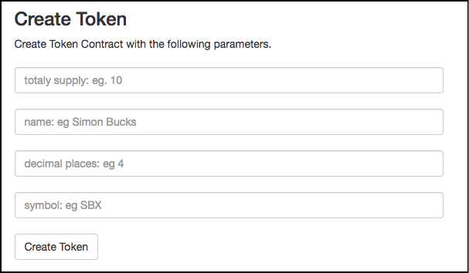
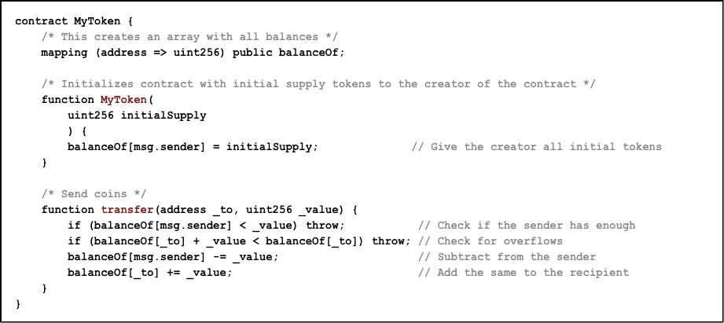
So let’s break down the code into its bare necessities. As you can see, there are three specific parts of this function:
- The mapping
- Giving the creator all the tokens.
- Transfer the token to a sender for ether.

What Are ICOs?
ICOs or initial Coin Offerings are basically crowd sales.
- Funding for their project.
- Anyone can become invested in a project they are interested and become a part of the project themselves.
So, how does an ICO work?
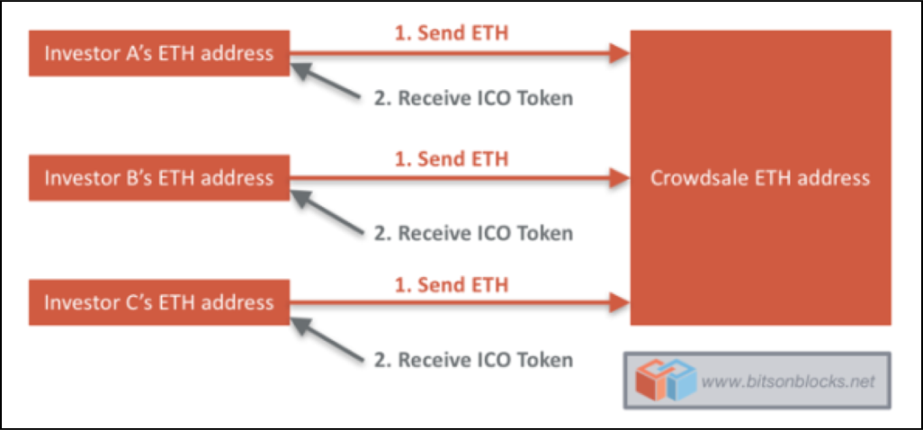
Popular projects

Golem
Token Cap: 1 Billion GNT
Money Raised In ICO: $8.6 million
Golem describes itself as an “Airbnb for computers”. It is essentially a peer-to-peer network which is aiming to be the world’s first decentralized supercomputer. By tapping into the Golem network you can essentially “rent out” some of the CPU power in the network and use it for your own projects.

There are 3 kinds of people in the Golem network:
- Requestors.
- Providers.
- Software Developers.
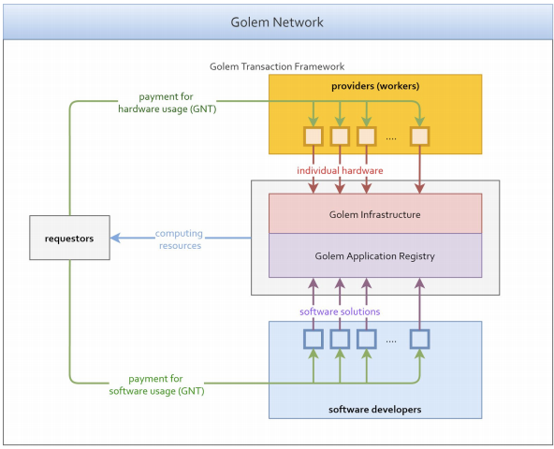
Requestors: These are people who want to access the power in the golem network.
Providers: These are people in the Golem network who are renting out their computer power.
Software Developers: These are people who are going to be uploading the software they develop into the Golem system.

The Sandbox
There is one way that the Golem system can be exploited.

Bancor
While you can easily exchange and buy tokens like GNT, what happens when you have tokens that nobody wants to exchange with? How do you liquidate your tokens then? This is where Bancor offers an extremely elegant solution. Bancor has come up with the idea of issuing smart tokens.

Client wallet

Ledger Nano S (Hardware Wallet)
Mist (Desktop Wallet)
MetaMask (Desktop Wallet / Chrome Extension)
MyEtherWallet (Web open source wallet / Web3)

Token standard
https://github.com/ethereum/EIPs/blob/master/EIPS/eip-20.md

How growth ethereum difficulty
https://www.coinwarz.com/difficulty-charts/ethereum-difficulty-chart

ABI decoder
https://github.com/ConsenSys/abi-decoder

Mist issue with tetstrpc
https://github.com/ethereum/mist/issues/2131

Most convenient way to interact with smart contracts
https://www.myetherwallet.com/#contracts

