InsightForge
An AI-Powered Business Intelligence Assistant

Advanced Generative AI · Capstone Project Report
Enabling AI-Powered Business Intelligence for Organizations
Built with LangChain, Retrieval-Augmented Generation and Streamlit
Repository: github.com/pm3nasag/InsightForge
Live application: insightforge-uuna235appup5czvxwocjtr.streamlit.app
20 September 2026

1. Executive summary
InsightForge is a business intelligence assistant that turns a raw sales dataset into an analyst a non-technical user can simply talk to. It computes the business metrics with pandas, indexes those metrics alongside reference BI literature in a FAISS vector store, and answers natural-language questions through a LangChain retrieval-augmented generation (RAG) pipeline with conversational memory. A Streamlit interface exposes the assistant together with dashboards, a chained insight report, automated evaluation and operational monitoring.
The central problem in applying a large language model to business data is that language models are fluent but not arithmetically reliable: asked for a revenue figure, a model will produce a plausible-looking number. InsightForge addresses this by never asking the model to compute anything. Every figure is calculated in pandas first, and the model's only job is to select, explain and contextualise numbers that are handed to it. The custom retriever goes one step further and recomputes exact figures at query time for whatever entities the question names.
The result is measurable. Against 12 questions whose ground-truth answers are computed from the dataset itself, the assistant scores 91.7% on LangChain's QAEvalChain judge and 91.7% on a deterministic numeric-grounding check, at an average latency of 2.32 seconds per answer.
All seven steps required by the problem statement are implemented, tested and deployed. The codebase is 3,265 lines of Python across 16 modules, covered by 26 automated tests that run offline in under three seconds.

2. Problem statement and objective
Organisations accumulate large volumes of operational data but frequently lack the resources to convert it into decisions. Commercial business intelligence tooling is expensive and demands specialist skills, which puts it out of reach of small and medium-sized enterprises. Meanwhile the people who most need the answers — sales managers, regional leads, founders — are precisely the people least able to write the queries that produce them.
The capstone brief sets three objectives for the assistant:
- Analyse business data — perform comprehensive analysis to identify key trends and patterns.
- Generate insights and recommendations — use natural language processing to deliver actionable business insights.
- Visualise data insights — present findings through visualisations for easier interpretation.
Section 5 walks through the seven prescribed implementation steps in order and shows where each one lives in the codebase.

3. The dataset
The supplied dataset contains 2,500 sales transactions spanning 2022-01-01 to 2028-11-04. It arrives clean — 0 missing values and 0 duplicate rows — so, as the brief directs, the work goes into analysis rather than cleaning.
Column | Type | Description
Date | date | Transaction date, 2022-01-01 to 2028-11-04
Product | category | Widget A, Widget B, Widget C, Widget D
Region | category | East, North, South, West
Sales | numeric | Order value, 100 to 999
Customer_Age | numeric | 18 to 69 years
Customer_Gender | category | Female, Male
Customer_Satisfaction | numeric | Rating from 1 to 5

Four derived columns are added at load time because the analysis and the retriever both depend on them: calendar parts (year, quarter, month, weekday), an age band, and a satisfaction band that classifies each customer as Detractor, Neutral or Promoter.
A second, unstructured knowledge source is also used: four reference PDFs on business intelligence practice, time-series prediction and retail sales analysis, which give the assistant domain vocabulary beyond the numbers in the CSV.

4. Solution architecture
The system has three layers: a deterministic analytics layer that owns all arithmetic, a retrieval layer that decides what the model is allowed to see, and a generation layer that turns retrieved facts into prose. Data flows in one direction.
sales_data.csv ─► data_loader ─► DataAnalyzer ─► metrics
│
reference PDFs ─► PyPDFLoader ──┐ │
└► narrative documents ─► FAISS index
│
question ─► condense (memory) ─► BusinessStatsRetriever ─► context
│ keyword routing │
│ live pandas slice ▼
└ vector search QA prompt ─► LLM ─► answer

Two properties of this design are worth drawing out.
Arithmetic never reaches the model. Totals, medians, standard deviations, growth rates and correlations are all computed in pandas and rendered into short factual documents before retrieval. The model receives numbers; it does not produce them.
The knowledge base is written for retrieval, not for storage. Rather than indexing raw rows, the metrics are rendered as self-contained natural-language statements — "Regional performance analysis: West → total sales 361,383; orders 644; …" — so that a semantic search over them actually surfaces the right fact. This produces 20 metric documents, which sit alongside 318 chunks from the reference PDFs for a 338-document index.

5. Implementation of the seven required steps
Each subsection below corresponds to a numbered step in the problem statement and names the module that implements it.

5.1 Step 1 — Data preparation
Module: insightforge/data_loader.py
Because the data is already clean, this stage enriches rather than repairs. It coerces types, sorts chronologically, and derives the calendar, age-band and satisfaction-band columns that everything downstream depends on. A dataset profile is produced at the same time and becomes the first document in the knowledge base.

5.2 Step 2 — Knowledge base creation
Module: insightforge/knowledge_base.py
The knowledge base combines structured and unstructured knowledge. The computed metrics are rendered as narrative documents, one per topic — overview, KPIs, sales by year/quarter/month/weekday, growth, product performance, regional performance, the product×region matrix, three customer segmentations, descriptive statistics per numeric column, and correlations. The reference PDFs are chunked with RecursiveCharacterTextSplitter at 900 characters with 120 characters of overlap, and chunks shorter than 80 characters are discarded to keep page headers out of the index. Both sets are embedded and stored in FAISS.

5.3 Step 3 — LLM application development
Modules: insightforge/analysis.py, insightforge/retriever.py, insightforge/prompts.py
The advanced data summary covers all four areas the brief lists: sales performance by time period, product and regional analysis, customer segmentation by demographics, and statistical measures including median, standard deviation, variance, quartiles, IQR, skew, kurtosis, coefficient of variation, outlier counts and pairwise correlations.
The custom retriever is the most consequential piece of engineering in the project, and is described in its own right in section 6.1.

5.4 Step 4 — Chain prompts
Modules: insightforge/prompts.py, insightforge/rag_chain.py
Rather than one large prompt, the system uses a small library of single-purpose prompts. Three of them run in sequence, each consuming the previous output: the metrics are turned into quantified insights, the insights into prioritised recommendations, and both together into an executive summary for a non-technical reader. A fourth prompt condenses follow-up questions, and a fifth grades answers during evaluation.

5.5 Step 5 — RAG system setup
Module: insightforge/rag_chain.py
The RAG chain is expressed in LangChain Expression Language: the question is condensed against memory, passed to the custom retriever, the retrieved documents are formatted into a labelled context block, and the result is rendered through the QA prompt and sent to the model. The chain deliberately stops at the model rather than at a string parser so that token-usage metadata remains available for the monitoring layer.

5.6 Step 6 — Memory integration
Module: insightforge/rag_chain.py (WindowedMemory)
Memory is a sliding window over the last six exchanges, held in a LangChain chat history. Before retrieval, a follow-up question is rewritten into a standalone question against that history — which is what allows a conversation to proceed naturally:
User: Which product generates the most revenue?
Agent: Widget A, with 375,235.00 (27.13% of total revenue).
User: And how does it do in the West?
→ condensed to: "How does Widget A perform in the West region?"
Without condensation the retriever would receive the phrase “and how does it do in the West”, which names no product and would retrieve the wrong statistics.

5.7 Step 7 — LLMOps: evaluation, visualisation, UI and monitoring
Modules: insightforge/evaluation.py, visualization.py, monitoring.py, streamlit_app.py
Model evaluation applies QAEvalChain as required, backed by a second deterministic check; both are described in section 7. Nine charts cover the four required visualisation families. The Streamlit interface presents six tabs — Chat, Dashboard, Insights, Evaluation, Monitoring and Knowledge base. Every interaction is appended to a JSONL log with latency, token counts, provider and any error, which the Monitoring tab aggregates into average and 95th-percentile latency, total token consumption and error counts.

6. Key design decisions

6.1 A custom retriever, not plain vector search
Semantic search over the metric documents answers broad questions well but fails on specific ones. Asked “how did Widget B do in the West in 2024?”, a pure vector search returns the documents whose wording is closest to the question — but no pre-computed document contains that particular cell, so the model is left to guess.
BusinessStatsRetriever therefore performs three steps for every query:
- Routing. Keyword rules map the question to the metric topics capable of answering it — time, product, region, demographics, satisfaction, statistics or overview.
- Live computation. When the question names a concrete product, region, gender, age band, year, quarter or month, the retriever filters the dataframe with pandas at query time and emits a freshly computed fact document, including a breakdown along whichever dimension was not constrained.
- Semantic back-fill. Any remaining slots are filled from the FAISS index, which is also how the reference PDFs enter an answer.
This is what makes the figures in answers exact rather than merely plausible, and it is the main reason the numeric-grounding score is as high as it is.

6.2 Ground truth computed from the data, not written by hand
The evaluation set is generated from the analysis output at run time, so each reference answer is derived from the same dataframe the assistant is questioned about. A hand-written answer key would silently go stale the moment the dataset changed; this one cannot.

6.3 Local embeddings with a hosted language model
The project uses OpenRouter, which is OpenAI-compatible but serves chat completions only — it has no embeddings endpoint. Rather than take a dependency on a second paid provider, the retrieval index is built locally by a TF-IDF plus truncated-SVD (latent semantic analysis) embedding model that implements LangChain's Embeddings interface. Indexing is therefore free, offline and fast, while the reasoning still runs on a hosted model. If an OpenAI key is present the code switches to OpenAIEmbeddings automatically.

6.4 A graceful offline mode
With no API key at all, the assistant falls back to a deterministic extractive model that selects the most relevant lines from the retrieved statistics and presents them directly. It is not generative and does not pretend to be, but it means retrieval, memory, charting, evaluation and the entire user interface can be demonstrated and graded with no credentials and no network access.

6.5 Per-session API keys
The deployed application offers a key field in its sidebar so a visitor can use their own quota. A key entered there is passed down to that session's model client only and is never written to the shared settings object: a single Streamlit process serves every visitor, so a stored key would be picked up by the next person's requests and billed to whoever typed it. The key is never logged or persisted.

6.6 Dependency versions
The course-supplied requirements file pins releases from 2023 that do not build on current Python. The project therefore uses the same stack at current versions on Python 3.13. QAEvalChain moved from the langchain package to langchain-classic in LangChain 1.0, so it is imported through a shim that works with either release.

7. Results

7.1 Evaluation
Every answer is graded twice. QAEvalChain, LangChain's LLM-as-judge, assesses whether the answer conveys the same factual content as the reference. A deterministic numeric-grounding check independently confirms that the reference figures actually appear in the answer; this second check is what makes the offline mode scoreable and catches a fluent answer that has quietly dropped a number.
Metric | Result
Evaluation questions | 12
QAEvalChain accuracy | 91.7% (11/12 judged correct)
Numeric grounding rate | 91.7%
Average latency per answer | 2.32 s
Errors | 0
Provider | openrouter:openai/gpt-4o-mini

The complete graded result set:
Question | Grade | Grounded
What is the total revenue in the dataset and how many orders… | CORRECT | Yes
Which product generates the most revenue, and how much? | CORRECT | Yes
Which product performs worst by revenue? | CORRECT | Yes
Which region has the highest sales? | CORRECT | Yes
What is the average and median order value? | CORRECT | Yes
What is the standard deviation of sales? | CORRECT | Yes
Which month had the highest total sales? | CORRECT | Yes
Is the monthly sales trend going up or down? | CORRECT | Yes
How do male and female customers compare in total revenue? | CORRECT | No
Which customer age group spends the most in total? | CORRECT | Yes
What is the average customer satisfaction score? | CORRECT | Yes
Is customer satisfaction correlated with sales? | INCORRECT | Yes

The failures are informative rather than alarming. The gender-comparison question is marked ungrounded because the reference answer carries four figures — two revenue totals and two order counts — and the model reported the revenues but omitted the counts; the answer is correct, but the strict check requires nearly all reference figures to appear. Because QAEvalChain is itself a language model, its verdict on interpretive questions varies slightly between runs.

7.2 Business findings surfaced by the assistant
Applied to the supplied dataset, the assistant reports the following.
Finding | Value
Total revenue | 1,383,220 across 2,500 orders
Average / median order value | 553.29 / 552.50
Order-value standard deviation | 260.10
Strongest product | Widget A — 375,235
Weakest product | Widget D — 326,854
Strongest region | West — 361,383
Weakest region | East — 320,296
Average satisfaction | 3.03 out of 5
Monthly trend | downward, slope -5.09 per month over 83 months
Sales vs. satisfaction correlation | 0.04

Two observations deserve emphasis because they are the kind of finding a dashboard alone would not volunteer. First, the spread between the best and worst performing product is narrow relative to the variance of individual orders, which means product-level ranking is a weaker signal here than it first appears. Second, the correlation between customer satisfaction and order value is effectively zero, so the common assumption that happier customers spend more is not supported by this data — satisfaction should be pursued for retention reasons, not as a revenue lever.

8. The application and its visualisations

8.1 The deployed assistant
The application is deployed on Streamlit Community Cloud and answers against the live index. Figure 1 shows the Chat tab mid-conversation; Figure 2 shows the control sidebar alongside it.
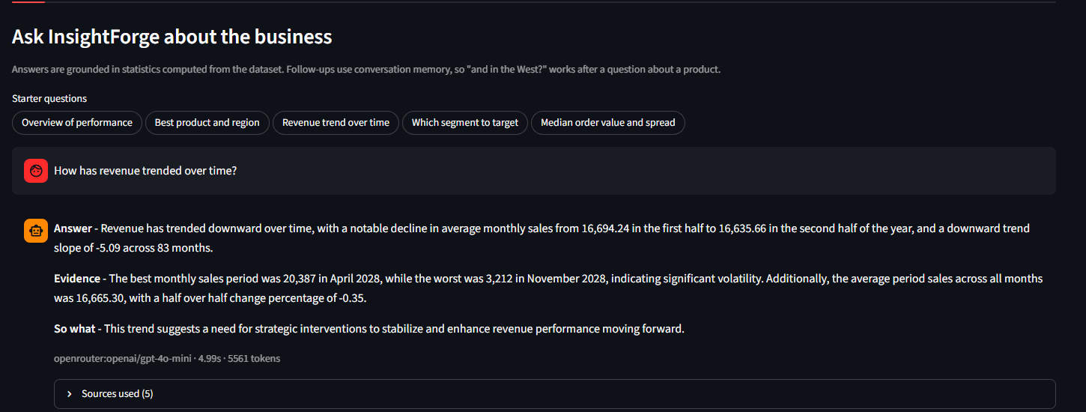
Figure 1 — The Chat tab. Every answer follows the structure the QA prompt imposes: a direct answer, the supporting figures, then the business implication. The line beneath records provider, latency and token count, and “Sources used” expands to the exact documents retrieved, so any figure can be traced back to its source.
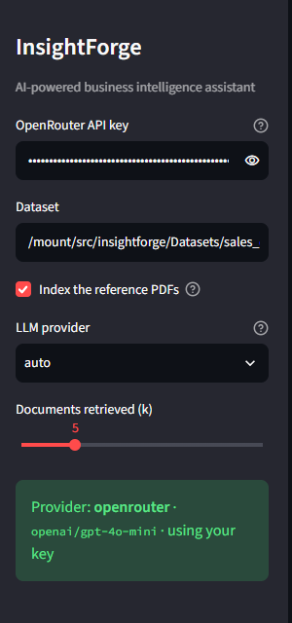
Figure 2 — The sidebar: a masked key field so a visitor can supply their own key for that session, and a status panel reporting the resolved provider, the model and whose key is in use.

8.2 Charts
Nine charts cover the four families named in the brief. All are rendered with matplotlib and seaborn on a shared palette, exposed in the Streamlit dashboard and written to disk by the pipeline runner.
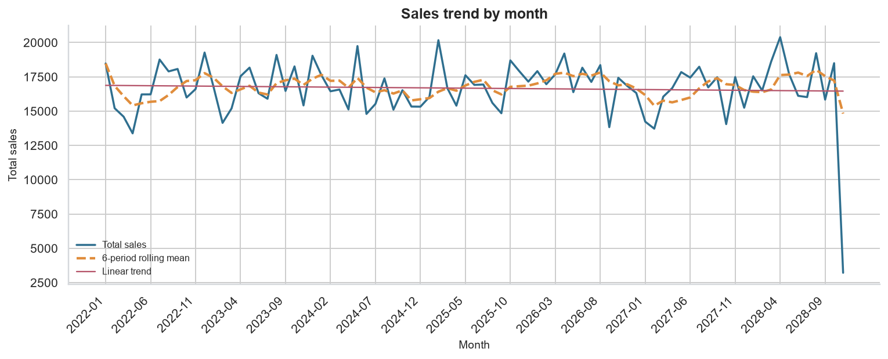
Figure 3 — Sales trend over time, with rolling mean and linear trend (required family 1).
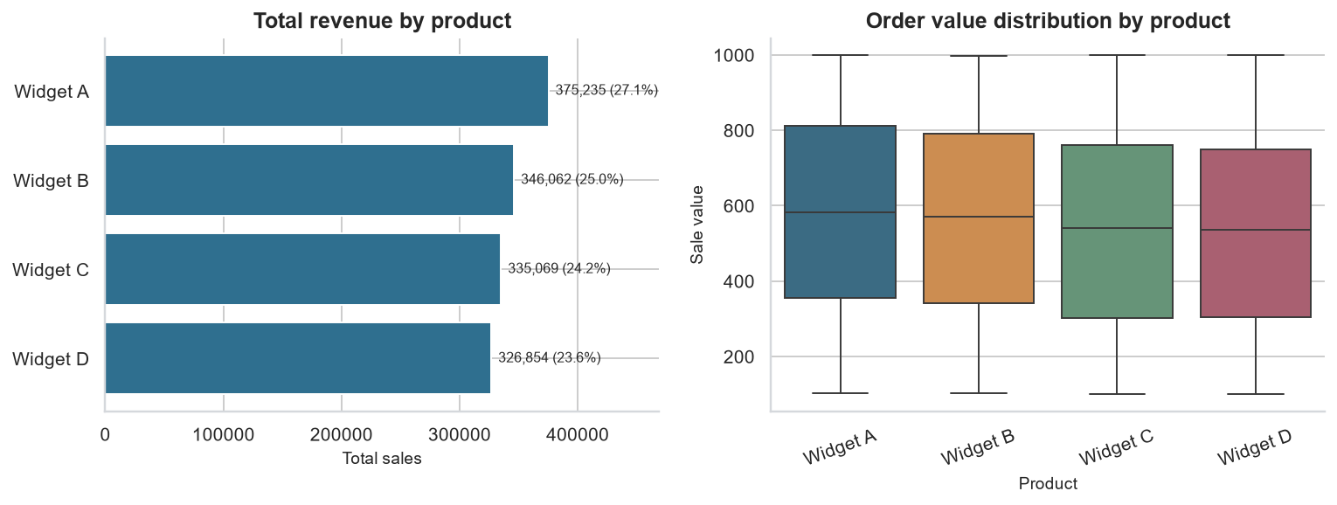
Figure 4 — Product performance: revenue ranking and order-value distribution (required family 2).
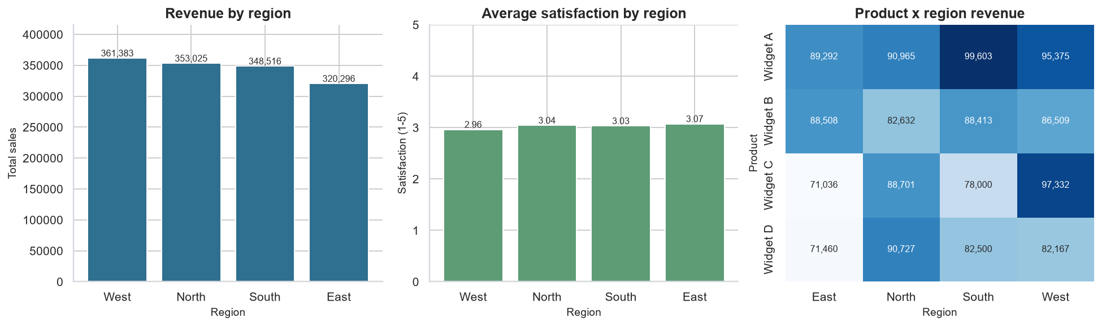
Figure 5 — Regional analysis: revenue, satisfaction and the product×region heatmap (required family 3).

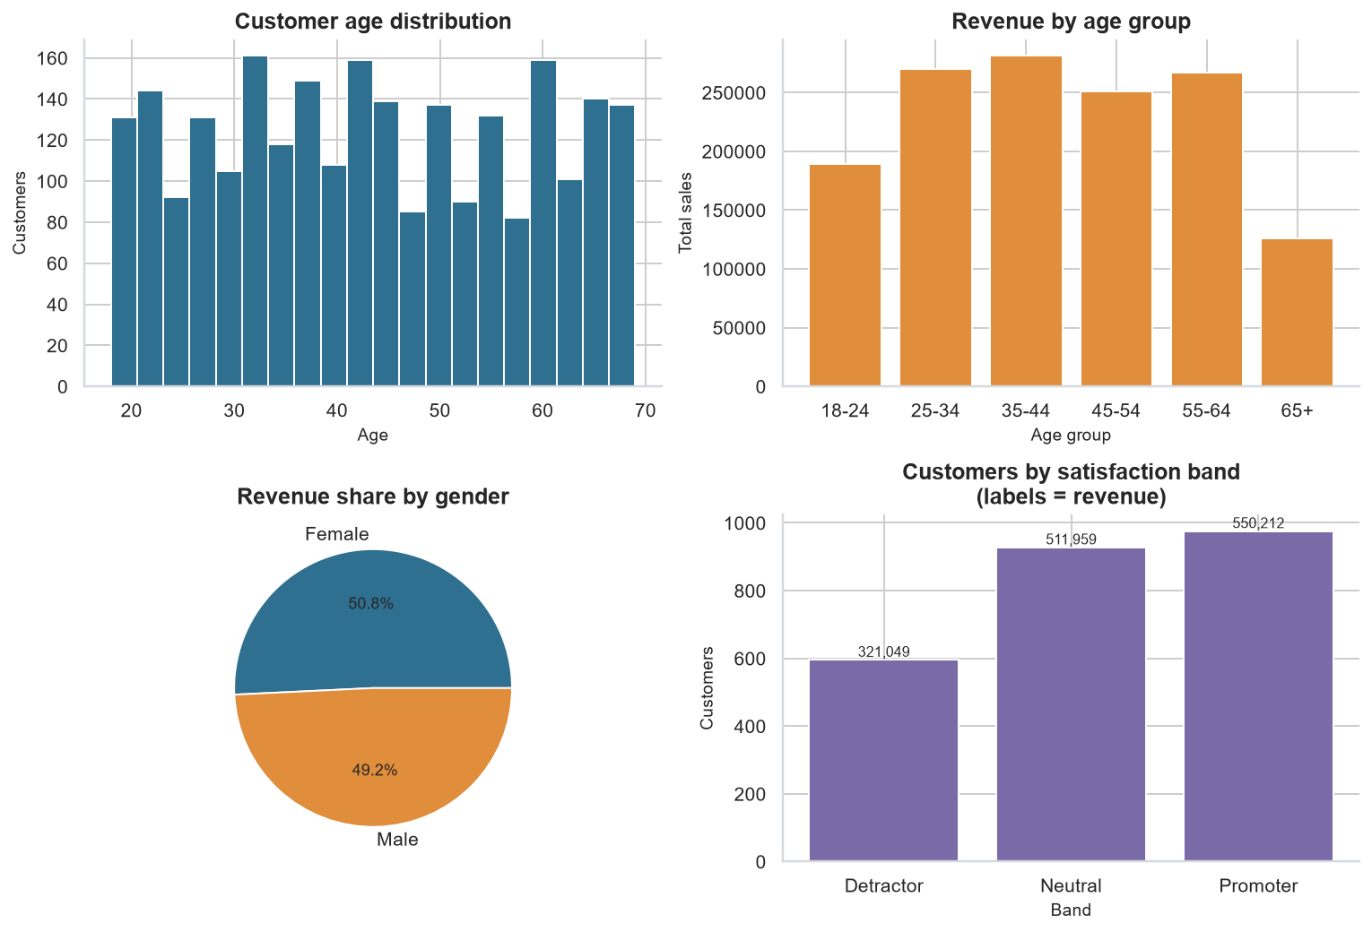
Figure 6 — Customer demographics and segmentation: age distribution, revenue by age band, gender split and satisfaction mix (required family 4).

9. Testing and verification
The deterministic half of the system is covered by 26 automated tests that require neither an API key nor network access and complete in under three seconds. They verify that enrichment produces the expected columns, that every headline KPI matches an independent pandas recomputation, that revenue shares sum to 100%, that the analysis output is JSON-serialisable, that the retriever routes each question type correctly, that live-computed slices match pandas, that the memory window evicts correctly, that judge verdicts parse correctly, and that monitoring aggregates as expected.
Beyond unit testing, the Streamlit interface is exercised with Streamlit's own AppTest harness: all six tabs are rendered and asserted to raise no exceptions, and a question is submitted through the chat input and answered end to end.
Verification | Result
Unit tests | 26 passed, no API key required
Streamlit tabs rendered | 6 of 6, zero exceptions
End-to-end pipeline | Completes in approximately 80 seconds
Conversational memory | Follow-up correctly condensed and answered
Offline fallback | Answers without credentials or network

10. Limitations and further work
- Keyword routing does not generalise. The retriever's routing table is a hand-built keyword map. It covers the vocabulary of this dataset well but would need extending for a new domain. Replacing it with a small classifier, or with LLM-driven tool selection, would remove that maintenance burden.
- Local embeddings trade quality for independence. TF-IDF with latent semantic analysis captures lexical similarity well but lacks the semantic depth of a trained embedding model, which mainly affects retrieval over the reference PDFs rather than over the metric documents.
- The judge is itself a language model. QAEvalChain verdicts on interpretive questions vary between runs. The deterministic numeric-grounding check exists precisely to provide a stable second signal.
- Monitoring is file-based. The JSONL interaction log is appropriate at this scale but would be replaced by a proper tracing backend, such as LangSmith, in a production deployment.
- No forecasting. The assistant characterises the historical trend but does not project it. Adding a time-series forecast would be a natural next increment.

11. Running the project
The repository is public and the application is deployed and running at insightforge-uuna235appup5czvxwocjtr.streamlit.app. To run it locally:
python -m venv venv && venv\Scripts\activate
pip install -r requirements.txt
python run_pipeline.py # analysis, charts, report, evaluation
streamlit run streamlit_app.py
python -m pytest tests -q # 26 tests, no key needed

An OpenRouter API key may be supplied through an environment variable, a .env file, Streamlit secrets, or the sidebar field in the running application. With no key the assistant runs in offline extractive mode.

Repository layout
Path | Purpose
streamlit_app.py | Streamlit user interface, six tabs
run_pipeline.py | End-to-end command-line runner
insightforge/analysis.py | All business metrics
insightforge/knowledge_base.py | Metrics and PDFs to vector store
insightforge/retriever.py | Hybrid custom retriever
insightforge/rag_chain.py | RAG chain, prompt chain, memory
insightforge/evaluation.py | QAEvalChain harness
insightforge/visualization.py | Nine charts
insightforge/monitoring.py | Interaction telemetry
notebooks/ | Guided walkthrough of all seven steps
tests/ | 26 offline tests

Environment
Python 3.13.7 · langchain 1.4.2 · langchain-core 1.6.3 · langchain-community 0.4.2 · langchain-openai 1.6.2 · faiss-cpu 1.15.1 · streamlit 1.64.0 · pandas 3.0.6 · scikit-learn 1.9.1 · matplotlib 3.11.2 · seaborn 0.13.2

