## PM4KNIME Exercises

### Introduction

The exercises are provided to help user get familiar with PM4KNIME in KNIME. It covers the following parts, reading and writing event logs and process model, log manipulation, process discovery, conformance checking. For each exercise detailed solutions are provided which you can use when you get stuck.

#### Exercise 1 -- process discovery

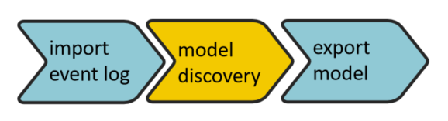

1. Download the file from the link???
2. Import the event log from the XES file exercise1.xes
3. Inspect the contents of exercise1.xes using the log visualization and answer the following questions:
   1. What are the traces with the minimal and maximal number of events?
   2. What is the frequency of the event “” in the whole log?
   3. What is the most frequent trace variant in the event log?
4. Discover the event log by Inductive Miner with settings, infrequent + 0.2 noise threshold
5. Write the generate Petri net on disk under name in path??

#### Solution 1 -- process discovery

1. Download the file from the link???

f

1. Import the event log from the XES file exercise1.xes
2. Inspect the contents of exercise1.xes using the log visualization and answer the following questions:
   1. What are the traces with the minimal and maximal number of events?
   2. What is the frequency of the event “” in the whole log?
   3. What is the most frequent trace variant in the event log?
3. Discover the event log by Inductive Miner with settings, infrequent + 0.2 noise threshold
4. Write the generate Petri net on disk under name in path??

#### Exercise 2 -- conformance checking

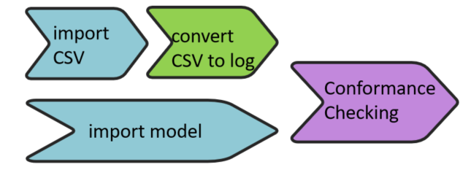

1. Download the CSV file from the link??? and the process model from link???
2. Import the CSV file into KNIME with CSV Reader with the settings to show all the attributes
3. Convert the imported Data Table into event log with the following options:
   1. Trace attributes include ???
   2. Time stamp is in format ??
   3. Event attributes include ???
4. Import the Petri net from file ??
5. Replay the event log on the imported Petri net with settings:
   1. ILP-Miner
   2. Cost for Move on log as 2, and move on model as 1, syn cost as 0
6. Show the fitness after replay by using the node ??
7. Calculate the precision after replaying by the node ??

#### Solution 2 -- conformance checking

1. Download the CSV file from the link??? and the process model from link???
2. Import the CSV file into KNIME with CSV Reader with the settings to show all the attributes
3. Convert the imported Data Table into event log with the following options:
   1. Trace attributes include ???
   2. Time stamp is in format ??
   3. Event attributes include ???
4. Import the Petri net from file ??
5. Replay the event log on the imported Petri net with settings:
   1. ILP-Miner
   2. Cost for Move on log as 2, and move on model as 1, syn cost as 0
6. Show the fitness after replay by using the node ??
7. Calculate the precision after replaying by the node ??

#### Exercise 3 -- log manipulation

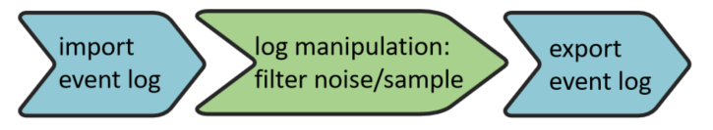

1. Download the event log from XES file with link???
2. Import the event log into KNIME
3. Filter log with the following attributes:
   1. Kpi-outcome?
   2. Trace attributes?
4. Split the event log into two parts according to ?
5. Classify the one of the sub event logs as ??
6. Merge the the two sub event logs back by using merge event log
7. Write the sub event log into file

#### Solution 3 -- log manipulation

#### Exercise 4 -- repetitive workflow with loop 01

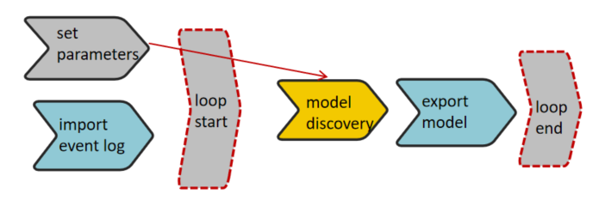

1. Download the file with parameters settings from link???
2. Import the files into KNIME by Table Reader
3. Import event log from ???
4. Begin loop
   1. Change the parameters in InductiveMiner from 0.2-0.8 with step 0.1 for infrequently miner. Based on the parameter, discover Petri net.
   2. Export the discovered Petri net
5. End loop

#### Solution 4 -- repetitive workflow with loop

#### Exercise 5 -- repetitive workflow with loop 02

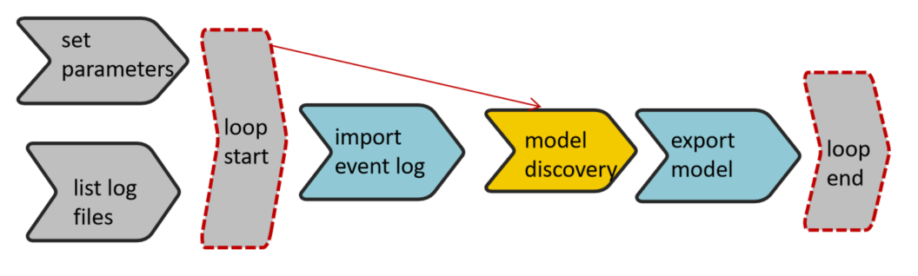

Following the last task, which discovers process model with different parameters, the current task asks to repeat the same process for all event logs in the same folder.

1. Read the set parameters from file
2. List all XES files in the folder ??
3. Begin loop
   1. Import event log with the same given from files list from last step
   2. Set the parameter for Inductive Mier
   3. Export model
4. End loop

#### Solution 5 -- repetitive workflow with loop 02

#### 