AirlineAnalysis.R

puj83

Mon Jul 29 20:11:13 2019

# Airline X

# Guest Satisfaction Survey Data

# Business Problem  
  
# Given data set of 8,000 guest satisfaction survey records to determine the key drivers for likelihood to recommend Airline X.   
# The dependent variable in the data set is Q1.   
# key drivers you found, how you derived them (data used, manipulations/transformations if you used any, models run, sampling, etc.),   
# and what information/data, if necessary, you'd like to make a recommendation on key drivers.

GuestData<-read.csv(file = "C:/Users/puj83/OneDrive/CV/Cases/AirlineX/Guest_Satisfaction_Survey_Data.csv", header = T, sep = ",")  
# saveRDS(GuestData, file = "GuestData.rds")  
  
# GuestData<-load(file = "GuestData.rds")  
  
names(GuestData)

## [1] "Q1" "Q132" "Q94"   
## [4] "Q91_1" "Q91_2" "Q91_3"   
## [7] "Q135" "Q115" "Q95"   
## [10] "Q53_1" "Q53_2" "Q53_3"   
## [13] "Q53_4" "Q55" "Q119"   
## [16] "Q116" "Q131" "Q109"   
## [19] "Q96" "Q100" "Q102_1"   
## [22] "Q102_2" "Q102_3" "Q102_4"   
## [25] "Q104" "Q134" "Q138"   
## [28] "Q130" "Q106_1" "Q106_2"   
## [31] "Q106_3" "Q126" "Q108"   
## [34] "Q110" "Q112" "Q118"   
## [37] "Q141" "Q129" "Q114_1"   
## [40] "Q114_2" "Q114_3" "Q116.1"   
## [43] "Q117" "Q137" "Q120"   
## [46] "Q35" "Q37_1" "Q37_2"   
## [49] "Q37_3" "Q37_4" "Q37_5"   
## [52] "Q111" "Q113" "Q112.1"   
## [55] "Q8" "Q9" "Q11"   
## [58] "Q12" "Q107" "Q105"   
## [61] "Q106" "Q40" "Q15"   
## [64] "Q18" "Q20" "Q22"   
## [67] "Q24" "Q28_1" "Q34"   
## [70] "Q36_1" "Q36_2" "Q3"   
## [73] "Q5" "Q6_1" "Q6_2"   
## [76] "Q6_3" "Q6_4" "Q7"   
## [79] "Q60" "Q114" "Q107.1"   
## [82] "Q108.1" "Q48" "Q50"   
## [85] "Q52" "Q54_1" "Q54_2"   
## [88] "Q54_3" "Q54_4" "Q54_5"   
## [91] "Q145" "Q99" "Q127"   
## [94] "Q100.1" "Booking.Channel" "Flight.Date.Time"   
## [97] "Pax.per.PNR" "Segment1.Destination" "Segment1.Origin"

library(dplyr)

##   
## Attaching package: 'dplyr'

## The following objects are masked from 'package:stats':  
##   
## filter, lag

## The following objects are masked from 'package:base':  
##   
## intersect, setdiff, setequal, union

# install.packages("tibble")  
# install.packages("pdflatex")  
  
library(rlang)

## Warning: package 'rlang' was built under R version 3.5.3

library(tibble)

## Warning: package 'tibble' was built under R version 3.5.3

library(ggplot2)  
# library(pdflatex)  
  
GuestData<-GuestData %>% mutate_all(as.factor)  
  
# Convert all columns to factors  
  
# Transform all 'ordinal' columns into 'numerical columns'  
  
# Treating missing values:  
  
# Missing observations will be ignored and analysis is done on the variables present.   
  
# Look at all levels of the variables.   
  
GuestData2<-GuestData %>% sapply(levels)  
  
library(plyr)

## -------------------------------------------------------------------------

## You have loaded plyr after dplyr - this is likely to cause problems.  
## If you need functions from both plyr and dplyr, please load plyr first, then dplyr:  
## library(plyr); library(dplyr)

## -------------------------------------------------------------------------

##   
## Attaching package: 'plyr'

## The following objects are masked from 'package:dplyr':  
##   
## arrange, count, desc, failwith, id, mutate, rename, summarise,  
## summarize

# [1] "Q1" "Q132" "Q94" "Q91_1" "Q91_2" "Q91_3" "Q135" "Q115" "Q95"   
# [10] "Q53_1" "Q53_2" "Q53_3" "Q53_4" "Q55" "Q119" "Q116" "Q131" "Q109"   
# [19] "Q96" "Q100" "Q102_1" "Q102_2" "Q102_3" "Q102_4" "Q104" "Q134" "Q138"   
# [28] "Q130" "Q106_1" "Q106_2" "Q106_3" "Q126" "Q108" "Q110" "Q112" "Q118"   
# [37] "Q141" "Q129" "Q114_1" "Q114_2" "Q114_3" "Q116.1" "Q117" "Q137" "Q120"   
# [46] "Q35" "Q37_1" "Q37_2" "Q37_3" "Q37_4" "Q37_5" "Q111" "Q113" "Q112.1"   
# [55] "Q8" "Q9" "Q11" "Q12" "Q107" "Q105" "Q106" "Q40" "Q15"   
# [64] "Q18" "Q20" "Q22" "Q24" "Q28_1" "Q34" "Q36_1" "Q36_2" "Q3"   
# [73] "Q5" "Q6_1" "Q6_2" "Q6_3" "Q6_4" "Q7" "Q60" "Q114" "Q107.1"   
# [82] "Q108.1" "Q48" "Q50" "Q52" "Q54_1" "Q54_2" "Q54_3" "Q54_4" "Q54_5"   
# [91] "Q145" "Q99" "Q127" "Q100.1" "Booking.Channel" "Flight.Date.Time" "Pax.per.PNR" "Segment1.Destination" "Segment1.Origin"   
  
# Response Variable (Factors that explain the performance of this variable):  
# $Q1  
# ""   
# "0"   
# "1"   
# "10"   
# "2"   
# "3"   
# "4"   
# "5"   
# "6"   
# "7"   
# "8"   
# "9"   
# "On\na scale from 0-10, how likely are you to recommend AirlineX Airlines to a friend\nor colleague?"  
  
GuestData$Q1<-as.numeric(as.character(GuestData$Q1))

## Warning: NAs introduced by coercion

ggplot(GuestData, aes(x=Q1)) +  
 geom_histogram(binwidth=1, colour="black", fill="blue")

## Warning: Removed 7 rows containing non-finite values (stat_bin).

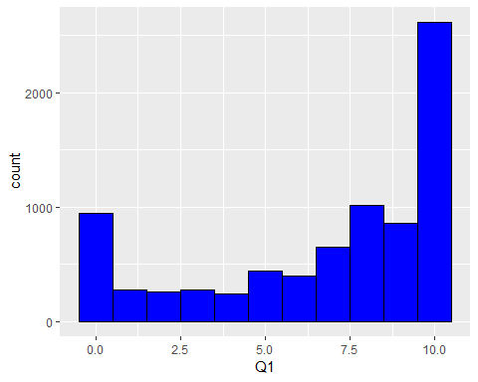

# $Q132  
#""   
#"Extremely dissatisfied"   
#"Extremely satisfied"   
#"How satisfied were you with your kiosk experience?"  
#"Neither satisfied nor dissatisfied"   
#"Somewhat dissatisfied"   
#"Somewhat satisfied"   
  
GuestData$Q132<-revalue(GuestData$Q132, c("Extremely dissatisfied" = "1", "Somewhat dissatisfied" = "2", "Neither satisfied nor dissatisfied" = "3", "Somewhat satisfied" = "4", "Extremely satisfied" = "5"))  
GuestData$Q132<-as.numeric(as.character(GuestData$Q132))

## Warning: NAs introduced by coercion

ggplot(GuestData, aes(x=Q132)) +  
 geom_histogram(binwidth=1, colour="black", fill="blue")

## Warning: Removed 7715 rows containing non-finite values (stat_bin).

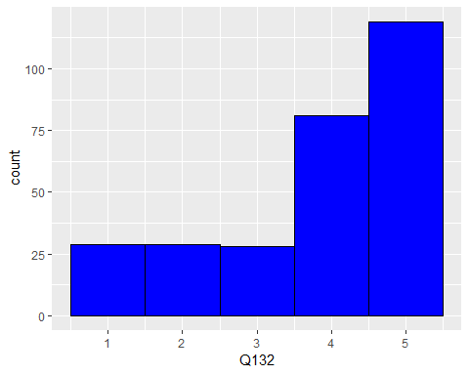

#$Q94  
#""   
#"How long were the lines to use the kiosks?"   
#"Long"   
#"Normal"   
#"Short"   
#"Very long"   
#"Very short"   
  
GuestData$Q94<-revalue(GuestData$Q94, c("Very short"="1", "Short"="2", "Normal"="3", "Long"="4", "Very long"="5"))  
GuestData$Q94<-as.numeric(as.character(GuestData$Q94))

## Warning: NAs introduced by coercion

ggplot(GuestData, aes(x=Q94)) +  
 geom_histogram(binwidth=1, colour="black", fill="blue")

## Warning: Removed 7712 rows containing non-finite values (stat_bin).

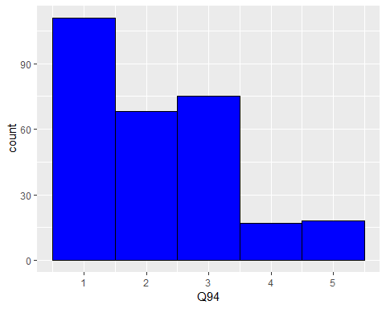

#$Q91_1  
#""   
#"Agree"   
#"Disagree"   
#"Neither agree nor disagree"   
#"Please rate the following statements about your check-in kiosk interaction:\nThe check-in kiosk was... - Responsive"  
#"Strongly agree"   
#"Strongly Disagree"   
  
GuestData$Q91_1<-revalue(GuestData$Q91_1, c("Strongly Disagree"="1", "Disagree"="2", "Neither agree nor disagree" = "3", "Agree" = "4", "Strongly agree" = "5"))  
GuestData$Q91_1<-as.numeric(as.character(GuestData$Q91_1))

## Warning: NAs introduced by coercion

ggplot(GuestData, aes(x=Q91_1)) +  
 geom_histogram(binwidth=1, colour="black", fill="blue")

## Warning: Removed 7712 rows containing non-finite values (stat_bin).

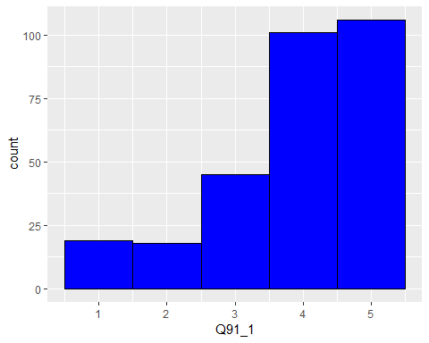

#$Q91_2  
#""   
#"Agree"   
#"Disagree"   
#"Neither agree nor disagree"   
#"Please rate the following statements about your check-in kiosk interaction:\nThe check-in kiosk was... - Easy-to-use"  
#"Strongly agree"   
#"Strongly Disagree"   
  
GuestData$Q91_2<-revalue(GuestData$Q91_2, c("Strongly Disagree"="1", "Disagree"="2", "Neither agree nor disagree" = "3", "Agree" = "4", "Strongly agree" = "5"))  
GuestData$Q91_2<-as.numeric(as.character(GuestData$Q91_2))

## Warning: NAs introduced by coercion

ggplot(GuestData, aes(x=Q91_2)) +  
 geom_histogram(binwidth=1, colour="black", fill="blue")

## Warning: Removed 7712 rows containing non-finite values (stat_bin).

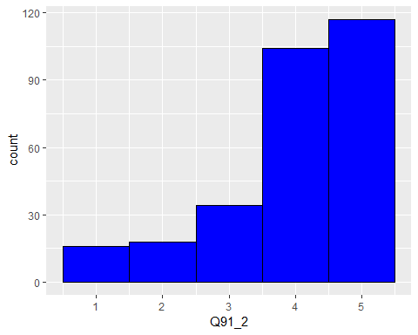

#$Q91_3  
#""   
#"Agree"   
#"Disagree"   
#"Neither agree nor disagree"   
#"Please rate the following statements about your check-in kiosk interaction:\nThe check-in kiosk was... - Available"  
#"Strongly agree"   
#"Strongly Disagree"   
  
GuestData$Q91_3<-revalue(GuestData$Q91_3, c("Strongly Disagree"="1", "Disagree"="2", "Neither agree nor disagree" = "3", "Agree" = "4", "Strongly agree" = "5"))  
GuestData$Q91_3<-as.numeric(as.character(GuestData$Q91_3))

## Warning: NAs introduced by coercion

ggplot(GuestData, aes(x=Q91_3)) +  
 geom_histogram(binwidth=1, colour="black", fill="blue")

## Warning: Removed 7712 rows containing non-finite values (stat_bin).

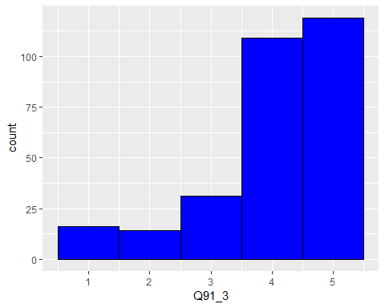

#$Q135  
#""   
#"Did you use the self-bag tags printed from the kiosk?"   
#"No"   
#"Yes"   
  
GuestData$Q135<-revalue(GuestData$Q135, c("Yes"="1", "No"="2"))  
GuestData$Q135<-as.numeric(as.character(GuestData$Q135))

## Warning: NAs introduced by coercion

ggplot(GuestData, aes(x=Q135)) +  
 geom_histogram(binwidth=1, colour="black", fill="blue")

## Warning: Removed 7853 rows containing non-finite values (stat_bin).

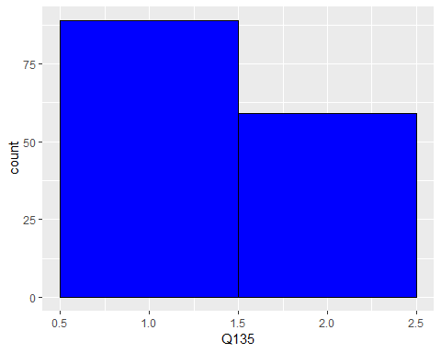

#$Q115  
#""   
#"Neither satisfied nor dissatisfied"   
#"Not satisfied at all"   
#"Overall, how satisfied were you with the self-bag tag process?"   
#"Somewhat dissatisfied"   
#"Somewhat satisfied"   
#"Very satisfied"   
  
GuestData$Q115<-revalue(GuestData$Q115, c("Not satisfied at all" = "1", "Somewhat dissatisfied" = "2", "Neither satisfied nor dissatisfied" = "3", "Somewhat satisfied" = "4", "Very satisfied" = "5"))  
GuestData$Q115<-as.numeric(as.character(GuestData$Q115))

## Warning: NAs introduced by coercion

ggplot(GuestData, aes(x=Q115)) +  
 geom_histogram(binwidth=1, colour="black", fill="blue")

## Warning: Removed 7912 rows containing non-finite values (stat_bin).

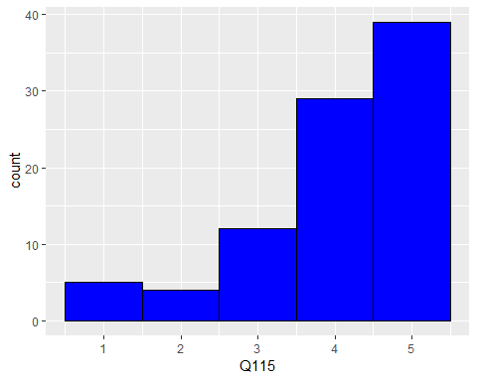

#$Q95  
#""   
#"How long were the lines to check your bags?"   
#"Long"   
#"Normal"   
#"Short"   
#"Very long"   
#"Very short"   
  
GuestData$Q95<-revalue(GuestData$Q95, c("Very short"="1", "Short"="2", "Normal"="3", "Long"="4", "Very long"="5"))  
GuestData$Q95<-as.numeric(as.character(GuestData$Q95))

## Warning: NAs introduced by coercion

ggplot(GuestData, aes(x=Q95)) +  
 geom_histogram(binwidth=1, colour="black", fill="blue")

## Warning: Removed 7854 rows containing non-finite values (stat_bin).

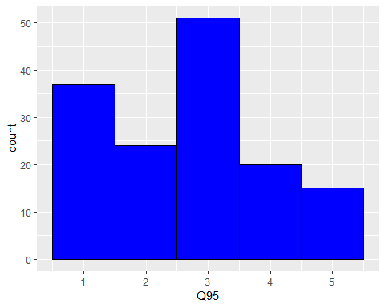

# $Q53_1  
#""   
#"Agree"   
#"Disagree"   
#"Neither agree nor disagree"   
#"Please rate the following statements about your check-in experience:\n\nThe terminal lobby was... - Clean" "Strongly agree"   
#"Strongly disagree"   
  
GuestData$Q53_1<-revalue(GuestData$Q53_1, c("Strongly disagree"="1", "Disagree"="2", "Neither agree nor disagree" = "3", "Agree" = "4", "Strongly agree" = "5"))  
GuestData$Q53_1<-as.numeric(as.character(GuestData$Q132))  
  
ggplot(GuestData, aes(x=Q53_1)) +  
 geom_histogram(binwidth=1, colour="black", fill="blue")

## Warning: Removed 7715 rows containing non-finite values (stat_bin).

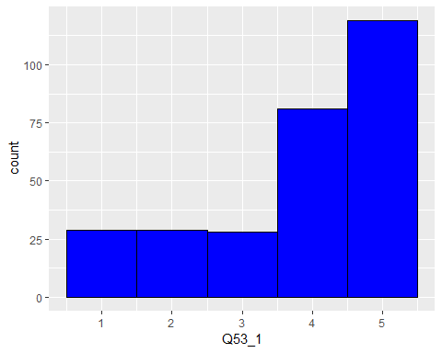

#$Q53_2  
#""   
#"Agree"   
#"Disagree"   
#"Neither agree nor disagree"   
#"Please rate the following statements about your check-in experience:\n\nThe terminal lobby was... - Organized"   
#"Strongly agree"   
#"Strongly disagree"   
  
GuestData$Q53_2<-revalue(GuestData$Q53_2, c("Strongly disagree"="1", "Disagree"="2", "Neither agree nor disagree" = "3", "Agree" = "4", "Strongly agree" = "5"))  
GuestData$Q53_2<-as.numeric(as.character(GuestData$Q53_2))

## Warning: NAs introduced by coercion

ggplot(GuestData, aes(x=Q53_2)) +  
 geom_histogram(binwidth=1, colour="black", fill="blue")

## Warning: Removed 6166 rows containing non-finite values (stat_bin).

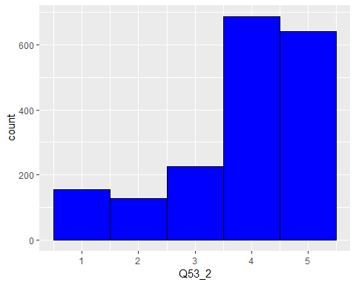

#$Q53_3  
#""   
#"Agree"   
#"Disagree"   
#"Neither agree nor disagree"   
#"Please rate the following statements about your check-in experience:\n\nThe terminal lobby was... - Fast" "Strongly agree"   
#"Strongly disagree"   
  
GuestData$Q53_3<-revalue(GuestData$Q53_3, c("Strongly disagree"="1", "Disagree"="2", "Neither agree nor disagree" = "3", "Agree" = "4", "Strongly agree" = "5"))  
GuestData$Q53_3<-as.numeric(as.character(GuestData$Q53_3))

## Warning: NAs introduced by coercion

ggplot(GuestData, aes(x=Q53_3)) +  
 geom_histogram(binwidth=1, colour="black", fill="blue")

## Warning: Removed 6166 rows containing non-finite values (stat_bin).

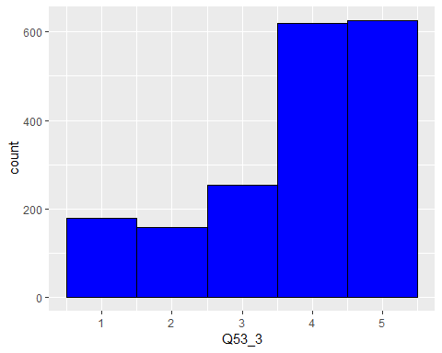

#$Q53_4  
#""   
#"Agree"   
#"Disagree"   
#"Neither agree nor disagree"   
#"Please rate the following statements about your check-in experience:\n\nThe terminal lobby was... - Spacious" "Strongly agree"   
#"Strongly disagree"  
  
GuestData$Q53_4<-revalue(GuestData$Q53_4, c("Strongly disagree"="1", "Disagree"="2", "Neither agree nor disagree" = "3", "Agree" = "4", "Strongly agree" = "5"))  
GuestData$Q53_4<-as.numeric(as.character(GuestData$Q53_4))

## Warning: NAs introduced by coercion

ggplot(GuestData, aes(x=Q53_4)) +  
 geom_histogram(binwidth=1, colour="black", fill="blue")

## Warning: Removed 6166 rows containing non-finite values (stat_bin).

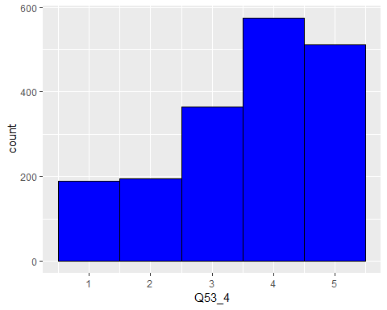

#$Q55  
#""   
#"Extremely clear"   
#"Extremely unclear"   
#"How clear were directions to check-in and bag drop after arriving to the terminal?"  
#"Neither clear nor unclear"   
#"Somewhat clear"   
#"Somewhat unclear"  
  
GuestData$Q55<-revalue(GuestData$Q55, c("Extremely unclear"="1", "Somewhat unclear"="2", "Neither clear nor unclear" = "3", "Somewhat clear" = "4", "Extremely clear" = "5"))  
GuestData$Q55<-as.numeric(as.character(GuestData$Q55))

## Warning: NAs introduced by coercion

ggplot(GuestData, aes(x=Q55)) +  
 geom_histogram(binwidth=1, colour="black", fill="blue")

## Warning: Removed 7109 rows containing non-finite values (stat_bin).

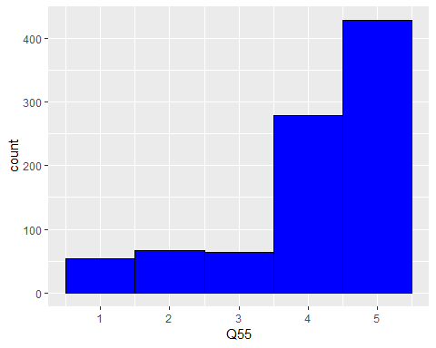

#$Q131  
#""   
#"Extremely dissatisfied"   
#"Extremely satisfied"   
#"How satisfied were you with your check-in or bag-drop counter experience?"  
#"Neither satisfied nor dissatisfied"   
#"Somewhat dissatisfied"   
#"Somewhat satisfied"   
  
GuestData$Q131<-revalue(GuestData$Q131, c("Extremely dissatisfied" = "1", "Somewhat dissatisfied" = "2", "Neither satisfied nor dissatisfied" = "3", "Somewhat satisfied" = "4", "Extremely satisfied" = "5"))  
GuestData$Q131<-as.numeric(as.character(GuestData$Q131))

## Warning: NAs introduced by coercion

ggplot(GuestData, aes(x=Q131)) +  
 geom_histogram(binwidth=1, colour="black", fill="blue")

## Warning: Removed 7600 rows containing non-finite values (stat_bin).

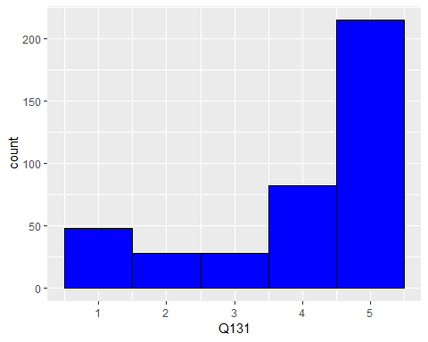

#$Q96  
#""   
#"How long were the lines to check-in at the counter?"   
#"Long"   
#"Normal"   
#"Short"   
#"Very long"   
#"Very short"   
  
GuestData$Q96<-revalue(GuestData$Q96, c("Very short"="1", "Short"="2", "Normal"="3", "Long"="4", "Very long"="5"))  
GuestData$Q96<-as.numeric(as.character(GuestData$Q96))

## Warning: NAs introduced by coercion

ggplot(GuestData, aes(x=Q96)) +  
 geom_histogram(binwidth=1, colour="black", fill="blue")

## Warning: Removed 7607 rows containing non-finite values (stat_bin).

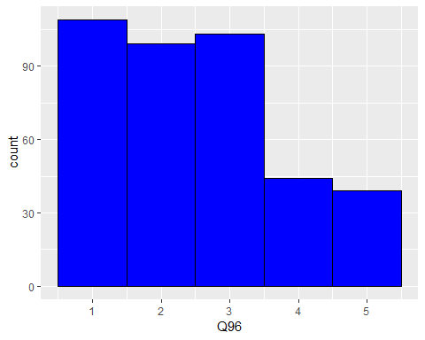

#$Q100  
#""   
#"After reaching the counter, were you greeted by the counter agent?"   
#"I don't remember"   
#"No"   
#"Yes"   
  
GuestData$Q100<-revalue(GuestData$Q100, c("Yes"="1", "I don't remember" = "2", "No"="3"))  
GuestData$Q100<-as.numeric(as.character(GuestData$Q100))

## Warning: NAs introduced by coercion

ggplot(GuestData, aes(x=Q100)) +  
 geom_histogram(binwidth=1, colour="black", fill="blue")

## Warning: Removed 7600 rows containing non-finite values (stat_bin).

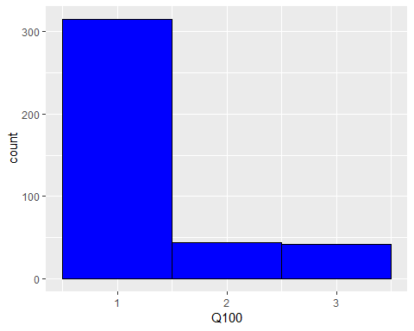

#$Q102_1  
#""   
#"Agree"   
#"Disagree"   
#"Neither agree nor disagree"   
#"Please rate the following\nstatements:\n\n \n\nThe\ncustomer service agents at the check-in/bag-drop counter on your flight from [Field-Journey%20Origin%20Name] were: - Attentive"  
#"Strongly agree"   
#"Strongly disagree"   
  
GuestData$Q102_1<-revalue(GuestData$Q102_1, c("Strongly disagree"="1", "Disagree"="2", "Neither agree nor disagree" = "3", "Agree" = "4", "Strongly agree" = "5"))  
GuestData$Q102_1<-as.numeric(as.character(GuestData$Q102_1))

## Warning: NAs introduced by coercion

ggplot(GuestData, aes(x=Q102_1)) +  
 geom_histogram(binwidth=1, colour="black", fill="blue")

## Warning: Removed 7608 rows containing non-finite values (stat_bin).

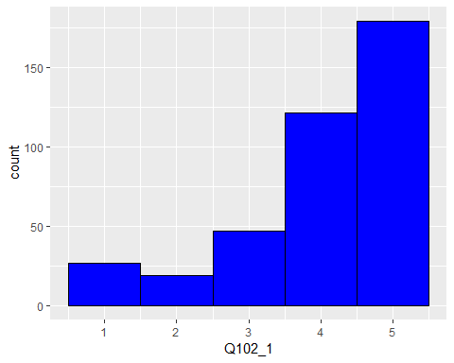

#$Q102_2  
#""   
#"Agree"   
#"Disagree"   
#"Neither agree nor disagree"   
#"Please rate the following\nstatements:\n\n \n\nThe\ncustomer service agents at the check-in/bag-drop counter on your flight from [Field-Journey%20Origin%20Name] were: - Professional"  
#"Strongly agree"   
#"Strongly disagree"   
  
GuestData$Q102_2<-revalue(GuestData$Q102_2, c("Strongly disagree"="1", "Disagree"="2", "Neither agree nor disagree" = "3", "Agree" = "4", "Strongly agree" = "5"))  
GuestData$Q102_2<-as.numeric(as.character(GuestData$Q102_2))

## Warning: NAs introduced by coercion

ggplot(GuestData, aes(x=Q102_2)) +  
 geom_histogram(binwidth=1, colour="black", fill="blue")

## Warning: Removed 7615 rows containing non-finite values (stat_bin).

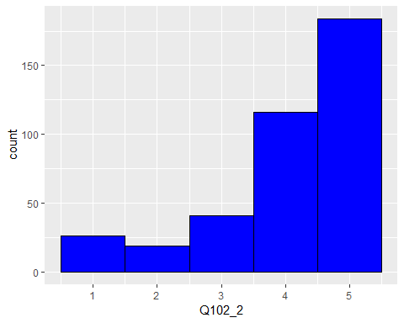

#$Q102_3  
#""   
#"Agree"   
#"Disagree"   
#"Neither agree nor disagree"   
#"Please rate the following\nstatements:\n\n \n\nThe\ncustomer service agents at the check-in/bag-drop counter on your flight from [Field-Journey%20Origin%20Name] were: - Friendly"  
#"Strongly agree"   
#"Strongly disagree"   
  
GuestData$Q102_3<-revalue(GuestData$Q102_3, c("Strongly disagree"="1", "Disagree"="2", "Neither agree nor disagree" = "3", "Agree" = "4", "Strongly agree" = "5"))  
GuestData$Q102_3<-as.numeric(as.character(GuestData$Q102_3))

## Warning: NAs introduced by coercion

ggplot(GuestData, aes(x=Q102_3)) +  
 geom_histogram(binwidth=1, colour="black", fill="blue")

## Warning: Removed 7617 rows containing non-finite values (stat_bin).

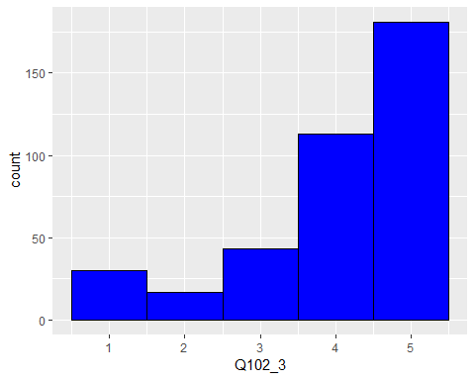

#$Q102_4  
#""   
#"Agree"   
#"Disagree"   
#"Neither agree nor disagree"   
#"Please rate the following\nstatements:\n\n \n\nThe\ncustomer service agents at the check-in/bag-drop counter on your flight from [Field-Journey%20Origin%20Name] were: - Helpful"  
#"Strongly agree"   
#"Strongly disagree"   
  
GuestData$Q102_4<-revalue(GuestData$Q102_4, c("Strongly disagree"="1", "Disagree"="2", "Neither agree nor disagree" = "3", "Agree" = "4", "Strongly agree" = "5"))  
GuestData$Q102_4<-as.numeric(as.character(GuestData$Q102_4))

## Warning: NAs introduced by coercion

ggplot(GuestData, aes(x=Q102_4)) +  
 geom_histogram(binwidth=1, colour="black", fill="blue")

## Warning: Removed 7619 rows containing non-finite values (stat_bin).

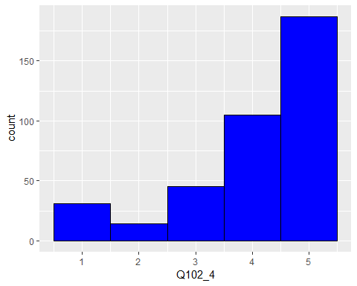

#$Q104  
#""   
#"At the end of your ticket counter interaction, did the agent provide you with the current gate information and boarding time?"  
#"I don't remember"   
#"No"   
#"Yes"   
  
GuestData$Q104<-revalue(GuestData$Q104, c("Yes"="1", "I don't remember" = "2", "No"="3"))  
GuestData$Q104<-as.numeric(as.character(GuestData$Q104))

## Warning: NAs introduced by coercion

ggplot(GuestData, aes(x=Q104)) +  
 geom_histogram(binwidth=1, colour="black", fill="blue")

## Warning: Removed 7600 rows containing non-finite values (stat_bin).

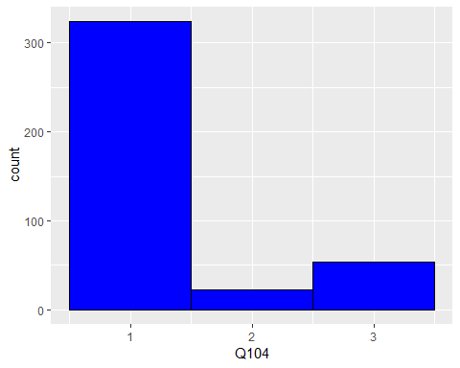

#$Q134  
#""   
#"How long were the lines to get through the TSA security line?"   
#"Long"   
#"Normal"   
#"Short"   
#"Very long"   
#"Very short"  
  
GuestData$Q134<-revalue(GuestData$Q134, c("Very short"="1", "Short"="2", "Normal"="3", "Long"="4", "Very long"="5"))  
GuestData$Q134<-as.numeric(as.character(GuestData$Q134))

## Warning: NAs introduced by coercion

ggplot(GuestData, aes(x=Q134)) +  
 geom_histogram(binwidth=1, colour="black", fill="blue")

## Warning: Removed 7603 rows containing non-finite values (stat_bin).

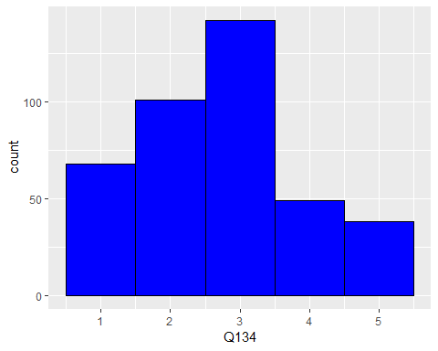

#$Q138  
#""   
#"Did you experience any issues during check-in?"   
#"No"   
#"Yes"   
  
GuestData$Q138<-revalue(GuestData$Q138, c("Yes"="1", "No"="0"))  
GuestData$Q138<-as.numeric(as.character(GuestData$Q138))

## Warning: NAs introduced by coercion

ggplot(GuestData, aes(x=Q138)) +  
 geom_histogram(binwidth=1, colour="black", fill="blue")

## Warning: Removed 7605 rows containing non-finite values (stat_bin).

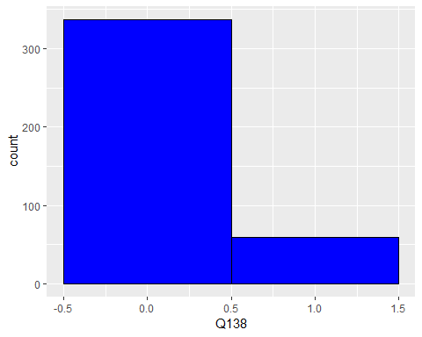

#$Q130  
#""   
#"Extremely dissatisfied"   
#"Extremely satisfied"   
#"How satisfied were you with your gate experience?"  
#"Neither satisfied nor dissatisfied"   
#"Somewhat dissatisfied"   
#"Somewhat satisfied"   
  
GuestData$Q130<-revalue(GuestData$Q130, c("Extremely dissatisfied" = "1", "Somewhat dissatisfied" = "2", "Neither satisfied nor dissatisfied" = "3", "Somewhat satisfied" = "4", "Extremely satisfied" = "5"))  
GuestData$Q130<-as.numeric(as.character(GuestData$Q130))

## Warning: NAs introduced by coercion

ggplot(GuestData, aes(x=Q130)) +  
 geom_histogram(binwidth=1, colour="black", fill="blue")

## Warning: Removed 6177 rows containing non-finite values (stat_bin).

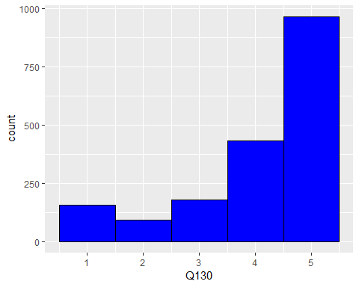

#$Q106_1  
#""   
#"Agree"   
#"Disagree"   
#"Neither agree nor disagree"   
#"Please rate the following statements about the gate and boarding area:\n\nThe gate area was... - Spacious"   
#"Strongly agree"   
#"Strongly disagree"   
  
GuestData$Q106_1<-revalue(GuestData$Q106_1, c("Strongly disagree"="1", "Disagree"="2", "Neither agree nor disagree" = "3", "Agree" = "4", "Strongly agree" = "5"))  
GuestData$Q106_1<-as.numeric(as.character(GuestData$Q106_1))

## Warning: NAs introduced by coercion

ggplot(GuestData, aes(Q106_1)) +  
 geom_histogram(binwidth=1, colour="black", fill="blue")

## Warning: Removed 6174 rows containing non-finite values (stat_bin).

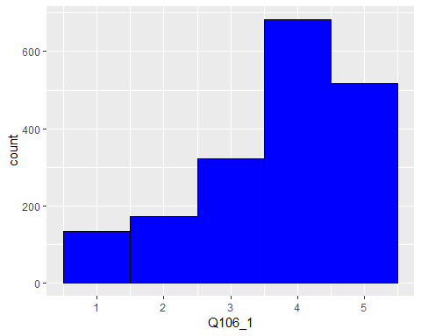

#$Q106_2  
#""   
#"Agree"   
#"Disagree"   
#"Neither agree nor disagree"   
#"Please rate the following statements about the gate and boarding area:\n\nThe gate area was... - Comfortable"   
#"Strongly agree"   
#"Strongly disagree"   
  
GuestData$Q106_2<-revalue(GuestData$Q106_2, c("Strongly disagree"="1", "Disagree"="2", "Neither agree nor disagree" = "3", "Agree" = "4", "Strongly agree" = "5"))  
GuestData$Q106_2<-as.numeric(as.character(GuestData$Q106_2))

## Warning: NAs introduced by coercion

ggplot(GuestData, aes(x=Q106_2)) +  
 geom_histogram(binwidth=1, colour="black", fill="blue")

## Warning: Removed 6174 rows containing non-finite values (stat_bin).

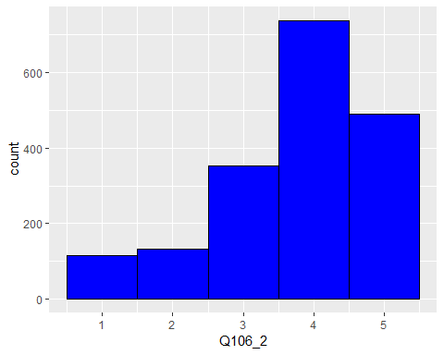

#$Q106_3  
#""   
#"Agree"   
#"Disagree"   
#"Neither agree nor disagree"   
#"Please rate the following statements about the gate and boarding area:\n\nThe gate area was... - Clean"   
#"Strongly agree"   
#"Strongly disagree"   
  
GuestData$Q106_3<-revalue(GuestData$Q106_3, c("Strongly disagree"="1", "Disagree"="2", "Neither agree nor disagree" = "3", "Agree" = "4", "Strongly agree" = "5"))  
GuestData$Q106_3<-as.numeric(as.character(GuestData$Q106_3))

## Warning: NAs introduced by coercion

ggplot(GuestData, aes(x=Q106_3)) +  
 geom_histogram(binwidth=1, colour="black", fill="blue")

## Warning: Removed 6174 rows containing non-finite values (stat_bin).

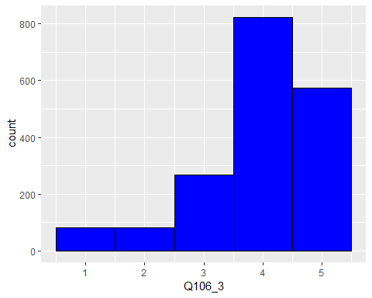

#$Q126  
#""   
#"Clear"   
#"How clear were announcements made at the gate?"   
#"Neither clear nor poor"   
#"Poor"   
#"Very clear"   
#"Very poor"   
  
GuestData$Q126<-revalue(GuestData$Q126, c("Very poor"="1", "Poor"="2", "Neither clear nor poor" = "3", "Clear" = "4", "Very clear" = "5"))  
GuestData$Q126<-as.numeric(as.character(GuestData$Q126))

## Warning: NAs introduced by coercion

ggplot(GuestData, aes(x=Q126)) +  
 geom_histogram(binwidth=1, colour="black", fill="blue")

## Warning: Removed 6180 rows containing non-finite values (stat_bin).

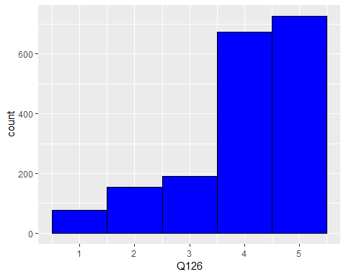

#$Q108  
#""   
#"Did you require any assistance from the gate agent after going through security?"  
#"No"   
#"Yes"   
  
GuestData$Q108<-revalue(GuestData$Q108, c("Yes"="1", "No"="0"))  
GuestData$Q108<-as.numeric(as.character(GuestData$Q108))

## Warning: NAs introduced by coercion

ggplot(GuestData, aes(x=Q108)) +  
 geom_histogram(binwidth=1, colour="black", fill="blue")

## Warning: Removed 6174 rows containing non-finite values (stat_bin).

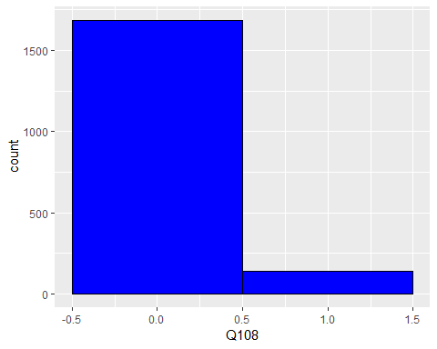

#$Q110  
#""   
#"I don't remember"   
#"No"   
#"Were AirlineX team members available at the gate counter to assist you?"   
#"Yes"  
  
GuestData$Q110<-revalue(GuestData$Q110, c("Yes"="1", "I don't remember" = "2", "No"="3"))  
GuestData$Q110<-as.numeric(as.character(GuestData$Q110))

## Warning: NAs introduced by coercion

ggplot(GuestData, aes(x=Q110)) +  
 geom_histogram(binwidth=1, colour="black", fill="blue")

## Warning: Removed 7860 rows containing non-finite values (stat_bin).

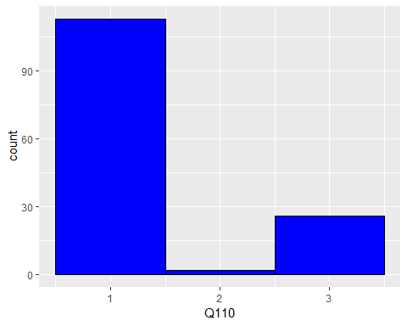

#$Q141  
#""   
#"Did you experience any issues at the gate?"   
#"No"   
#"Yes"   
  
GuestData$Q141<-revalue(GuestData$Q141, c("Yes"="1", "No"="0"))  
GuestData$Q141<-as.numeric(as.character(GuestData$Q141))

## Warning: NAs introduced by coercion

ggplot(GuestData, aes(x=Q141)) +  
 geom_histogram(binwidth=1, colour="black", fill="blue")

## Warning: Removed 6176 rows containing non-finite values (stat_bin).

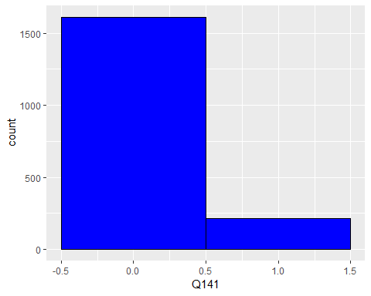

#$Q129  
#""   
#"Extremely dissatisfied"   
#"Extremely satisfied"   
#"How satisfied were you with the boarding process?"  
#"Neither satisfied nor dissatisfied"   
#"Somewhat dissatisfied"   
#"Somewhat satisfied"   
  
GuestData$Q129<-revalue(GuestData$Q129, c("Extremely dissatisfied" = "1", "Somewhat dissatisfied" = "2", "Neither satisfied nor dissatisfied" = "3", "Somewhat satisfied" = "4", "Extremely satisfied" = "5"))  
GuestData$Q129<-as.numeric(as.character(GuestData$Q129))

## Warning: NAs introduced by coercion

ggplot(GuestData, aes(x=Q129)) +  
 geom_histogram(binwidth=1, colour="black", fill="blue")

## Warning: Removed 6205 rows containing non-finite values (stat_bin).

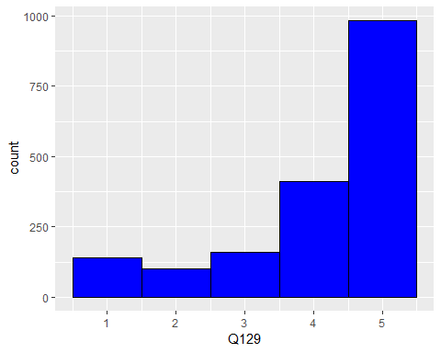

#$Q114_1  
#""   
#"Agree"   
#"Disagree"   
#"Neither agree nor disagree"   
#"Please rate the following statements about the boarding process:\n\nThe boarding process was... - Organized"   
#"Strongly agree"   
#"Strongly disagree"  
  
GuestData$Q114_1<-revalue(GuestData$Q114_1, c("Strongly disagree"="1", "Disagree"="2", "Neither agree nor disagree" = "3", "Agree" = "4", "Strongly agree" = "5"))  
GuestData$Q114_1<-as.numeric(as.character(GuestData$Q114_1))

## Warning: NAs introduced by coercion

ggplot(GuestData, aes(x=Q114_1)) +  
 geom_histogram(binwidth=1, colour="black", fill="blue")

## Warning: Removed 6200 rows containing non-finite values (stat_bin).

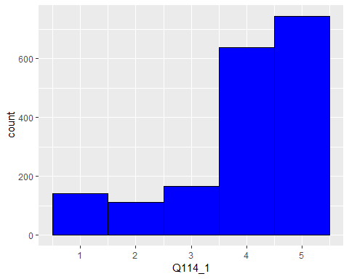

#$Q114_2  
#""   
#"Agree"   
#"Disagree"   
#"Neither agree nor disagree"   
#"Please rate the following statements about the boarding process:\n\nThe boarding process was... - Easy to understand"  
#"Strongly agree"   
#"Strongly disagree"   
  
GuestData$Q114_2<-revalue(GuestData$Q114_2, c("Strongly disagree"="1", "Disagree"="2", "Neither agree nor disagree" = "3", "Agree" = "4", "Strongly agree" = "5"))  
GuestData$Q114_2<-as.numeric(as.character(GuestData$Q114_2))

## Warning: NAs introduced by coercion

ggplot(GuestData, aes(x=Q114_2)) +  
 geom_histogram(binwidth=1, colour="black", fill="blue")

## Warning: Removed 6200 rows containing non-finite values (stat_bin).

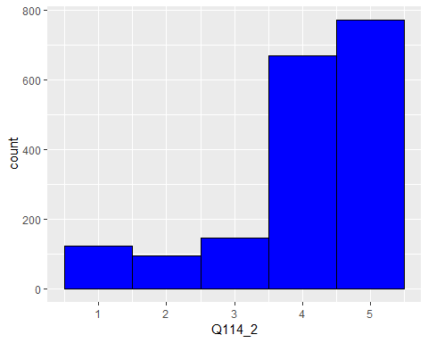

#$Q114_3  
#""   
#"Agree"   
#"Disagree"   
#"Neither agree nor disagree"   
#"Please rate the following statements about the boarding process:\n\nThe boarding process was... - Fast"   
#"Strongly agree"   
#"Strongly disagree"  
  
GuestData$Q114_3<-revalue(GuestData$Q114_3, c("Strongly disagree"="1", "Disagree"="2", "Neither agree nor disagree" = "3", "Agree" = "4", "Strongly agree" = "5"))  
GuestData$Q114_3<-as.numeric(as.character(GuestData$Q114_3))

## Warning: NAs introduced by coercion

ggplot(GuestData, aes(x=Q114_3)) +  
 geom_histogram(binwidth=1, colour="black", fill="blue")

## Warning: Removed 6200 rows containing non-finite values (stat_bin).

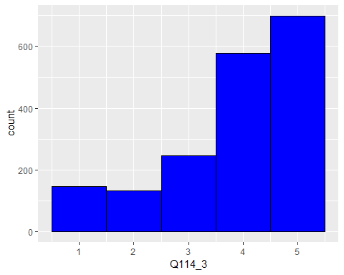

#$Q116.1  
#""   
#"Did the gate agent thank you for flying AirlineX?"   
#"I don't remember"   
#"No"   
#"Yes"   
  
GuestData$Q116.1<-revalue(GuestData$Q116.1, c("Yes"="1", "I don't remember" = "2", "No"="3"))  
GuestData$Q116.1<-as.numeric(as.character(GuestData$Q116.1))

## Warning: NAs introduced by coercion

ggplot(GuestData, aes(x=Q116.1)) +  
 geom_histogram(binwidth=1, colour="black", fill="blue")

## Warning: Removed 6200 rows containing non-finite values (stat_bin).

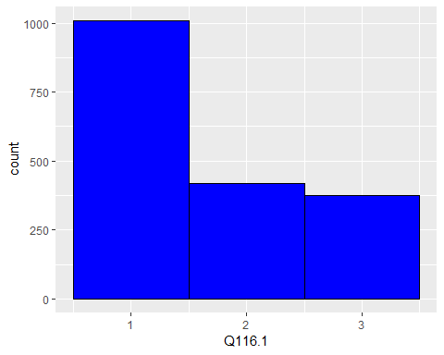

#$Q137  
#""   
#"Did you experience any issues during the boarding process?"   
#"No"

Yes’

GuestData$Q137<-revalue(GuestData$Q137, c("Yes"="1", "No"="0"))  
GuestData$Q137<-as.numeric(as.character(GuestData$Q137))

## Warning: NAs introduced by coercion

ggplot(GuestData, aes(x=Q137)) +  
 geom_histogram(binwidth=1, colour="black", fill="blue")

## Warning: Removed 6202 rows containing non-finite values (stat_bin).

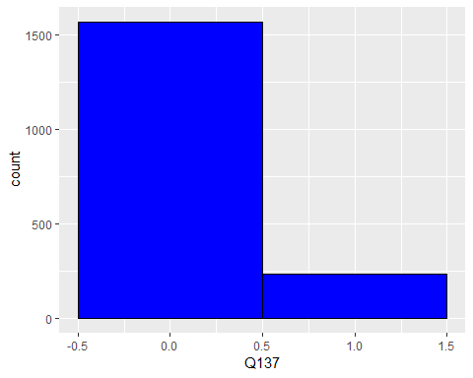

#$Q120  
#""   
#"Extremely dissatisfied"   
#"Extremely satisfied"   
#"How satisfied were you with your arrival experience?"  
#"Neither satisfied nor dissatisfied"   
#"Somewhat dissatisfied"   
#"Somewhat satisfied"   
  
GuestData$Q120<-revalue(GuestData$Q120, c("Extremely dissatisfied" = "1", "Somewhat dissatisfied" = "2", "Neither satisfied nor dissatisfied" = "3", "Somewhat satisfied" = "4", "Extremely satisfied" = "5"))  
GuestData$Q120<-as.numeric(as.character(GuestData$Q120))

## Warning: NAs introduced by coercion

ggplot(GuestData, aes(x=Q120)) +  
 geom_histogram(binwidth=1, colour="black", fill="blue")

## Warning: Removed 6138 rows containing non-finite values (stat_bin).

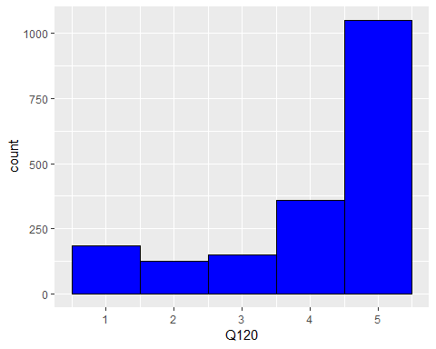

#$Q35  
#""   
#"Did you interact with\na gate agent after deplaning?"   
#"No"   
#"Yes"   
  
GuestData$Q35<-revalue(GuestData$Q35, c("Yes"="1", "No"="0"))  
GuestData$Q35<-as.numeric(as.character(GuestData$Q35))

## Warning: NAs introduced by coercion

ggplot(GuestData, aes(x=Q35)) +  
 geom_histogram(binwidth=1, colour="black", fill="blue")

## Warning: Removed 6141 rows containing non-finite values (stat_bin).

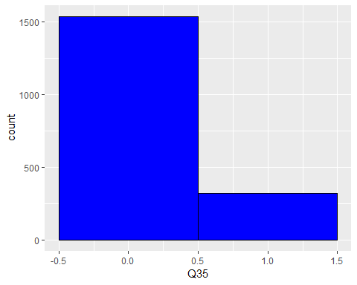

#$Q37_1  
#""   
#"Neither agree nor disagree"   
#"Somewhat agree"   
#"Somewhat disagree"   
#"Strongly agree"   
#"Strongly disagree"   
#"The customer service\nagent at your arrival gate was... - Available"  
  
GuestData$Q37_1<-revalue(GuestData$Q37_1, c("Strongly disagree"="1", "Somewhat disagree"="2", "Neither agree nor disagree" = "3", "Somewhat agree" = "4", "Strongly agree" = "5"))  
GuestData$Q37_1<-as.numeric(as.character(GuestData$Q37_1))

## Warning: NAs introduced by coercion

ggplot(GuestData, aes(x=Q37_1)) +  
 geom_histogram(binwidth=1, colour="black", fill="blue")

## Warning: Removed 7691 rows containing non-finite values (stat_bin).

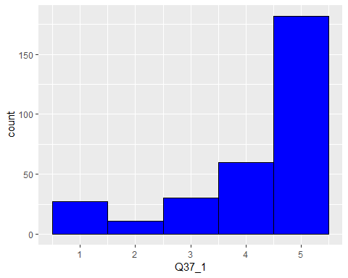

#$Q37_2  
#""   
#"Neither agree nor disagree"   
#"Somewhat agree"   
#"Somewhat disagree"   
#"Strongly agree"   
#"Strongly disagree"   
#"The customer service\nagent at your arrival gate was... - Professional"  
  
GuestData$Q37_2<-revalue(GuestData$Q37_2, c("Strongly disagree"="1", "Somewhat disagree"="2", "Neither agree nor disagree" = "3", "Somewhat agree" = "4", "Strongly agree" = "5"))  
GuestData$Q37_2<-as.numeric(as.character(GuestData$Q37_2))

## Warning: NAs introduced by coercion

ggplot(GuestData, aes(x=Q37_2)) +  
 geom_histogram(binwidth=1, colour="black", fill="blue")

## Warning: Removed 7698 rows containing non-finite values (stat_bin).

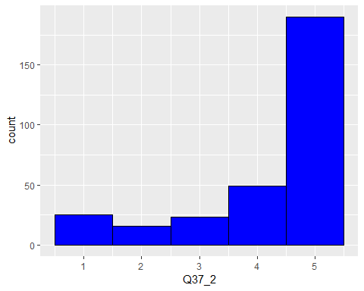

#$Q37_3  
#""   
#"Neither agree nor disagree"   
#"Somewhat agree"   
#"Somewhat disagree"   
#"Strongly agree"   
#"Strongly disagree"   
#"The customer service\nagent at your arrival gate was... - Friendly"  
  
GuestData$Q37_3<-revalue(GuestData$Q37_3, c("Strongly disagree"="1", "Somewhat disagree"="2", "Neither agree nor disagree" = "3", "Somewhat agree" = "4", "Strongly agree" = "5"))  
GuestData$Q37_3<-as.numeric(as.character(GuestData$Q37_3))

## Warning: NAs introduced by coercion

ggplot(GuestData, aes(x=Q37_3)) +  
 geom_histogram(binwidth=1, colour="black", fill="blue")

## Warning: Removed 7696 rows containing non-finite values (stat_bin).

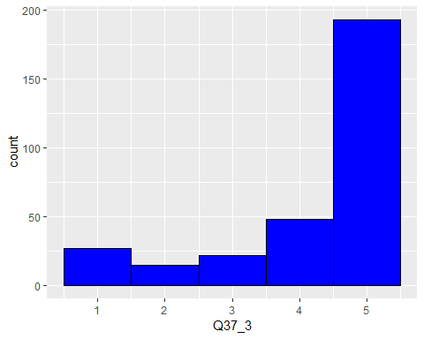

#$Q37_4  
#""   
#"Neither agree nor disagree"   
#"Somewhat agree"   
#"Somewhat disagree"   
#"Strongly agree"   
#"Strongly disagree"   
#"The customer service\nagent at your arrival gate was... - Attentive"  
  
GuestData$Q37_4<-revalue(GuestData$Q37_4, c("Strongly disagree"="1", "Somewhat disagree"="2", "Neither agree nor disagree" = "3", "Somewhat agree" = "4", "Strongly agree" = "5"))  
GuestData$Q37_4<-as.numeric(as.character(GuestData$Q37_4))

## Warning: NAs introduced by coercion

ggplot(GuestData, aes(x=Q37_4)) +  
 geom_histogram(binwidth=1, colour="black", fill="blue")

## Warning: Removed 7701 rows containing non-finite values (stat_bin).

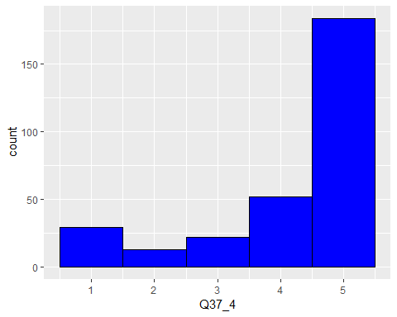

#$Q37_5  
#""   
#"Neither agree nor disagree"   
#"Somewhat agree"   
#"Somewhat disagree"   
#"Strongly agree"   
#"Strongly disagree"   
#"The customer service\nagent at your arrival gate was... - Helpful"  
  
GuestData$Q37_5<-revalue(GuestData$Q37_5, c("Strongly disagree"="1", "Somewhat disagree"="2", "Neither agree nor disagree" = "3", "Somewhat agree" = "4", "Strongly agree" = "5"))  
GuestData$Q37_5<-as.numeric(as.character(GuestData$Q37_5))

## Warning: NAs introduced by coercion

ggplot(GuestData, aes(x=Q37_5)) +  
 geom_histogram(binwidth=1, colour="black", fill="blue")

## Warning: Removed 7701 rows containing non-finite values (stat_bin).

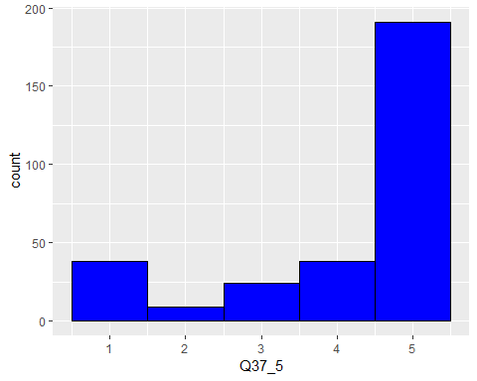

#$Q111  
#""   
#"Did you gate-check a stroller or wheelchair?"   
#"No"   
#"Yes"   
  
GuestData$Q111<-revalue(GuestData$Q111, c("Yes"="1", "No"="0"))  
GuestData$Q111<-as.numeric(as.character(GuestData$Q111))

## Warning: NAs introduced by coercion

ggplot(GuestData, aes(x=Q111)) +  
 geom_histogram(binwidth=1, colour="black", fill="blue")

## Warning: Removed 6143 rows containing non-finite values (stat_bin).

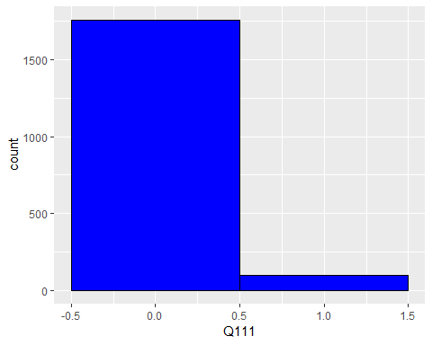

# $Q112.1  
# ""   
# "How quickly was your gate-checked stroller or wheelchair returned to you upon arrival to your destination?"  
# "Neither quickly nor slowly"   
# "Quickly"   
# "Slowly"   
# "Very quickly"   
# "Very slowly"   
  
GuestData$Q112.1<-revalue(GuestData$Q112.1, c("Very slowly"="1", "Slowly" = "2", "Neither quickly nor slowly"="3", "Quickly" = "4", "Very quickly"="5"))  
GuestData$Q112.1<-as.numeric(as.character(GuestData$Q112.1))

## Warning: NAs introduced by coercion

ggplot(GuestData, aes(x=Q112.1)) +  
 geom_histogram(binwidth=1, colour="black", fill="blue")

## Warning: Removed 7901 rows containing non-finite values (stat_bin).

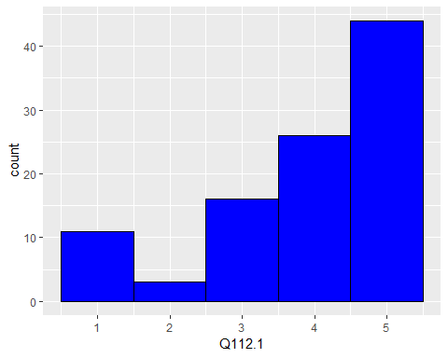

# $Q8  
# ""   
# "Clean"   
# "Dirty"   
# "Filthy"   
# "How\nclean was the aircraft cabin upon boarding?"   
# "Somewhat between clean and dirty"   
# "Spotless"   
  
GuestData$Q8<-revalue(GuestData$Q8, c("Spotless"="1", "Clean" = "2", "Somewhat between clean and dirty"="3", "Dirty" = "4", "Filthy"="5"))  
GuestData$Q8<-as.numeric(as.character(GuestData$Q8))

## Warning: NAs introduced by coercion

ggplot(GuestData, aes(x=Q8)) +  
 geom_histogram(binwidth=1, colour="black", fill="blue")

## Warning: Removed 7240 rows containing non-finite values (stat_bin).

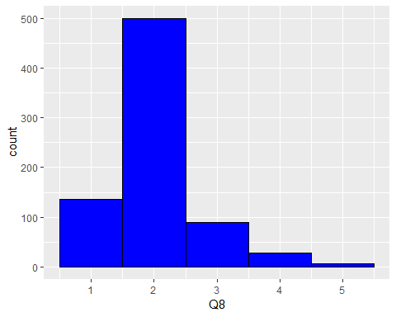

# $Q9  
# ""   
# "Chilly"   
# "Extremely Cold"   
# "Extremely Hot"   
# "How\nwas the cabin temperature on the aircraft?"   
# "Perfect"   
# "Warm"   
  
GuestData$Q9<-revalue(GuestData$Q9, c("Extremely Cold"="1", "Chilly" = "2", "Perfect"="3", "Warm" = "4", "Extremely Hot"="5"))  
GuestData$Q9<-as.numeric(as.character(GuestData$Q9))

## Warning: NAs introduced by coercion

ggplot(GuestData, aes(x=Q9)) +  
 geom_histogram(binwidth=1, colour="black", fill="blue")

## Warning: Removed 7242 rows containing non-finite values (stat_bin).

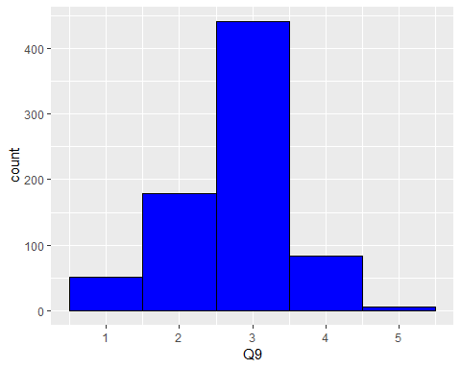

# $Q11  
# ""   
# "Extremely comfortable"   
# "Extremely uncomfortable"   
# "How comfortable were the\nseats?"   
# "Neither comfortable nor uncomfortable"  
# "Somewhat comfortable"   
# "Somewhat uncomfortable"   
  
GuestData$Q11<-revalue(GuestData$Q11, c("Extremely uncomfortable" ="1", "Somewhat uncomfortable" = "2", "Neither comfortable nor uncomfortable"="3",   
 "Somewhat comfortable" = "4", "Extremely comfortable"="5"))  
  
GuestData$Q11<-as.numeric(as.character(GuestData$Q11))

## Warning: NAs introduced by coercion

ggplot(GuestData, aes(x=Q11)) +  
 geom_histogram(binwidth=1, colour="black", fill="blue")

## Warning: Removed 7241 rows containing non-finite values (stat_bin).

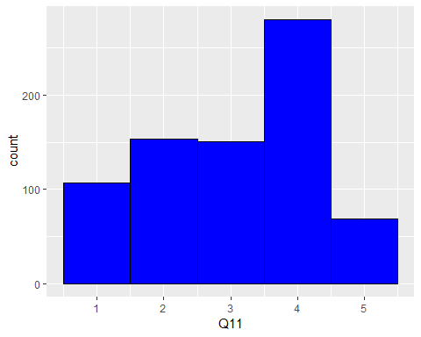

# $Q107  
# ""   
# "Did you use the onboard lavatory?"   
# "No"   
# "Yes"   
  
GuestData$Q107<-revalue(GuestData$Q107, c("Yes"="1", "No"="0"))  
GuestData$Q107<-as.numeric(as.character(GuestData$Q107))

## Warning: NAs introduced by coercion

ggplot(GuestData, aes(x=Q107)) +  
 geom_histogram(binwidth=1, colour="black", fill="blue")

## Warning: Removed 7240 rows containing non-finite values (stat_bin).

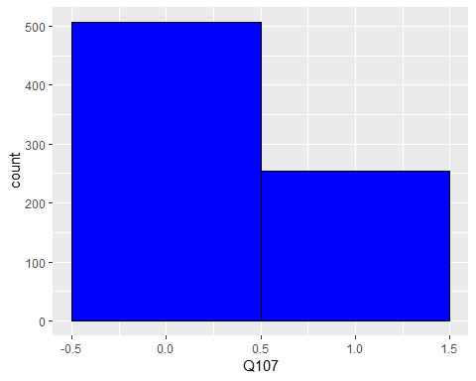

# $Q105  
# ""   
# "Clean"   
# "Dirty"   
# "Filthy"   
# "How clean was the lavatory onboard your flight?"   
# "Somewhat between clean and dirty"   
# "Spotless"   
  
GuestData$Q105<-revalue(GuestData$Q105, c("Spotless"="1", "Clean" = "2", "Somewhat between clean and dirty"="3", "Dirty" = "4", "Filthy"="5"))  
GuestData$Q105<-as.numeric(as.character(GuestData$Q105))

## Warning: NAs introduced by coercion

ggplot(GuestData, aes(x=Q105)) +  
 geom_histogram(binwidth=1, colour="black", fill="blue")

## Warning: Removed 7747 rows containing non-finite values (stat_bin).

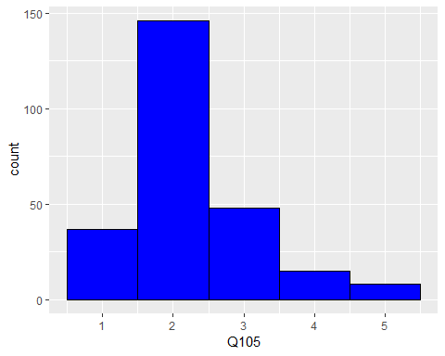

# $Q40  
# ""   
# "Extremely dissatisfied"   
# "Extremely satisfied"   
# "Neither satisfied nor dissatisfied"   
# "Overall, how satisfied are you with AirlineX's onboard food and beverage experience?"   
# "Somewhat dissatisfied"   
# "Somewhat satisfied"   
  
GuestData$Q40<-revalue(GuestData$Q40, c("Extremely dissatisfied" = "1", "Somewhat dissatisfied" = "2", "Neither satisfied nor dissatisfied" = "3", "Somewhat satisfied" = "4", "Extremely satisfied" = "5"))  
GuestData$Q40<-as.numeric(as.character(GuestData$Q40))

## Warning: NAs introduced by coercion

ggplot(GuestData, aes(x=Q40)) +  
 geom_histogram(binwidth=1, colour="black", fill="blue")

## Warning: Removed 7273 rows containing non-finite values (stat_bin).

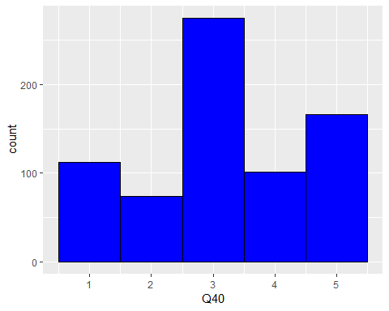

# $Q15  
# ""   
# "Did you make a food or beverage purchase onboard during this flight?"   
# "No"   
# "Yes"   
  
GuestData$Q15<-revalue(GuestData$Q15, c("Yes"="1", "No"="0"))  
GuestData$Q15<-as.numeric(as.character(GuestData$Q15))

## Warning: NAs introduced by coercion

ggplot(GuestData, aes(x=Q15)) +  
 geom_histogram(binwidth=1, colour="black", fill="blue")

## Warning: Removed 7274 rows containing non-finite values (stat_bin).

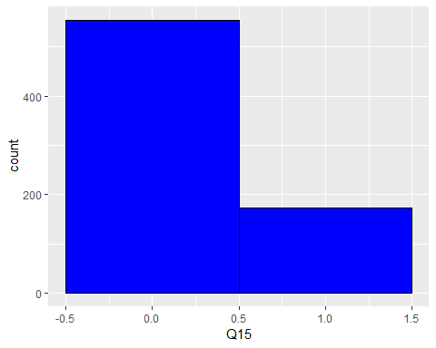

# $Q3  
# ""   
# "Extremely dissatisfied"   
# "Extremely satisfied"   
# "How satisfied were you with your in-flight experience?"   
# "Neither satisfied nor dissatisfied"   
# "Somewhat dissatisfied"   
# "Somewhat satisfied"  
  
GuestData$Q3<-revalue(GuestData$Q3, c("Extremely dissatisfied" = "1", "Somewhat dissatisfied" = "2", "Neither satisfied nor dissatisfied" = "3", "Somewhat satisfied" = "4", "Extremely satisfied" = "5"))  
GuestData$Q3<-as.numeric(as.character(GuestData$Q3))

## Warning: NAs introduced by coercion

ggplot(GuestData, aes(x=Q3)) +  
 geom_histogram(binwidth=1, colour="black", fill="blue")

## Warning: Removed 7241 rows containing non-finite values (stat_bin).

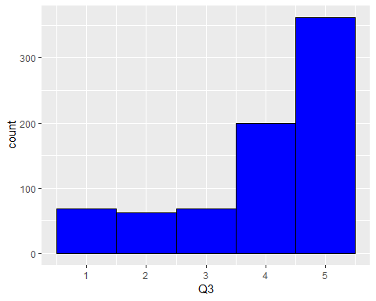

# $Q5  
# ""   
# "I don't remember"   
# "No"   
# "Were you greeted by the\nflight attendants as you boarded the aircraft?"   
# "Yes"   
  
GuestData$Q5<-revalue(GuestData$Q5, c("Yes"="1", "I don't remember" = "2", "No"="3"))  
GuestData$Q5<-as.numeric(as.character(GuestData$Q5))

## Warning: NAs introduced by coercion

ggplot(GuestData, aes(x=Q5)) +  
 geom_histogram(binwidth=1, colour="black", fill="blue")

## Warning: Removed 7243 rows containing non-finite values (stat_bin).

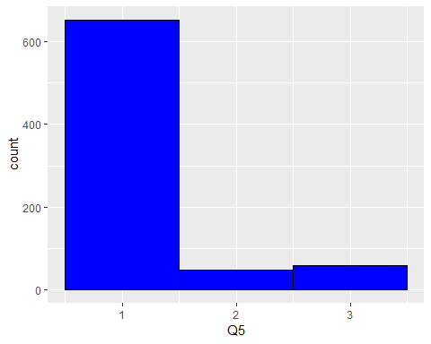

# $Q6_1  
# ""   
# "Neither agree nor disagree"   
# "Please\nrate the following statements: \n\n\nThe flight attendants on your flight from [Field-Journey%20Origin%20Name] to\n[Field-Journey%20Destination%20Name] were... - Attentive"  
# "Somewhat agree"   
# "Somewhat disagree"   
# "Strongly agree"   
# "Strongly disagree"   
  
GuestData$Q6_1<-revalue(GuestData$Q6_1, c("Strongly disagree"="1", "Somewhat disagree"="2", "Neither agree nor disagree" = "3", "Somewhat agree" = "4", "Strongly agree" = "5"))  
GuestData$Q6_1<-as.numeric(as.character(GuestData$Q6_1))

## Warning: NAs introduced by coercion

ggplot(GuestData, aes(x=Q6_1)) +  
 geom_histogram(binwidth=1, colour="black", fill="blue")

## Warning: Removed 7249 rows containing non-finite values (stat_bin).

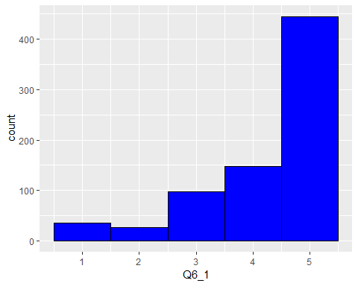

# $Q6_2  
# ""   
# "Neither agree nor disagree"   
# "Please\nrate the following statements: \n\n\nThe flight attendants on your flight from [Field-Journey%20Origin%20Name] to\n[Field-Journey%20Destination%20Name] were... - Professional"  
# "Somewhat agree"   
# "Somewhat disagree"   
# "Strongly agree"   
# "Strongly disagree"   
  
GuestData$Q6_2<-revalue(GuestData$Q6_2, c("Strongly disagree"="1", "Somewhat disagree"="2", "Neither agree nor disagree" = "3", "Somewhat agree" = "4", "Strongly agree" = "5"))  
GuestData$Q6_2<-as.numeric(as.character(GuestData$Q6_2))

## Warning: NAs introduced by coercion

ggplot(GuestData, aes(x=Q6_2)) +  
 geom_histogram(binwidth=1, colour="black", fill="blue")

## Warning: Removed 7268 rows containing non-finite values (stat_bin).

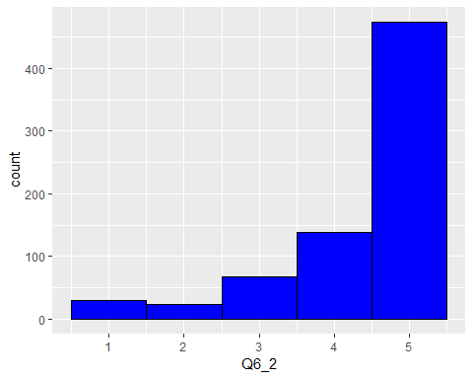

# $Q6_3  
# ""   
# "Neither agree nor disagree"   
# "Please\nrate the following statements: \n\n\nThe flight attendants on your flight from [Field-Journey%20Origin%20Name] to\n[Field-Journey%20Destination%20Name] were... - Fun"  
# "Somewhat agree"   
# "Somewhat disagree"   
# "Strongly agree"   
# "Strongly disagree"   
  
GuestData$Q6_3<-revalue(GuestData$Q6_3, c("Strongly disagree"="1", "Somewhat disagree"="2", "Neither agree nor disagree" = "3", "Somewhat agree" = "4", "Strongly agree" = "5"))  
GuestData$Q6_3<-as.numeric(as.character(GuestData$Q6_3))

## Warning: NAs introduced by coercion

ggplot(GuestData, aes(x=Q6_3)) +  
 geom_histogram(binwidth=1, colour="black", fill="blue")

## Warning: Removed 7265 rows containing non-finite values (stat_bin).

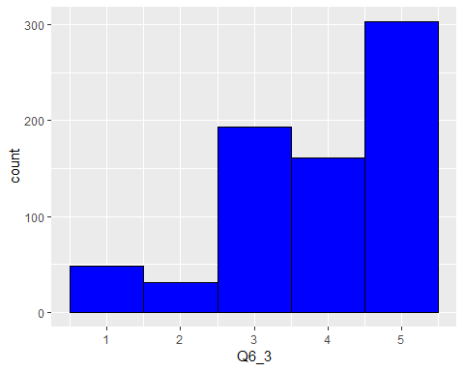

# $Q6_4  
# ""   
# "Neither agree nor disagree"   
# "Please\nrate the following statements: \n\n\nThe flight attendants on your flight from [Field-Journey%20Origin%20Name] to\n[Field-Journey%20Destination%20Name] were... - Friendly"  
# "Somewhat agree"   
# "Somewhat disagree"   
# "Strongly agree"   
# "Strongly disagree"   
  
GuestData$Q6_4<-revalue(GuestData$Q6_4, c("Strongly disagree"="1", "Somewhat disagree"="2", "Neither agree nor disagree" = "3", "Somewhat agree" = "4", "Strongly agree" = "5"))  
GuestData$Q6_4<-as.numeric(as.character(GuestData$Q6_4))

## Warning: NAs introduced by coercion

ggplot(GuestData, aes(x=Q6_4)) +  
 geom_histogram(binwidth=1, colour="black", fill="blue")

## Warning: Removed 7268 rows containing non-finite values (stat_bin).

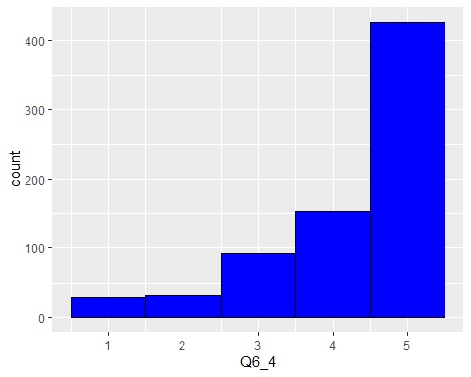

# $Q7  
# ""   
# "Extremely well"   
# "How well were you kept\nup-to-date with information updates from the pilots and flight attendants?"   
# "Moderately well"   
# "Not well at all"   
# "Slightly well"   
# "Very well"   
  
GuestData$Q7<-revalue(GuestData$Q7, c("Not well at all" ="1", "Slightly well"="2", "Moderately well"="3", "Very well" ="4", "Extremely well" ="5"))  
GuestData$Q7<-as.numeric(as.character(GuestData$Q7))

## Warning: NAs introduced by coercion

ggplot(GuestData, aes(x=Q7)) +  
 geom_histogram(binwidth=1, colour="black", fill="blue")

## Warning: Removed 7245 rows containing non-finite values (stat_bin).

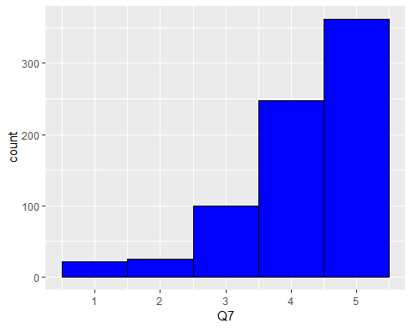

# $Q60  
# ""   
# "Did\nthe flight crew thank you for flying AirlineX as you deplaned?"   
# "No"   
# "Yes"   
  
GuestData$Q60<-revalue(GuestData$Q60, c("Yes"="1", "No"="0"))  
GuestData$Q60<-as.numeric(as.character(GuestData$Q60))

## Warning: NAs introduced by coercion

ggplot(GuestData, aes(x=Q60)) +  
 geom_histogram(binwidth=1, colour="black", fill="blue")

## Warning: Removed 7245 rows containing non-finite values (stat_bin).

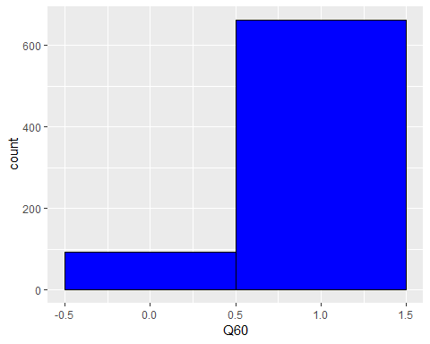

# $Q114  
# ""   
# "Extremely dissatisfied"   
# "Extremely satisfied"   
# "How satisfied were you with your baggage claim experience?"   
# "Neither satisfied nor dissatisfied"   
# "Somewhat dissatisfied"   
# "Somewhat satisfied"   
  
GuestData$Q114<-revalue(GuestData$Q114, c("Extremely dissatisfied" = "1", "Somewhat dissatisfied" = "2", "Neither satisfied nor dissatisfied" = "3", "Somewhat satisfied" = "4", "Extremely satisfied" = "5"))  
GuestData$Q114<-as.numeric(as.character(GuestData$Q114))

## Warning: NAs introduced by coercion

ggplot(GuestData, aes(x=Q114)) +  
 geom_histogram(binwidth=1, colour="black", fill="blue")

## Warning: Removed 6341 rows containing non-finite values (stat_bin).

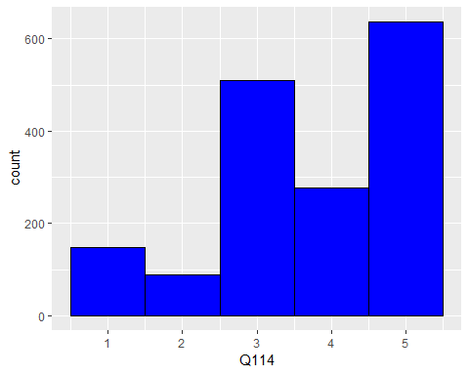

# $Q108.1  
# ""   
# "Extremely difficult"   
# "Extremely easy"   
# "How easy was it to obtain baggage claim information?"  
# "Neither easy nor difficult"   
# "Somewhat difficult"   
# "Somewhat easy"   
  
GuestData$Q108.1<-revalue(GuestData$Q108.1, c("Extremely difficult"="1", "Somewhat difficult"="2", "Neither easy nor difficult"="3",   
 "Somewhat easy"="4", "Extremely easy"="5"))  
GuestData$Q108.1<-as.numeric(as.character(GuestData$Q108.1))

## Warning: NAs introduced by coercion

ggplot(GuestData, aes(x=Q108.1)) +  
 geom_histogram(binwidth=1, colour="black", fill="blue")

## Warning: Removed 6444 rows containing non-finite values (stat_bin).

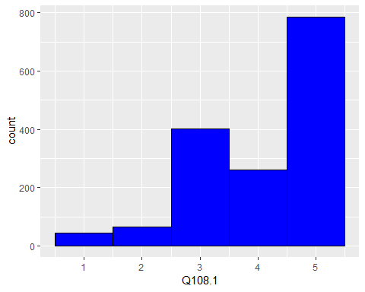

# $Q48  
# ""   
# "How long was the wait\nto retrieve your checked baggage?"   
# "Long"   
# "Normal"   
# "Short"   
# "Very long"   
# "Very short"   
  
GuestData$Q48<-revalue(GuestData$Q48, c("Very short"="1", "Short"="2", "Normal"="3", "Long"="4", "Very long"="5"))  
GuestData$Q48<-as.numeric(as.character(GuestData$Q48))

## Warning: NAs introduced by coercion

ggplot(GuestData, aes(x=Q48)) +  
 geom_histogram(binwidth=1, colour="black", fill="blue")

## Warning: Removed 6627 rows containing non-finite values (stat_bin).

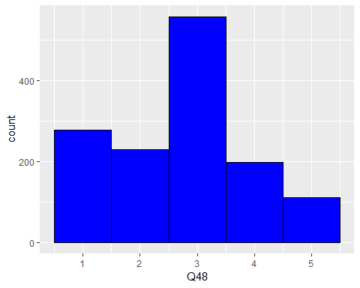

# $Q54_1  
# ""   
# "Neither agree nor disagree"   
# "Somewhat agree"   
# "Somewhat disagree"   
# "Strongly agree"   
# "Strongly disagree"   
# "The customer service agent\nyou spoke with was: - Available"  
  
GuestData$Q54_1<-revalue(GuestData$Q54_1, c("Strongly disagree"="1", "Somewhat disagree"="2", "Neither agree nor disagree" = "3", "Somewhat agree" = "4", "Strongly agree" = "5"))  
GuestData$Q54_1<-as.numeric(as.character(GuestData$Q54_1))

## Warning: NAs introduced by coercion

ggplot(GuestData, aes(x=Q54_1)) +  
 geom_histogram(binwidth=1, colour="black", fill="blue")

## Warning: Removed 6927 rows containing non-finite values (stat_bin).

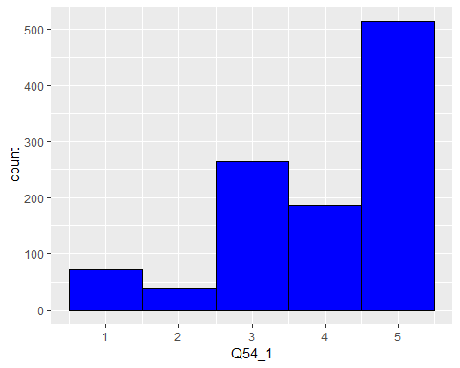

# $Q54_2  
# ""   
# "Neither agree nor disagree"   
# "Somewhat agree"   
# "Somewhat disagree"   
# "Strongly agree"   
# "Strongly disagree"   
# "The customer service agent\nyou spoke with was: - Attentive"  
  
GuestData$Q54_2<-revalue(GuestData$Q54_2, c("Strongly disagree"="1", "Somewhat disagree"="2", "Neither agree nor disagree" = "3", "Somewhat agree" = "4", "Strongly agree" = "5"))  
GuestData$Q54_2<-as.numeric(as.character(GuestData$Q54_2))

## Warning: NAs introduced by coercion

ggplot(GuestData, aes(x=Q54_2)) +  
 geom_histogram(binwidth=1, colour="black", fill="blue")

## Warning: Removed 6969 rows containing non-finite values (stat_bin).

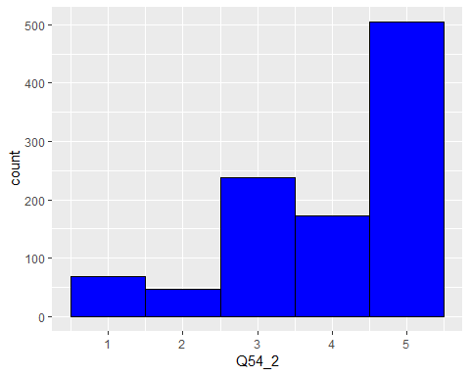

# $Q54_3  
# ""   
# "Neither agree nor disagree"   
# "Somewhat agree"   
# "Somewhat disagree"   
# "Strongly agree"   
# "Strongly disagree"   
# "The customer service agent\nyou spoke with was: - Professional"  
  
GuestData$Q54_3<-revalue(GuestData$Q54_3, c("Strongly disagree"="1", "Somewhat disagree"="2", "Neither agree nor disagree" = "3", "Somewhat agree" = "4", "Strongly agree" = "5"))  
GuestData$Q54_3<-as.numeric(as.character(GuestData$Q54_3))

## Warning: NAs introduced by coercion

ggplot(GuestData, aes(x=Q54_3)) +  
 geom_histogram(binwidth=1, colour="black", fill="blue")

## Warning: Removed 6951 rows containing non-finite values (stat_bin).

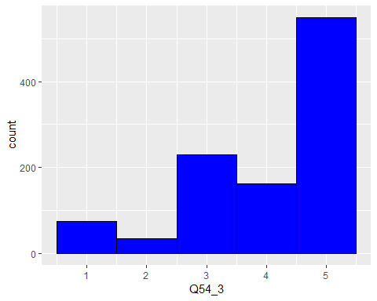

# $Q54_4  
# ""   
# "Neither agree nor disagree"   
# "Somewhat agree"   
# "Somewhat disagree"   
# "Strongly agree"   
# "Strongly disagree"   
# "The customer service agent\nyou spoke with was: - Friendly"  
  
GuestData$Q54_4<-revalue(GuestData$Q54_4, c("Strongly disagree"="1", "Somewhat disagree"="2", "Neither agree nor disagree" = "3", "Somewhat agree" = "4", "Strongly agree" = "5"))  
GuestData$Q54_4<-as.numeric(as.character(GuestData$Q54_4))

## Warning: NAs introduced by coercion

ggplot(GuestData, aes(x=Q54_4)) +  
 geom_histogram(binwidth=1, colour="black", fill="blue")

## Warning: Removed 6954 rows containing non-finite values (stat_bin).

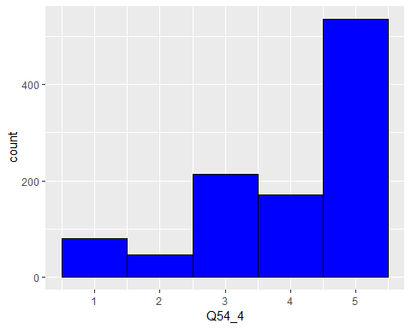

# $Q54_5  
# ""   
# "Neither agree nor disagree"   
# "Somewhat agree"   
# "Somewhat disagree"   
# "Strongly agree"   
# "Strongly disagree"   
# "The customer service agent\nyou spoke with was: - Helpful"  
  
GuestData$Q54_5<-revalue(GuestData$Q54_5, c("Strongly disagree"="1", "Somewhat disagree"="2", "Neither agree nor disagree" = "3", "Somewhat agree" = "4", "Strongly agree" = "5"))  
GuestData$Q54_5<-as.numeric(as.character(GuestData$Q54_5))

## Warning: NAs introduced by coercion

ggplot(GuestData, aes(x=Q54_5)) +  
 geom_histogram(binwidth=1, colour="black", fill="blue")

## Warning: Removed 6961 rows containing non-finite values (stat_bin).

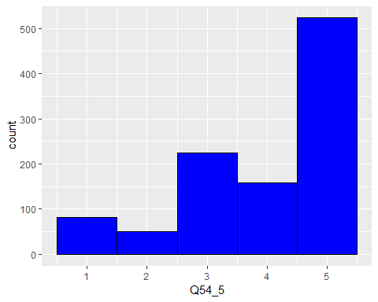

# $Q127  
# ""   
# "Do you plan on flying with AirlineX within the next year?"   
# "No"   
# "Yes"   
  
GuestData$Q127<-revalue(GuestData$Q127, c("Yes"="1", "No"="0"))  
GuestData$Q127<-as.numeric(as.character(GuestData$Q127))

## Warning: NAs introduced by coercion

ggplot(GuestData, aes(x=Q127)) +  
 geom_histogram(binwidth=1, colour="black", fill="blue")

## Warning: Removed 123 rows containing non-finite values (stat_bin).

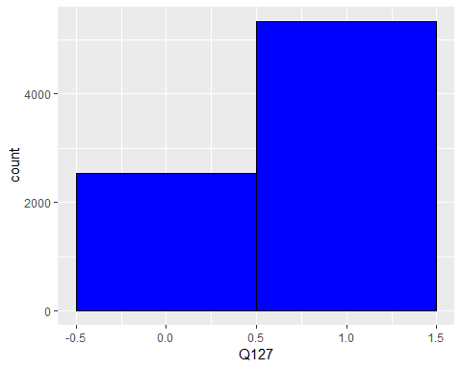

# $Q100.1  
# ""   
# "Did any of our team members help make your experience on AirlineX Airlines a positive one?"  
# "No"   
# "Yes"   
  
GuestData$Q100.1<-revalue(GuestData$Q100.1, c("Yes"="1", "No"="0"))  
GuestData$Q100.1<-as.numeric(as.character(GuestData$Q100.1))

## Warning: NAs introduced by coercion

ggplot(GuestData, aes(x=Q100.1)) +  
 geom_histogram(binwidth=1, colour="black", fill="blue")

## Warning: Removed 181 rows containing non-finite values (stat_bin).

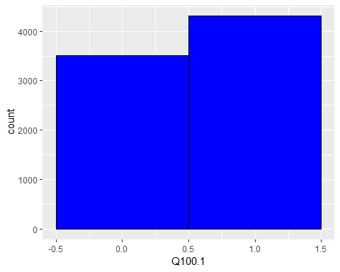

GuestData1<-GuestData  
# colnames(GuestData1) <- as.character(unlist(GuestData1[1,]))  
# GuestData1 = GuestData1[-1, ]  
  
GuestData1[ GuestData1 == "Pax per PNR" ] <- NA  
GuestData1[ GuestData1 == "Including your flight on [Field-Flight%20Date], how many flights have you taken in the past twelve months?" ] <- NA  
  
# names(GuestData1)  
  
GuestData1$Q116<-NULL   
GuestData1$Q119<-NULL   
GuestData1$Q109<-NULL   
GuestData1$Q112<-NULL   
GuestData1$Q118<-NULL   
GuestData1$Q117<-NULL   
GuestData1$Q113<-NULL   
GuestData1$Q12<-NULL   
GuestData1$Q106<-NULL   
GuestData1$Q18<-NULL   
GuestData1$Q20<-NULL   
GuestData1$Q22<-NULL   
GuestData1$Q24<-NULL   
GuestData1$Q28_1<-NULL   
GuestData1$Q34<-NULL   
GuestData1$Q36_1<-NULL   
GuestData1$Q36_2<-NULL   
GuestData1$Q107.1<-NULL   
GuestData1$Q50<-NULL   
GuestData1$Q52<-NULL   
GuestData1$Q145<-NULL   
GuestData1$Booking.Channel<-NULL   
GuestData1$Flight.Date.Time<-NULL   
GuestData1$Segment1.Destination<-NULL   
GuestData1$Segment1.Origin<-NULL   
  
GuestData1 = as.data.frame(sapply(GuestData1, as.numeric))

# Random Forest Model

# install.packages("sfsmisc")  
# install.packages("tibble")  
# install.packages("rsample")  
# install.packages("randomForest")  
# install.packages("ranger")  
# install.packages("caret")  
# install.packages("h2o")  
# install.packages("AmesHousing")  
  
library(sfsmisc)

## Warning: package 'sfsmisc' was built under R version 3.5.3

##   
## Attaching package: 'sfsmisc'

## The following object is masked from 'package:dplyr':  
##   
## last

library(tibble)  
library(rsample)

## Warning: package 'rsample' was built under R version 3.5.3

## Loading required package: tidyr

library(randomForest)

## Warning: package 'randomForest' was built under R version 3.5.3

## randomForest 4.6-14

## Type rfNews() to see new features/changes/bug fixes.

##   
## Attaching package: 'randomForest'

## The following object is masked from 'package:ggplot2':  
##   
## margin

## The following object is masked from 'package:dplyr':  
##   
## combine

library(ranger)

## Warning: package 'ranger' was built under R version 3.5.3

##   
## Attaching package: 'ranger'

## The following object is masked from 'package:randomForest':  
##   
## importance

library(caret)

## Warning: package 'caret' was built under R version 3.5.3

## Loading required package: lattice

library(h2o)

## Warning: package 'h2o' was built under R version 3.5.3

##   
## ----------------------------------------------------------------------  
##   
## Your next step is to start H2O:  
## > h2o.init()  
##   
## For H2O package documentation, ask for help:  
## > ??h2o  
##   
## After starting H2O, you can use the Web UI at http://localhost:54321  
## For more information visit http://docs.h2o.ai  
##   
## ----------------------------------------------------------------------

##   
## Attaching package: 'h2o'

## The following objects are masked from 'package:stats':  
##   
## cor, sd, var

## The following objects are masked from 'package:base':  
##   
## %*%, %in%, &&, ||, apply, as.factor, as.numeric, colnames,  
## colnames<-, ifelse, is.character, is.factor, is.numeric, log,  
## log10, log1p, log2, round, signif, trunc

library(AmesHousing)

## Warning: package 'AmesHousing' was built under R version 3.5.3

set.seed(123)  
  
# Treating missing values  
  
GuestData1<-GuestData1[, -which(colMeans(is.na(GuestData1)) > 0.77)]  
  
## 75% of the sample size  
smp_size <- floor(0.75 * nrow(GuestData1))  
  
## set the seed to make your partition reproducible  
set.seed(123)  
train_ind <- sample(seq_len(nrow(GuestData1)), size = smp_size)  
  
train <- GuestData1[train_ind, ]  
test <- GuestData1[-train_ind, ]  
  
# for reproducibility  
  
set.seed(123)  
  
train$Q1<-as.numeric(as.character(train$Q1))  
  
rf1<-randomForest(Q1 ~.,  
 data = train, ntree = 500,  
 mtry = 4, importance = TRUE, na.action = na.omit)  
  
print(rf1)

##   
## Call:  
## randomForest(formula = Q1 ~ ., data = train, ntree = 500, mtry = 4, importance = TRUE, na.action = na.omit)   
## Type of random forest: regression  
## Number of trees: 500  
## No. of variables tried at each split: 4  
##   
## Mean of squared residuals: 4.279212  
## % Var explained: 64.93

varImpPlot(rf1)

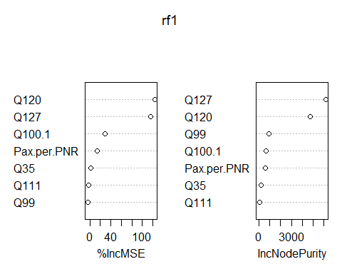

rf2<-randomForest(Q1 ~ Q127 + Q120,  
 data = train, ntree = 500,  
 mtry = 2, importance = TRUE, na.action = na.omit)  
  
print(rf2)

##   
## Call:  
## randomForest(formula = Q1 ~ Q127 + Q120, data = train, ntree = 500, mtry = 2, importance = TRUE, na.action = na.omit)   
## Type of random forest: regression  
## Number of trees: 500  
## No. of variables tried at each split: 2  
##   
## Mean of squared residuals: 3.926502  
## % Var explained: 67.68

test$pred_randomForest<-predict(rf2, test)  
  
simple.fit = lm(pred_randomForest~Q1, data = test)  
summary(simple.fit)

##   
## Call:  
## lm(formula = pred_randomForest ~ Q1, data = test)  
##   
## Residuals:  
## Min 1Q Median 3Q Max   
## -5.7046 -1.0413 0.1379 0.8406 7.1647   
##   
## Coefficients:  
## Estimate Std. Error t value Pr(>|t|)   
## (Intercept) 2.03210 0.16541 12.29 <2e-16 ***  
## Q1 0.70268 0.02181 32.23 <2e-16 ***  
## ---  
## Signif. codes: 0 '***' 0.001 '**' 0.01 '*' 0.05 '.' 0.1 ' ' 1  
##   
## Residual standard error: 1.66 on 466 degrees of freedom  
## (1533 observations deleted due to missingness)  
## Multiple R-squared: 0.6903, Adjusted R-squared: 0.6896   
## F-statistic: 1038 on 1 and 466 DF, p-value: < 2.2e-16

scatter.smooth(x=test$Q1, y=test$pred_randomForest, main = "pred_randomForest ~ Q1") # scatterplot

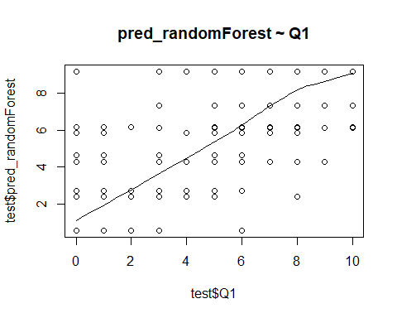

# Excel Test Data

# Business Problem:  
  
# The attached workbook contains guest survey data for aircraft cabin cleanliness ratings.  
# Each aircraft has a "tail number" that uniquely identifies the aircraft.  
# Every aircraft stays overnight at a particular airport where the cleaning operation takes place.  
# Every morning, each aircraft departs, flies to different airports serving many guests and again stays overnight at some airport at the end of the day.  
# Each guest's cleanliness rating shows the effectiveness of the cleaning operation at the overnight airport.  
# For simplicity, you can use a 0 to 5 scale to represent the cleanliness rating where 0 = filthy and 5 = spotless.  
  
# Questions to answer:  
# Which airports are the best at cleaning aircraft?  
# Do certain airports impact the aircraft cleanliness ratings more than others?  
# What other factors could drive the cleanliness ratings to be low?

Surveys<-read.csv(file = "C:/Users/puj83/OneDrive/CV/Cases/AirlineX/Surveys.csv", header = T, sep = ",")  
Tail_Number_Data<-read.csv(file = "C:/Users/puj83/OneDrive/CV/Cases/AirlineX/Tail_Number_Data.csv", header = T, sep = ",")  
Overnight_Station_Data<-read.csv(file = "C:/Users/puj83/OneDrive/CV/Cases/AirlineX/Overnight_Station_Data.csv", header = T, sep = ",")  
Airport_Delivery_Dates<-read.csv(file = "C:/Users/puj83/OneDrive/CV/Cases/AirlineX/Airport_Delivery_Dates.csv", header = T, sep = ",")  
  
names(Surveys)

## [1] "PNR" "Origin" "Destination"   
## [4] "Flight.Date.Time" "Survey.Date" "Cleanliness.Rating"

# [1] "PNR" "Origin" "Destination" "Flight.Date.Time" "Survey.Date" "Cleanliness.Rating"  
  
names(Tail_Number_Data)

## [1] "PNR" "Departure.Date" "Tail.Number"   
## [4] "Airport.Code.Deprt.." "Airport.Code.Arrvl.."

# [1] "PNR" "Departure.Date" "Tail.Number" "Airport.Code.Deprt.." "Airport.Code.Arrvl.."  
  
names(Overnight_Station_Data)

## [1] "Airport.Code.Deprt.." "Tail.Number" "Departure.Date"

# "Airport.Code.Deprt.." "Tail.Number" "Departure.Date"  
  
names(Airport_Delivery_Dates)

## [1] "Tail.Number" "Aircraft.Delivery.Date"

# [1] "Tail.Number" "Aircraft.Delivery.Date"  
  
Surveys$PNR<-as.character(Surveys$PNR)  
Tail_Number_Data$PNR<-as.character(Tail_Number_Data$PNR)  
  
dim(Surveys)

## [1] 9399 6

dim(Tail_Number_Data)

## [1] 8606 5

# Left outer join Tail_Number_Data so that the specified Tail Numbers would have a cabin cleanliness rating.  
  
Test<-left_join(Surveys, Tail_Number_Data, by = "PNR")  
dim(Test)

## [1] 9676 10

names(Test)

## [1] "PNR" "Origin" "Destination"   
## [4] "Flight.Date.Time" "Survey.Date" "Cleanliness.Rating"   
## [7] "Departure.Date" "Tail.Number" "Airport.Code.Deprt.."  
## [10] "Airport.Code.Arrvl.."

# Concatenate Tail.Number and Departure.Date in Overnight_Station_Data for a unique ID.  
# Concatenate Tail.Number and Departure.Date in Test so you can join Overnight_Station_Data on Test Data.  
  
Test$x <- paste(Test$Tail.Number, "-", Test$Departure.Date)  
Overnight_Station_Data$x <- paste(Overnight_Station_Data$Tail.Number, "-", Overnight_Station_Data$Departure.Date)  
  
Test$x<-as.character(Test$x)  
Overnight_Station_Data$x<-as.character(Overnight_Station_Data$x)  
  
#Get rid of Tail.Number, Departure.Date in Overnight_Station_Data to get rid of duplicate columns (when they join)  
#Change the name of "Airport.Code.Deprt.." to "Overnight_Airport"in Overnight_Station_Data  
  
Overnight_Station_Data$Tail.Number<-NULL  
Overnight_Station_Data$Departure.Date<-NULL  
colnames(Overnight_Station_Data)[colnames(Overnight_Station_Data)=="Airport.Code.Deprt.."] <- "Overnight_Airport"  
  
# Left outer join Overnight_Station_Data on Test to get Overnight_Aiport matched up with cleanliness rating in original Test Data.  
  
Test<-left_join(Test, Overnight_Station_Data, by = "x")  
  
# Left outer join Airport_Delivery_Dates on Test to get Aircraft Delivery Dates matched up with cleanliness rating in original Test Data.  
  
Test<-left_join(Test, Airport_Delivery_Dates, by = "Tail.Number")  
  
Test$Cleanliness.Rating<-as.factor(Test$Cleanliness.Rating)  
levels(Test$Cleanliness.Rating)

## [1] "Clean" "Dirty" "Filthy" "Somewhat Clean"  
## [5] "Somewhat Dirty" "Spotless"

# Convert cleanliness rating where 0 = filthy and 5 = spotless.  
  
Test$Cleanliness.Rating<-revalue(Test$Cleanliness.Rating, c("Filthy"="0", "Dirty"="1", "Somewhat Dirty"="2", "Somewhat Clean"="3", "Clean"="4", "Spotless"="5"))  
Test$Cleanliness.Rating<-as.numeric(as.character(Test$Cleanliness.Rating))  
  
# Plot histogram to for data exploration  
  
ggplot(Test, aes(x=Cleanliness.Rating)) +  
 geom_histogram(binwidth=1, colour="black", fill="blue")

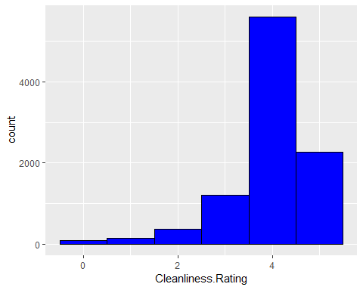

# Write to csv and do further analysis in PowerBI.  
  
# write.csv(Test, "C:/Users/puj83/OneDrive/CV/Cases/AirlineX/Test.csv")