Insurance_X_Classification_Exercise.R

puj83

Mon May 11 15:09:25 2020

# Some notes before starting:  
# * Read all the way through the instructions.   
# * Models must be built using Python, R, or SAS.  
# * New features can be created.  
# * Users cannot add or supplement with external data.   
# * While simple techniques may develop adequate models, success in this exercise typically involves feature engineering and model tuning.  
# * Throughout your code, please use comments to document your thought process as you move through exploratory data analysis, feature engineering, model tuning, etc.   
# * Please review your submission against the submission expectations.  
#   
#   
# Step 1 - Clean and prepare your data:   
# There are several entries where values have been deleted to simulate dirty data. Please clean the data with whatever method(s) you believe is best/most suitable. Note that some of the missing values are truly blank (unknown answers). Success in this exercise typically involves feature engineering and avoiding data leakage.  
#   
# Step 2 - Build your models:   
# Please use two different machine learning/statistical algorithms to develop a total of two models. Please include comments that document choices you make (such as those for feature engineering and for model tuning).   
#   
# Step 3 - Generate predictions:  
# Create predictions on the data in test.csv using each of your trained models. The predictions should be the class probabilities for belonging to the positive class (labeled '1').   
#   
# Be sure to output a prediction for each of the rows in the test dataset (10K rows). Save the results of each of your models in a separate CSV file. Title the two files 'results1.csv' and 'results2.csv'. A result file should each have a single column representing the output from one model (no header label or index column is needed).   
#   
# Step 4 - Compare your modeling approaches:  
# Please prepare a relatively short write-up comparing the pros and cons of the two algorithms you used (PDF preferred). As part of the write-up, please identify which algorithm you think will perform the best. For the best performing model, are there choices you made in the context of the exercise that might be different in a business context? How would explain to a business partner the concept that one model is better than the other?  
#   
# Step 5 - Submit your work:   
# Your submission should consist of all the code used for exploratory data analysis, cleaning, prepping, and modeling (text, html, or pdf preferred), the two result files (.csv format - each containing 10,000 decimal probabilities), and your write-up comparing the pros and cons of the two modeling techniques used (text, html, or pdf preferred). Note: The results files should not include the original data, only the probabilities.  
#   
# Your work will be scored on techniques used (appropriateness and complexity), evaluation of the two techniques compared in the write-up, model performance on the data hold out - measured by AUC, and your overall code/comments. The threshold for passing model performance is set high, expecting that model tuning and feature engineering will be used. The best score of the two models submitted will be used.  
#   
# Please do not submit the original data back to us.   
  
# install.packages("pillar")  
# install.packages("dplyr")  
# install.packages("tibble")  
# install.packages("pdflatex")  
# install.packages("ggpubr")  
# install.packages("neuralnet")  
# install.packages("ada")  
  
library(pillar)  
library(dplyr)

## Warning: package 'dplyr' was built under R version 3.5.3

##   
## Attaching package: 'dplyr'

## The following object is masked from 'package:pillar':  
##   
## dim_desc

## The following objects are masked from 'package:stats':  
##   
## filter, lag

## The following objects are masked from 'package:base':  
##   
## intersect, setdiff, setequal, union

library(ggplot2)  
# library(pdflatex)  
library(reshape2)  
library(ggcorrplot)

## Warning: package 'ggcorrplot' was built under R version 3.5.3

library(randomForest)

## Warning: package 'randomForest' was built under R version 3.5.3

## randomForest 4.6-14

## Type rfNews() to see new features/changes/bug fixes.

##   
## Attaching package: 'randomForest'

## The following object is masked from 'package:ggplot2':  
##   
## margin

## The following object is masked from 'package:dplyr':  
##   
## combine

library(factoextra)

## Warning: package 'factoextra' was built under R version 3.5.3

## Welcome! Want to learn more? See two factoextra-related books at https://goo.gl/ve3WBa

library(ggpubr)  
library(neuralnet)

## Warning: package 'neuralnet' was built under R version 3.5.3

##   
## Attaching package: 'neuralnet'

## The following object is masked from 'package:dplyr':  
##   
## compute

library(ada)

## Warning: package 'ada' was built under R version 3.5.3

## Loading required package: rpart

########################################################################################################################  
# Importing the data  
########################################################################################################################  
  
SF_Train<-read.csv(file = "C:/Users/puj83/OneDrive/CV/Cases/InsuranceX/exercise_04_train.csv", header = T, sep = ",")  
SF_Test<-read.csv(file = "C:/Users/puj83/OneDrive/CV/Cases/InsuranceX/exercise_04_test.csv", header = T, sep = ",")  
  
names(SF_Train)

## [1] "x0" "x1" "x2" "x3" "x4" "x5" "x6" "x7" "x8" "x9" "x10"  
## [12] "x11" "x12" "x13" "x14" "x15" "x16" "x17" "x18" "x19" "x20" "x21"  
## [23] "x22" "x23" "x24" "x25" "x26" "x27" "x28" "x29" "x30" "x31" "x32"  
## [34] "x33" "x34" "x35" "x36" "x37" "x38" "x39" "x40" "x41" "x42" "x43"  
## [45] "x44" "x45" "x46" "x47" "x48" "x49" "x50" "x51" "x52" "x53" "x54"  
## [56] "x55" "x56" "x57" "x58" "x59" "x60" "x61" "x62" "x63" "x64" "x65"  
## [67] "x66" "x67" "x68" "x69" "x70" "x71" "x72" "x73" "x74" "x75" "x76"  
## [78] "x77" "x78" "x79" "x80" "x81" "x82" "x83" "x84" "x85" "x86" "x87"  
## [89] "x88" "x89" "x90" "x91" "x92" "x93" "x94" "x95" "x96" "x97" "x98"  
## [100] "x99" "y"

names(SF_Test)

## [1] "x0" "x1" "x2" "x3" "x4" "x5" "x6" "x7" "x8" "x9" "x10"  
## [12] "x11" "x12" "x13" "x14" "x15" "x16" "x17" "x18" "x19" "x20" "x21"  
## [23] "x22" "x23" "x24" "x25" "x26" "x27" "x28" "x29" "x30" "x31" "x32"  
## [34] "x33" "x34" "x35" "x36" "x37" "x38" "x39" "x40" "x41" "x42" "x43"  
## [45] "x44" "x45" "x46" "x47" "x48" "x49" "x50" "x51" "x52" "x53" "x54"  
## [56] "x55" "x56" "x57" "x58" "x59" "x60" "x61" "x62" "x63" "x64" "x65"  
## [67] "x66" "x67" "x68" "x69" "x70" "x71" "x72" "x73" "x74" "x75" "x76"  
## [78] "x77" "x78" "x79" "x80" "x81" "x82" "x83" "x84" "x85" "x86" "x87"  
## [89] "x88" "x89" "x90" "x91" "x92" "x93" "x94" "x95" "x96" "x97" "x98"  
## [100] "x99"

# str(SF_Train)  
  
# Below are factors in SF_Train  
  
# $ x34: Factor w/ 11 levels "","bmw","chevrolet",..: 2 10 2 10 10 10 2 9 9 4 ...  
# $ x35: Factor w/ 9 levels "","fri","friday",..: 5 9 6 8 9 8 9 6 8 9 ...  
# $ x41: Factor w/ 37814 levels "","$0.03 ","$0.09 ",..: 21448 27346 24405 28719 1817 22615 22255 4083 1533 28524 ...  
# $ x45: Factor w/ 10 levels "","-0.01%","-0.02%",..: 2 6 6 7 2 6 7 7 6 6 ...  
# $ x68: Factor w/ 13 levels "","Apr","Aug",..: 13 7 7 2 3 3 7 7 3 10 ...  
# $ x93: Factor w/ 4 levels "","america","asia",..: 3 3 3 3 3 3 2 3 3 3 ...  
  
# str(SF_Test)  
  
# Below are factors in SF_Test  
  
# $ x34: Factor w/ 11 levels "","bmw","chevrolet",..: 2 10 2 10 10 10 2 9 9 4 ...  
# $ x35: Factor w/ 9 levels "","fri","friday",..: 5 9 6 8 9 8 9 6 8 9 ...  
# $ x41: Factor w/ 37814 levels "","$0.03 ","$0.09 ",..: 21448 27346 24405 28719 1817 22615 22255 4083 1533 28524 ...  
# $ x45: Factor w/ 10 levels "","-0.01%","-0.02%",..: 2 6 6 7 2 6 7 7 6 6 ...  
# $ x68: Factor w/ 13 levels "","Apr","Aug",..: 13 7 7 2 3 3 7 7 3 10 ...  
# $ x93: Factor w/ 4 levels "","america","asia",..: 3 3 3 3 3 3 2 3 3 3 ...  
  
# Only Numerics  
  
SF_Train_Correlation_Var <- subset(SF_Train, select = -c(x34, x35, x41, x45, x68, x93, y))  
SF_Train_Correlation_Var_Copy<-SF_Train_Correlation_Var  
SF_Train_Correlation_Var1<- subset(SF_Train, select = -c(x34, x35, x41, x45, x68, x93))  
  
SF_Validation <- subset(SF_Test, select = -c(x34, x35, x41, x45, x68, x93))  
SF_Validation_Copy<-SF_Validation  
  
set.seed(123)  
  
########################################################################################################################  
# Basic Feature Engineering  
########################################################################################################################  
  
#########################  
# Training Set  
#########################  
  
# Checking missing values  
  
sum(is.na(SF_Train_Correlation_Var))/prod(dim(SF_Train_Correlation_Var))

## [1] 0.0002005319

SF_Train_Correlation_Var %>% summarize_all(funs(sum(is.na(.)) / length(.)))

## Warning: funs() is soft deprecated as of dplyr 0.8.0  
## Please use a list of either functions or lambdas:   
##   
## # Simple named list:   
## list(mean = mean, median = median)  
##   
## # Auto named with `tibble::lst()`:   
## tibble::lst(mean, median)  
##   
## # Using lambdas  
## list(~ mean(., trim = .2), ~ median(., na.rm = TRUE))  
## This warning is displayed once per session.

## x0 x1 x2 x3 x4 x5 x6 x7 x8  
## 1 0.000275 0.000275 0.000175 0.000225 2e-04 0.000275 0.000175 3e-04 1e-04  
## x9 x10 x11 x12 x13 x14 x15 x16 x17  
## 1 2e-04 0.00025 0.00015 3e-04 0.000275 7.5e-05 0.00015 0.000175 0.00025  
## x18 x19 x20 x21 x22 x23 x24 x25  
## 1 0.000325 0.000175 0.000125 0.000375 0.000175 0.00015 3e-04 2e-04  
## x26 x27 x28 x29 x30 x31 x32 x33  
## 1 0.000225 1e-04 0.000225 0.000125 0.000125 0.000175 0.00015 0.000225  
## x36 x37 x38 x39 x40 x42 x43 x44 x46  
## 1 0.00015 0.000125 0.000125 2e-04 2e-04 0.000325 5e-05 1e-04 0.00025  
## x47 x48 x49 x50 x51 x52 x53 x54 x55  
## 1 0.000125 2e-04 7.5e-05 0.000175 0.000275 0.00025 0.000125 0.00015 4e-04  
## x56 x57 x58 x59 x60 x61 x62 x63 x64  
## 1 0.000275 0.000175 2e-04 2e-04 0.000275 0.00015 3e-04 0.000325 0.00015  
## x65 x66 x67 x69 x70 x71 x72 x73 x74  
## 1 3e-04 0.000225 0.00015 0.000275 1e-04 0.000125 0.00025 2e-04 0.000175  
## x75 x76 x77 x78 x79 x80 x81 x82  
## 1 0.00025 0.000275 0.000175 0.000225 0.000175 0.000175 1e-04 0.000175  
## x83 x84 x85 x86 x87 x88 x89 x90  
## 1 0.000125 7.5e-05 3e-04 0.000225 0.000175 1e-04 0.000275 0.000125  
## x91 x92 x94 x95 x96 x97 x98 x99  
## 1 0.000125 2e-04 0.00025 2e-04 0.000375 0.000225 0.000125 0.00025

# Mean imputation  
  
SF_Train_Correlation_Var[] <- lapply(SF_Train_Correlation_Var, function(x) {  
 x[is.na(x)] <- mean(x, na.rm = TRUE)  
 x  
})  
  
# Standardizing/normalizing data  
  
SF_Train_Correlation_Var<-apply(SF_Train_Correlation_Var, MARGIN = 2, FUN = function(X) (X - min(X))/diff(range(X)))  
SF_Train_Correlation_Var<-as.data.frame(SF_Train_Correlation_Var)  
  
#########################  
# Validation Set  
#########################  
  
# Checking missing values  
  
sum(is.na(SF_Validation))/prod(dim(SF_Validation))

## [1] 0.0002042553

SF_Validation %>% summarize_all(funs(sum(is.na(.)) / length(.)))

## x0 x1 x2 x3 x4 x5 x6 x7 x8 x9 x10 x11 x12  
## 1 3e-04 1e-04 2e-04 4e-04 0 0 4e-04 1e-04 3e-04 1e-04 1e-04 3e-04 0  
## x13 x14 x15 x16 x17 x18 x19 x20 x21 x22 x23 x24  
## 1 6e-04 2e-04 3e-04 2e-04 3e-04 2e-04 2e-04 2e-04 0 0 3e-04 4e-04  
## x25 x26 x27 x28 x29 x30 x31 x32 x33 x36 x37 x38  
## 1 3e-04 2e-04 5e-04 3e-04 1e-04 0 3e-04 1e-04 3e-04 3e-04 1e-04 1e-04  
## x39 x40 x42 x43 x44 x46 x47 x48 x49 x50 x51 x52 x53  
## 1 2e-04 0 2e-04 0 1e-04 1e-04 1e-04 6e-04 3e-04 0 2e-04 1e-04 1e-04  
## x54 x55 x56 x57 x58 x59 x60 x61 x62 x63 x64 x65  
## 1 0 1e-04 1e-04 3e-04 2e-04 3e-04 3e-04 3e-04 4e-04 2e-04 0 2e-04  
## x66 x67 x69 x70 x71 x72 x73 x74 x75 x76 x77 x78  
## 1 2e-04 4e-04 3e-04 2e-04 1e-04 0 5e-04 3e-04 2e-04 0 5e-04 1e-04  
## x79 x80 x81 x82 x83 x84 x85 x86 x87 x88 x89 x90  
## 1 3e-04 2e-04 2e-04 3e-04 1e-04 0 3e-04 3e-04 2e-04 2e-04 2e-04 3e-04  
## x91 x92 x94 x95 x96 x97 x98 x99  
## 1 0 0 2e-04 1e-04 2e-04 4e-04 2e-04 5e-04

# Mean imputation  
  
SF_Validation[] <- lapply(SF_Validation, function(x) {  
 x[is.na(x)] <- mean(x, na.rm = TRUE)  
 x  
})  
  
# Standardizing/normalizing data  
  
SF_Validation<-apply(SF_Validation, MARGIN = 2, FUN = function(X) (X - min(X))/diff(range(X)))  
SF_Validation<-as.data.frame(SF_Validation)  
  
########################################################################################################################  
# PCA Analysis / Exploratory Data Analysis (Feature Extraction)  
########################################################################################################################  
  
# PCA on Training Data to determine potential predictors to test on validation set  
  
# Arguments for princomp():  
# x: a numeric matrix or data frame  
# cor: a logical value. If TRUE, the data will be centered and scaled before the analysis  
# scores: a logical value. If TRUE, the coordinates on each principal component are calculated  
  
res.pca<-princomp(SF_Train_Correlation_Var, cor = FALSE, scores = TRUE)  
  
#Visualize eigenvalues (scree plot). Show the percentage of variances explained by each principal component.  
  
fviz_eig(res.pca)

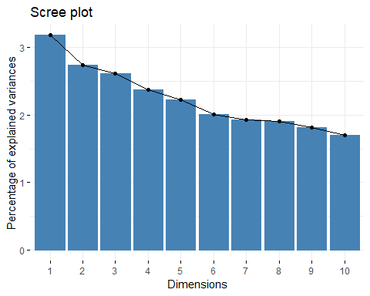

# Graph of variables.  
# Positive correlated variables point to the same side of the plot.  
# Negative correlated variables point to opposite sides of the graph.  
  
fviz_pca_var(res.pca,  
 col.var = "contrib", # Color by contributions to the PC  
 gradient.cols = c("#00AFBB", "#E7B800", "#FC4E07"),  
 repel = TRUE # Avoid text overlapping  
)

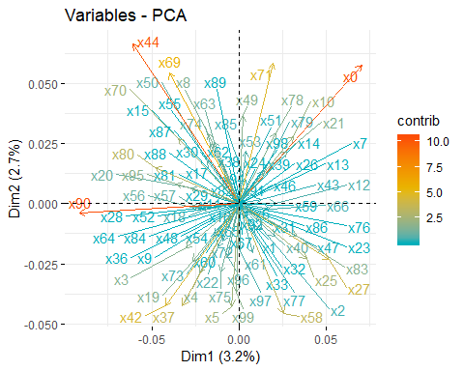

# PCA Results  
  
eig.val <- get_eigenvalue(res.pca)  
  
# Results for Variables  
res.var <- get_pca_var(res.pca)  
# res.var$coord # Coordinates  
# res.var$contrib # Contributions to the PCs  
# res.var$cos2 # Quality of representation  
  
quanti.sup <- SF_Train_Correlation_Var  
# head(quanti.sup)  
  
# Predict coordinates and compute cos2  
quanti.coord <- cor(quanti.sup, res.pca$x)  
quanti.cos2 <- quanti.coord^2  
# Graph of variables including supplementary variables  
p <- fviz_pca_var(res.pca)  
fviz_add(p, quanti.coord, color ="blue", geom="arrow")

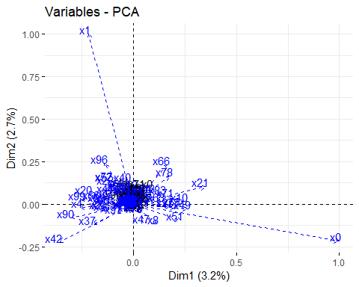

# Here we'll show how to calculate the PCA results for variables: coordinates, cos2 and contributions:  
  
# var.coord = loadings * the component standard deviations  
# var.cos2 = var.coord^2  
# var.contrib. The contribution of a variable to a given principal component is (in percentage) : (var.cos2 * 100) / (total cos2 of the component)  
  
var_coord_func <- function(loadings, comp.sdev){  
 loadings*comp.sdev  
}  
# Compute Coordinates  
#::::::::::::::::::::::::::::::::::::::::  
loadings <- res.pca$loadings  
sdev <- res.pca$sdev  
var.coord <- t(apply(loadings, 1, var_coord_func, sdev))  
head(var.coord[, 1:4])

## Comp.1 Comp.2 Comp.3 Comp.4  
## x0 0.070306870 0.05756889 0.01891283 0.01870020  
## x1 0.004697459 -0.00569136 -0.01225523 0.02875406  
## x2 0.013299706 -0.01057674 -0.03422464 -0.02174533  
## x3 -0.030518395 -0.01833448 0.01697233 -0.01968608  
## x4 -0.022797489 -0.02874476 0.01846526 0.01283098  
## x5 -0.004354739 -0.04265499 -0.06070574 0.04409827

# Compute Cos2  
#::::::::::::::::::::::::::::::::::::::::  
var.cos2 <- var.coord^2  
head(var.cos2[, 1:4])

## Comp.1 Comp.2 Comp.3 Comp.4  
## x0 4.943056e-03 3.314177e-03 0.0003576952 0.0003496975  
## x1 2.206612e-05 3.239157e-05 0.0001501907 0.0008267957  
## x2 1.768822e-04 1.118675e-04 0.0011713262 0.0004728594  
## x3 9.313724e-04 3.361530e-04 0.0002880600 0.0003875416  
## x4 5.197255e-04 8.262611e-04 0.0003409657 0.0001646342  
## x5 1.896375e-05 1.819448e-03 0.0036851870 0.0019446578

# Compute contributions  
#::::::::::::::::::::::::::::::::::::::::  
comp.cos2 <- apply(var.cos2, 2, sum)  
contrib <- function(var.cos2, comp.cos2){var.cos2*100/comp.cos2}  
var.contrib <- t(apply(var.cos2,1, contrib, comp.cos2))  
Contributions<-var.contrib[, 1:4]  
ggcorrplot(Contributions)

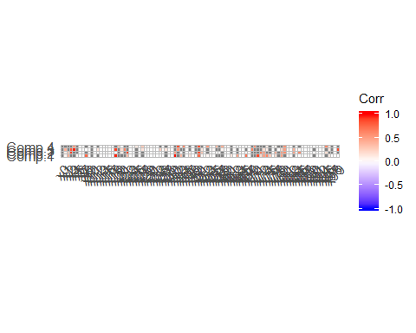

SF_Train_Correlation_Vars_Corr <- subset(SF_Train_Correlation_Var, select = c(x42, x90, x44, x69, x71, x0, x27, x58, x5, x37))  
corr2<- round(cor(SF_Train_Correlation_Vars_Corr), 2)  
ggcorrplot(corr2)

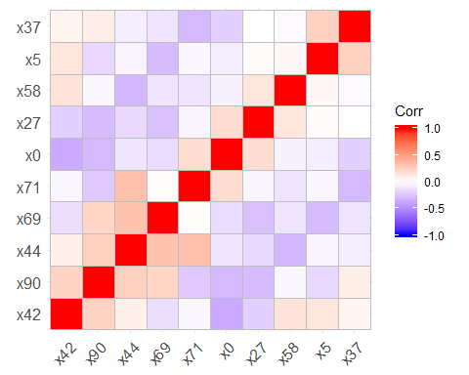

## set the seed to make your partition reproducible  
set.seed(123)  
  
# Histograms of variables  
  
ggplot(SF_Train_Correlation_Var1, aes(x=x42)) +  
 geom_histogram(binwidth=1, colour="red", fill="red")

## Warning: Removed 13 rows containing non-finite values (stat_bin).

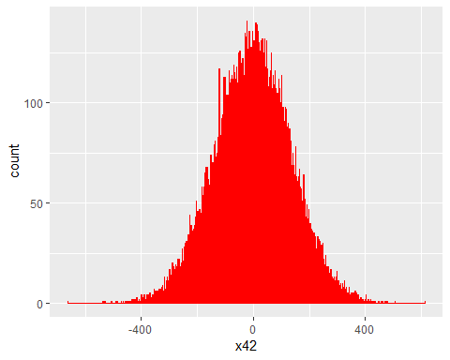

ggplot(SF_Train_Correlation_Var1, aes(x=x90)) +  
 geom_histogram(binwidth=1, colour="black", fill="black")

## Warning: Removed 5 rows containing non-finite values (stat_bin).

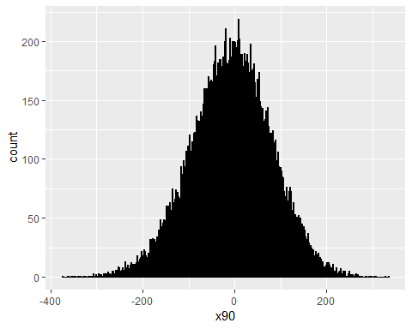

ggplot(SF_Train_Correlation_Var1, aes(x=x44)) +  
 geom_histogram(binwidth=1, colour="green", fill="green")

## Warning: Removed 4 rows containing non-finite values (stat_bin).

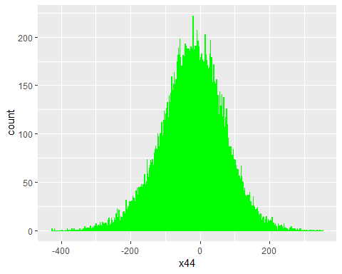

ggplot(SF_Train_Correlation_Var1, aes(x=x69)) +  
 geom_histogram(binwidth=1, colour="blue", fill="blue")

## Warning: Removed 11 rows containing non-finite values (stat_bin).

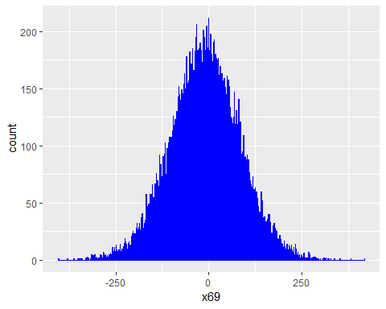

ggplot(SF_Train_Correlation_Var1, aes(x=x71)) +  
 geom_histogram(binwidth=1, colour="brown", fill="brown")

## Warning: Removed 5 rows containing non-finite values (stat_bin).

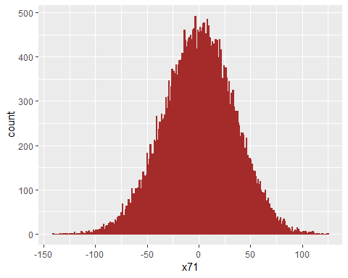

ggplot(SF_Train_Correlation_Var1, aes(x=x0)) +  
 geom_histogram(binwidth=1, colour="purple", fill="purple")

## Warning: Removed 11 rows containing non-finite values (stat_bin).

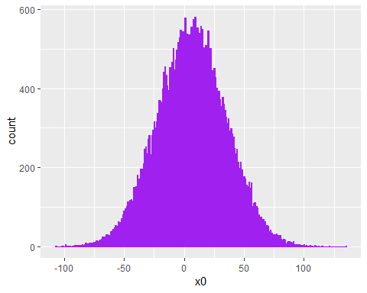

########################################################################################################################  
# Applying Machine Learning Algorithms via Basic Feature Engineering (Feature Selection)  
########################################################################################################################  
  
# Algorithm #1: Random Forest  
  
SF_Train_Correlation_Var1$y<-as.numeric(as.character(SF_Train_Correlation_Var1$y))  
SF_Train_Correlation_Var1_y<-as.data.frame(SF_Train_Correlation_Var1$y)  
SF_Train_Correlation_Var<-cbind(SF_Train_Correlation_Var, SF_Train_Correlation_Var1_y)  
  
names(SF_Train_Correlation_Var)[names(SF_Train_Correlation_Var) == "SF_Train_Correlation_Var1$y"] <- "y"  
SF_Train_Correlation_Var$y<-as.factor(SF_Train_Correlation_Var$y)  
  
## 75% of the sample size  
smp_size <- floor(0.80 * nrow(SF_Train_Correlation_Var))  
  
## set the seed to make your partition reproducible  
set.seed(123)  
train_ind <- sample(seq_len(nrow(SF_Train_Correlation_Var)), size = smp_size)  
  
train <- SF_Train_Correlation_Var[train_ind, ]  
test <- SF_Train_Correlation_Var[-train_ind, ]  
  
# for reproducibility  
  
set.seed(123)  
  
#train  
  
rf1<-randomForest(y~ x90 + x44 + x42 + x69 + x71 +x0 + x27 + x58+ x5 + x37,  
 data = train, ntree = 500,  
 mtry = 4, importance = TRUE, na.action = na.omit)  
  
print(rf1)

##   
## Call:  
## randomForest(formula = y ~ x90 + x44 + x42 + x69 + x71 + x0 + x27 + x58 + x5 + x37, data = train, ntree = 500, mtry = 4, importance = TRUE, na.action = na.omit)   
## Type of random forest: classification  
## Number of trees: 500  
## No. of variables tried at each split: 4  
##   
## OOB estimate of error rate: 17.25%  
## Confusion matrix:  
## 0 1 class.error  
## 0 24733 779 0.03053465  
## 1 4742 1746 0.73088779

#test  
  
rf2<-randomForest(y~ x90 + x44 + x42 + x69 + x71 +x0 + x27 + x58+ x5 + x37,  
 data = test, ntree = 500,  
 mtry = 4, importance = TRUE, na.action = na.omit)  
  
print(rf2)

##   
## Call:  
## randomForest(formula = y ~ x90 + x44 + x42 + x69 + x71 + x0 + x27 + x58 + x5 + x37, data = test, ntree = 500, mtry = 4, importance = TRUE, na.action = na.omit)   
## Type of random forest: classification  
## Number of trees: 500  
## No. of variables tried at each split: 4  
##   
## OOB estimate of error rate: 18.57%  
## Confusion matrix:  
## 0 1 class.error  
## 0 6193 175 0.02748116  
## 1 1311 321 0.80330882

test$pred_randomForest<-predict(rf1, test)  
test_rf_comparison<-test %>% select(y, pred_randomForest)  
  
#Validation  
  
SF_Validation$pred_randomForest<-predict(rf1, SF_Validation)  
  
# Algorithm #2: Adaboost  
  
train_var <- subset(train, select = c(x90, x44, x42, x69, x71, x0, x27, x58, x5, x37))  
ind_Attr1<-names(train_var)  
  
test_var <- subset(test, select = c(x90, x44, x42, x69, x71, x0, x27, x58, x5, x37))  
ind_Attr2<-names(test_var)  
  
# Build best ada boost model  
ada1<-ada(x = train[,ind_Attr1],  
 y = train$y,  
 iter=20, loss="logistic",verbose=TRUE) # 20 Iterations

## FINAL: iter= 20 rate= 5.321952e-10   
## FINAL: iter= 20 rate= 5.754619e-10   
## FINAL: iter= 20 rate= 6.228893e-10   
## FINAL: iter= 20 rate= 6.457764e-10   
## FINAL: iter= 20 rate= 5.776881e-10   
## FINAL: iter= 20 rate= 7.230121e-10   
## FINAL: iter= 20 rate= 6.026166e-10   
## FINAL: iter= 20 rate= 6.882537e-10   
## FINAL: iter= 20 rate= 7.523619e-10   
## FINAL: iter= 20 rate= 4.596955e-10   
## FINAL: iter= 20 rate= 6.597402e-10   
## FINAL: iter= 20 rate= 7.288775e-10   
## FINAL: iter= 20 rate= 6.896165e-10   
## FINAL: iter= 20 rate= 6.447544e-10   
## FINAL: iter= 20 rate= 7.564216e-10   
## FINAL: iter= 20 rate= 8.116626e-10   
## FINAL: iter= 20 rate= 5.996096e-10   
## FINAL: iter= 20 rate= 2.706232e-10   
## FINAL: iter= 20 rate= 3.824858e-10   
## FINAL: iter= 20 rate= 5.678407e-10

# Look at the model summary  
summary(ada1)

## Call:  
## ada(train[, ind_Attr1], y = train$y, loss = "logistic", iter = 20,   
## verbose = TRUE)  
##   
## Loss: logistic Method: discrete Iteration: 20   
##   
## Training Results  
##   
## Accuracy: 0.806 Kappa: 0.096

# Build best ada boost model  
ada2<-ada(x = test[,ind_Attr2],  
 y = test$y,  
 iter=20, loss="logistic",verbose=TRUE) # 20 Iterations

## FINAL: iter= 20 rate= 8.784741e-09   
## FINAL: iter= 20 rate= 9.343813e-09   
## FINAL: iter= 20 rate= 9.585764e-09   
## FINAL: iter= 20 rate= 1.011139e-08   
## FINAL: iter= 20 rate= 9.547399e-09   
## FINAL: iter= 20 rate= 1.036407e-08   
## FINAL: iter= 20 rate= 1.221325e-08   
## FINAL: iter= 20 rate= 1.139484e-08   
## FINAL: iter= 20 rate= 1.18086e-08   
## FINAL: iter= 20 rate= 6.414827e-09   
## FINAL: iter= 20 rate= 1.212286e-08   
## FINAL: iter= 20 rate= 6.872939e-09   
## FINAL: iter= 20 rate= 9.732799e-09   
## FINAL: iter= 20 rate= 1.025242e-08   
## FINAL: iter= 20 rate= 6.871456e-09   
## FINAL: iter= 20 rate= 7.980506e-09   
## FINAL: iter= 20 rate= 8.629301e-09   
## FINAL: iter= 20 rate= 7.707187e-09   
## FINAL: iter= 20 rate= 5.370915e-09   
## FINAL: iter= 20 rate= 1.272687e-08

# Look at the model summary  
summary(ada2)

## Call:  
## ada(test[, ind_Attr2], y = test$y, loss = "logistic", iter = 20,   
## verbose = TRUE)  
##   
## Loss: logistic Method: discrete Iteration: 20   
##   
## Training Results  
##   
## Accuracy: 0.807 Kappa: 0.115

# Predict on train data  
pred_Train<-predict(ada1, train[,ind_Attr1])  
  
# Build confusion matrix and find accuracy  
cm_Train = table(train$y, pred_Train)  
accu_Train= sum(diag(cm_Train))/sum(cm_Train)  
rm(pred_Train, cm_Train)  
  
# Predict on test data  
pred_Test = predict(ada1, test[,ind_Attr2])  
  
# Build confusion matrix and find accuracy  
cm_Test = table(test$y, pred_Test)  
accu_Test= sum(diag(cm_Test))/sum(cm_Test)  
rm(pred_Test, cm_Test)  
  
#Validation  
  
SF_Validation$pred_ada<-predict(ada1, SF_Validation)  
  
########################################################################################################################  
# More Feature Engineering to Improve Model  
########################################################################################################################  
  
#########################  
# Training Set  
#########################  
  
# Checking missing values  
  
sum(is.na(SF_Train_Correlation_Var_Copy))/prod(dim(SF_Train_Correlation_Var_Copy))

## [1] 0.0002005319

SF_Train_Correlation_Var_Copy %>% summarize_all(funs(sum(is.na(.)) / length(.)))

## x0 x1 x2 x3 x4 x5 x6 x7 x8  
## 1 0.000275 0.000275 0.000175 0.000225 2e-04 0.000275 0.000175 3e-04 1e-04  
## x9 x10 x11 x12 x13 x14 x15 x16 x17  
## 1 2e-04 0.00025 0.00015 3e-04 0.000275 7.5e-05 0.00015 0.000175 0.00025  
## x18 x19 x20 x21 x22 x23 x24 x25  
## 1 0.000325 0.000175 0.000125 0.000375 0.000175 0.00015 3e-04 2e-04  
## x26 x27 x28 x29 x30 x31 x32 x33  
## 1 0.000225 1e-04 0.000225 0.000125 0.000125 0.000175 0.00015 0.000225  
## x36 x37 x38 x39 x40 x42 x43 x44 x46  
## 1 0.00015 0.000125 0.000125 2e-04 2e-04 0.000325 5e-05 1e-04 0.00025  
## x47 x48 x49 x50 x51 x52 x53 x54 x55  
## 1 0.000125 2e-04 7.5e-05 0.000175 0.000275 0.00025 0.000125 0.00015 4e-04  
## x56 x57 x58 x59 x60 x61 x62 x63 x64  
## 1 0.000275 0.000175 2e-04 2e-04 0.000275 0.00015 3e-04 0.000325 0.00015  
## x65 x66 x67 x69 x70 x71 x72 x73 x74  
## 1 3e-04 0.000225 0.00015 0.000275 1e-04 0.000125 0.00025 2e-04 0.000175  
## x75 x76 x77 x78 x79 x80 x81 x82  
## 1 0.00025 0.000275 0.000175 0.000225 0.000175 0.000175 1e-04 0.000175  
## x83 x84 x85 x86 x87 x88 x89 x90  
## 1 0.000125 7.5e-05 3e-04 0.000225 0.000175 1e-04 0.000275 0.000125  
## x91 x92 x94 x95 x96 x97 x98 x99  
## 1 0.000125 2e-04 0.00025 2e-04 0.000375 0.000225 0.000125 0.00025

# Mean imputation  
  
SF_Train_Correlation_Var_Copy[] <- lapply(SF_Train_Correlation_Var_Copy, function(x) {   
 x[is.na(x)] <- mean(x, na.rm = TRUE)  
 x  
})  
  
# Treating outliers by Winsorizing/Capping  
  
# Winsorizing  
  
fun <- function(x){  
 quantiles <- quantile( x, c(.05, .95 ) )  
 x[ x < quantiles[1] ] <- quantiles[1]  
 x[ x > quantiles[2] ] <- quantiles[2]  
 x  
}  
  
SF_Train_Correlation_Var_Copy_BP <- subset(SF_Train_Correlation_Var_Copy, select = c(x90, x44, x42, x69, x71, x0, x27, x58, x5, x37))  
ggplot(data = melt(SF_Train_Correlation_Var_Copy_BP), aes(x=variable, y=value)) + geom_boxplot(aes(fill=variable))

## No id variables; using all as measure variables

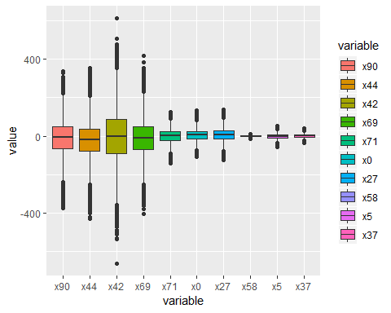

SF_Train_Correlation_Var_Copy$x90_WC<-fun(SF_Train_Correlation_Var_Copy$x90)  
SF_Train_Correlation_Var_Copy$x44_WC<-fun(SF_Train_Correlation_Var_Copy$x44)  
SF_Train_Correlation_Var_Copy$x42_WC<-fun(SF_Train_Correlation_Var_Copy$x42)  
SF_Train_Correlation_Var_Copy$x69_WC<-fun(SF_Train_Correlation_Var_Copy$x69)  
SF_Train_Correlation_Var_Copy$x71_WC<-fun(SF_Train_Correlation_Var_Copy$x71)  
SF_Train_Correlation_Var_Copy$x0_WC<-fun(SF_Train_Correlation_Var_Copy$x0)  
SF_Train_Correlation_Var_Copy$x27_WC<-fun(SF_Train_Correlation_Var_Copy$x27)  
SF_Train_Correlation_Var_Copy$x58_WC<-fun(SF_Train_Correlation_Var_Copy$x58)  
SF_Train_Correlation_Var_Copy$x5_WC<-fun(SF_Train_Correlation_Var_Copy$x5)  
SF_Train_Correlation_Var_Copy$x37_WC<-fun(SF_Train_Correlation_Var_Copy$x37)  
  
SF_Train_Correlation_Var_Copy_BP2 <- subset(SF_Train_Correlation_Var_Copy, select = c(x90_WC, x44_WC, x42_WC, x69_WC, x71_WC, x0_WC, x27_WC, x58_WC, x5_WC, x37_WC))  
ggplot(data = melt(SF_Train_Correlation_Var_Copy_BP2), aes(x=variable, y=value)) + geom_boxplot(aes(fill=variable))

## No id variables; using all as measure variables

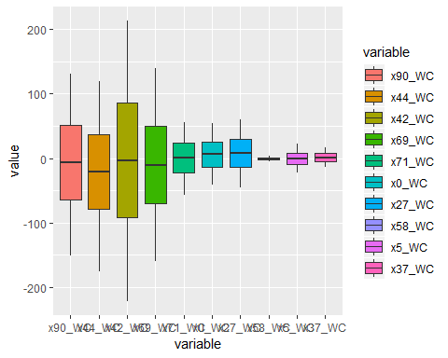

# Capping  
  
SF_Train_Correlation_Var_Copy$x42_WC[SF_Train_Correlation_Var_Copy$x42_WC > 200] = 200  
SF_Train_Correlation_Var_Copy$x42_WC[SF_Train_Correlation_Var_Copy$x42_WC < -200] = 200  
  
max(SF_Train_Correlation_Var_Copy$x42_WC)

## [1] 200

min(SF_Train_Correlation_Var_Copy$x42_WC)

## [1] -199.9812

# Standardizing/normalizing data   
  
SF_Train_Correlation_Var_Copy<-apply(SF_Train_Correlation_Var_Copy, MARGIN = 2, FUN = function(X) (X - min(X))/diff(range(X)))  
SF_Train_Correlation_Var_Copy<-as.data.frame(SF_Train_Correlation_Var_Copy)  
  
# Bucketing/binning/categorization  
  
SF_Train_Correlation_Var_Copy$x90_WC <- ifelse(SF_Train_Correlation_Var_Copy$x90_WC > 0.5, 1, 0)  
SF_Train_Correlation_Var_Copy$x44_WC <- ifelse(SF_Train_Correlation_Var_Copy$x44_WC > 0.5, 1, 0)  
SF_Train_Correlation_Var_Copy$x0_WC <- ifelse(SF_Train_Correlation_Var_Copy$x0_WC > 0.5, 1, 0)  
  
# Interaction  
  
SF_Train_Correlation_Var_Copy$Three_Var_mean <- rowMeans(subset(SF_Train_Correlation_Var_Copy, select = c(x90, x44, x0)), na.rm = TRUE)  
  
  
#########################  
# Validation Set  
#########################  
  
# Checking missing values  
  
sum(is.na(SF_Validation_Copy))/prod(dim(SF_Validation_Copy))

## [1] 0.0002042553

SF_Validation_Copy %>% summarize_all(funs(sum(is.na(.)) / length(.)))

## x0 x1 x2 x3 x4 x5 x6 x7 x8 x9 x10 x11 x12  
## 1 3e-04 1e-04 2e-04 4e-04 0 0 4e-04 1e-04 3e-04 1e-04 1e-04 3e-04 0  
## x13 x14 x15 x16 x17 x18 x19 x20 x21 x22 x23 x24  
## 1 6e-04 2e-04 3e-04 2e-04 3e-04 2e-04 2e-04 2e-04 0 0 3e-04 4e-04  
## x25 x26 x27 x28 x29 x30 x31 x32 x33 x36 x37 x38  
## 1 3e-04 2e-04 5e-04 3e-04 1e-04 0 3e-04 1e-04 3e-04 3e-04 1e-04 1e-04  
## x39 x40 x42 x43 x44 x46 x47 x48 x49 x50 x51 x52 x53  
## 1 2e-04 0 2e-04 0 1e-04 1e-04 1e-04 6e-04 3e-04 0 2e-04 1e-04 1e-04  
## x54 x55 x56 x57 x58 x59 x60 x61 x62 x63 x64 x65  
## 1 0 1e-04 1e-04 3e-04 2e-04 3e-04 3e-04 3e-04 4e-04 2e-04 0 2e-04  
## x66 x67 x69 x70 x71 x72 x73 x74 x75 x76 x77 x78  
## 1 2e-04 4e-04 3e-04 2e-04 1e-04 0 5e-04 3e-04 2e-04 0 5e-04 1e-04  
## x79 x80 x81 x82 x83 x84 x85 x86 x87 x88 x89 x90  
## 1 3e-04 2e-04 2e-04 3e-04 1e-04 0 3e-04 3e-04 2e-04 2e-04 2e-04 3e-04  
## x91 x92 x94 x95 x96 x97 x98 x99  
## 1 0 0 2e-04 1e-04 2e-04 4e-04 2e-04 5e-04

# Mean imputation  
  
SF_Validation_Copy[] <- lapply(SF_Validation_Copy, function(x) {   
 x[is.na(x)] <- mean(x, na.rm = TRUE)  
 x  
})  
  
# Treating outliers by Winsorizing/Capping  
  
# Winsorizing  
  
fun <- function(x){  
 quantiles <- quantile( x, c(.05, .95 ) )  
 x[ x < quantiles[1] ] <- quantiles[1]  
 x[ x > quantiles[2] ] <- quantiles[2]  
 x  
}  
  
SF_Validation_Correlation_Var_Copy_BP <- subset(SF_Validation_Copy, select = c(x90, x44, x42, x69, x71, x0, x27, x58, x5, x37))  
ggplot(data = melt(SF_Validation_Correlation_Var_Copy_BP), aes(x=variable, y=value)) + geom_boxplot(aes(fill=variable))

## No id variables; using all as measure variables

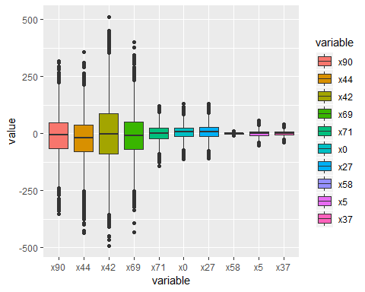

SF_Validation_Copy$x90_WC<-fun(SF_Validation_Copy$x90)  
SF_Validation_Copy$x44_WC<-fun(SF_Validation_Copy$x44)  
SF_Validation_Copy$x42_WC<-fun(SF_Validation_Copy$x42)  
SF_Validation_Copy$x69_WC<-fun(SF_Validation_Copy$x69)  
SF_Validation_Copy$x71_WC<-fun(SF_Validation_Copy$x71)  
SF_Validation_Copy$x0_WC<-fun(SF_Validation_Copy$x0)  
SF_Validation_Copy$x27_WC<-fun(SF_Validation_Copy$x27)  
SF_Validation_Copy$x58_WC<-fun(SF_Validation_Copy$x58)  
SF_Validation_Copy$x5_WC<-fun(SF_Validation_Copy$x5)  
SF_Validation_Copy$x37_WC<-fun(SF_Validation_Copy$x37)  
  
SF_Validation_Correlation_Var_Copy_BP2 <- subset(SF_Validation_Copy, select = c(x90_WC, x44_WC, x42_WC, x69_WC, x71_WC, x0_WC, x27_WC, x58_WC, x5_WC, x37_WC))  
ggplot(data = melt(SF_Validation_Correlation_Var_Copy_BP2), aes(x=variable, y=value)) + geom_boxplot(aes(fill=variable))

## No id variables; using all as measure variables

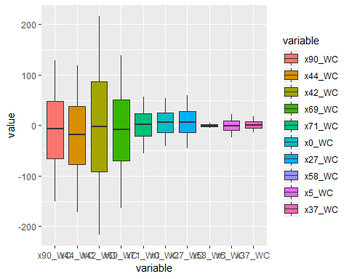

# Capping  
  
SF_Validation_Copy$x42_WC[SF_Validation_Copy$x42_WC > 200] = 200  
SF_Validation_Copy$x42_WC[SF_Validation_Copy$x42_WC < -200] = 200  
  
max(SF_Validation_Copy$x42_WC)

## [1] 200

min(SF_Validation_Copy$x42_WC)

## [1] -199.7655

# Standardizing/normalizing data   
  
SF_Validation_Copy<-apply(SF_Validation_Copy, MARGIN = 2, FUN = function(X) (X - min(X))/diff(range(X)))  
SF_Validation_Copy<-as.data.frame(SF_Validation_Copy)  
  
# Bucketing/binning/categorization  
  
SF_Validation_Copy$x90_WC <- ifelse(SF_Validation_Copy$x90_WC > 0.5, 1, 0)  
SF_Validation_Copy$x44_WC <- ifelse(SF_Validation_Copy$x44_WC > 0.5, 1, 0)  
SF_Validation_Copy$x0_WC <- ifelse(SF_Validation_Copy$x0_WC > 0.5, 1, 0)  
  
# Interaction  
  
SF_Validation_Copy$Three_Var_mean <- rowMeans(subset(SF_Validation_Copy, select = c(x90, x44, x0)), na.rm = TRUE)  
  
########################################################################################################################  
# Machine Learning Algorithms After Advanced Feature Engineering (Feature Selection)  
########################################################################################################################  
  
# Algorithm #1: Random Forest   
  
SF_Train_Correlation_Var1$y<-as.numeric(as.character(SF_Train_Correlation_Var1$y))  
SF_Train_Correlation_Var1_y<-as.data.frame(SF_Train_Correlation_Var1$y)  
SF_Train_Correlation_Var_Copy<-cbind(SF_Train_Correlation_Var_Copy, SF_Train_Correlation_Var1_y)  
  
names(SF_Train_Correlation_Var_Copy)[names(SF_Train_Correlation_Var_Copy) == "SF_Train_Correlation_Var1$y"] <- "y"  
SF_Train_Correlation_Var_Copy$y<-as.factor(SF_Train_Correlation_Var_Copy$y)  
  
## 75% of the sample size  
smp_size <- floor(0.80 * nrow(SF_Train_Correlation_Var_Copy))  
  
## set the seed to make your partition reproducible  
set.seed(123)  
train_ind <- sample(seq_len(nrow(SF_Train_Correlation_Var_Copy)), size = smp_size)  
  
train <- SF_Train_Correlation_Var_Copy[train_ind, ]  
test <- SF_Train_Correlation_Var_Copy[-train_ind, ]  
  
# for reproducibility  
  
set.seed(123)  
  
#train  
  
rf1<-randomForest(y~ x90 + x44 + x0 + x42 + x69 + x71 +   
 x0 + x40 + x25 + x95 + x8 + x53 + x61 + x22 + x10 + x78 +   
 x21 + x74 + x20 + x63 + x75 + x57 + x56 + x19 + x18 + x49 +   
 x96 + x97 + x50 + x99 + x4 + x3 + x80 + x70 + x83 + x58 +   
 x5 + x37 + x27 + x12 + x66,  
 data = train, ntree = 500,  
 mtry = 12, importance = TRUE, na.action = na.omit)  
  
print(rf1)

##   
## Call:  
## randomForest(formula = y ~ x90 + x44 + x0 + x42 + x69 + x71 + x0 + x40 + x25 + x95 + x8 + x53 + x61 + x22 + x10 + x78 + x21 + x74 + x20 + x63 + x75 + x57 + x56 + x19 + x18 + x49 + x96 + x97 + x50 + x99 + x4 + x3 + x80 + x70 + x83 + x58 + x5 + x37 + x27 + x12 + x66, data = train, ntree = 500, mtry = 12, importance = TRUE, na.action = na.omit)   
## Type of random forest: classification  
## Number of trees: 500  
## No. of variables tried at each split: 12  
##   
## OOB estimate of error rate: 8.69%  
## Confusion matrix:  
## 0 1 class.error  
## 0 25431 81 0.003174976  
## 1 2700 3788 0.416152898

#test  
  
rf2<-randomForest(y~ x90 + x44 + x0 + x42 + x69 + x71 +   
 x0 + x40 + x25 + x95 + x8 + x53 + x61 + x22 + x10 + x78 +   
 x21 + x74 + x20 + x63 + x75 + x57 + x56 + x19 + x18 + x49 +   
 x96 + x97 + x50 + x99 + x4 + x3 + x80 + x70 + x83 + x58 +   
 x5 + x37 + x27 + x12 + x66,  
 data = train, ntree = 500,  
 mtry = 12, importance = TRUE, na.action = na.omit)  
print(rf2)

##   
## Call:  
## randomForest(formula = y ~ x90 + x44 + x0 + x42 + x69 + x71 + x0 + x40 + x25 + x95 + x8 + x53 + x61 + x22 + x10 + x78 + x21 + x74 + x20 + x63 + x75 + x57 + x56 + x19 + x18 + x49 + x96 + x97 + x50 + x99 + x4 + x3 + x80 + x70 + x83 + x58 + x5 + x37 + x27 + x12 + x66, data = train, ntree = 500, mtry = 12, importance = TRUE, na.action = na.omit)   
## Type of random forest: classification  
## Number of trees: 500  
## No. of variables tried at each split: 12  
##   
## OOB estimate of error rate: 8.64%  
## Confusion matrix:  
## 0 1 class.error  
## 0 25426 86 0.003370963  
## 1 2680 3808 0.413070284

test$pred_randomForest<-predict(rf1, test)  
test_rf_comparison<-test %>% select(x90, x44, x0, x42, x69, x71,   
 x40, x25, x95, x8, x53, x61, x22, x10, x78,   
 x21, x74, x20, x63, x75, x57, x56, x19, x18, x49,   
 x96, x97, x50, x99, x4, x3, x80, x70, x83, x58,   
 x5, x37, x27, x12, x66, y, pred_randomForest)  
test_rf_comparison$Misclassified <- ifelse(test_rf_comparison$y == test_rf_comparison$pred_randomForest, 1, 0)  
  
# View(test_rf_comparison)  
  
# write.csv(test_rf_comparison, "C:/Users/puj83/OneDrive/CV/Cases/InsuranceX/test_rf_comparison.csv")  
  
#Validation  
  
SF_Validation_Copy$pred_randomForest<-predict(rf1, SF_Validation_Copy)  
write.csv(SF_Validation_Copy$pred_randomForest, "C:/Users/puj83/OneDrive/CV/Cases/InsuranceX/SF_Validation_RF_Probabilities.csv")  
  
# Algorithm #2: Adaboost  
  
train_var <- subset(train, select = c(x90, x44, x0, x42, x69, x71,   
 x40, x25, x95, x8, x53, x61, x22, x10, x78,   
 x21, x74, x20, x63, x75, x57, x56, x19, x18, x49,   
 x96, x97, x50, x99, x4, x3, x80, x70, x83, x58,   
 x5, x37, x27, x12, x66))  
ind_Attr1<-names(train_var)  
  
test_var <- subset(test, select = c(x90, x44, x0, x42, x69, x71,   
 x40, x25, x95, x8, x53, x61, x22, x10, x78,   
 x21, x74, x20, x63, x75, x57, x56, x19, x18, x49,   
 x96, x97, x50, x99, x4, x3, x80, x70, x83, x58,   
 x5, x37, x27, x12, x66))  
ind_Attr2<-names(test_var)  
  
# Build best ada boost model   
ada1<-ada(x = train[,ind_Attr1],   
 y = train$y,   
 iter=100, loss="logistic",verbose=TRUE) # 100 Iterations

## FINAL: iter= 20 rate= 7.270273e-10   
## FINAL: iter= 20 rate= 7.350812e-10   
## FINAL: iter= 20 rate= 7.978094e-10   
## FINAL: iter= 20 rate= 7.891144e-10   
## FINAL: iter= 20 rate= 8.541243e-10   
## FINAL: iter= 20 rate= 9.257497e-10   
## FINAL: iter= 20 rate= 9.199033e-10   
## FINAL: iter= 20 rate= 8.573362e-10   
## FINAL: iter= 20 rate= 9.067585e-10   
## FINAL: iter= 20 rate= 9.542565e-10   
## FINAL: iter= 20 rate= 9.066468e-10   
## FINAL: iter= 20 rate= 1.050889e-09   
## FINAL: iter= 20 rate= 8.146492e-10   
## FINAL: iter= 20 rate= 9.74536e-10   
## FINAL: iter= 20 rate= 8.835592e-10   
## FINAL: iter= 20 rate= 7.159046e-10   
## FINAL: iter= 20 rate= 4.352105e-10   
## FINAL: iter= 20 rate= 8.680678e-10   
## FINAL: iter= 20 rate= 8.976717e-10   
## FINAL: iter= 20 rate= 6.75081e-10   
## FINAL: iter= 20 rate= 9.836579e-10   
## FINAL: iter= 20 rate= 5.673822e-10   
## FINAL: iter= 20 rate= 5.911755e-10   
## FINAL: iter= 20 rate= 8.103907e-10   
## FINAL: iter= 20 rate= 7.080509e-10   
## FINAL: iter= 20 rate= 6.698432e-10   
## FINAL: iter= 20 rate= 1.264922e-10   
## FINAL: iter= 20 rate= 7.534306e-10   
## FINAL: iter= 20 rate= 3.156793e-10   
## FINAL: iter= 20 rate= 5.384017e-10   
## FINAL: iter= 20 rate= 3.488313e-10   
## FINAL: iter= 20 rate= 7.88669e-10   
## FINAL: iter= 20 rate= 9.244461e-10   
## FINAL: iter= 20 rate= 4.466367e-10   
## FINAL: iter= 20 rate= 4.124026e-10   
## FINAL: iter= 20 rate= 1.984488e-10   
## FINAL: iter= 20 rate= 5.830776e-10   
## FINAL: iter= 20 rate= 6.079827e-10   
## FINAL: iter= 20 rate= 2.166816e-10   
## FINAL: iter= 20 rate= 5.341926e-10   
## FINAL: iter= 20 rate= 3.148042e-10   
## FINAL: iter= 20 rate= 5.403687e-10   
## FINAL: iter= 20 rate= 4.044786e-10   
## FINAL: iter= 1 rate= 4.739246e-11   
## FINAL: iter= 20 rate= 4.34258e-10   
## FINAL: iter= 20 rate= 4.591445e-10   
## FINAL: iter= 20 rate= 3.149217e-10   
## FINAL: iter= 20 rate= 2.811438e-10   
## FINAL: iter= 20 rate= 3.559336e-10   
## FINAL: iter= 20 rate= 3.04989e-10   
## FINAL: iter= 20 rate= 2.232833e-10   
## FINAL: iter= 20 rate= 4.242693e-10   
## FINAL: iter= 20 rate= 2.464675e-10   
## FINAL: iter= 20 rate= 3.399279e-10   
## FINAL: iter= 20 rate= 2.431495e-10   
## FINAL: iter= 20 rate= 4.539175e-10   
## FINAL: iter= 20 rate= 5.294197e-10   
## FINAL: iter= 20 rate= 3.835664e-10   
## FINAL: iter= 20 rate= 3.43124e-10   
## FINAL: iter= 20 rate= 2.211558e-10   
## FINAL: iter= 20 rate= 3.906954e-10   
## FINAL: iter= 20 rate= 1.104908e-10   
## FINAL: iter= 20 rate= 2.0413e-10   
## FINAL: iter= 20 rate= 7.36642e-10   
## FINAL: iter= 20 rate= 1.379461e-10   
## FINAL: iter= 20 rate= 6.117702e-10   
## FINAL: iter= 20 rate= 1.781088e-10   
## FINAL: iter= 20 rate= 1.693436e-10   
## FINAL: iter= 20 rate= 5.242139e-10   
## FINAL: iter= 20 rate= 1.948211e-10   
## FINAL: iter= 20 rate= 3.054947e-10   
## FINAL: iter= 20 rate= 8.227172e-10   
## FINAL: iter= 1 rate= 9.334476e-11   
## FINAL: iter= 20 rate= 2.015881e-10   
## FINAL: iter= 20 rate= 2.174163e-10   
## FINAL: iter= 20 rate= 5.851969e-10   
## FINAL: iter= 20 rate= 1.571685e-10   
## FINAL: iter= 20 rate= 3.991679e-10   
## FINAL: iter= 20 rate= 3.393663e-10   
## FINAL: iter= 20 rate= 3.217976e-10   
## FINAL: iter= 20 rate= 3.846654e-10   
## FINAL: iter= 20 rate= 2.464514e-10   
## FINAL: iter= 20 rate= 4.126385e-10   
## FINAL: iter= 20 rate= 4.595006e-10   
## FINAL: iter= 20 rate= 2.00796e-10   
## FINAL: iter= 20 rate= 7.08271e-10   
## FINAL: iter= 20 rate= 2.279958e-10   
## FINAL: iter= 20 rate= 5.640797e-10   
## FINAL: iter= 20 rate= 5.554978e-10   
## FINAL: iter= 20 rate= 6.729028e-10   
## FINAL: iter= 20 rate= 1.911991e-10   
## FINAL: iter= 20 rate= 1.792385e-10   
## FINAL: iter= 20 rate= 4.954627e-10   
## FINAL: iter= 20 rate= 2.952691e-10   
## FINAL: iter= 20 rate= 4.930212e-10   
## FINAL: iter= 20 rate= 3.219048e-10   
## FINAL: iter= 20 rate= 2.805726e-10   
## FINAL: iter= 1 rate= 5.196241e-11   
## FINAL: iter= 20 rate= 4.343211e-10   
## FINAL: iter= 20 rate= 1.608355e-10

# Look at the model summary  
summary(ada1)

## Call:  
## ada(train[, ind_Attr1], y = train$y, loss = "logistic", iter = 100,   
## verbose = TRUE)  
##   
## Loss: logistic Method: discrete Iteration: 100   
##   
## Training Results  
##   
## Accuracy: 0.932 Kappa: 0.768

# Build best ada boost model   
ada2<-ada(x = test[,ind_Attr2],   
 y = test$y,   
 iter=100, loss="logistic",verbose=TRUE) # 100 Iterations

## FINAL: iter= 20 rate= 1.195168e-08   
## FINAL: iter= 20 rate= 1.373453e-08   
## FINAL: iter= 20 rate= 1.200256e-08   
## FINAL: iter= 20 rate= 1.288116e-08   
## FINAL: iter= 20 rate= 1.49356e-08   
## FINAL: iter= 20 rate= 1.349332e-08   
## FINAL: iter= 20 rate= 1.488461e-08   
## FINAL: iter= 20 rate= 1.818764e-08   
## FINAL: iter= 20 rate= 1.479619e-08   
## FINAL: iter= 20 rate= 1.54999e-08   
## FINAL: iter= 20 rate= 1.678202e-08   
## FINAL: iter= 20 rate= 1.234952e-08   
## FINAL: iter= 20 rate= 1.27415e-08   
## FINAL: iter= 20 rate= 1.573005e-08   
## FINAL: iter= 20 rate= 1.348809e-08   
## FINAL: iter= 20 rate= 1.208222e-08   
## FINAL: iter= 20 rate= 1.387138e-08   
## FINAL: iter= 20 rate= 1.468057e-08   
## FINAL: iter= 20 rate= 1.034939e-08   
## FINAL: iter= 20 rate= 1.41367e-08   
## FINAL: iter= 20 rate= 1.370265e-08   
## FINAL: iter= 20 rate= 1.559521e-08   
## FINAL: iter= 20 rate= 1.111798e-08   
## FINAL: iter= 20 rate= 1.407988e-08   
## FINAL: iter= 20 rate= 9.399562e-09   
## FINAL: iter= 20 rate= 1.498483e-08   
## FINAL: iter= 20 rate= 1.065625e-08   
## FINAL: iter= 20 rate= 1.547611e-08   
## FINAL: iter= 20 rate= 1.048973e-08   
## FINAL: iter= 20 rate= 4.153946e-09   
## FINAL: iter= 20 rate= 8.159132e-09   
## FINAL: iter= 20 rate= 1.450159e-08   
## FINAL: iter= 20 rate= 7.947011e-09   
## FINAL: iter= 20 rate= 8.349986e-09   
## FINAL: iter= 20 rate= 9.488003e-09   
## FINAL: iter= 20 rate= 1.254506e-08   
## FINAL: iter= 20 rate= 5.528693e-09   
## FINAL: iter= 20 rate= 9.199314e-09   
## FINAL: iter= 20 rate= 4.944792e-09   
## FINAL: iter= 20 rate= 8.118268e-09   
## FINAL: iter= 20 rate= 3.86583e-09   
## FINAL: iter= 20 rate= 7.194203e-09   
## FINAL: iter= 20 rate= 7.586195e-09   
## FINAL: iter= 20 rate= 1.147636e-08   
## FINAL: iter= 20 rate= 7.841426e-09   
## FINAL: iter= 20 rate= 7.267615e-09   
## FINAL: iter= 20 rate= 1.077324e-08   
## FINAL: iter= 20 rate= 1.348579e-08   
## FINAL: iter= 20 rate= 1.081396e-08   
## FINAL: iter= 20 rate= 7.298567e-09   
## FINAL: iter= 20 rate= 3.974059e-09   
## FINAL: iter= 20 rate= 9.121228e-09   
## FINAL: iter= 20 rate= 8.190527e-09   
## FINAL: iter= 20 rate= 7.684173e-09   
## FINAL: iter= 20 rate= 6.024397e-09   
## FINAL: iter= 20 rate= 9.411653e-09   
## FINAL: iter= 20 rate= 2.775772e-09   
## FINAL: iter= 20 rate= 8.306979e-09   
## FINAL: iter= 20 rate= 9.554501e-09   
## FINAL: iter= 20 rate= 1.332125e-08   
## FINAL: iter= 20 rate= 2.465232e-09   
## FINAL: iter= 20 rate= 7.740251e-09   
## FINAL: iter= 20 rate= 9.487451e-09   
## FINAL: iter= 20 rate= 1.666704e-08   
## FINAL: iter= 20 rate= 6.940449e-09   
## FINAL: iter= 20 rate= 2.494297e-09   
## FINAL: iter= 20 rate= 3.037242e-09   
## FINAL: iter= 20 rate= 8.780883e-09   
## FINAL: iter= 20 rate= 1.022022e-08   
## FINAL: iter= 20 rate= 4.649636e-09   
## FINAL: iter= 20 rate= 8.929052e-09   
## FINAL: iter= 20 rate= 3.06658e-09   
## FINAL: iter= 20 rate= 9.755575e-09   
## FINAL: iter= 20 rate= 7.227495e-09   
## FINAL: iter= 20 rate= 9.860004e-09   
## FINAL: iter= 20 rate= 4.144415e-09   
## FINAL: iter= 20 rate= 7.500793e-09   
## FINAL: iter= 20 rate= 1.011373e-08   
## FINAL: iter= 20 rate= 8.539173e-09   
## FINAL: iter= 20 rate= 1.376126e-08   
## FINAL: iter= 20 rate= 9.434911e-09   
## FINAL: iter= 20 rate= 2.07325e-09   
## FINAL: iter= 20 rate= 7.438951e-09   
## FINAL: iter= 20 rate= 6.339554e-09   
## FINAL: iter= 20 rate= 9.644056e-09   
## FINAL: iter= 20 rate= 8.996895e-09   
## FINAL: iter= 20 rate= 6.441065e-09   
## FINAL: iter= 20 rate= 7.258042e-09   
## FINAL: iter= 20 rate= 3.824125e-09   
## FINAL: iter= 20 rate= 3.950805e-09   
## FINAL: iter= 20 rate= 1.049527e-08   
## FINAL: iter= 20 rate= 5.176843e-09   
## FINAL: iter= 20 rate= 1.655619e-09   
## FINAL: iter= 20 rate= 6.153958e-09   
## FINAL: iter= 20 rate= 1.25339e-08   
## FINAL: iter= 20 rate= 7.396718e-09   
## FINAL: iter= 20 rate= 1.10849e-08   
## FINAL: iter= 20 rate= 9.085713e-09   
## FINAL: iter= 20 rate= 7.867943e-09   
## FINAL: iter= 20 rate= 9.773363e-09

# Look at the model summary  
summary(ada2)

## Call:  
## ada(test[, ind_Attr2], y = test$y, loss = "logistic", iter = 100,   
## verbose = TRUE)  
##   
## Loss: logistic Method: discrete Iteration: 100   
##   
## Training Results  
##   
## Accuracy: 0.968 Kappa: 0.897

# Predict on train data   
pred_Train<-predict(ada1, train[,ind_Attr1])   
  
# Build confusion matrix and find accuracy   
cm_Train = table(train$y, pred_Train)  
accu_Train= sum(diag(cm_Train))/sum(cm_Train)  
rm(pred_Train, cm_Train)  
  
# Predict on test data  
pred_Test = predict(ada1, test[,ind_Attr2])   
  
# Build confusion matrix and find accuracy   
cm_Test = table(test$y, pred_Test)  
accu_Test= sum(diag(cm_Test))/sum(cm_Test)  
rm(pred_Test, cm_Test)  
  
#Validation  
  
SF_Validation_Copy$pred_ada<-predict(ada1, SF_Validation_Copy)  
write.csv(SF_Validation_Copy$pred_ada, "C:/Users/puj83/OneDrive/CV/Cases/InsuranceX/SF_Validation_AdaBoost_Probabilities.csv")