ACME_Data_Analysis.R

puj83

Mon Jul 29 20:32:09 2019

# Brief background- Urinalyses are an important part of a patient work up in order to assess kidney function. UAs consist of physical, chemical and microscopic analyses of the urine.   
# More specific information about UAs and their interpretation can be found here (http://www.eclinpath.com/urinalysis/).   
# While dipstick tests are commonly used as a sensitive measure to detect proteinuria (the presence of protein in the urine), the urine protein:creatinine ratio is recognized as a more accurate assessment of proteinuria.   
# UPCs are commonly used as a follow up test when protein is detected in UA results via dipstick, as it requires a separate workflow in the laboratory and is run on a chemistry analyzer.   
# Additional information can be found here (http://www.eclinpath.com/urinalysis/chemical-constituents/).   
#   
# ACME is a corporate account that has been running UPCs (urine protein creatinine ratios) on most of their UAs (urinalyses) they send in to the MedX reference lab.   
# Their pricing is changing and they will no longer be receiving UPCs for free.   
# Please use ACME's data from the last year to help the professional service veterinarian and corporate accounts manager communicate to ACME's veterinarians   
# that they have been running unnecessary UPCs and that MedX's Urinalysis with Reflex UPCs offering might be a good fit for them and help them reduce unnecessary testing when UPCs are not appropriate.   
# Please use the indicated parameters found below in the MedX Test Directory for your analyses.  
# MedX Test Directory info: Urinalysis with Reflex UPC (If Indicated) (2326)  
# If the urinalysis is positive for protein and the sediment is not active, a urine protein:creatinine (UPC) ratio is automatically performed.   
# If the urinalysis is negative for protein, or if there is an active sediment (white blood cells ???6/hpf, red blood cells ??? 100/hpf, color is red or pink, and/or bacteria are seen),   
# the UPC ratio will not be performed. The test price is the same whether or not a UPC ratio is performed.  
  
  
  
# install.packages("ggplot2")  
# install.packages("stringr")  
# install.packages("dplyr")  
# install.packages("plyr")  
  
library(stringr)  
library(ggplot2)  
library(dplyr)

##   
## Attaching package: 'dplyr'

## The following objects are masked from 'package:stats':  
##   
## filter, lag

## The following objects are masked from 'package:base':  
##   
## intersect, setdiff, setequal, union

library(plyr)

## -------------------------------------------------------------------------

## You have loaded plyr after dplyr - this is likely to cause problems.  
## If you need functions from both plyr and dplyr, please load plyr first, then dplyr:  
## library(plyr); library(dplyr)

## -------------------------------------------------------------------------

##   
## Attaching package: 'plyr'

## The following objects are masked from 'package:dplyr':  
##   
## arrange, count, desc, failwith, id, mutate, rename, summarise,  
## summarize

ACME_Data<-read.csv(file = "C:/Users/puj83/OneDrive/CV/Cases/MedX/ACME_Data.csv", header = T, sep = ",")  
ACME_Data$Result.Text.URINALYSIS.BACTERIA <- as.character(ACME_Data$Result.Text.URINALYSIS.BACTERIA)  
ACME_Data$Result.Text.URINALYSIS.BACTERIA[ACME_Data$Result.Text.URINALYSIS.BACTERIA==""] <- "NA"  
ACME_Data$Result.Text.URINALYSIS.BACTERIA <- as.factor(ACME_Data$Result.Text.URINALYSIS.BACTERIA)  
  
# 1. How many urinalyses were run?  
  
ACME_Data$UA_Count <- ifelse(grepl("NA", ACME_Data$Result.Text.URINALYSIS.BACTERIA), "1", "0")  
ACME_Data$UA_Count<-as.numeric(as.character(ACME_Data$UA_Count))  
  
dfl <- ddply(ACME_Data, .(UA_Count), summarize, y=length(UA_Count))  
dfl$y<-as.numeric(as.character(dfl$y))  
  
dfl<-as.data.frame(dfl)  
  
ggplot(dfl, aes(UA_Count, y=y, fill=UA_Count)) + geom_bar(stat="identity") +  
geom_text(aes(label=y), vjust=0)

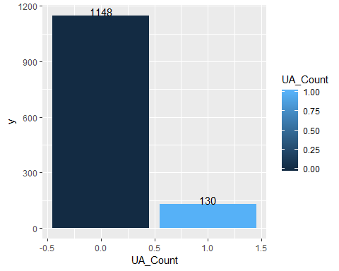

# 2. How many UAs were positive for protein?   
  
ACME_Data$Result.Text.URINALYSIS.PROTEIN<-as.factor(ACME_Data$Result.Text.URINALYSIS.PROTEIN)  
levels(ACME_Data$Result.Text.URINALYSIS.PROTEIN)

## [1] ""   
## [2] "1+ (100-200 mg/dL)"   
## [3] "2+ (200-300 mg/dL)"   
## [4] "3+ (300-500 mg/dL)"   
## [5] "4+ (>500 mg/dL)"   
## [6] "DNR"   
## [7] "INSUFFICIENT SAMPLE FOR COMPLETE ANALYSIS."  
## [8] "NEGATIVE"   
## [9] "TRACE"

ACME_Data$Result.Text.URINALYSIS.PROTEIN<-as.character(ACME_Data$Result.Text.URINALYSIS.PROTEIN)  
ACME_Data$UAs_Positive_Count <- ifelse(grepl("1+|2+|3+|4+", ACME_Data$Result.Text.URINALYSIS.PROTEIN), "1", "0")  
ACME_Data$UAs_Positive_Count<-as.numeric(as.character(ACME_Data$UAs_Positive_Count))  
  
df2 <- ddply(ACME_Data, .(UAs_Positive_Count), summarize, y=length(UAs_Positive_Count))  
df2$y<-as.numeric(as.character(df2$y))  
df2<-as.data.frame(df2)  
  
ggplot(df2, aes(UAs_Positive_Count, y=y, fill=UAs_Positive_Count)) + geom_bar(stat="identity") +  
 geom_text(aes(label=y), vjust=0)

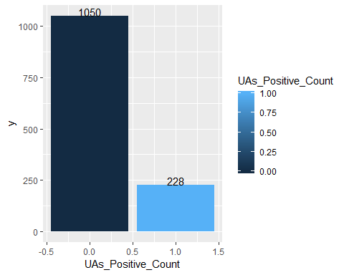

# 3. How many UAs were positive for protein and had no active sediment? (Number of UPCs which would have been run IF ACME used the Reflex UPC test offering)  
  
ACME_Data$UAs_Positive_Count<-as.factor(ACME_Data$UAs_Positive_Count)  
levels(ACME_Data$UAs_Positive_Count)

## [1] "0" "1"

ACME_Data$Result.Text.URINALYSIS.BACTERIA<-as.factor(ACME_Data$Result.Text.URINALYSIS.BACTERIA)  
levels(ACME_Data$Result.Text.URINALYSIS.BACTERIA)

## [1] "0"   
## [2] "DNR"   
## [3] "INSUFFICIENT SAMPLE FOR COMPLETE ANALYSIS."  
## [4] "MARKED (>40/HPF)"   
## [5] "MARKED >40/HPF, RODS AND COCCI PRESENT"   
## [6] "MARKED COCCI >40/HPF"   
## [7] "Marked Rods (>40/HPF)"   
## [8] "MARKED RODS >40/HPF"   
## [9] "MODERATE (9-40/HPF)"   
## [10] "MODERATE 9-40/HPF, RODS AND COCCI PRESENT"   
## [11] "MODERATE COCCI 9-40/HPF"   
## [12] "MODERATE RODS 9-40/HPF"   
## [13] "NA"   
## [14] "NONE SEEN"   
## [15] "RARE (<8/HPF)"   
## [16] "RARE <9/HPF, RODS AND COCCI PRESENT"   
## [17] "RARE COCCI <9/HPF"   
## [18] "RARE RODS <9/HPF"

ACME_Data$Result.Text.URINALYSIS.COLOR<-as.factor(ACME_Data$Result.Text.URINALYSIS.COLOR)  
levels(ACME_Data$Result.Text.URINALYSIS.COLOR)

## [1] "" "AMBER" "BROWN" "COLORLESS" "DARK YELLOW"  
## [6] "DNR" "ORANGE" "OTHER" "PALE YELLOW" "PINK"   
## [11] "RED" "STRAW" "Yellow" "YELLOW"

ACME_Data$Result.Text.URINALYSIS.RBC<-as.factor(ACME_Data$Result.Text.URINALYSIS.RBC)  
levels(ACME_Data$Result.Text.URINALYSIS.RBC)

## [1] ""   
## [2] ">100"   
## [3] "0-2"   
## [4] "10-Jun"   
## [5] "15-20"   
## [6] "15-Oct"   
## [7] "20-30"   
## [8] "30-50"   
## [9] "5-Feb"   
## [10] "50-75"   
## [11] "75-100"   
## [12] "DNR"   
## [13] "INSUFFICIENT SAMPLE FOR COMPLETE ANALYSIS."  
## [14] "NONE SEEN"

levels(ACME_Data$Result.Text.URINALYSIS.RBC)[levels(ACME_Data$Result.Text.URINALYSIS.RBC) == "10-Jun"]<-"6-10"  
levels(ACME_Data$Result.Text.URINALYSIS.RBC)[levels(ACME_Data$Result.Text.URINALYSIS.RBC) == "15-Oct"]<-"10-15"  
levels(ACME_Data$Result.Text.URINALYSIS.RBC)[levels(ACME_Data$Result.Text.URINALYSIS.RBC) == "5-Feb"]<-"2-5"  
  
ACME_Data$Result.Text.URINALYSIS.WBC<-as.factor(ACME_Data$Result.Text.URINALYSIS.WBC)  
levels(ACME_Data$Result.Text.URINALYSIS.WBC)

## [1] ""   
## [2] ">100"   
## [3] "0-2"   
## [4] "10-Jun"   
## [5] "15-20"   
## [6] "15-Oct"   
## [7] "20-30"   
## [8] "30-50"   
## [9] "5-Feb"   
## [10] "50-75"   
## [11] "75-100"   
## [12] "DNR"   
## [13] "INSUFFICIENT SAMPLE FOR COMPLETE ANALYSIS."  
## [14] "NONE SEEN"

levels(ACME_Data$Result.Text.URINALYSIS.WBC)[levels(ACME_Data$Result.Text.URINALYSIS.WBC) == "10-Jun"]<-"6-10"  
levels(ACME_Data$Result.Text.URINALYSIS.WBC)[levels(ACME_Data$Result.Text.URINALYSIS.WBC) == "15-Oct"]<-"10-15"  
levels(ACME_Data$Result.Text.URINALYSIS.WBC)[levels(ACME_Data$Result.Text.URINALYSIS.WBC) == "5-Feb"]<-"2-5"  
  
ACME_Data$Result.Text.URINALYSIS.BACTERIA<-as.character(ACME_Data$Result.Text.URINALYSIS.BACTERIA)  
ACME_Data$Bacteria_Q <- ifelse(grepl("0|NONE SEEN|RARE COCCI <9/HPF", ACME_Data$Result.Text.URINALYSIS.BACTERIA), "1", "0")  
ACME_Data$Bacteria_Q<-as.numeric(as.character(ACME_Data$Bacteria_Q))  
  
ACME_Data$Result.Text.URINALYSIS.COLOR<-as.character(ACME_Data$Result.Text.URINALYSIS.COLOR)  
ACME_Data$Color_Q <- ifelse(grepl("AMBER|BROWN|COLORLESS|DARK YELLOW|ORANGE|OTHER|PALE YELLOW|STRAW|YELLOW", ACME_Data$Result.Text.URINALYSIS.COLOR), "1", "0")  
ACME_Data$Color_Q<-as.numeric(as.character(ACME_Data$Color_Q))  
  
ACME_Data$Result.Text.URINALYSIS.RBC<-as.character(ACME_Data$Result.Text.URINALYSIS.RBC)  
ACME_Data$RBC_Q <- ifelse(grepl("0-2|6-10|15-20|10-15|20-30|30-50|2-5|50-75|75-100", ACME_Data$Result.Text.URINALYSIS.RBC), "1", "0")  
ACME_Data$RBC_Q<-as.numeric(as.character(ACME_Data$RBC_Q))  
  
ACME_Data$Result.Text.URINALYSIS.WBC<-as.character(ACME_Data$Result.Text.URINALYSIS.WBC)  
ACME_Data$WBC_Q <- ifelse(grepl("0-2|2-5", ACME_Data$Result.Text.URINALYSIS.WBC), "1", "0")  
ACME_Data$WBC_Q<-as.numeric(as.character(ACME_Data$WBC_Q))  
  
ACME_Data$Positive_NoSediment<-with(ACME_Data, ifelse(ACME_Data$UAs_Positive_Count == 1 &   
 ACME_Data$Bacteria_Q == 1 &  
 ACME_Data$Color_Q == 1 &  
 ACME_Data$RBC_Q == 1 &  
 ACME_Data$WBC_Q == 1, 1, 0))  
  
df3 <- ddply(ACME_Data, .(Positive_NoSediment), summarize, y=length(Positive_NoSediment))  
df3$y<-as.numeric(as.character(df3$y))  
df3<-as.data.frame(df3)  
  
ggplot(df3, aes(Positive_NoSediment, y=y, fill=Positive_NoSediment)) + geom_bar(stat="identity") +  
 geom_text(aes(label=y), vjust=0)

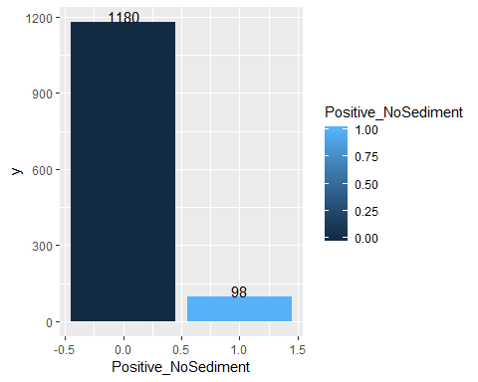

# 4. Number of actual UPCs run:   
  
#IF UPC was run cell would not be blank, if one cell is blank all three are  
  
UPCRATIOBLANK<-is.na(ACME_Data$Result.Text.UPC.Ratio)  
sum(UPCRATIOBLANK)

## [1] 0

#46 UPC tests did not run, plus the 2 are insufficent, 48 did not run   
  
#1230 ran   
   
# 5. How many UPCs were run that might have been unnecessary using the reflex UPC testing criteria?  
  
ACME_Data$Result.Text.UPC.Ratio<-as.factor(ACME_Data$Result.Text.UPC.Ratio)  
levels(ACME_Data$Result.Text.UPC.Ratio)

## [1] ""   
## [2] "0"   
## [3] "0.1"   
## [4] "0.2"   
## [5] "0.3"   
## [6] "0.4"   
## [7] "0.5"   
## [8] "0.6"   
## [9] "0.7"   
## [10] "0.8"   
## [11] "0.9"   
## [12] "1"   
## [13] "1.1"   
## [14] "1.2"   
## [15] "1.3"   
## [16] "1.4"   
## [17] "1.5"   
## [18] "1.6"   
## [19] "1.7"   
## [20] "1.8"   
## [21] "1.9"   
## [22] "10.4"   
## [23] "10.6"   
## [24] "11.2"   
## [25] "17.8"   
## [26] "2"   
## [27] "2.1"   
## [28] "2.2"   
## [29] "2.3"   
## [30] "2.4"   
## [31] "2.5"   
## [32] "2.6"   
## [33] "2.7"   
## [34] "2.8"   
## [35] "2.9"   
## [36] "3.1"   
## [37] "3.2"   
## [38] "3.3"   
## [39] "3.4"   
## [40] "3.5"   
## [41] "3.6"   
## [42] "3.9"   
## [43] "4"   
## [44] "4.1"   
## [45] "4.2"   
## [46] "4.3"   
## [47] "4.5"   
## [48] "4.6"   
## [49] "4.7"   
## [50] "4.8"   
## [51] "5"   
## [52] "5.2"   
## [53] "5.4"   
## [54] "5.5"   
## [55] "5.6"   
## [56] "5.7"   
## [57] "5.8"   
## [58] "6.1"   
## [59] "6.2"   
## [60] "6.4"   
## [61] "6.6"   
## [62] "6.9"   
## [63] "7"   
## [64] "7.2"   
## [65] "7.3"   
## [66] "7.4"   
## [67] "7.7"   
## [68] "8.6"   
## [69] "8.8"   
## [70] "9.4"   
## [71] "9.8"   
## [72] "INSUFFICIENT SAMPLE FOR COMPLETE ANALYSIS."

ACME_Data$Result.Text.UPC.Ratio<-as.numeric(as.character(ACME_Data$Result.Text.UPC.Ratio))

## Warning: NAs introduced by coercion

ACME_Data$Unnecessary_UPCs<-with(ACME_Data, ifelse(ACME_Data$UAs_Positive_Count == 0 &   
 ACME_Data$Result.Text.UPC.Ratio > 0, 1, 0))  
  
df4 <- ddply(ACME_Data, .(Unnecessary_UPCs), summarize, y=length(Unnecessary_UPCs))  
df4$y<-as.numeric(as.character(df4$y))  
df4<-as.data.frame(df4)  
  
ggplot(df4, aes(Unnecessary_UPCs, y=y, fill=Unnecessary_UPCs)) + geom_bar(stat="identity") +  
 geom_text(aes(label=y), vjust=0)

## Warning: Removed 1 rows containing missing values (position_stack).

## Warning: Removed 1 rows containing missing values (geom_text).

