Assignment 13.1

Problem Statement :-

Create a Scala application to find the GCD of two numbers.

Solution:-

CD (Greatest Common Divisor) or HCF (Highest Common Factor) of two numbers is the largest number that divides both of them.

For example:-

36 = 2 x 2 x 3 x 3

60 = 2 x 2 x 3 x 5

GCD = Mulipication of common factors

= 2 x 2 x 3 = 12

Thus,Scala Application to find GCD of two numbers is as follows:-object GCD {

def gcd(a: Int,b: Int): Int = {

if(b ==0) a else gcd(b, a%b)

}

def main(args: Array[String]) {

println(gcd(36,60))

}

}
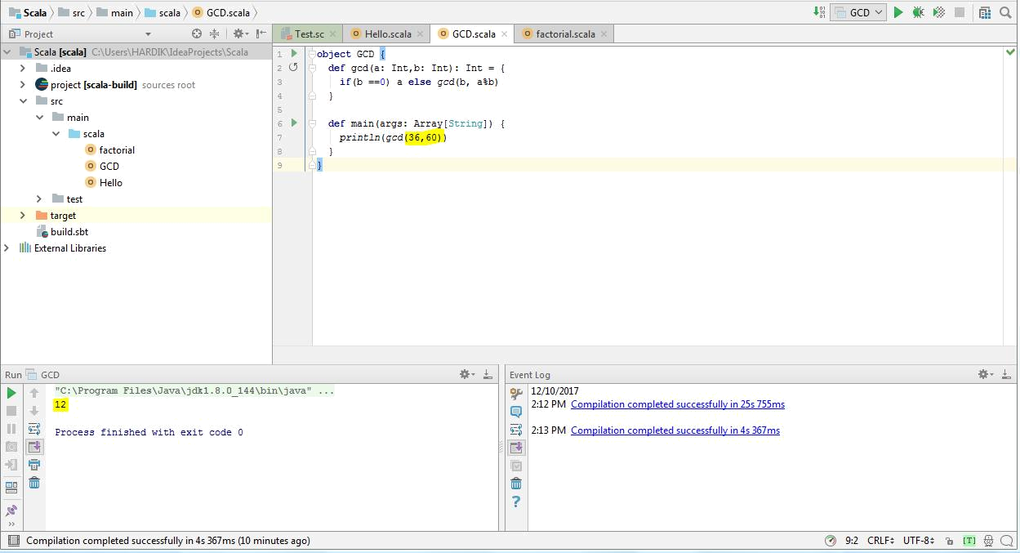
Than now try with other set of numbers as 20 and 28

20 = 4 x 5

28 = 4 x 7

GCD = 4
