Assignment 14.1

Problem Statement :-

Create a calculator to work with rational numbers.

Requirements:

- It should provide capability to add, subtract, divide and multiply rational numbers

- Create a method to compute GCD (this will come in handy during operations on rational)

Add option to work with whole numbers which are also rational numbers i.e. (n/1)

- achieve the above using auxiliary constructors

- enable method overloading to enable each function to work with numbers and rational.

Solution:-

Below is the scala class written to achieve above objective-

class Calc (n:Int, d:Int){

require(d!=0)

private val g = gcd(n.abs,d.abs)

val numerator = n/g

val denominator = d/g

private def gcd(x:Int, y:Int) :Int = {

if(x==0) y
else if (x<0) gcd(-x,y)

else if (y<0) gcd(x,-y)

else gcd(y%x,x)

}

def this(n: Int) = this(n, 1) // auxiliary constructor

def add (r:Calc): Calc =

new Calc(numerator * r.denominator + r.numerator*denominator , denominator*r.denominator)

def add (i: Int): Calc = // overloaded for add

new Calc(numerator + i * denominator, denominator)

def subtract (r:Calc) =

new Calc(numerator*r.denominator - r.numerator*denominator,denominator*r.denominator)

def subtract (i: Int): Calc = // overloaded for subtract new Calc(numerator - i * denominator, denominator)

def multiply (r:Calc) =

new Calc(numerator*r.numerator,denominator*r.denominator)

def multiply (i: Int): Calc = // overloaded for multiply new Calc(numerator * i , denominator)

def divide (r:Calc) = new

Calc(numerator*r.denominator,denominator*r.numerator)

def divide (i: Int): Calc = // overloaded for division new Calc(numerator , denominator * i)

override def toString = numerator + "/" + denominator

}

Below is the singleton object CalcObj defined to call above functions defined and do the operation-

object CalcObj {

def main(args: Array[String]): Unit = {

val a = new Calc(10,9)

val b = new Calc(17)
val c = new Calc(13,26)

val d = new Calc(11)

val p = a add 5

println(p)

val q = b multiply new Calc(11,9)

println(q)

val r = c subtract new Calc(16,1)

println(r)

val s = d divide 51

println(s)

}

}
Above codes are written in Intellij Idea, below are the screenshots-
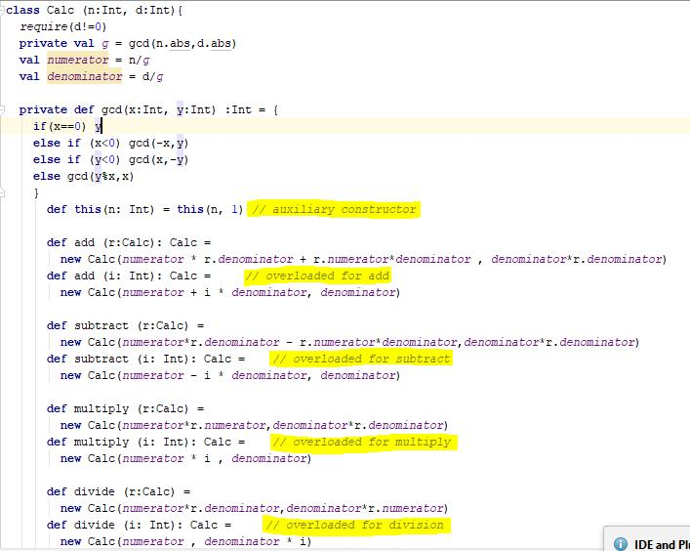

Here this statement def this(n: Int) = this(n, 1) basically working as an auxiliary constructor

Below is the screenshot for the singleton object for performing above operations.

This statement enables us to work with whole numbers which are also rational numbers i.e. (n/1).

Here each function- add, subtract, multiply, divide has been defined in such a manner via method overloading that it allows the user to work with numbers and rational.
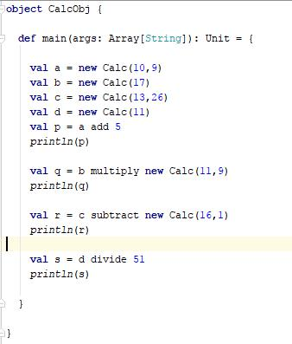

Below is the screenshot of the output produced after running above singleton object-
