Problem Statement

Using spark-sql, Find:
- What are the total number of gold medal winners every year

Below is the command used to find the result-
- val SportsData = sc.textFile("/home/acadgild/Assignment-19/Sports_data.txt")

- val schemaString = "firstname:string,lastname:string,sports:string,medal:string,age:integer,year:integer,country:s tring"

- val schema = StructType(schemaString.split(",").map(x => StructField(x.split(":")(0), if (x.split(":")(1).equals("string")) StringType else IntegerType, true)))

- val rowRDD = SportsData.map(_.split(",")).map(r => Row(r(0), r(1), r(2), r(3), r(4).toInt, r(5).toInt, r(6)))

- val SportsDataDF = spark.createDataFrame(rowRDD, schema)

- SportsDataDF.createOrReplaceTempView("Sports_Data")

- val result1DF = spark.sql("SELECT year,COUNT(*) FROM Sports_Data WHERE medal = 'gold' GROUP BY year")
- result1DF.show()

In order to proceed we need to import some dependencies as shown below-
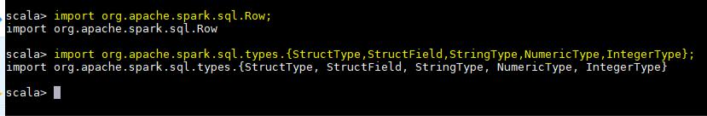

Now we are creating a RDD which reads from the input file-
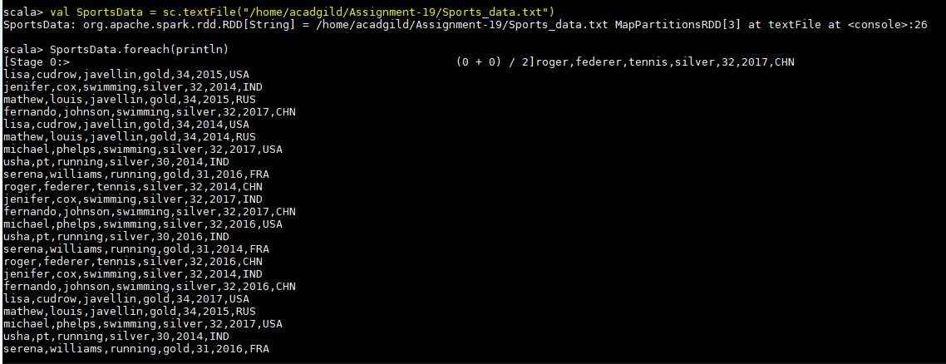

Since it is a text file we need to define schema too. Below screenshot shows the same-
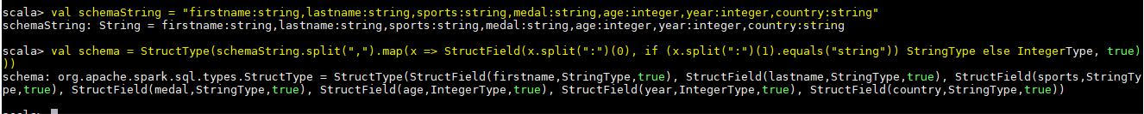

Now we are splitting the input file and extracting the rows from it-

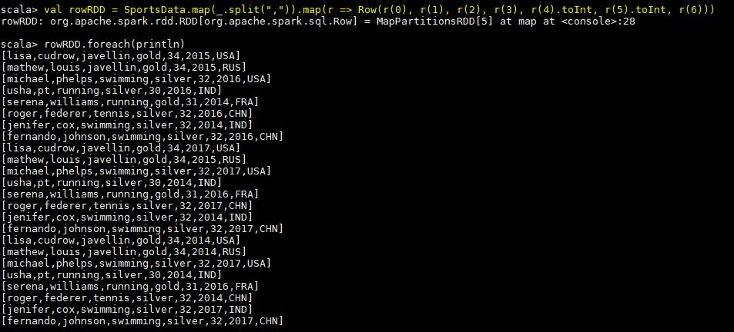

Now we are creating the dataframe by passing the RDD which reads the file and schema to spark session object-
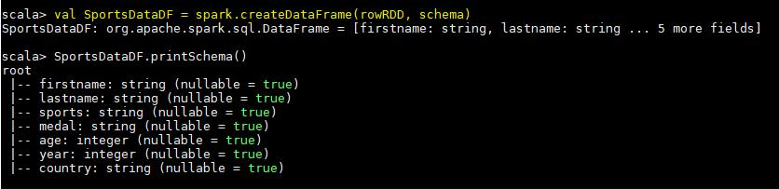

Here we are creating a temporary table first from the dataframe. Finally we can execute our SQL query on the temporary table to find the result-
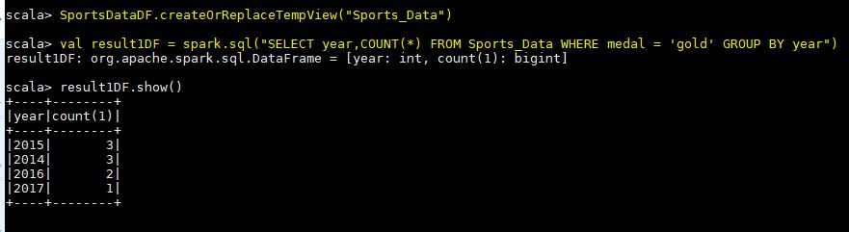
- How many silver medals have been won by USA in each sport?

Below is the code used to find the result-
- val SportsData = sc.textFile("/home/acadgild/Assignment-19/Sports_data.txt")

- val schemaString = "firstname:string,lastname:string,sports:string,medal:string,age:integer,year:integer,country:s tring"

- val schema = StructType(schemaString.split(",").map(x => StructField(x.split(":")(0), if (x.split(":")(1).equals("string")) StringType else IntegerType, true)))

- val rowRDD = SportsData.map(_.split(",")).map(r => Row(r(0), r(1), r(2), r(3), r(4).toInt, r(5).toInt, r(6)))

- val SportsDataDF = spark.createDataFrame(rowRDD, schema)

- SportsDataDF.createOrReplaceTempView("Sports_Data")

- val result2DF = spark.sql("SELECT sports,COUNT(*) FROM Sports_Data WHERE medal = 'silver' and country ='USA' GROUP BY sports")

- result2DF.show()

In order to proceed we need to import some dependencies as shown below-
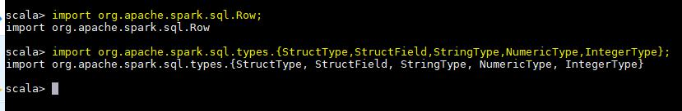

Now we are creating a RDD which reads from the input file-
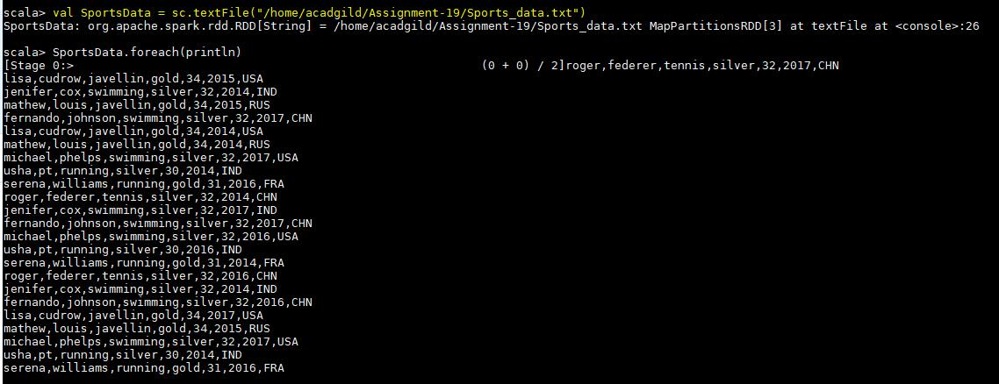

Since it is a text file we need to define schema too. Below screenshot shows the same-
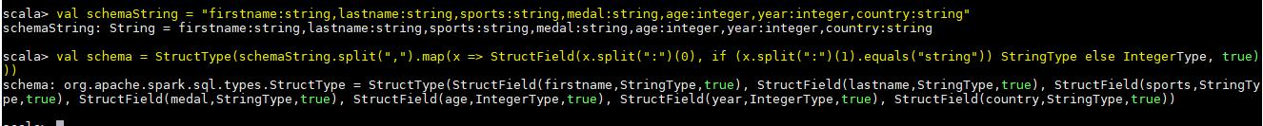

Now we are splitting the input file and extracting the rows from it-

Now we are creating the dataframe by passing the RDD which reads the file and schema to spark session object-

Finally we can execute our query by applying it on the temporary table created-
