Assignment 2.1

# Task 1:

Create a directory: /user/acadgild/hadoop

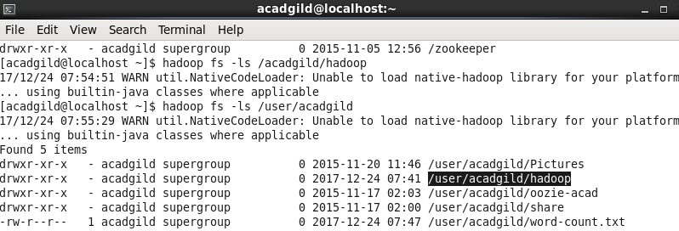

# Task 2:

Create a file wordcount under /user/acadgild/Hadoop path

