Assignement 1.1

# Acadgild VM downloaded

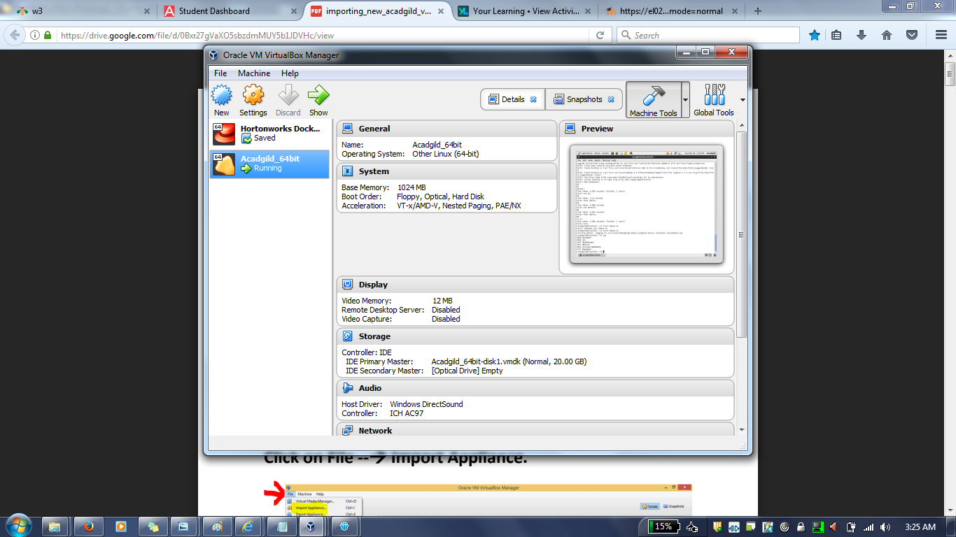

# JPS & Start the history server:

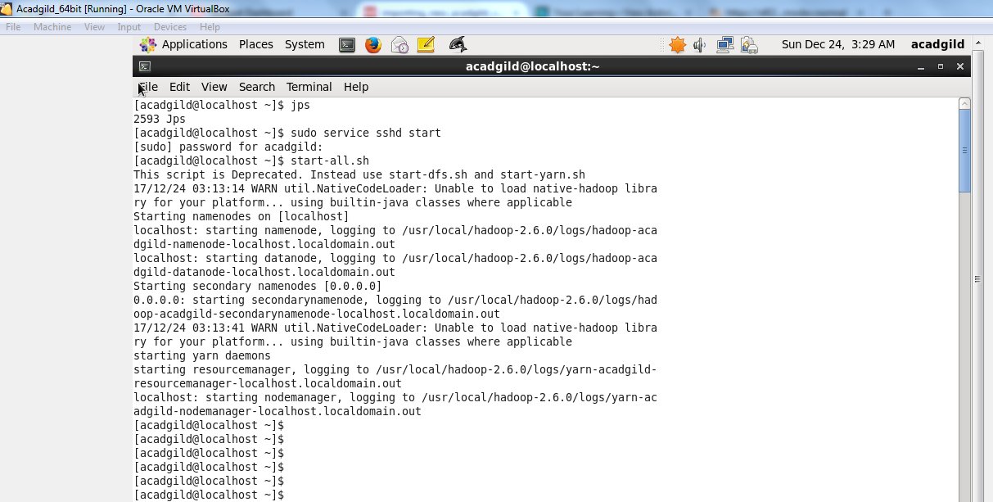

# 

# Pig:

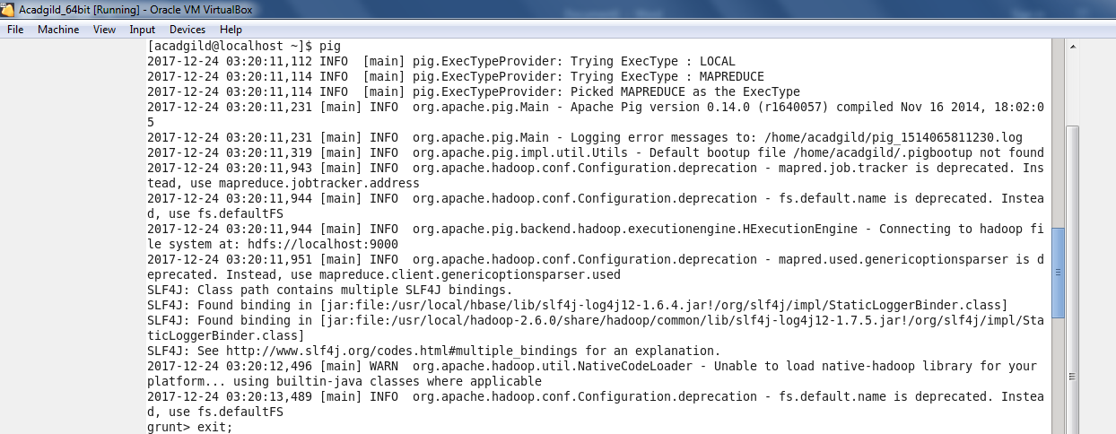

# Sudo services mysqld start & hive

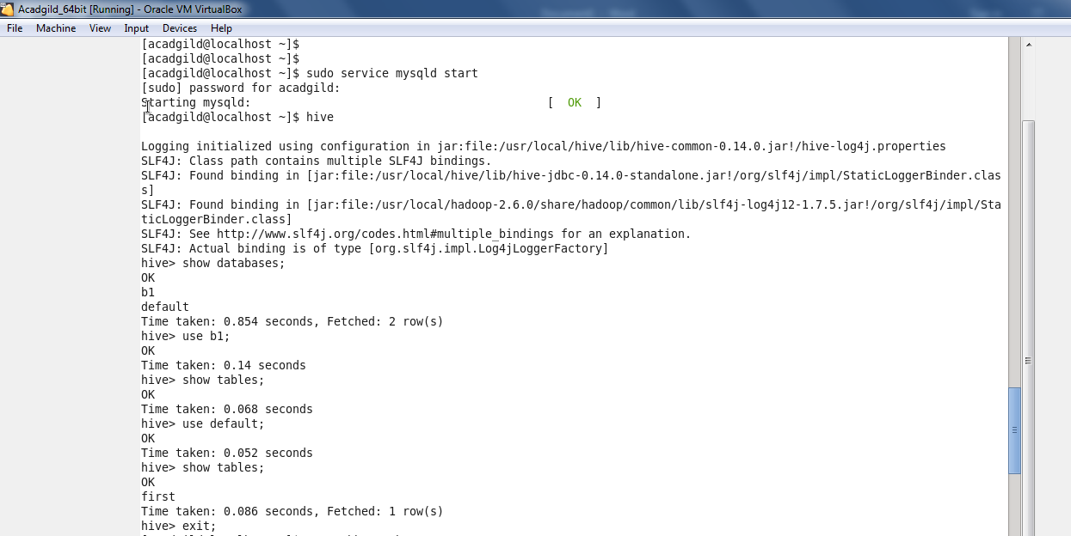

# Start hbase

