**Assignment 1.2**

1. **pwd:** Command is used to show the current directory.

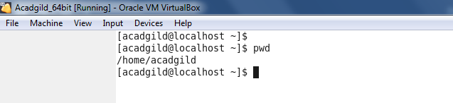

1. **vi:** command is used to modify the content of a file or create a new file.

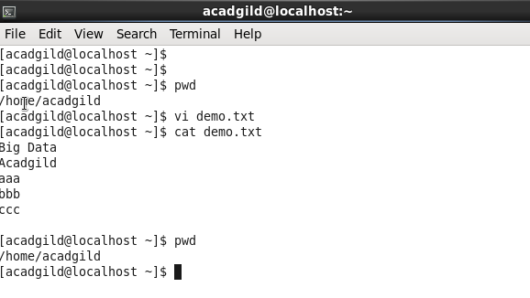

1. **touch:** command is used to create an empty file.

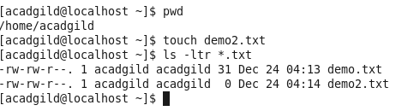

1. **mkdir:**  to make a new directory.

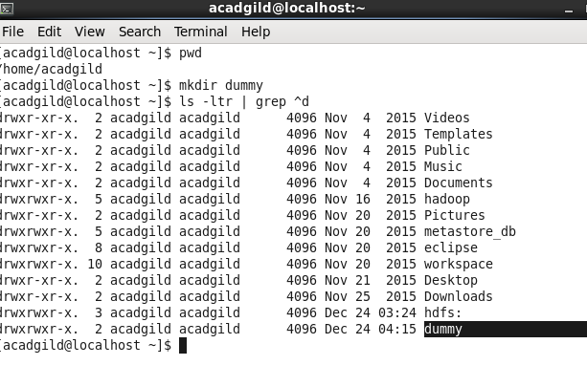

1. **rm:** remove a file.

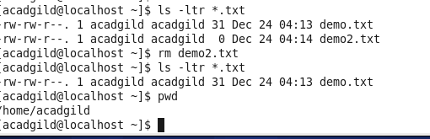

1. **ls:** list out the content of a directory.

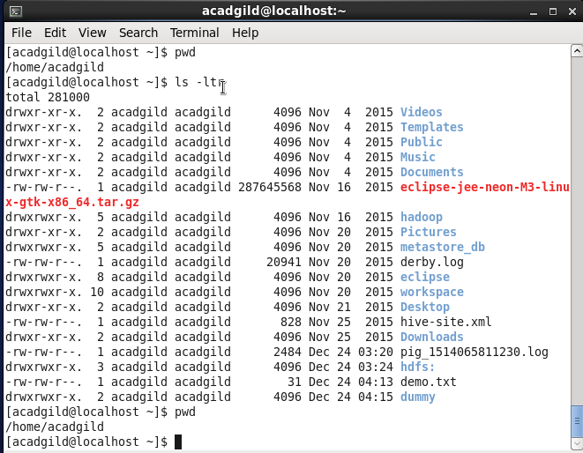

1. **echo:** command is used to show the messages on the terminal.



1. **cat:** command is used to display the contents of a file.

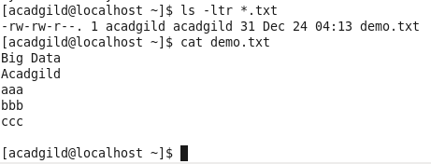

1. **who:** command is used to show the currently logged in users.

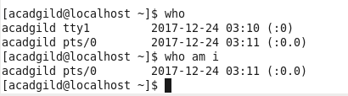

1. **cd:** current directory. It is used to go in the directory or come back from a directory**.**

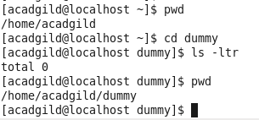

1. **date:** shows the current date and time.



1. **cal:** shows a calendar of the current month.

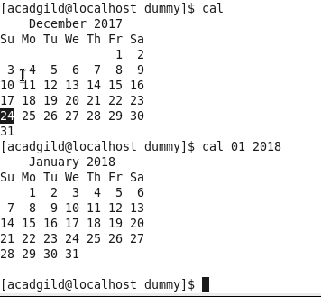

1. **mv:**  to rename a file/directory name and move a file from one location to another location

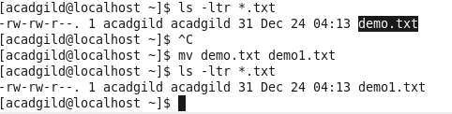

1. **cp:** to copy a file

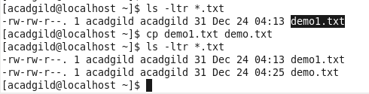

1. **which:** shows the full path of (shell) commands.

