Assignment 2.2

# Task 3:

Create a file temp_date.txt in local FS and move it to Hadoop.

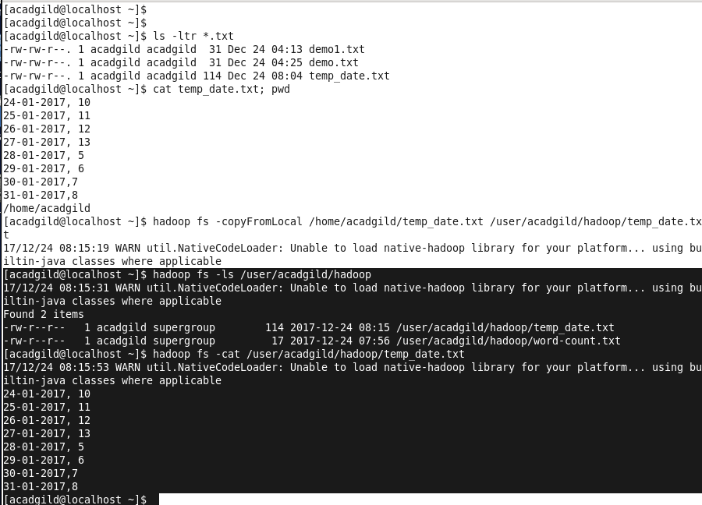

# Task 4:

Tasks:4

Change the permission of the file /user/acadgild/hadoop/max-temp.txt, such that only the owner and the group members have full control over the file.Others do not have any control over it.

