**ITIS 6400/8400 Principles of Human Computer Interaction**

**Spring 2018**

**Group Activity – Visual Design Critique**

**Names: Snigdha Bose, Robert Corzine, Poorna Chandrika Maddisetty, Moe Nagahisarchoghaei**

During this activity you will develop an understanding of the principles of good visual design, using mobile interfaces as an example. For mobile applications, the use of grids, alignment, fonts and font styles can create attractive visual designs and communicate content more effectively, but the visual design is also significantly affected by the style of the day: for example, the selection of fonts and colors are specific to a particular device, year, and expectations from that community.

Some general principles for identifying and critiquing visual design:

Grid: Use alignment for clarity and ease of reading

Font weight: Use bold, or italic to distinguish importance or emphasis

Font size: Scale and hierarchy to emphasize what is important

Color: Use scale and layout first, then use color last to distinguish

Space: Make space to guide the eye

You will critique two of the three the following mobile applications: WeatherBug, BBC News, and Facebook. During your critique, on each image, draw the grid showing columns and gutters. (If doing this electronically, you can cut and paste the images into this document, or start another)

Identify where the grid is broken if you think it has been. Circle the use of font color. Use other markings as necessary to answer the following questions. Feel free to open the apps yourself on your own phones to explore other screens, and comment on them.

**Part 1: Grid and Alignment**

For each image:

* Identify the columns, gutters, show where text is horizontally aligned (there will generally only be one column in a mobile app)
* Which elements cut across more than one column? How are the rows used?
* Where is the grid broken?
* What are the different columns or sections used for?
* Where and why is white space used?

**Part 2: Typeface and Emphasis**

For each image:

* Is font size used effectively? Where and how?
* Critique the use of font weight for importance or emphasis
* How is font color used? How many different colors are used?

**Part 3: Overall Critique:**

Compare the 2 apps and comment on the style and effectiveness of the visual design. Is the style used typical for that type of an app? Is it effective in communicating content?

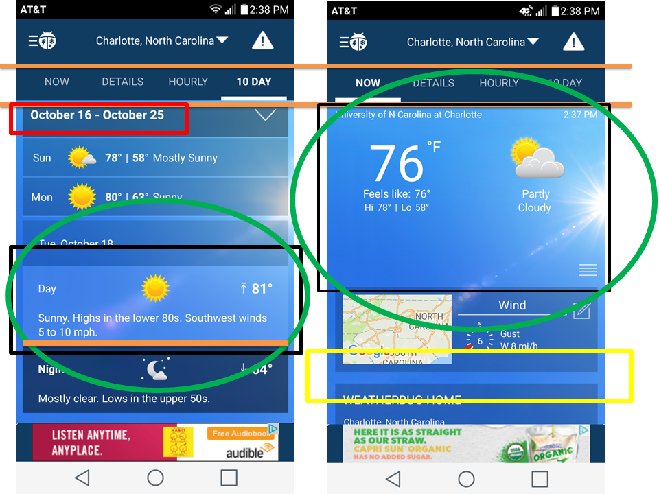

**Part 1: Grid and Alignment**

* **Identify the columns, gutters, show where text is horizontally aligned (there will generally only be one column in a mobile app)**

*Answer:* Illustration: The areas are marked on the respective images:

Green circle: white spaces

Black square: broken grid

Orange line: horizontal text

Red square: font section

Yellow square: gutters

* **Which elements cut across more than one column? How are the rows used?**

*Answer*: There is only one column. The rows are divided by the current day and current night then by each day of the week.

* **Where is the grid broken?**

*Answer:*  Black square: broken grid

* **What are the different columns or sections used for?**

*Answer:* They use for sorting data so that it will be easier to understand by user.

Also different columns or sections can use for guiding user to important contents.

Besides, it even used for attracting user to some specific parts that programmer want to show.

* **Where and why is white space used?**

*Answer:* Green circle: white spaces

White spaces are the negative spaces that are generally used to draw the attention of users. It stands out of the remaining elements in prioritizing the important information. White spaces are generally used for three main reasons: 1) Improving Comprehension 2) Clarifying relationships 3) Attracting attention

The above image shows the highlighted green circle gives white spaces used to highlight the temperature

**Part 2: Typeface and Emphasis**

* **Is font size used effectively? Where and how?**

*Answer:* The font size used is effective in center of the line so that most users pay attention on the centerline. The navigation bar at the top of the page has the text centered to show the that it is a button.

* **Critique the use of font weight for importance or emphasis**

*Answer:* The red square shows the thickness of the weight to enhance the readability of the text.

* **How is font color used? How many different colors are used?**

*Answer:* The red square shows the color used that helps make the readability of the text greater. The font colors that are used are all opposite to enhance the readability. Such as white text on a blue background.

**Part 3: Overall Critique:**

* **Compare the 2 apps and comment on the style and effectiveness of the visual design. Is the style used typical for that type of an app? Is it effective in communicating content?**

*Answer:*  The overall aspect of weatherbug compared to BBC news is similar in design but BBC news makes better use of the whitespace. Weatherbug has to much whitespace that could be used for valuable information. Overall weatherbug has a great style of its application and it does effectively communicate to the users the proper information.

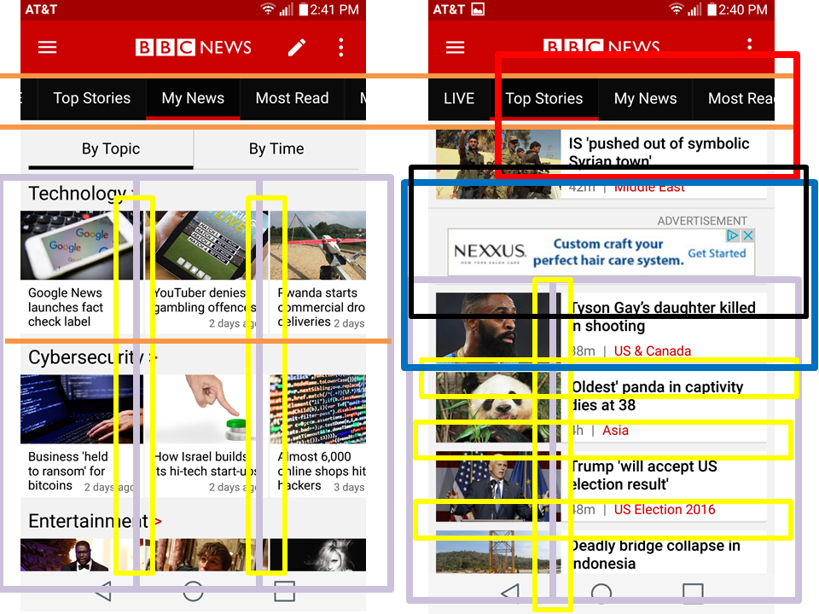

**Part 1: Grid and Alignment**

* **Identify the columns, gutters, show where text is horizontally aligned (there will generally only be one column in a mobile app)**

*Answer:* Illustration: The areas are marked on the respective images:

Green circle: white spaces

Black square: broken grid

Orange line: horizontal text

Red square: font section

Yellow square: gutters

Purple square: columns

Blue square: element cut across

* **Which elements cut across more than one column? How are the rows used?**

*Answer:* The blue square represents an advertisement that cuts across two columns for no reason besides causing confusion to the user.

* **Where is the grid broken?**

*Answer:* The black square shows where the grid is broken from the annoying advertisement.

* **What are the different columns or sections used for?**

*Answer:* The columns are broken into two pieces left column displays the image of the story, and the right column is the highlight or title of the story. The sections are broken up into different pieces represented as different stories or current events.

* **Where and why is white space used?**

*Answer:* This application did not have any whitespace.

**Part 2: Typeface and Emphasis**

* **Is font size used effectively? Where and how?**

*Answer:* The red square shows the font size is constant to every text on the page. We would change the size of the navigation to emphasize their buttons.

* **Critique the use of font weight for importance or emphasis**

*Answer:* The red square shows the font weight is good because it allows for readability.

* **How is font color used? How many different colors are used?**

*Answer:* The red square shows the color used that helps make the readability of the text greater. The font colors that are used are all opposite to enhance the readability. Such as white text on a black background.

**Part 3: Overall Critique:**

* **Compare the 2 apps and comment on the style and effectiveness of the visual design. Is the style used typical for that type of an app? Is it effective in communicating content?**

*Answer:* Overall this application has a better layout of the real estate. The content is more constant with informing the user of current events compared to weatherbug giving the current forecast. The style is not fancy at all so its straight forward about saying to the user this is news or current events. By having the style this way we believe that it allows for more effective communication to the users.