
Journal of Geophysical Research Planets
Supporting Information for
The effect of target properties on transient crater scaling for simple craters
N. C. Prieur¹, T. Rolf¹, R. Luther², K. Wünnemann², Z. Xiao^{1,3,4} and S. C. Werner¹
¹Centre for Earth Evolution and Dynamics (CEED), University of Oslo, Oslo, Norway.
²Museum für Naturkunde, Leibniz-Institute for Evolution and Biodiversity Science, Berlin, Germany.
³Planetary Science Institute, School of Earth Sciences, China University of Geosciences, Wuhan, China.
⁴Space Science Institute, Macau University of Science and Technology, Macau, China.

Corresponding author: Nils Charles Prieur (nilscp@geo.uio.no)

Contents of this file

Texts S1 to S3
Figures S1 to S3
Text S1. Dependencies of the scaling results on the transient crater definition

We consider the influence of the transient crater cavity definition on crater diameters and derived scaling relationships. To do this, we first define the transient crater in three different ways (listed here in the order of their expected time of appearance in the crater formation of a simple crater):

- The cavity at the time when the maximum cavity depth is first reached,
- The cavity at the time when the maximum cavity depth is last reached (i.e. before the onset of the modification stage),
- The cavity at the time of its maximum volume [e.g., Elbeshausen et al., 2009; Wünnemann et al., 2011; Güldemeister et al., 2015].

Each of these definitions were used to determine transient craters for the same simulation case, i.e., projectiles with diameters L = 100-1000 m impacting on a target with constant properties (f = 0.6, Φ = 30% and Y₀ = 5 Pa). Results are presented in Figure S1 and compared to the experimental dry-sand scaling [Holsapple and Housen, 2007], which have relatively similar target properties (f~0.7, Φ~30-40%). Depending on the selected definition, transient craters are reached at different times during crater formation, which results in different crater diameters and thus scaling relationships. This is apparent for instance with definition (1), where the maximum depth is reached relatively early during crater formation, compared to definitions (2) and (3). For comparison with the dry-sand scaling, the best agreement between numerical and physical experiments is found using definition (2). However, a better consistency is obtained with the maximum cavity volume definition for the transient crater diameter, which yields a scaling exponent and coefficient within 1% and 6 % of those inferred from laboratory experiments, respectively. Therefore, we select the maximum cavity volume as transient crater definition for the rest of this study.
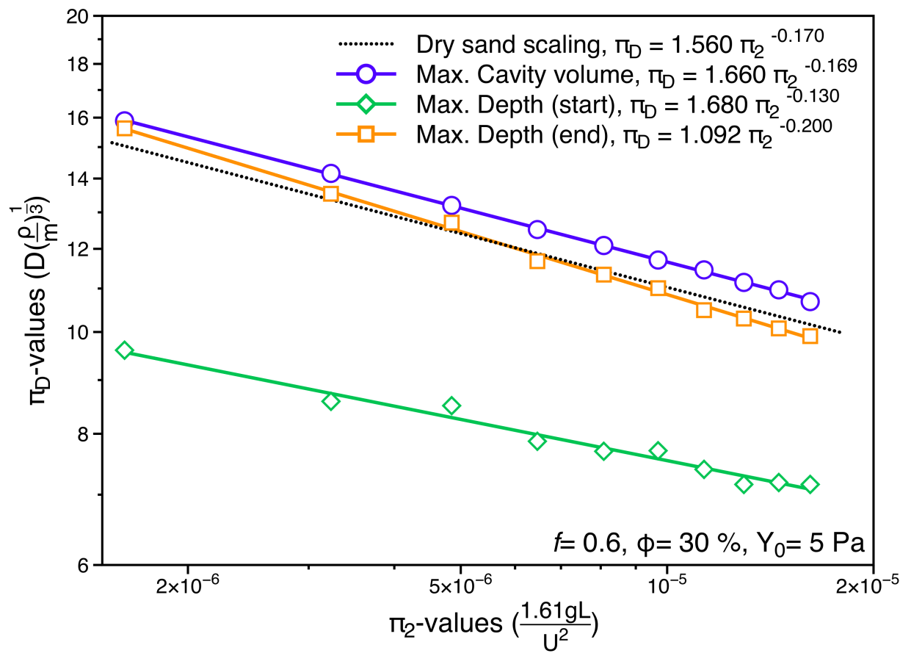
Figure S1. Dimensionless crater diameter (π_{D}) plotted versus the gravity-scaled size (π₂) for a target with friction coefficient f = 0.6, porosity Φ = 30 %, and cohesion Y₀ = 5 Pa. Different colors indicate scaling relationships derived with various transient crater definitions. The dry-sand scaling derived from Holsapple and Housen [2007] is given for reference.

Text S2. Dependencies of transient crater diameter on model resolution
The resolution in iSALE is quantified by the number of cells per projectile radius (CPPR) [Pierazzo et al., 2008]. In order to investigate the sensitivity of transient crater diameters on resolution, a test was performed for different resolutions (CPPR = 5, 10, 20 and 40). The impact velocity U = 12.7 km/s, projectile diameter L = 40 m, and all other properties were kept constant. Resulting transient crater diameters are shown in Figure S2. For CPPR = 10 transient crater diameter are underestimated by ~3%, while CPPR = 5 causes an underestimation of 11% relative to the values obtained for the highest resolution (CPPR = 40). For CPPR≥10-15 differences become smaller and smaller, such that a further increase of resolution does not lead to results closer to the absolute true values (i.e. the value at an infinite resolution). Therefore, a value of CPPR = 20 cells was deemed sufficient to resolve the governing processes, while keeping computational costs reasonable.
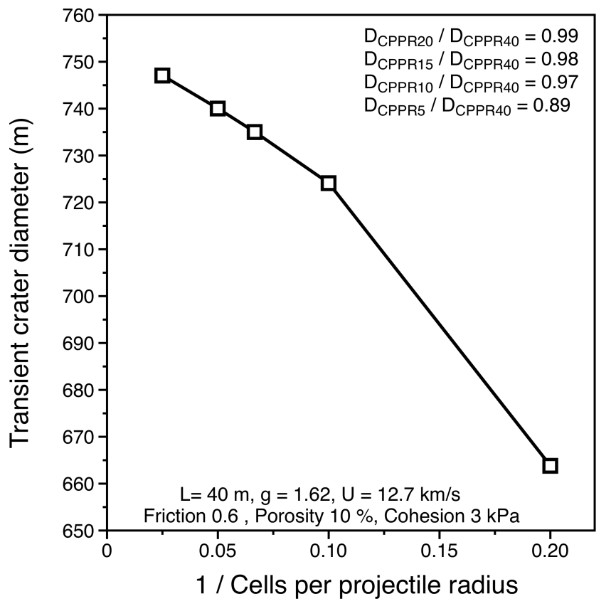
Figure S2. Transient crater diameter as a function of the inverse of the number of cells per projectile radius. This resolution test was conducted for a simulation with a projectile diameter of L = 40 m, a gravity of g = 1.62 m/s², an impact velocity of U = 12.7 km/s, a coefficient of friction of f = 0.6, a porosity of Φ = 10 %, and a cohesion of Y₀ = 3 kPa. Transient crater diameters normalized to the highest resolution case (CPPR = 40) are depicted in the upper right corner of the figure.
Text S3. The influence of transient crater morphologies on derived scaling parameters
We here examined how much transient crater morphologies vary with target properties and whether this could affect the derived scaling parameters. Figure S3 depicts transient crater cavities for various combinations of f and Φ for a given projectile (L = 100 m, Figure S3a), and for L = 25-1000 m for targets with f = 0.2 and f = 0.8 (Figures S3b and S3c, respectively), with particular emphasis on depth-diameter ratios (d/D). Results indicate that the shape of the transient crater is dependent on target properties and projectile diameters. Indeed, increases in the coefficient of friction decrease both transient crater depths and diameters (Figure S3a), whereas increases in porosity decrease only transient crater diameters. Over the range of projectile diameters studied, the largest averaged d/D ratios are observed for targets with large porosity and small friction (Figures S3b and S3c). We speculate that the shape of the transient crater could probably have an influence on the scaling exponent and coefficients derived and could therefore be the reason for the observed increase of the scaling exponent μ in targets with low frictions and large porosities.

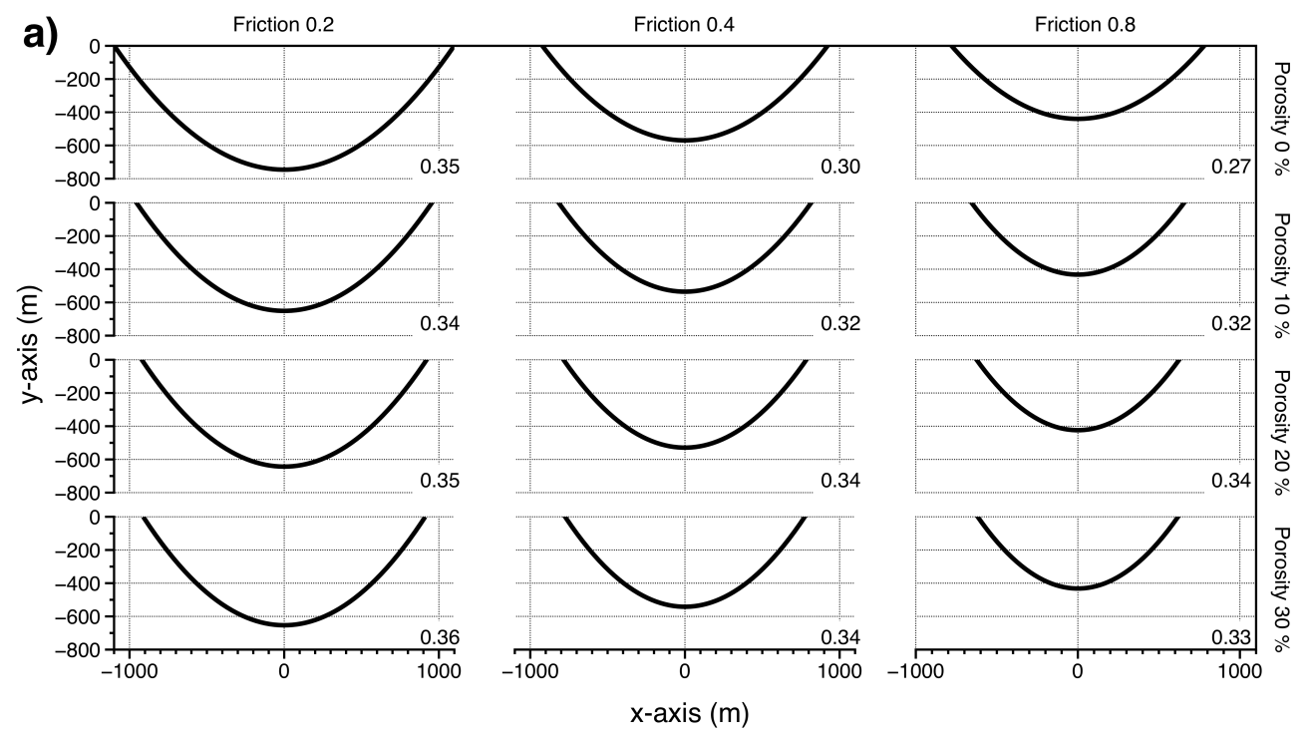
Figure S3. a) Depth-to-diameter ratios for transient craters resulting from an impact with a projectile diameter of L = 100 m on targets with various coefficient of frictions and porosities. Depth-to-diameter ratios as a function of projectile diameter (L = 25 to 1000 meters) for targets with varying porosities (Φ = 0, 10, 20, 30, 40 and 50%) and an angle of friction of 0.2 and 0.8 are shown in (b) and (c), respectively.
References
Elbeshausen, D., K. Wünnemann, and G. S. Collins (2009), Scaling of oblique impacts in frictional targets: Implications for crater size and formation mechanisms, Icarus, 204(2), 716-731, doi:https://doi.org/10.1016/j.icarus.2009.07.018.
Güldemeister, N., K. Wünnemann, and M. Poelchau (2015), Scaling impact crater dimensions in cohesive rock by numerical modeling and laboratory experiments, Geological Society of America Special Papers, 518, SPE518-502, doi:10.1130/2015.2518(02).
Holsapple, K. A., and K. R. Housen (2007), A crater and its ejecta: An interpretation of Deep Impact, Icarus, 191(2), 586-597, doi:10.1016/j.icarus.2006.08.035.
Pierazzo, E., N. Artemieva, E. Asphaug, E. C. Baldwin, J. Cazamias, R. Coker, G. S. Collins, D. A. Crawford, T. M. Davison, and D. Elbeshausen (2008), Validation of numerical codes for impact and explosion cratering: Impacts on strengthless and metal targets, Meteoritics & Planetary Science, 43(12), 1917-1938, doi:10.1111/j.1945-5100.2008.tb00653.x.
Wünnemann, K., D. Nowka, G. S. Collins, D. Elbeshausen, and M. Bierhaus (2011), Scaling of impact crater formation on planetary surfaces: Insights from numerical modeling, in Proceedings of the 11th Hypervelocity Impact Symposium, Freiburg, edited.

