<https://learn.microsoft.com/en-us/training/modules/power-bi-copilot/>

<https://learn.microsoft.com/en-us/training/paths/prepare-visualize-data-power-bi/>

<https://www.microsoft.com/en-us/power-platform/products/power-bi/pricing?msockid=39ec0afca64a6a832c8b1e66a7b16bac>

<https://learn.microsoft.com/en-us/power-bi/fundamentals/service-features-license-type>

<https://www.microsoft.com/en-us/power-platform/products/power-bi/downloads>

**Power BI Licensing and Access**

If a Power BI report is hosted in a **workspace that uses Power BI Premium capacity**, then:

* **Users without a Power BI Pro or Premium Per User (PPU) license** can **view the report** *only if* the report is in a Premium capacity workspace and they have been granted access.
* If the report is created by someone with a **Premium Per User (PPU)** license and stored in a **PPU workspace**, then **only other users with a PPU license** can access it. Users without a PPU license **cannot** view reports in a PPU workspace.
* Fabric Capacity license includes the Power BI Premium License

ttps://learn.microsoft.com/en-us/power-query/connectors/

Jacqueline Do8/1/2025 10:11 AMcan power apps, power automate flow or microsoft flow be integrated with Power BI directly?

<https://learn.microsoft.com/en-us/power-bi/visuals/power-bi-visualization-powerapp>

<https://learn.microsoft.com/en-us/power-bi/create-reports/power-bi-automate-visual>

Prabir Maiti8/1/2025 10:21 AMhow can we ensure no data is saved locally when loading and transforming the data in powerbi?

by using DirectQuery in PBI or DirectLake in Fabric

Transform -> Power Query editor

Load -> Desktop

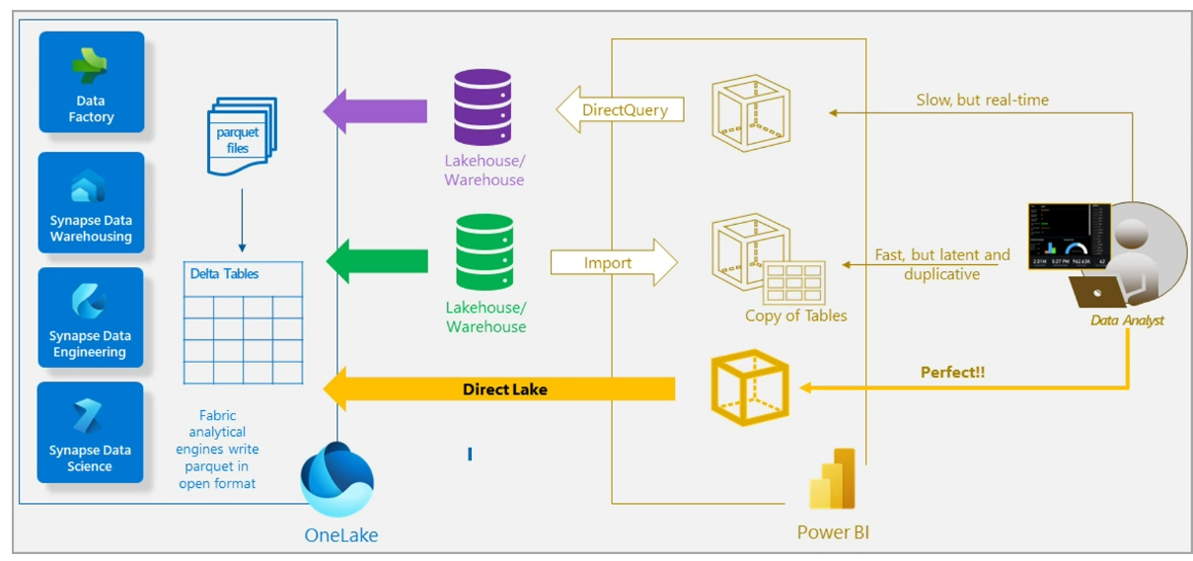

Create a Microsoft Account: <https://account.microsoft.com>

**Lab portal:**<https://esi.learnondemand.net>

**Lab key:** EE815291E42348C0

Login - Skillable TMS

Direct Lake is storage - you can use it with a Datawarehouse - T-SQL

Lakehouse - Pyspark, Spark SQL, R and more

Prabir Maiti8/1/2025 11:57 AMalso, do we need a Power BI desktop software to be installed to build our visualization always?

You can use Power BI Service too

<https://www.ehansalytics.com/blog/2021/5/8/use-data-profiling-in-power-query>

<https://www.techtarget.com/searchdatamanagement/definition/data-scrubbing#:~:text=Data%20cleansing%2C%20data%20cleaning%20and,old%20data%20from%20data%20sets>.

<https://learn.microsoft.com/en-us/power-bi/visuals/power-bi-visualization-types-for-reports-and-q-and-a>

<https://www.microsoft.com/en-us/power-platform/products/power-bi/topics/data-visualization/data-visualization-vs-storytelling>

<https://www.numerro.io/guides/the-complete-guide-to-designing-power-bi-reports>

<https://learn.microsoft.com/en-us/power-bi/create-reports/desktop-accessibility-creating-reports>

<https://community.fabric.microsoft.com/t5/Data-Stories-Gallery/bd-p/DataStoriesGallery>

<https://copilot.microsoft.com>

<https://learn.microsoft.com/en-us/power-bi/create-reports/copilot-introduction>

M and DAX are two languages to be used for Power BI queries

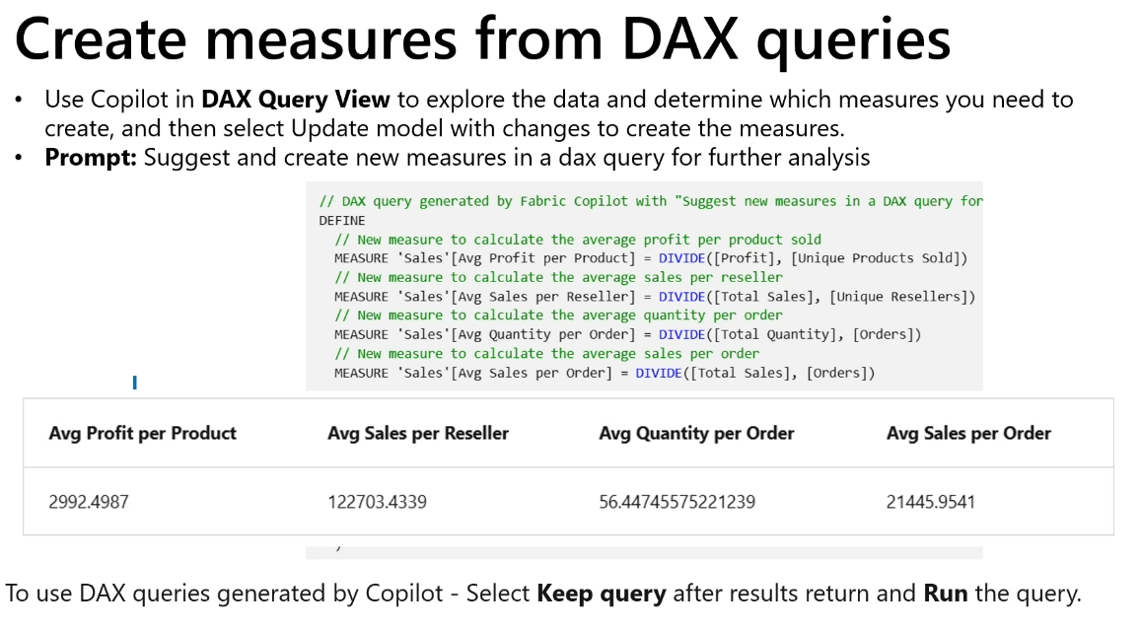

Hale, Loren8/1/2025 3:39 PM

So a measure is a saved calculation written in DAX?

a measure just the formula that is run every time that you need it. It is calculated on the fly

DP-600 - 4 day course - fabric

DP-601 – Lakehouse

DP-602 – Warehouse

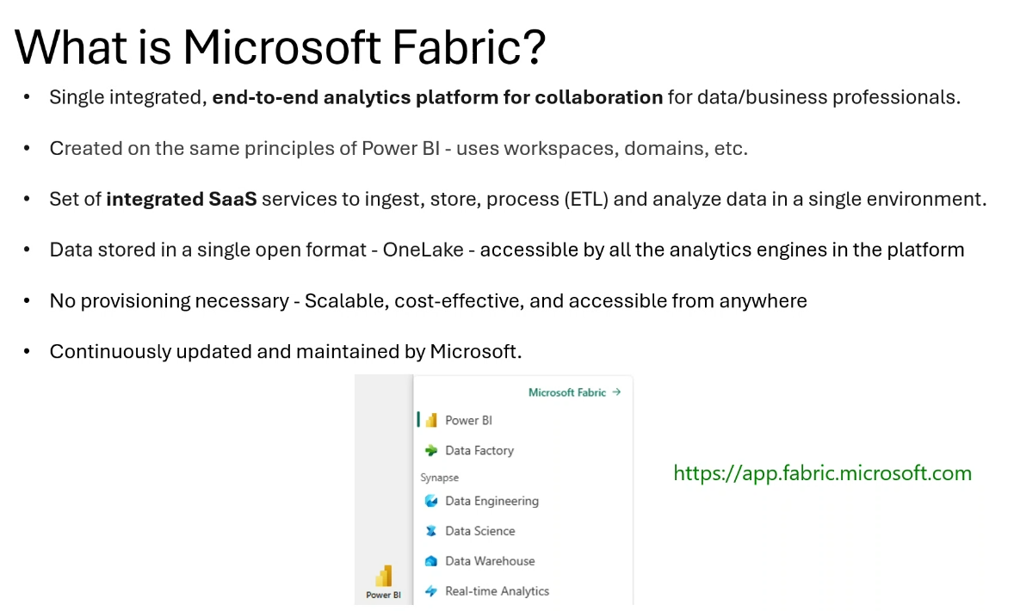

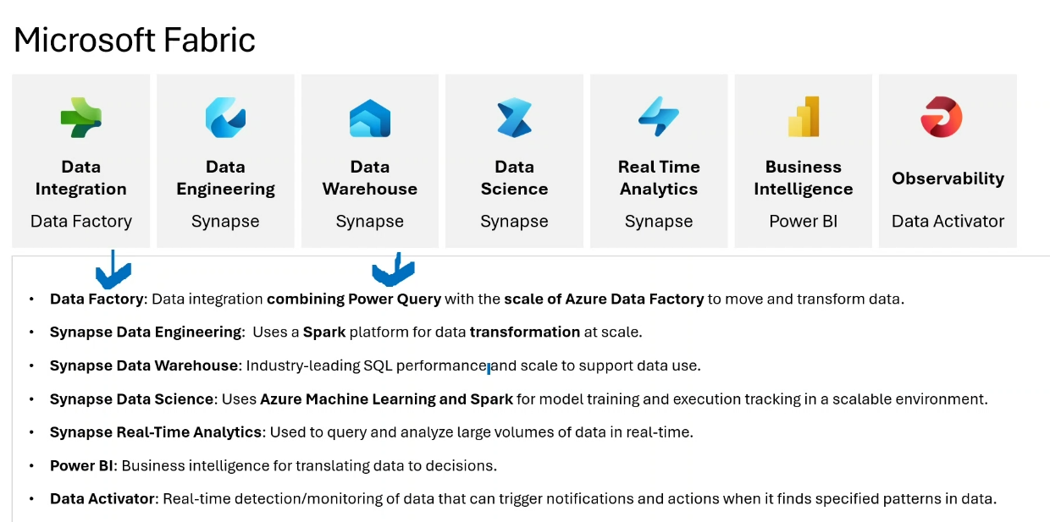

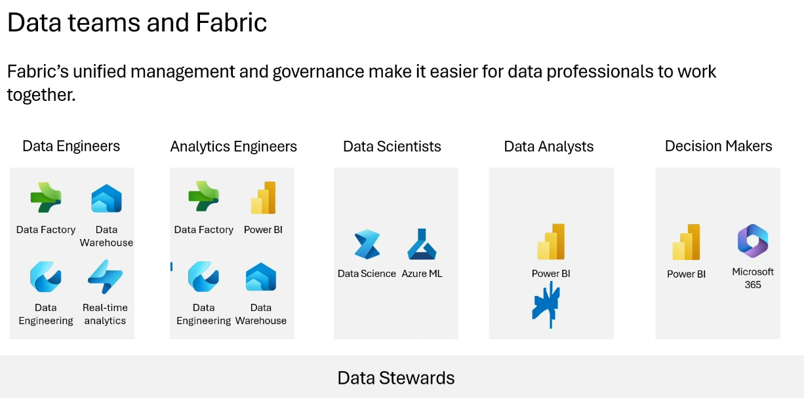

<https://learn.microsoft.com/en-us/training/paths/draft-analyze-present-microsoft-365-copilot/>

*AI-generated content. Be sure to check for accuracy.*

**Power BI Fundamentals Training – Key Notes**

* **Power BI Overview**
  + Power BI is a suite of services (Desktop, Service, Mobile) for building and sharing reports to support decision-making.
  + Three main license types: Free (for Desktop), Pro (for sharing/collaboration), Premium/Fabric Capacity (for advanced features and broader sharing). 1
  + Power BI Desktop is Windows-only; Mobile apps are available for iOS, Android, and Windows. 2
* **Power BI Workflow**
  + Typical flow: Connect to data sources → Transform/Clean data (ETL) → Build semantic model and reports in Desktop → Publish to Service → Share with users (including via apps). 3
  + Data sources can include Excel, SQL, SharePoint, cloud databases, and more. 4
* **Licensing and Access**
  + Free license allows personal use and publishing to “My Workspace” only.
  + Sharing with others requires Pro or Premium/Fabric Capacity licenses.
  + Premium/Fabric Capacity enables sharing with free users if workspace is assigned to capacity. 5
  + Fabric Capacity is the new name for Premium Capacity. 6
* **Data Connection and ETL**
  + Power BI connects to a wide range of data sources (see [List of all Power Query connectors](https://www.shared_links/link_7.com) (chat)).
  + ETL (Extract, Transform, Load) can be performed in Power Query Editor (built into Desktop and available online in Fabric).
  + For large datasets or advanced cleaning, Azure or Fabric tools (Dataflow Gen2, Data Wrangler, pipelines) can be used. 7
* **Data Modeling**
  + Star schema (fact table with dimension tables) is recommended for performance and clarity. 8
  + Relationships: One-to-many, many-to-one, one-to-one, and many-to-many are supported.
  + Date/time tables should be explicitly created and marked to avoid hidden tables and improve performance. 9
  + Hierarchies (e.g., category > subcategory > product) should be in a single table for best performance. 10
* **Report Design Best Practices**
  + Keep reports simple, consistent, and accurate; know your audience and the report’s purpose. 11
  + Use 6–10 visuals per page; split into multiple pages if needed. 12
  + Divide layout: summary at top, main visuals in middle, supporting info at bottom, slicers/filters on the left. 13
  + Choose visuals based on data/story (see [The Complete Guide to Designing Power BI Reports](https://www.shared_links/link_20.com) (chat)).
  + Use built-in visuals or add custom visuals from the AppSource or organizational gallery. 14
  + Accessibility and color best practices are important (see [How to design Power BI reports for accessibility](https://www.shared_links/link_18.com) (chat)).
* **Labs and Hands-On**
  + Three labs: Get Data, Clean/Transform Data, Design Report.
  + Labs are self-contained and can be saved (except the last one); access for six months, up to 10 launches per lab. 15
  + Lab environment uses Learn on Demand; personal Microsoft account required. 16
* **Copilot and AI in Power BI**
  + Copilot (generative AI) can summarize models, suggest relationships, create DAX measures, generate reports, and provide executive summaries.
  + Requires Fabric Capacity (F64 or higher) or Premium Per Capacity license. 17
  + Copilot works in both Desktop and Service; prompts are in natural language.
  + Other AI features: Q&A visual, anomaly detection, forecasting, sentiment analysis, and smart narrative. 18
* **Fabric Overview**
  + Fabric is a SaaS data platform integrating Power BI, Data Factory, Data Engineering, Data Science, and Real-Time Analytics.
  + OneLake is the unified storage layer; supports structured (warehouse) and unstructured/semi-structured (lakehouse) data. 19
  + Fabric simplifies architecture—just create a workspace, add lakehouse/warehouse, and ingest data.
  + Courses: DP-600 (4 days, advanced), DP-601 (Lakehouse), DP-602 (Data Warehouse), MS-4018 (Copilot). 20
* **Resources & Links (chat)**
  + [Prepare and visualize data with Microsoft Power BI DP-605T00 - Training - Microsoft Learn](https://learn.microsoft.com/en-us/training/paths/prepare-visualize-data-power-bi/)
  + [Power BI: Pricing Plan - Microsoft Power Platform](https://www.microsoft.com/en-us/power-platform/products/power-bi/pricing?msockid=39ec0afca64a6a832c8b1e66a7b16bac)
  + [Data Stories Gallery - Microsoft Fabric Community](https://community.fabric.microsoft.com/t5/Data-Stories-Gallery/bd-p/DataStoriesGallery)
  + [Overview of Copilot for Power BI - Power BI - Microsoft Learn](https://learn.microsoft.com/en-us/power-bi/create-reports/copilot-introduction)
  + [Draft, analyze, and present with Microsoft Copilot 365 MS-4018 - Training - Microsoft Learn](https://learn.microsoft.com/en-us/training/paths/draft-analyze-present-microsoft-365-copilot/)
* **Other Notes**
  + Each lab is independent; no dependency between them. 21
  + Saving a lab allows resuming within seven days. 22
  + Survey completion is requested at the end of class for feedback and to receive extra resources. 23

Draft, analyze, and present with Microsoft 365 Copilot MS-4018.

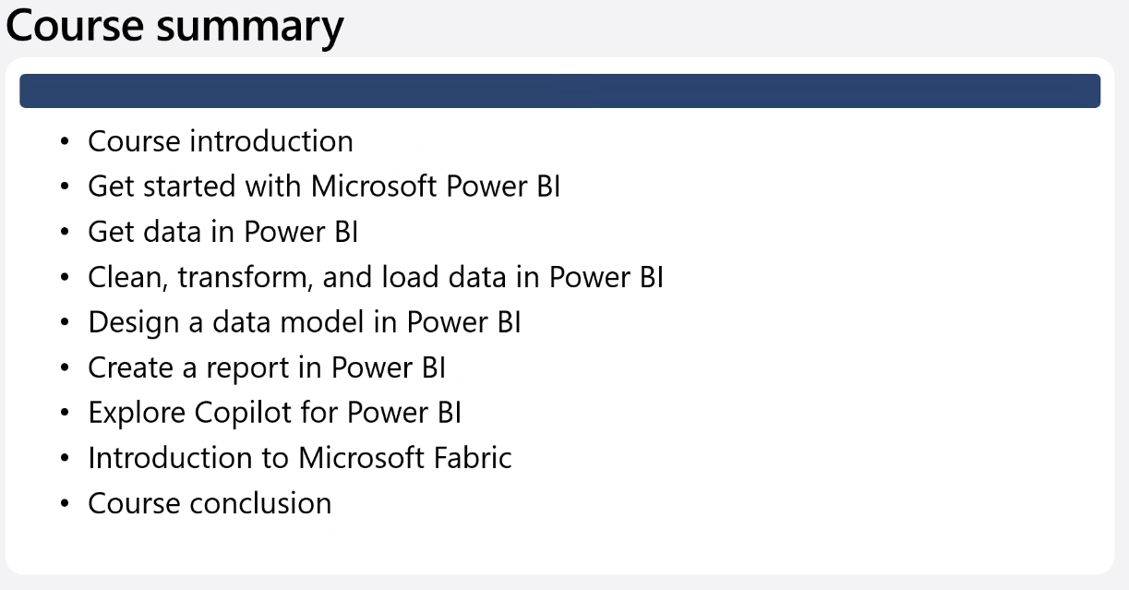

<https://community.fabric.microsoft.com/t5/custom/page/page-id/CareerHubPage?ocid=fabric24_careerhub_fabriccomm_header_clp&WT.mc_id=data-122180-somelezediko>

<https://arch-center.azureedge.net/Credentials/Certification-Poster_en-us.pdf>