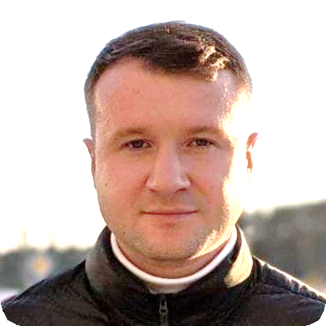Pavel Makhakhei

QA Architect, Test Automation

# Profile

I’m specializing in building strategies and holistic ecosystems aiming to improve time to market, quality in production, testing effectiveness.

**Highlights:**

* 10+ years' experience in Quality Assurance, Test Automation
* 5+ years' experience in leading, consulting, management
* Successfully implemented transformation strategy for multiple projects with focus on business goals
* Led multiple client-facing Quality Assurance and Test Automation assessments, improvement programs
* Supported Testing pre-sales for enterprise clients
* Enabled continuous monitoring on projects via developing Quality Metrics and KPIs framework
* Played the role of hiring manager in TA and managed group of 10+ engineers and project teams
* Conference speaker, trainer: conducted up to 10 internal and external events
* Certified technical interviewer: conducted 100+ global tech interviews
* Led initiatives on Cloud-Native testing competency, Continuous Testing and Test Automation technology trends

# Employment History

## Consultant / Quality Architect at EPAM

**January 2019 — Present**

Running audits and quality assessments, making proposals to clients, driving discovery phases, participation in pre-sales (RFI, RFP), creating POCs. Leading R&D work around Test Automation Trends, Continuous Testing, Testing in Cloud.

Completed ~10 internal and client-facing consulting engagements focused on improving product quality and (or) time to market and (or) testing effectiveness. Delivered 5+ proposals which ended-up in implementation of improvements and transformation roadmap for test automation and test strategy.

## Testing Team Lead / Project Coordinator at EPAM

**July 2014 — December 2018**

Customer: multinational media conglomerate, legal

Testing Team Lead and later Project Coordinator of the team of 20+ engineers. Coordinated QA and Dev team, created architecture for test automation solutions for Web Services, Web UI, Mobile native

## Details

Minsk, Belarus

[makhakhei.pavel@gmail.com](mailto:makhakhei.pavel@gmail.com)

## Links

[GitHub.io](https://pmakhakhei.github.io/)

[LinkedIn](https://www.linkedin.com/in/pavel-m-779955267i/)

[Telegram](https://t.me/pavel_m7i)

## Skills

Automated Testing

Leadership

CI/CD

Cloud, Microservices

Metrics and KPIs

Software Testing Life Cycle

Agile Methodologies

C# .NET

Java

Git

Selenium WebDriver

WebDriver.IO

Cypress

## Languages

English B2

applications. Integrated testing processes into software development life cycle, implemented continuous delivery pipeline for Azure cloud. Was responsible for direct communication and negotiation with clients as a project lead.

Tools: TFS 2017, MTM, Coded UI, MS Test, SOAP UI

Technologies: .NET, C#, REST, XML, JSON

## Lead Software Test Automation Engineer at EPAM

**February 2014 — May 2014**

Project: Large scale solution for Tax Committee highly integrated with external financial systems

Managed automation team of 3 engineers, implemented automation strategy, calculated ROI of test automation, planned automation activities, created framework from scratch based on Selenium + Java, led tests implementation according to target coverage. Delivering test automation training program for remote location.

Tools: Selenium WebDriver, Eclipse IDE, Oracle Enterprise Manager, Oracle SQL Developer, Oracle WebLogic, Red Hat Enterprise Linux, Microsoft Windows 7, Maven, TestNG

Technologies: Java 7, HTML, XML, Web Services (SOAP)

## Lead Software Test Automation Engineer at EPAM

**August 2012 — December 2013**

Project: enterprise information management software

Implemented automation framework in TestComplete and later automation framework for Web application from scratch based on WebDriver, designed automation frameworks architecture, implemented testing scenarios, developed automation strategy. Performed training and mentoring, code review.

Tools: Selenium WebDriver, TestComplete 8/9, NUnit, TestNG, TeamCity Professional 8, Apache Tomcat 7, TFS, Microsoft Visual Studio 2010, Apache Ant

Technologies: Java, XML, JScript, HTML, XPATH

## Senior Software Test Automation Engineer at EPAM

**February 2009 — August 2012**

Was running and troubleshooting regression scripts, migrating existing libraries, maintaining test automation framework, developing architecture of test automation framework. Was responsible for front-end and back-end automation, functional testing of integration with third-party systems, communication with customers, providing estimations.

Tools: Borland SilkTest 2008R2/2009(R2), Terminals, DBVisualizer, Windows Vista/XP/2003/Seven, IE 6/7/8, SQL Server Management Studio, Oracle SQL Developer, IIS 6.0/7.0, NUnit, TestComplete 8, TeamCity Professional, SpecFlow, Microsoft Visual Studio

Technologies: .Net 3.5, C#, 4Test script, XML, Web Services, JScript

## Junior Software Testing Engineer at EPAM

**July 2008 — January 2009**

Was responsible for Automation implementation, Software testing for part of the project.

Tools: Silk Test 6.5-2008, Clear Case, PMC, Putty, FAR Manager, Oracle, BugDB

# Education

## Master of Science, Information Security

## Belarussian State University of Informatics and Radioelectronics, Minsk

2004 — 2010