Characterizing High Intensity Precipitation Within Landfalling Atmospheric Rivers Along the West Coast of the United States

Parker Malek

Introduction
High intensity precipitation events are described by their unusually high rates of precipitation over a given duration of time, However, these events can also be distinguished by the various impacts that result from them. As known drivers of rapid and potentially hazardous changes in landscape through flash flooding, erosion, snow melting, landslides, and debris flows (IPCC, 2022), extreme high intensity precipitation (HIP) events can lead to high socioeconomic costs through their ability to simultaneously affect drinking water supplies, fishery health, and transportation infrastructure over short time periods. As studies have suggested that these kinds of precipitation events are likely to increase in intensity as the climate warms (Kunkel et al., 2013), understanding the physical characteristics of synoptic and meso-scale HIP events is critical for the development of future mitigation strategies and infrastructure improvements.
Previous research has investigated spatial and temporal patterns of high intensity precipitation along the West Coast of the US. For example, Ralph et al. (2006) and Neiman et al. (2011) used radar and streamflow data to analyze and document extreme precipitation events in California’s Russian River and Washington’s Olympic and Cascade Mountains. Guan et al. (2010) similarly analyzed precipitation data from the Sierra Nevada Mountain Range in California and found that the largest precipitation events were associated with atmospheric rivers (ARs), synoptic-scale (1000 km or larger) narrow bands of water vapor that can transport large amounts of moisture out of the tropics to the mid-latitudes. Atmospheric rivers account for a significant proportion of high impact hydrological events in California (Young et al. 2017).

Within these large-scale systems, smaller mesoscale characterizations of HIP events have also been described. Because of California’s unique water resource dependencies on a few extreme precipitation events during the winter season, numerous studies have utilized the state’s topographic variability and large spatial extent to describe HIP events in relation to orographic drivers and AR storm-level summary analyses (Lamjiri et al. (2018); Cannon et al. (2017)). Additional work has been done to describe smaller scale meteorological features embedded within ARs that contribute to HIP events. Convective narrow cold frontal rainbands (NCFRs) are a characteristic of particularly sharp frontal boundaries and are often accompanied by strong gusty winds and brief but intense precipitation. Studies have shown that the “precipitation cores” formed within NCFRs are associated with high surface convergence and some of the highest rates of precipitation in storms where the phenomena is observed (Houze et al., 1976; Hobbs & Persson, 1982; Koch & Kocin, 1991). These systems have additionally been associated with many costly and destructive debris flow and landslide events in Southern California (Cannon et al., 2018; Oakley et al., 2017; Sukup et al., 2016, de Orla-Barile, 2022).
Notable events illustrate the socioeconomic hazard HIP events can cause. The 2017 Oroville Dam Crisis in the state of California was in part precipitated by a series of atmospheric river events that affected the region in early February. The pulses of high intensity precipitation within these AR events led to heavy damage to the primary and emergency spillway of the Oroville Dam, leading to the evacuation of 188,000 people and around $1 billion in damage-related repairs. Other HIP Occurring in developed countries with weather monitoring, forecasting, and warning capabilities, the Summer 2021 flooding in Central Tennessee and Northern Europe were reminders of HIP causing widespread hazards. These extremes can also impact the hydrologic and geomorphic response to precipitation by changing the physical relationships among rainfall, runoff, erosion, and hillslope stability. HIP events that trigger these landscape responses increase the risk of multiple disasters where water and emergency managers face increasingly dire tradeoffs between water quality, transportation networks, community safety and flood prevention. Recent studies (Agilan, et al., 2017; Chanaud et al., 2021) have found that precipitation intensity-duration-frequency (IDF) relationships have changed from the historical curve in many regions, with many of these changes found in higher intensity, shorter duration events. Because these curves are used to design water control infrastructure, and the design of long-lifetime infrastructure is that the curves represent a stationary climate, non-stationarity implies risk to infrastructure and socioeconomic health.
Previous scholarly research has identified two distinct challenges associated with the current state of high intensity precipitation research:
- Poor understanding of processes that cause high intensity precipitation.
It is known that the highest precipitation rates on earth are found in deep convective cells. However, the details of how convective elements organize or how strong rising motion embeds within larger precipitating systems (e.g. cyclones or fronts) are poorly understood and are critical for understanding how high rates persist long enough to cause significant impact.
- Poor understanding of the landscape responses to high intensity precipitation.
Rainfall intensity is known to affect land surface processes such as infiltration, runoff efficiency, erosion, and runoff/liquid water retention during rain-on-snow events and sensitivity to HIP has been well-studied via laboratory and computational experiments. However, landscape scale processes are less understood (I.E. flash flooding, debris flow and landslide initiation, mass erosion, stream network sediment loading, and snowpack loss) and may become exacerbated when events occur within disturbed regimes. Sequencing of intra-event HIP is known to modulate the above impacts, but little work has been performed to link the sequencing of HIP in real events to hydrological and geomorphic outcomes (Dunkerley et al., 2021).

Study Objectives
Developing an understanding of the mesoscale features of HIP events will address the above challenges by improving the ability to accurately project these events in future climates through dynamical and statistical means, highlighting critical uncertainty in detection and prediction, providing gains in predictive skill and scientific insight into the impact of HIP on changing landscapes, and generating new decision-support information to assist water and environmental resource managers in developing the next generation of adaptive management practices.
This case study will provide mesoscale characterizations of HIP events on the western coast of the United States within a series of atmospheric river events . Rain gauge, radar product and reanalysis data will be used to identify high intensity, short duration precipitation pulses embedded within ARs at 3 distinct watershed regions across northern and southern California. Physical characteristics attributed to these pulses will be identified and statistically described, with results providing insight into how high intensity precipitation events form and geographically propagate.

Data and Methods

Study Region
The Yuba-Feather watershed region watersheds from Scripps Center for Western Weather and Water Extremes Forecast Informed Reservoir Operations (FIRO) were used as regions of interest: Russian River and Yuba-Feather watersheds in Northern and Central California and the Santa Ana watershed in Southern California. These three watersheds were selected because of their historical associations with extreme precipitation events and their high potential for socioeconomic impacts.
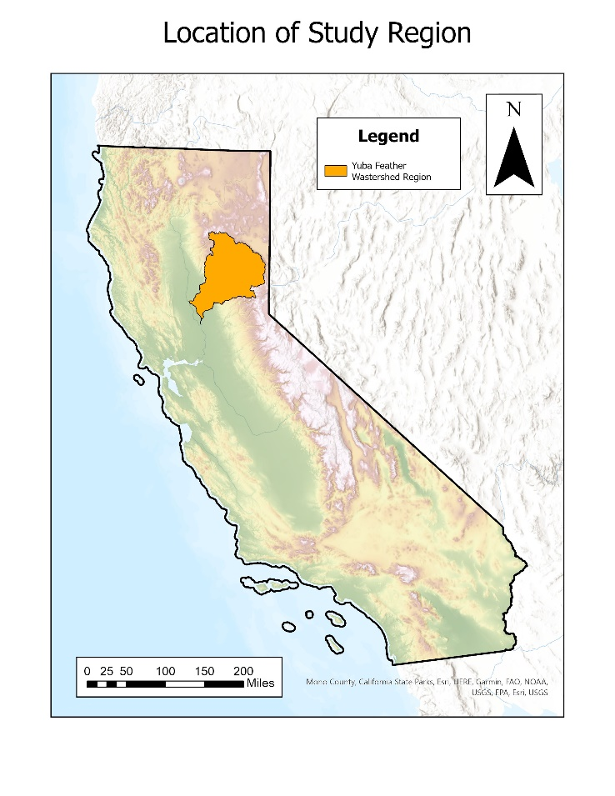
Figure 1. Study watershed region of interest

MesoWest Station Data

Data from University of Utah’s MesoWest was used to approximate hourly rainfall within each watershed region. Full records of station-level precipitation data were used as proxies for measuring rainfall in each watershed. Final stations chosen for the analysis were based on geographical proximity to each watershed region and the temporal resolution of data availability from each observational network. The following stations were selected for each watershed based on these criteria:
Watershed Region Name | Station Name | Station Code | Years of Data Available
Yuba-Feather | Oroville | kove | 24
Table 1. MesoWest sites selected for analysis, organized by associated watershed
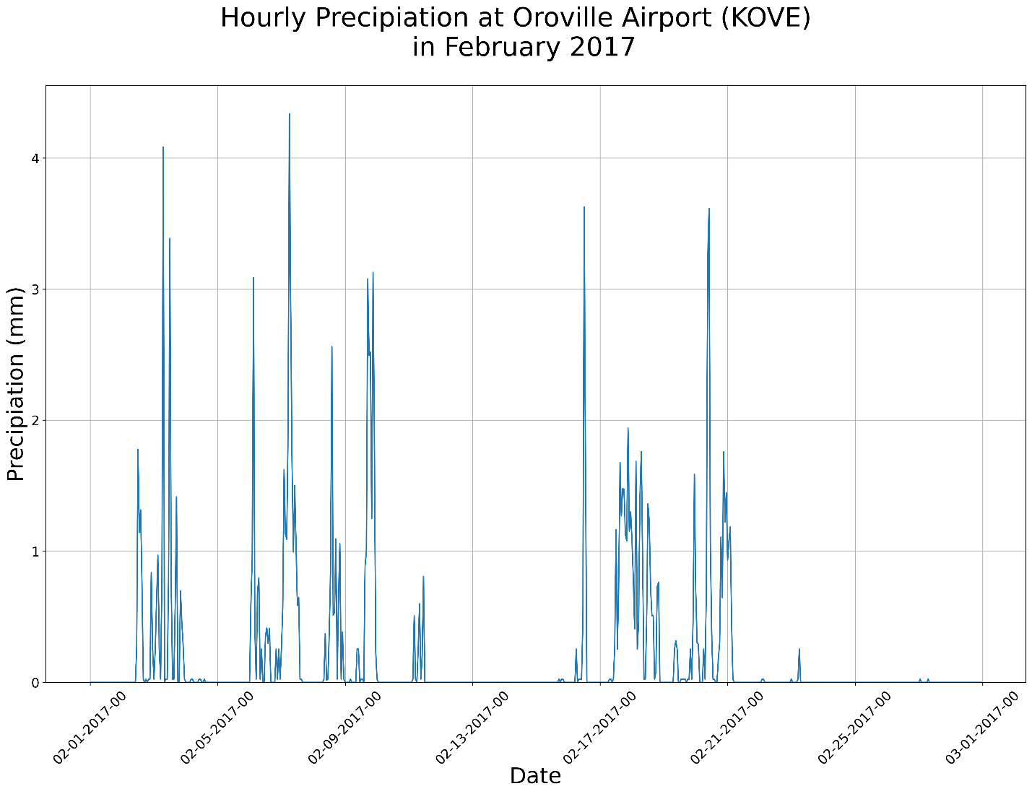
Figure 1. Resampled precipitation time series for Oroville Airport, California (Yuba-Feather watershed)

Resampling and Pulse Case Identification
Raw precipitation data from MesoWest requires resampling to consolidate precipitation values to the nearest hour. Data with multiple time stamps per hour were resampled using the mean value across each respective hour. Events of precipitation were first identified for each station by isolating temporal periods of nonzero precipitation that follow and precede periods of dryness for at least 24 hours. As HIP events with the most landscape impacts are likely to originate from storms where a large amount of precipitation has already fallen, events with suspected HIP activity were identified by isolating precipitation totals that were at or above the 95th percentile of total events for the entire period of record for each station.
These events are further filtered to capture scenarios that contain multiple distinct pulses in rainfall intensity. These multimodal events were determined by finding hourly episodes of rainfall separated by at least 5 days on zero hourly precipitation. For this case study, single short and long-term multimodal events are identified for each watershed region (6 total events) with short-term events representing a total temporal range of 2-3 days and long-term events representing 3 or more days.
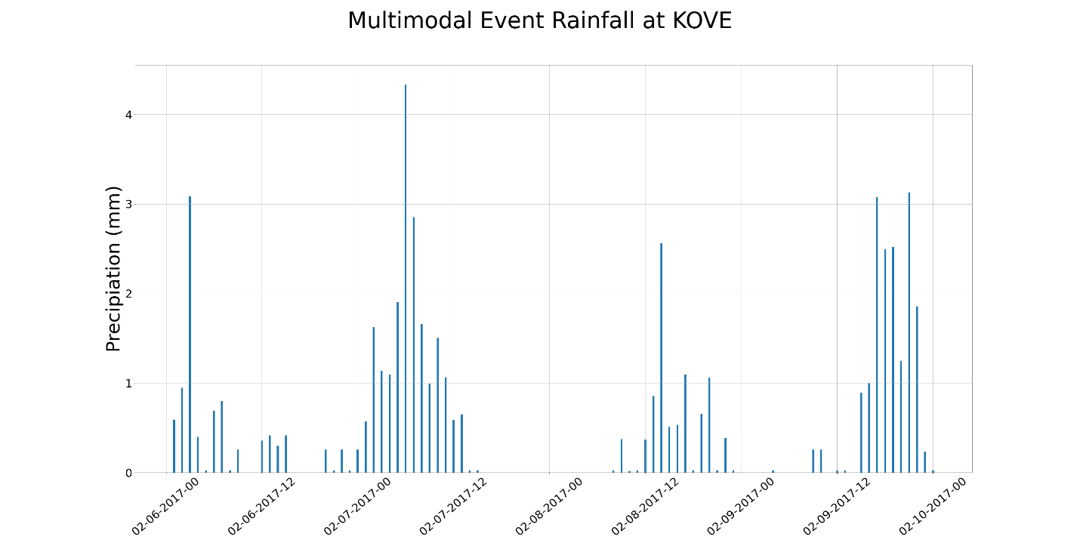

Figure 2. Example of “multimodal” pulses found within AR at Oroville Airport in February 2017

Characterizing Multimodal Events
Event identified by the methodology above will be evaluated and described through both synoptic-scale and meso-scale products:

Multi-Radar Multi-Sensor Quantitative Precipitation Estimation:
The Multi-Radar Multi-Sensor (MRMS) system designed by NOAA/National Severe Storms Laboratory (NSSL) integrates over 180 operational US WSR-88D weather radars, hourly gauge observations, and model analyses to create gridded precipitation products (Zhang et al., 2016). Quality-controlled radar reflectivity data is interpolated onto a 3D grid, with precipitation type (e.g. stratiform, convective, and snow) and surface rates derived at each grid point every 2 min. MRMS precipitation rate and quantitative precipitation estimate (QPE) products with 1-km resolution were temporally linked to precipitation events identified as having suspected HIP by the MesoWest analysis. After the structural and temporal extent of the event was identified from QPE, precipitation rates were then integrated over these dimensions to calculate a precipitation total for the suspected HIP event.

NEXRAD Doppler Radar
The Next Generation Weather Radar (NEXRAD) is a network of 160 high-resolution Doppler radar sites that detects precipitation and atmospheric movement and disseminates data in approximately 5-minute intervals from each site. NEXRAD enables severe storm prediction and is used by researchers and commercial enterprises to study and address the impact of weather across multiple sectors.

MERRA II Reanalysis

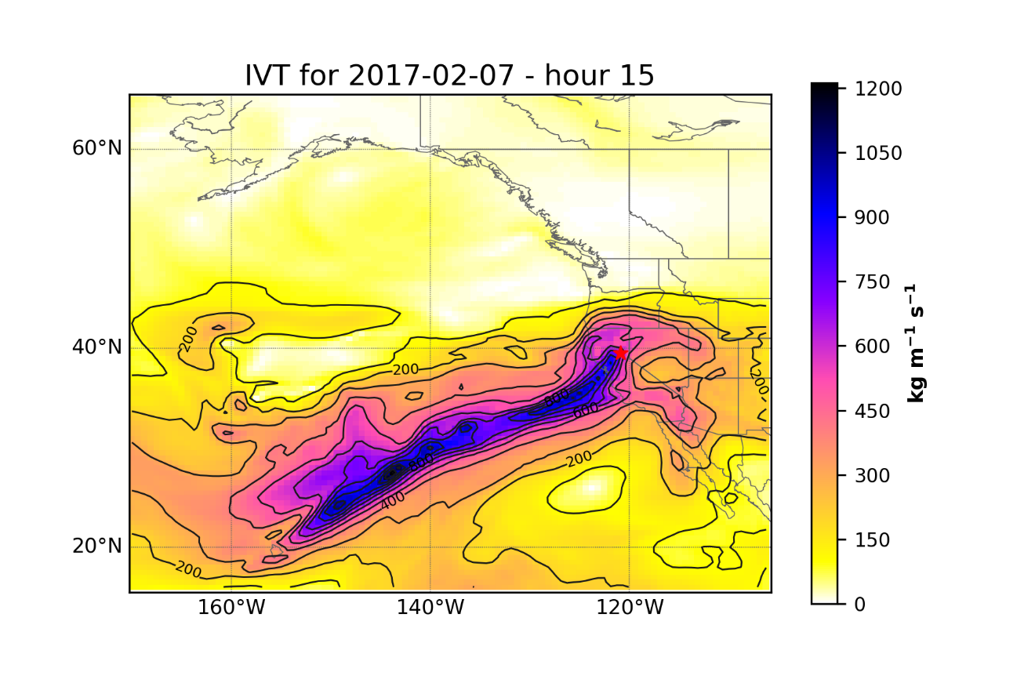
Figure 2. IVT for February 7th at 15:00 UTC

$$\frac{Precipitable Water From Localized Hourly Event}{Precipitable Water of Total Event}$$
For an event to be categorized as one with HIP, a threshold percentage was identified to indicate that a localized event dropped a statistically substantial amount of the total event’s precipitation.

Identifying Associated Atmospheric Rivers
Time points identified as having periods of high intensity precipitation were compared to a catalog of atmospheric rivers (AR) formulated from Guan & Waliser (2019) to characterize events as being part of larger synoptic scale weather systems. The AR catalog is a gridded 0.625° × 0.5° resolution product with 6-hour time steps beginning in 1980. Association of ARs to site-level events were determined by identifying the location and time of landfalling AR’s and latitudinally approximating landfall times with the time series dates of high intensity precipitation from each site respectively. AR landfall locations were approximated by the centroid of the grid cells defined above.
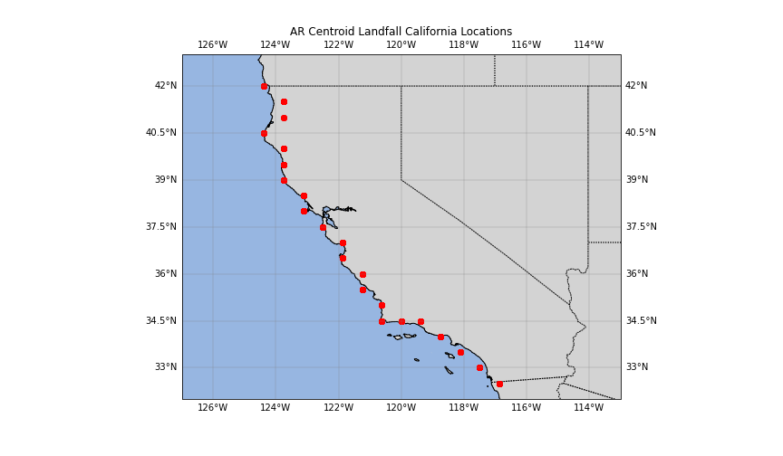
Figure 2. Coastal centroid locations of landfalling ARs in California from 1980-2020 (note: landfall locations are centroids of a grided product, so coordinates will not always align with coastal boundary)

Preliminary Results:
Events flagged as having HIP will be characterized in a catalog and will include general physical characteristics of the event (timing, location of watershed/station, etc), any associations with NCFRs or ARs, and any known landscape/infrastructure impacts. Additional features of selected HIP events (notable storm structures, particularly defined NCFRs, etc) will be highlighted in this section.
Watershed | Station | Start  Date/Time | End  Date/Time | NCFR | AR/  AR_CATEGORY | Any Known  Impacts on Landscape/  Infrastructure
Santa Ana | Riverside | 01/5/2016 H:15 | 01/7/2016 H:15 | Yes | Yes/5 | No
Table 2. Example Catalog Entry (note: test data)
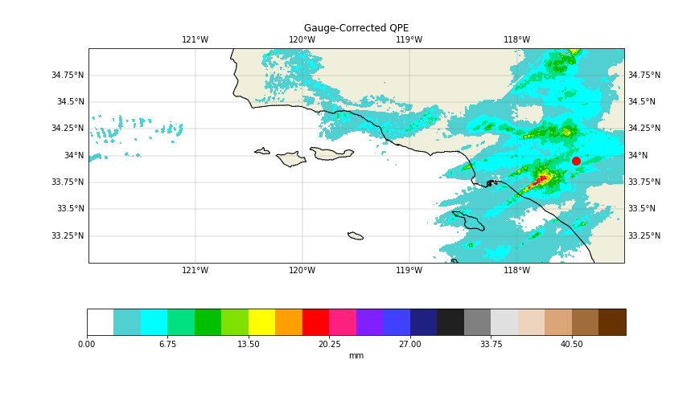
Figure 3. Preliminary Example of Southern California Quantitative Precipitation Estimates (mm) for Rainfall Event on Jan 5, 2016

Discussion and Broader Implications

The development of a catalog describing these characteristics has benefits for a wide variety of academic and non-academic communities.
The Center for Western Weather and Water Extremes Forecast Informed Reservoir Operations will be able to use these results to help develop more informed strategies for efficiently managing reservoir levels throughout California. As high intensity precipitation is not well understood in numerical models and poorly represented in longer-term climate data (Stephens et al., 2019, Martin et al., 2018, Suzuki et al., 2015, Dunkerley et al., 2010), the statistical characterizations from this study will also provide beneficial research for improving weather and climate forecasts in general. The public will also see benefits from the research proposed as understanding the local mechanisms underlying these extreme events will allow for the improvement of warning systems in vulnerable communities and can assist in the development of preemptive mitigation strategies to save property and lives.
There are opportunities for future research with this proposed project. All data being used is available for the full spatial extent of the United States, so an expansion of this catalog to more locations can be implemented with relative ease. Additional meteorological variables can also be easily incorporated into the catalog to provide a fuller picture of the mesoscale environments in which these high intensity precipitation events develop.
Below is a proposed timeline for the project, based on credits needed and deliverables expected:

MS in Geography  objective timeline | Summer 2023 | Fall 2024  (Defend Thesis Proposal) | Winter 2024 | Spring 2024 or Fall 2025  (Defend Thesis)
Action Items | Continue research; complete draft of methods | Defend Thesis Proposal | Continue research/Masters Thesis | Defend Thesis
Table 3. Proposed research timeline

References:
Kunkel, K.E., Karl, T.R., Easterling, D.R., Redmond, K., Young, J., Yin, X. and Hennon, P., 2013. Probable maximum precipitation and climate change. Geophysical Research Letters, 40(7), pp.1402-1408.
IPCC, 2022: Climate Change 2022: Impacts, Adaptation, and Vulnerability. Contribution of Working Group II to the Sixth Assessment Report of the Intergovernmental Panel on Climate Change [H.-O. Pörtner, D.C. Roberts, M. Tignor, E.S. Poloczanska, K. Mintenbeck, A. Alegría, M. Craig, S. Langsdorf, S. Löschke, V. Möller, A. Okem, B. Rama (eds.)]. Cambridge University Press. Cambridge University Press, Cambridge, UK and New York, NY, USA, 3056 pp., doi:10.1017/9781009325844.
Ralph, F. M., Neiman, P. J., Wick, G. A., Gutman, S. I., Dettinger, M. D., Cayan, D. R., & White, A. B. (2006). Flooding on California’s Russian River: Role of atmospheric rivers. In Geophysical Research Letters (Vol. 33, Issue 13). American Geophysical Union (AGU). https://doi.org/10.1029/2006gl026689
Neiman, P. J., Schick, L. J., Ralph, F. M., Hughes, M., & Wick, G. A. (2011). Flooding in Western Washington: The Connection to Atmospheric Rivers*. In Journal of Hydrometeorology (Vol. 12, Issue 6, pp. 1337–1358). American Meteorological Society. https://doi.org/10.1175/2011jhm1358.1
Neiman, P. J., Ralph, F. M., Wick, G. A., Lundquist, J. D., & Dettinger, M. D. (2008). Meteorological Characteristics and Overland Precipitation Impacts of Atmospheric Rivers Affecting the West Coast of North America Based on Eight Years of SSM/I Satellite Observations. In Journal of Hydrometeorology (Vol. 9, Issue 1, pp. 22–47). American Meteorological Society. https://doi.org/10.1175/2007jhm855.1
Kim, J., Waliser, D.E., Neiman, P.J. et al. Effects of atmospheric river landfalls on the cold season precipitation in California. Clim Dyn 40, 465–474 (2013). https://doi.org/10.1007/s00382-012-1322-3
Guan, B., Molotch, N. P., Waliser, D. E., Fetzer, E. J., & Neiman, P. J. (2010). Extreme snowfall events linked to atmospheric rivers and surface air temperature via satellite measurements. In Geophysical Research Letters (Vol. 37, Issue 20, p. n/a-n/a). American Geophysical Union (AGU). https://doi.org/10.1029/2010gl044696
Dettinger, M.D. 2011. Climate change, atmospheric rivers and floods in California—a multimodel analysis of storm frequency and magnitude changes. Journal of the American Water Resources Association. 47: 514–523. de Orla-Barile, M., Cannon, F., Oakley, N. S., & Ralph, F. M. (2022). A climatology of narrow cold frontal rainbands in Southern California. Geophysical Research Letters, 49, e2021GL095362. https://doi.org/10.1029/2021GL095362
Swain, D. L., Langenbrunner, B., Neelin, J. D., & Hall, A. (2018). Increasing precipitation volatility in twenty-first-century California. In Nature Climate Change (Vol. 8, Issue 5, pp. 427–433). Springer Science and Business Media LLC. https://doi.org/10.1038/s41558-018-0140-y
Agilan, V. and Umamahesh, N.V., 2017. Modelling nonlinear trend for developing non‐stationary rainfall intensity–duration–frequency curve. International Journal of Climatology, 37(3), pp.1265-1281.
Chagnaud, G., Panthou, G., Vischel, T., Blanchet, J. and Lebel, T., 2021. A unified statistical framework for detecting trends in multi-timescale precipitation extremes: application to non-stationary intensity-duration-frequency curves. Theoretical and Applied Climatology, pp.1-22.
Dunkerley, D.L., 2010. How do the rain rates of sub‐event intervals such as the maximum 5‐and 15‐min rates (I5 or I30) relate to the properties of the enclosing rainfall event?. Hydrological Processes, 24(17), pp.2425-2439.
Dunkerley, D., 2021. Rainfall intensity in geomorphology: Challenges and opportunities. Progress in Physical Geography: Earth and Environment, 45(4), pp.488-513.
Martin, A., Ralph, F.M., Demirdjian, R., DeHaan, L., Weihs, R., Helly, J., Reynolds, D. and Iacobellis, S., 2018. Evaluation of atmospheric river predictions by the WRF Model using aircraft and regional mesonet observations of orographic precipitation and its forcing. Journal of Hydrometeorology, 19(7), pp.1097-1113.
Stephens, G.L., Christensen, M., Andrews, T., Haywood, J., Malavelle, F.F., Suzuki, K., Jing, X., Lebsock, M., Li, J.L.F., Takahashi, H. and Sy, O., 2019. Cloud physics from space. Quarterly Journal of the Royal Meteorological Society, 145(724), pp.2854-2875.
Suzuki, K., Stephens, G., Bodas-Salcedo, A., Wang, M., Golaz, J.C., Yokohata, T. and Koshiro, T., 2015. Evaluation of the warm rain formation process in global models with satellite observations. Journal of the Atmospheric Sciences, 72(10), pp.3996-4014.
de Orla-Barile, M., Cannon, F., Oakley, N. S., & Ralph, F. M. (2022). A climatology of narrow cold-frontal rainbands in Southern California. Geophysical Research Letters, 49, e2021GL095362. https://doi.org/10.1029/2021GL095362
Zhang, J., Howard, K., Langston, C., Kaney, B., Qi, Y., Tang, L., Grams, H., Wang, Y., Cocks, S., Martinaitis, S., Arthur, A., Cooper, K., Brogden, J., & Kitzmiller, D. (2016). Multi-Radar Multi-Sensor (MRMS) Quantitative Precipitation Estimation: Initial Operating Capabilities. In Bulletin of the American Meteorological Society (Vol. 97, Issue 4, pp. 621–638). American Meteorological Society. https://doi.org/10.1175/bams-d-14-00174.1
Guan, B., & Waliser, D. E. (2019). Tracking Atmospheric Rivers Globally: Spatial Distributions and Temporal Evolution of Life Cycle Characteristics. In Journal of Geophysical Research: Atmospheres (Vol. 124, Issue 23, pp. 12523–12552). American Geophysical Union (AGU). https://doi.org/10.1029/2019jd031205
Horel, J.; Splitt, M.; Dunn, L.; Pechmann, J.; White, B.; Ciliberti, C.; Lazarus, S.; Slemmer, J.; Zaff, D.; Burks, J. MesoWest: Cooperative Mesonets in the Western United States. Bull. Am. Meteorol. Soc. 2002, 83, 211−225
Cannon, F., Hecht, C. W., Cordeira, J. M., & Ralph, F. M. (2018). Synoptic and mesoscale forcing of Southern California extreme precipitation. Journal of Geophysical Research: Atmospheres, 123, 13,714– 13,730. https://doi.org/10.1029/2018JD029045
Lamjiri, M. A., Dettinger, M. D., Ralph, F. M., and Guan, B. (2017), Hourly storm characteristics along the U.S. West Coast: Role of atmospheric rivers in extreme precipitation, Geophys. Res. Lett., 44, 7020– 7028, doi:10.1002/2017GL074193.
Sukup, S., Laber, J., Sweet, D., & Thomson, R. (2016). Analysis of an intense narrow cold frontal rainband and the Springs Fire burn area debris flows of 12 December 2014. NWS Technical Attachment 1601s. National Weather Forecast Office. Retrieved from https://www.weather.gov/media/wrh/online_publications/TAs/TA1601.pdf
Oakley, N. S., Lancaster, J. T., Kaplan, M. L., & Ralph, F. M. (2017). Synoptic conditions associated with cool season post-fire debris flows in the Transverse Ranges of southern California. In Natural Hazards (Vol. 88, Issue 1, pp. 327–354). Springer Science and Business Media LLC. https://doi.org/10.1007/s11069-017-2867-6
Hobbs, P. V., & Persson, P. O. G. (1982). The Mesoscale and Microscale Structure and organization of Clouds and precipitation in Midlatitude Cyclones. Part V: The Substructure of Narrow Cold-Frontal Rainbands. In Journal of the Atmospheric Sciences (Vol. 39, Issue 2, pp. 280–295). American Meteorological Society. https://doi.org/10.1175/1520-0469(1982)039<0280:tmamsa>2.0.co;2
Houze, R. A., Jr., Hobbs, P. V., Biswas, K. R., & Davis, W. M. (1976). Mesoscale Rainbands in Extratropical Cyclones. In Monthly Weather Review (Vol. 104, Issue 7, pp. 868–878). American Meteorological Society. https://doi.org/10.1175/1520-0493(1976)104<0868:mriec>2.0.co;2
Koch, S. E., & Kocin, P. J. (1991). Frontal contraction processes leading to the formation of an intense narrow rainband. In Meteorology and Atmospheric Physics (Vol. 46, Issues 3–4, pp. 123–154). Springer Science and Business Media LLC. https://doi.org/10.1007/bf01027339
Young, A. M., K. T. Skelly, and J. M. Cordeira (2017), High-impact hydrologic events and atmospheric rivers in California: An investigation using the NCEI Storm Events Database, Geophys. Res. Lett., 44, 3393–3401, doi:10.1002/2017GL073077.
Henn, B., Musselman, K. N., Lestak, L.,Ralph, F. M., & Molotch, N. P. (2020).Extreme runoff generation from atmospheric river driven snowmelt during the 2017 Oroville dam spillways incident.Geophysical Research Letters,47, e2020GL088189. https://doi.org/10.1029/2020GL088189
Vano, J. A., Miller, K., Dettinger, M. D., Cifelli, R., Curtis, D., Dufour, A., et al. (2018). Hydroclimate extremes as challenges for the water management community: Lessons from Oroville dam and hurricane Harvey. Bulletin of the American Meteorological Society, 100(1), S9–S14. https://doi.org/10.1175/BAMS-D-18-0219.1
White, A. B., Moore, B. J., Gottas, D. J., & Neiman, P. J. (2019). Winter storm conditions leading to excessive runoff above California’s Oroville Dam during January and February 2017. Bulletin of the American Meteorological Society, 100(1), 55–70. https://doi.org/10.1175/BAMS-D-18-0091.1

