Diagnosing Rainfall Variability Within A Series of Atmospheric Rivers over Northern California in February 2017
Parker Malek

Some general comments:
- I would encourage you to look at other raingages nearby to identify temporal precipitation patterns. This is an area with complex orographic rain processes (i.e. Neiman et al., 2010) and the Oroville Airport, located in the valley, may not give you the best chance at identifying HIP pulses. There is a comprehensive list of raingages in White et al., 2019 (Table 1)
- This is an event that has been studied extensively from a synoptic meteorology standpoint. You’ll probably get more out of this study if you lean on others’ synoptic analysis (esp. of IVT) and instead focus on mesoscale features.
- Following from the above advice in comment #2, your use of MRMS is a good choice. I’d also suggest looking at the vertical radar profilers available at https://psl.noaa.gov/data/obs/datadisplay/ and at radiosondes launched from Oakland, CA during the event.
- I am going to provide you a homework problem that I used to give as extra credit to my Severe Weather students. It covers the Oroville event from a mesoscale/mountain meteorology perspective. You may want to work through the first part of the assignment (the second half about freezing levels is probably irrelevant to your study) and see if you gain any additional insights about the types of data analysis that might help you uncover HIP driving mechanisms.

Introduction
High intensity precipitation events are described by their unusually high rates of precipitation over a given duration of time. However, these events can also be distinguished by the various impacts that result from them. As known drivers of rapid and potentially hazardous changes in landscape through flash flooding, erosion, snow melting, landslides, and debris flows (IPCC, 2022), extreme high intensity precipitation (HIP) events can lead to high socioeconomic costs through their ability to simultaneously affect drinking water supplies, fishery health, and transportation infrastructure over short time periods. As studies have suggested that these kinds of precipitation events are likely to increase in intensity as the climate warms (Kunkel et al., 2013), understanding the synoptic and mesoscale physical characteristics of HIP events is critical for the development of future mitigation strategies and infrastructure improvements.
Previous research has investigated spatial and temporal patterns of high intensity precipitation along the West Coast of the US. For example, Ralph et al. (2006) and Neiman et al. (2011) used radar and streamflow data to analyze and document extreme precipitation events in California’s Russian River and Washington’s Olympic and Cascade Mountains. Guan et al. (2010) similarly analyzed precipitation data from the Sierra Nevada Mountain Range in California and found that the largest precipitation events were associated with atmospheric rivers (ARs), synoptic-scale (1000 km or larger) narrow bands of water vapor that can transport large amounts of moisture out of the tropics to the mid-latitudes. Atmospheric rivers account for a significant proportion of high impact hydrological events in the state of California (Young et al. 2017).
Within these large-scale systems, smaller mesoscale characterizations of HIP events have also been described. Because of California’s unique water resource dependencies on a few extreme precipitation events during the winter season, numerous studies have utilized the state’s topographic variability and large spatial extent to describe HIP events in relation to orographic drivers and AR storm-level summary analyses (Lamjiri et al. (2018); Cannon et al. (2017)). Additional work has been done to describe smaller scale meteorological features embedded within ARs that contribute to HIP events. Convective narrow cold frontal rainbands (NCFRs) are a characteristic of particularly sharp frontal boundaries and are often accompanied by strong gusty winds and brief but intense precipitation. Studies have shown that the “precipitation cores” formed within NCFRs are associated with high surface convergence and some of the highest rates of precipitation in storms where the phenomena are observed (Houze et al., 1976; Hobbs & Persson, 1982; Koch & Kocin, 1991). These systems have additionally been associated with many costly and destructive debris flow and landslide events in Southern California (Cannon et al., 2018; Oakley et al., 2017; Sukup et al., 2016, de Orla-Barile, 2022).
As the hydroclimate of California is dominated by wild swings in drought and non-drought years, similar annual extreme events within the state often impact the hydrologic and geomorphic response to precipitation by changing the physical relationships among rainfall, runoff, erosion, and hillslope stability. HIP events that trigger these landscape responses increase the risk of simultaneous disasters where water and emergency managers face increasingly dire tradeoffs between water quality, transportation networks, community safety and flood prevention. Recent studies (Agilan, et al., 2017; Chanaud et al., 2021) have found that precipitation intensity-duration-frequency (IDF) relationships have changed from the historical curve in many regions, with many of these changes found in higher intensity, shorter duration events. Because these curves are oftentimes used to design water control infrastructure, and the design of long-lifetime infrastructure is that the curves represent a stationary climate, non-stationarity implies risk to infrastructure and socioeconomic health.
Previous scholarly research has identified two distinct challenges associated with the current state of high intensity precipitation research:
- Poor understanding of processes that cause high intensity precipitation.
It is known that the highest precipitation rates on earth are found in deep convective cells. However, the details of how convective elements organize or how strong rising motion embeds within larger precipitating systems (e.g. cyclones or fronts) are poorly understood and are critical for understanding how high rates persist long enough to cause significant impact (Poujol et al. 2021, Fowler et al. 2021). Furthermore, numerical climate models partially rely on the parameterization of these high resolution moist processes within storms, and it has been found that biases in storm track position and intensity are likely linked to uncertainties associated with these kinds of meso-scale processes (Shaw et al., 2016).
- Poor understanding of the landscape responses to high intensity precipitation.
Rainfall intensity is known to affect land surface processes such as infiltration, runoff efficiency, erosion, and runoff/liquid water retention during rain-on-snow events and sensitivity to HIP has been well-studied via laboratory and computational experiments. However, landscape scale processes are less understood (I.E. flash flooding, debris flow and landslide initiation, mass erosion, stream network sediment loading, and snowpack loss) and may become exacerbated when events occur within disturbed regimes. Sequencing of intra-event HIP is known to modulate the above impacts, but little work has been performed to link the sequencing of HIP in real events to hydrological and geomorphic outcomes (Dunkerley et al., 2021).
Notable events have illustrated the socioeconomic impact of HIP. In 2017, the Oroville Dam Crisis in the state of California was in part triggered by a series of atmospheric river events that affected the region in early February. The pulses of high intensity precipitation within these AR events caused heavy damage to the primary and emergency spillway of the Oroville Dam, leading to the evacuation of 188,000 people and around $1 billion in damage-related repairs (Henn et al., 2020; Vano et al., 2018; White et al., 2019). Previous studies have characterized the meteorological events surrounding the crisis with the intent of improving station-based ensemble surface meteorological analyses, describing the runoff mechanisms that led to the crisis, and quantifying the effects of climate warming on increased precipitable water in AR systems, but the drivers of within-AR rainfall intensity has not been well-described for the event (Bunn et al, 2022; White et al, 2019; Michaelis et al., 2022).

Study Objectives
This case study will provide synoptic and mesoscale characterizations of a series of landfalling ARs that triggered the February 2017 Oroville Dam Crisis in the state of California. Rain gauge, satellite-based, and reanalysis data will be used to identify high intensity, short duration precipitation pulses embedded within these ARs, and the local and synoptic-scale forcing characteristics attributed to these pulses will be identified and statistically described. Results will provide insight into how short duration high intensity precipitation propagates within larger storm systems and will expand our understanding of the mechanisms that drive high intensity precipitation variability from within-storm events.
Developing an understanding of the mesoscale features of HIP that occur within the events surrounding this crisis will address the above challenges by improving the ability to accurately project these events in future climates through dynamical and statistical means, highlighting critical uncertainty in detection and prediction, providing gains in predictive skill and scientific insight into the impact of HIP on changing landscapes, and generating new decision-support information to assist water and environmental resource managers in developing the next generation of adaptive management practices.

Data and Methods

Study Region
This work is associated with the Forecast-Informed Reservoir Operations (FIRO) project at the Scripps Center for Western Weather and Water Extremes Forecast Informed Reservoir Operations. FIRO is designed to utilize forecasting capabilities to inform and enhance water management and reservoir operations in the state of California. The Yuba-Feather watershed region consists of river systems that have a long history of catastrophic flooding, with five major floods resulting in 41 deaths since 1950 (FIRO). The region was identified as one of interest because of this climatological propensity to be affected by extreme precipitation events that often lead to high socioeconomic impacts.
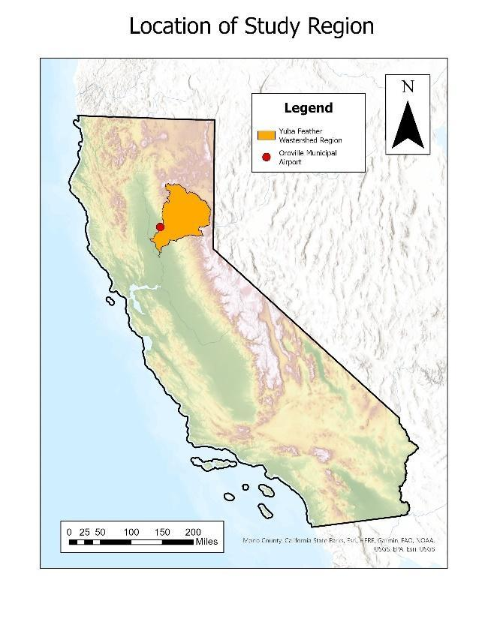
Figure 1. Study watershed region of interest

MesoWest Station Data
This study utilizes rain gauge data to approximate precipitation within the Yuba-Feather watershed region. The University of Utah’s MesoWest project provides access to archived weather observations across the United States, with extensive records of hourly precipitation available for many airport-based stations across the country. The station located at the Oroville Municipal Airport has an extensive record of hourly precipitation data and was used to pull precipitation records for February 2017. Raw precipitation data from MesoWest required resampling to consolidate precipitation values to the nearest hour. Data with multiple time stamps per hour were resampled using the mean value across each respective hour.

Watershed Region Name | Station Name | Station Code | Years of Data Available
Yuba-Feather | Oroville | kove | 24
Table 1. MesoWest sites selected for analysis
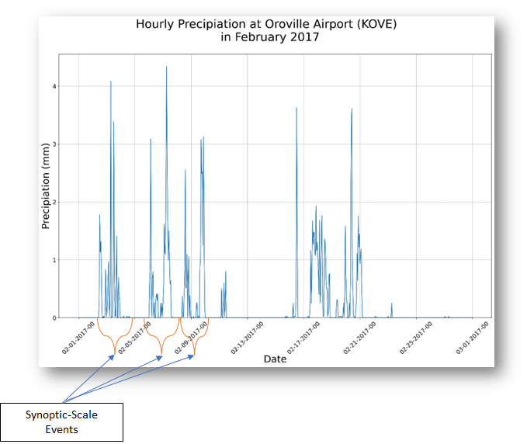
Figure 1. Resampled hourly precipitation time series for Oroville Airport, California (Yuba-Feather watershed) for February 2017. Example of synoptic scale events identified.

Synoptic and Mesoscale Pulse Identification
A two-pronged approach is used to categorize pulses of precipitation for the study. Longer-term synoptic scale events are first identified visually from the monthly time series of rainfall events at Oroville Municipal Airport. This process identified 7 separate synoptic-level events. Within each of these synoptic level events, individual mesoscale pulses are identified through a similar visual process. Each individual pulse of precipitation will be the characterization factor for these mesoscale pulses, with each syntopic level event often containing multiple pulses (Figure 2).
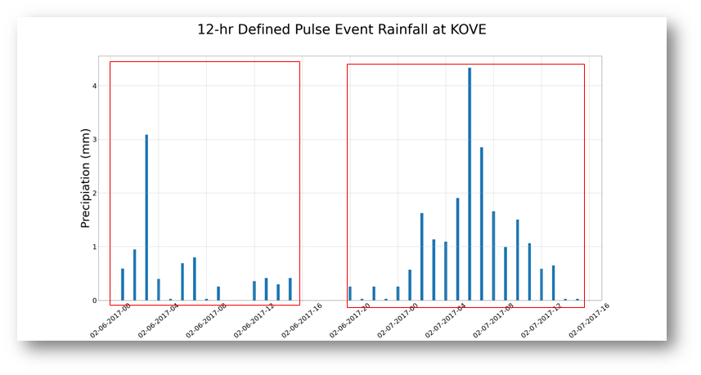

Figure 2. Example of “multimodal” pulses found within syntopic level event at Oroville Airport in February 2017

Characterizing Multimodal Events
Pulse events identified by the methodology above will be evaluated and described through both synoptic and meso-scale products:

MERRA II Reanalysis
Synoptic-scale characterizations of the storm systems that affected the Yuba-Feather watershed region in February 2017 will be used to describe the large-scale patterns influencing the precipitation pulses identified with the above methodology. Reanalysis data from the Modern-Era Retrospective analysis for Research and Applications, Version 2 (MERRA-2) will be used as a diagnostic tool to describe the flow of moisture into the Yuba-Feather watershed region during these events. The direction and magnitude of this high-level moisture profile will provide information on which locations within the region are more affected by pulses of high intensity rainfall. Because the directionality and intensity of moisture is the primary driver at the synoptic-scale, MERRA-2’s integrated water vapor transport will be the product used for this characterization effort.
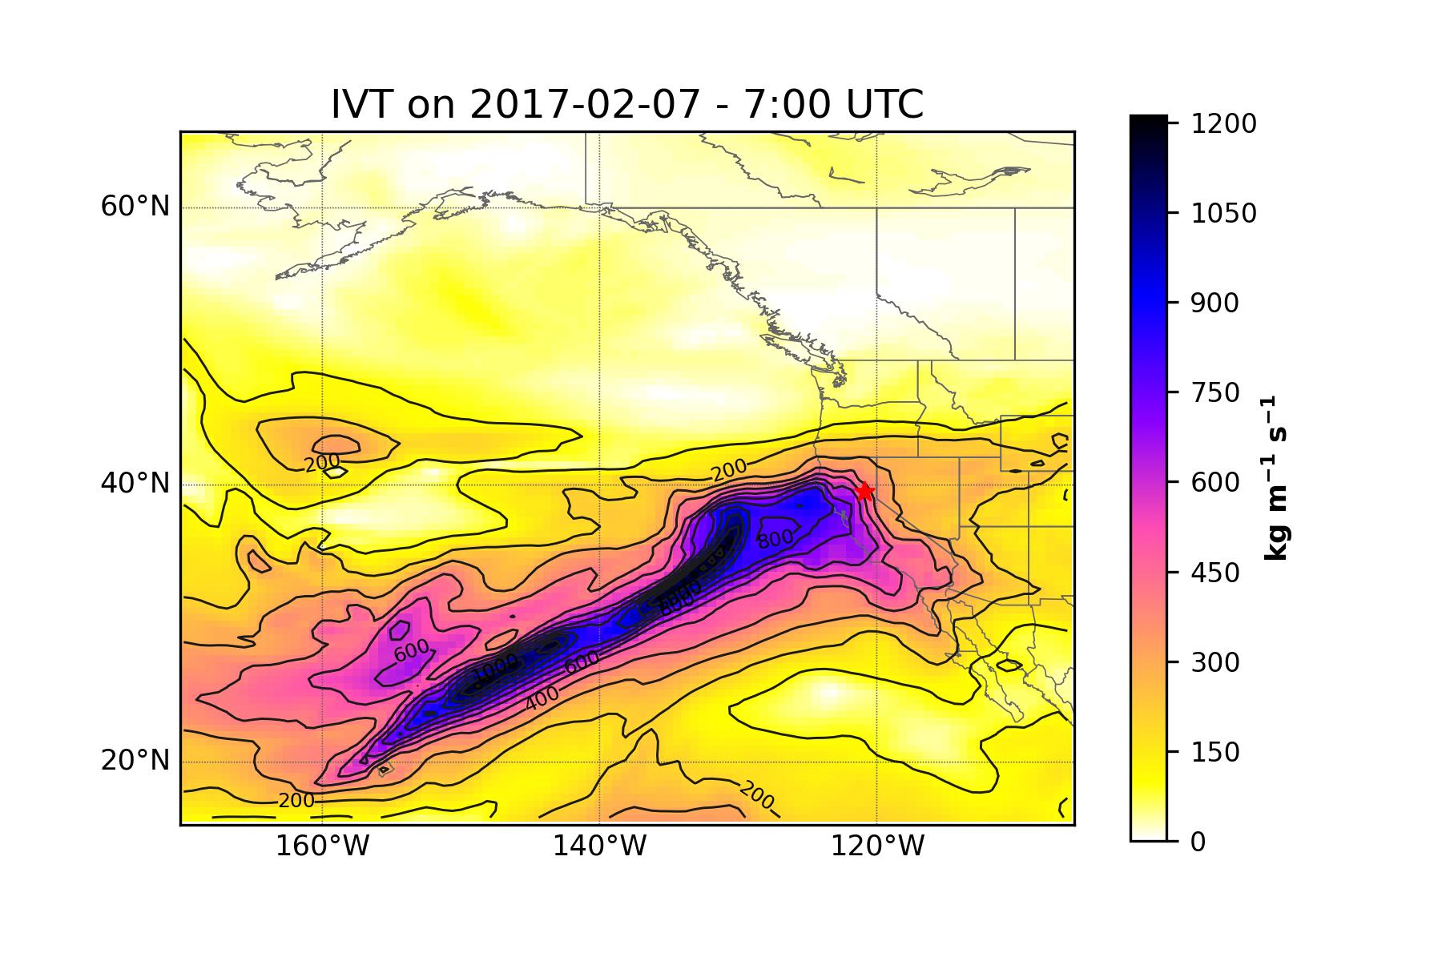
Figure 3. Example of IVT on February 7th, 2017 at 07:00 UTC

Multi-Radar Multi-Sensor Quantitative Precipitation Estimation:
The Multi-Radar Multi-Sensor (MRMS) system designed by NOAA/National Severe Storms Laboratory (NSSL) integrates over 180 operational US WSR-88D weather radars, hourly gauge observations, and model analyses to create gridded precipitation products (Zhang et al., 2016). Quality-controlled radar reflectivity data is interpolated onto a 3D grid, with precipitation type (e.g. stratiform, convective, and snow) and surface rates derived at each grid point every 2 min. Hourly MRMS quantitative precipitation estimate (QPE) products with 1-km resolution will be linked to precipitation pulses identified with the above methodology. As a derived product that measures accumulated precipitation with no topographical hindrance, MRMS QPE will be utilized to build a comprehensive picture of the spatial variability of rainfall driven by these individual pulses of precipitation within the February 2017 storm systems.
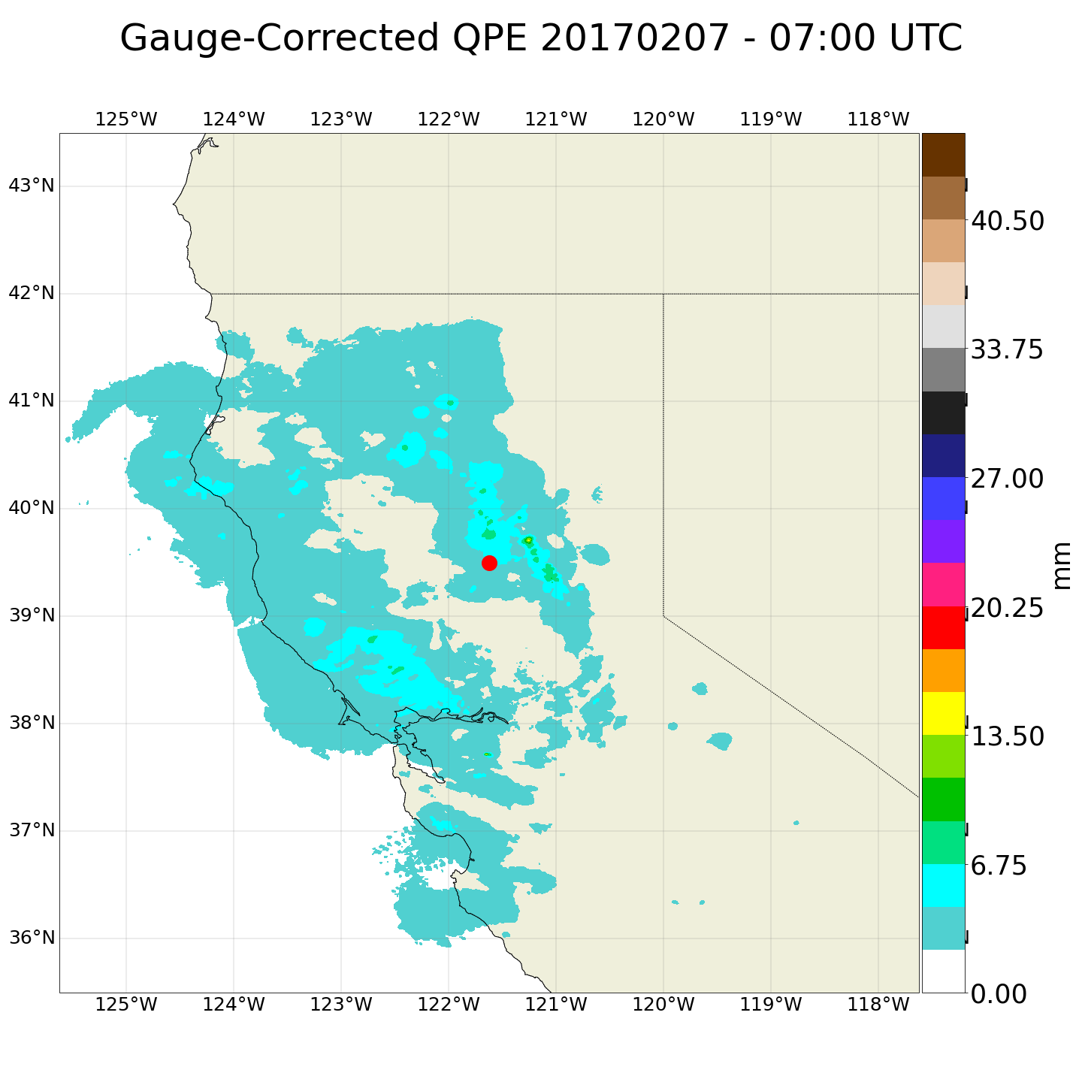
Figure 4. Example of QPE for February 7th, 2017 at 7:00 UTC

NEXRAD Doppler Radar
The Next Generation Weather Radar (NEXRAD) is a network of 160 high-resolution Doppler radar sites that detects precipitation and atmospheric movement and disseminates data in approximately 5-minute intervals from each site. NEXRAD enables severe storm prediction and is used by researchers and commercial enterprises to study and address the impact of weather across multiple sectors. The NEXRAD radar located at Beale Air Force Base in Yuba City, California will be used to identify sub-hourly mesoscale features associated with each precipitation pulse identified in this study. High intensity, short duration extreme rainfall events often occur at this temporal resolution, making the 5-minute intervals of the NEXRAD network imperative for this analysis.

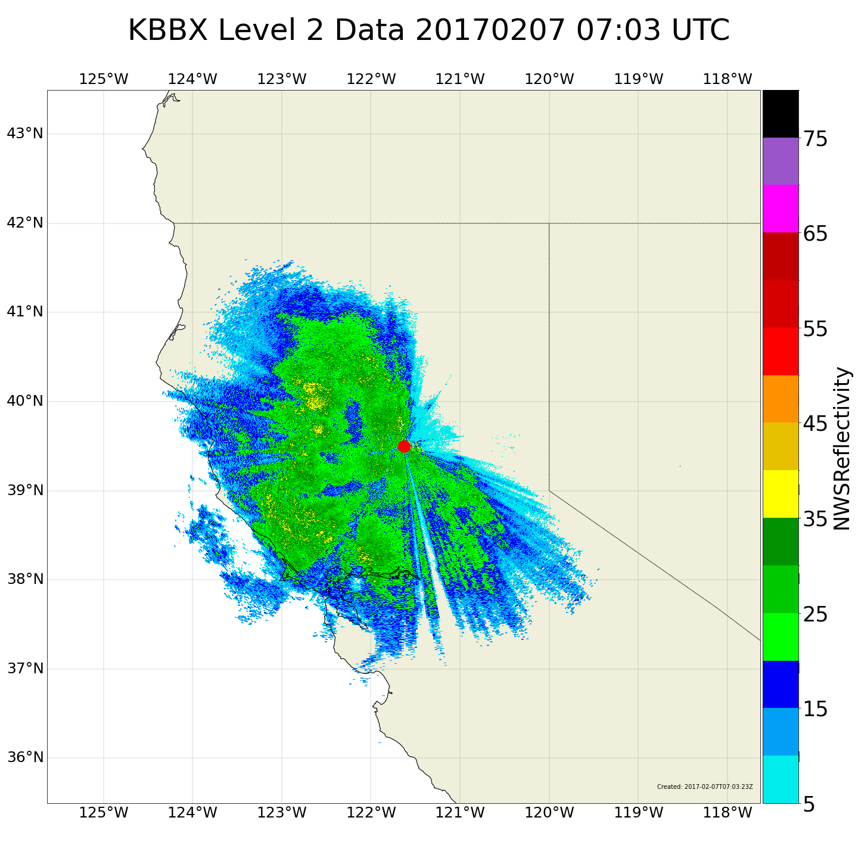
Figure 2. NEXRAD Reflectivity at Beale Air Force Base on February 7th, 2017 at 7:03 UTC

Preliminary Results:
Pulses identified in the methodology above will be characterized in a catalog that will include general physical characteristics of the event (timing, location of watershed/station, etc), any associations with NCFRs or ARs, and any known landscape/infrastructure impacts. Additional features of selected HIP events (notable storm structures, particularly defined NCFRs, etc) will be highlighted in this section.

Start  Date/Time | End  Date/Time | NCFR | AR/  AR_CATEGORY | Any Known  Impacts on Landscape/  Infrastructure
02/7/2017 H:7 | 02/7/2017 H:15 | Yes | Yes/5 | No
Table 2. Example Catalog Entry (note: test data)

Discussion and Broader Implications

The characterization of mesoscale within-event precipitation pulses have implications for the advancement of both numerical weather forecasting and increased quality of climate model parameterization. The Center for Western Weather and Water Extremes Forecast Informed Reservoir Operations will be able to use these results to help develop more informed strategies for efficiently managing reservoir levels throughout California during extreme rainfall events. As high intensity precipitation is not well understood in numerical models and poorly represented in longer-term climate data (Stephens et al., 2019, Martin et al., 2018, Suzuki et al., 2015, Dunkerley et al., 2010), the characterization of these pulses will advance our understanding of the meteorological mechanisms that drive short-term, high intensity precipitation and contribute knowledge to the high resolution hydrometeorological processes that are required as inputs into many climate models. The public will also see benefits from the research proposed as understanding the local mechanisms underlying these extreme events will allow for the improvement of warning systems in vulnerable communities and can assist in the development of preemptive mitigation strategies to save property and lives.
There are opportunities for future research with this proposed project. All data being used is available for the full spatial extent of the United States. A geographic expansion of the pulse identification methodologies presented in this study would shed light on how these high intensity precipitation pulses change across the country. The characterizations described in this study have the potential to provide the groundwork for an algorithmic approach to identifying within-storm precipitation pulses.
Below is a proposed timeline for the project, based on credits needed and deliverables expected:
MS in Geography  objective timeline | Fall 2024 | Winter 2024  (Defend Thesis Proposal) | Spring 2024 or Fall 2025  (Defend Thesis)
Action Items | Continue developing Thesis Proposal | Continue research/Masters Thesis | Defend Thesis

Table 3. Proposed research timeline

References:
Kunkel, K.E., Karl, T.R., Easterling, D.R., Redmond, K., Young, J., Yin, X. and Hennon, P., 2013. Probable maximum precipitation and climate change. Geophysical Research Letters, 40(7), pp.1402-1408.
IPCC, 2022: Climate Change 2022: Impacts, Adaptation, and Vulnerability. Contribution of Working Group II to the Sixth Assessment Report of the Intergovernmental Panel on Climate Change [H.-O. Pörtner, D.C. Roberts, M. Tignor, E.S. Poloczanska, K. Mintenbeck, A. Alegría, M. Craig, S. Langsdorf, S. Löschke, V. Möller, A. Okem, B. Rama (eds.)]. Cambridge University Press. Cambridge University Press, Cambridge, UK and New York, NY, USA, 3056 pp., doi:10.1017/9781009325844.
Ralph, F. M., Neiman, P. J., Wick, G. A., Gutman, S. I., Dettinger, M. D., Cayan, D. R., & White, A. B. (2006). Flooding on California’s Russian River: Role of atmospheric rivers. In Geophysical Research Letters (Vol. 33, Issue 13). American Geophysical Union (AGU). https://doi.org/10.1029/2006gl026689
Neiman, P. J., Schick, L. J., Ralph, F. M., Hughes, M., & Wick, G. A. (2011). Flooding in Western Washington: The Connection to Atmospheric Rivers*. In Journal of Hydrometeorology (Vol. 12, Issue 6, pp. 1337–1358). American Meteorological Society. https://doi.org/10.1175/2011jhm1358.1
Neiman, P. J., Ralph, F. M., Wick, G. A., Lundquist, J. D., & Dettinger, M. D. (2008). Meteorological Characteristics and Overland Precipitation Impacts of Atmospheric Rivers Affecting the West Coast of North America Based on Eight Years of SSM/I Satellite Observations. In Journal of Hydrometeorology (Vol. 9, Issue 1, pp. 22–47). American Meteorological Society. https://doi.org/10.1175/2007jhm855.1
Kim, J., Waliser, D.E., Neiman, P.J. et al. Effects of atmospheric river landfalls on the cold season precipitation in California. Clim Dyn 40, 465–474 (2013). https://doi.org/10.1007/s00382-012-1322-3
Guan, B., Molotch, N. P., Waliser, D. E., Fetzer, E. J., & Neiman, P. J. (2010). Extreme snowfall events linked to atmospheric rivers and surface air temperature via satellite measurements. In Geophysical Research Letters (Vol. 37, Issue 20, p. n/a-n/a). American Geophysical Union (AGU). https://doi.org/10.1029/2010gl044696
Dettinger, M.D. 2011. Climate change, atmospheric rivers and floods in California—a multimodel analysis of storm frequency and magnitude changes. Journal of the American Water Resources Association. 47: 514–523. de Orla-Barile, M., Cannon, F., Oakley, N. S., & Ralph, F. M. (2022). A climatology of narrow cold frontal rainbands in Southern California. Geophysical Research Letters, 49, e2021GL095362. https://doi.org/10.1029/2021GL095362
Swain, D. L., Langenbrunner, B., Neelin, J. D., & Hall, A. (2018). Increasing precipitation volatility in twenty-first-century California. In Nature Climate Change (Vol. 8, Issue 5, pp. 427–433). Springer Science and Business Media LLC. https://doi.org/10.1038/s41558-018-0140-y
Agilan, V. and Umamahesh, N.V., 2017. Modelling nonlinear trend for developing non‐stationary rainfall intensity–duration–frequency curve. International Journal of Climatology, 37(3), pp.1265-1281.
Chagnaud, G., Panthou, G., Vischel, T., Blanchet, J. and Lebel, T., 2021. A unified statistical framework for detecting trends in multi-timescale precipitation extremes: application to non-stationary intensity-duration-frequency curves. Theoretical and Applied Climatology, pp.1-22.
Dunkerley, D.L., 2010. How do the rain rates of sub‐event intervals such as the maximum 5‐and 15‐min rates (I5 or I30) relate to the properties of the enclosing rainfall event?. Hydrological Processes, 24(17), pp.2425-2439.
Dunkerley, D., 2021. Rainfall intensity in geomorphology: Challenges and opportunities. Progress in Physical Geography: Earth and Environment, 45(4), pp.488-513.
Martin, A., Ralph, F.M., Demirdjian, R., DeHaan, L., Weihs, R., Helly, J., Reynolds, D. and Iacobellis, S., 2018. Evaluation of atmospheric river predictions by the WRF Model using aircraft and regional mesonet observations of orographic precipitation and its forcing. Journal of Hydrometeorology, 19(7), pp.1097-1113.
Stephens, G.L., Christensen, M., Andrews, T., Haywood, J., Malavelle, F.F., Suzuki, K., Jing, X., Lebsock, M., Li, J.L.F., Takahashi, H. and Sy, O., 2019. Cloud physics from space. Quarterly Journal of the Royal Meteorological Society, 145(724), pp.2854-2875.
Suzuki, K., Stephens, G., Bodas-Salcedo, A., Wang, M., Golaz, J.C., Yokohata, T. and Koshiro, T., 2015. Evaluation of the warm rain formation process in global models with satellite observations. Journal of the Atmospheric Sciences, 72(10), pp.3996-4014.
de Orla-Barile, M., Cannon, F., Oakley, N. S., & Ralph, F. M. (2022). A climatology of narrow cold-frontal rainbands in Southern California. Geophysical Research Letters, 49, e2021GL095362. https://doi.org/10.1029/2021GL095362
Zhang, J., Howard, K., Langston, C., Kaney, B., Qi, Y., Tang, L., Grams, H., Wang, Y., Cocks, S., Martinaitis, S., Arthur, A., Cooper, K., Brogden, J., & Kitzmiller, D. (2016). Multi-Radar Multi-Sensor (MRMS) Quantitative Precipitation Estimation: Initial Operating Capabilities. In Bulletin of the American Meteorological Society (Vol. 97, Issue 4, pp. 621–638). American Meteorological Society. https://doi.org/10.1175/bams-d-14-00174.1
Guan, B., & Waliser, D. E. (2019). Tracking Atmospheric Rivers Globally: Spatial Distributions and Temporal Evolution of Life Cycle Characteristics. In Journal of Geophysical Research: Atmospheres (Vol. 124, Issue 23, pp. 12523–12552). American Geophysical Union (AGU). https://doi.org/10.1029/2019jd031205
Horel, J.; Splitt, M.; Dunn, L.; Pechmann, J.; White, B.; Ciliberti, C.; Lazarus, S.; Slemmer, J.; Zaff, D.; Burks, J. MesoWest: Cooperative Mesonets in the Western United States. Bull. Am. Meteorol. Soc. 2002, 83, 211−225
Cannon, F., Hecht, C. W., Cordeira, J. M., & Ralph, F. M. (2018). Synoptic and mesoscale forcing of Southern California extreme precipitation. Journal of Geophysical Research: Atmospheres, 123, 13,714– 13,730. https://doi.org/10.1029/2018JD029045
Lamjiri, M. A., Dettinger, M. D., Ralph, F. M., and Guan, B. (2017), Hourly storm characteristics along the U.S. West Coast: Role of atmospheric rivers in extreme precipitation, Geophys. Res. Lett., 44, 7020– 7028, doi:10.1002/2017GL074193.
Sukup, S., Laber, J., Sweet, D., & Thomson, R. (2016). Analysis of an intense narrow cold frontal rainband and the Springs Fire burn area debris flows of 12 December 2014. NWS Technical Attachment 1601s. National Weather Forecast Office. Retrieved from https://www.weather.gov/media/wrh/online_publications/TAs/TA1601.pdf
Oakley, N. S., Lancaster, J. T., Kaplan, M. L., & Ralph, F. M. (2017). Synoptic conditions associated with cool season post-fire debris flows in the Transverse Ranges of southern California. In Natural Hazards (Vol. 88, Issue 1, pp. 327–354). Springer Science and Business Media LLC. https://doi.org/10.1007/s11069-017-2867-6
Hobbs, P. V., & Persson, P. O. G. (1982). The Mesoscale and Microscale Structure and organization of Clouds and precipitation in Midlatitude Cyclones. Part V: The Substructure of Narrow Cold-Frontal Rainbands. In Journal of the Atmospheric Sciences (Vol. 39, Issue 2, pp. 280–295). American Meteorological Society. https://doi.org/10.1175/1520-0469(1982)039<0280:tmamsa>2.0.co;2
Houze, R. A., Jr., Hobbs, P. V., Biswas, K. R., & Davis, W. M. (1976). Mesoscale Rainbands in Extratropical Cyclones. In Monthly Weather Review (Vol. 104, Issue 7, pp. 868–878). American Meteorological Society. https://doi.org/10.1175/1520-0493(1976)104<0868:mriec>2.0.co;2
Koch, S. E., & Kocin, P. J. (1991). Frontal contraction processes leading to the formation of an intense narrow rainband. In Meteorology and Atmospheric Physics (Vol. 46, Issues 3–4, pp. 123–154). Springer Science and Business Media LLC. https://doi.org/10.1007/bf01027339
Young, A. M., K. T. Skelly, and J. M. Cordeira (2017), High-impact hydrologic events and atmospheric rivers in California: An investigation using the NCEI Storm Events Database, Geophys. Res. Lett., 44, 3393–3401, doi:10.1002/2017GL073077.
Henn, B., Musselman, K. N., Lestak, L.,Ralph, F. M., & Molotch, N. P. (2020).Extreme runoff generation from atmospheric river driven snowmelt during the 2017 Oroville dam spillways incident.Geophysical Research Letters,47, e2020GL088189. https://doi.org/10.1029/2020GL088189
Vano, J. A., Miller, K., Dettinger, M. D., Cifelli, R., Curtis, D., Dufour, A., et al. (2018). Hydroclimate extremes as challenges for the water management community: Lessons from Oroville dam and hurricane Harvey. Bulletin of the American Meteorological Society, 100(1), S9–S14. https://doi.org/10.1175/BAMS-D-18-0219.1
White, A. B., Moore, B. J., Gottas, D. J., & Neiman, P. J. (2019). Winter storm conditions leading to excessive runoff above California’s Oroville Dam during January and February 2017. Bulletin of the American Meteorological Society, 100(1), 55–70. https://doi.org/10.1175/BAMS-D-18-0091.1
Poujol, B., Mooney, P. A., & Sobolowski, S. P. (2021). Physical processes driving intensification of future precipitation in the mid- To high latitudes. Environmental Research Letters, 16(3). https://doi.org/10.1088/1748-9326/abdd5b
Fowler, H. J., Wasko, C., & Prein, A. F. (2021). Intensification of short-duration rainfall extremes and implications for flood risk: Current state of the art and future directions. In Philosophical Transactions of the Royal Society A: Mathematical, Physical and Engineering Sciences (Vol. 379, Issue 2195). Royal Society Publishing. https://doi.org/10.1098/rsta.2019.0541
Shaw, T. A., Baldwin, M., Barnes, E. A., Caballero, R., Garfinkel, C. I., Hwang, Y. T., Li, C., O’Gorman, P. A., Rivière, G., Simpson, I. R., & Voigt, A. (2016). Storm track processes and the opposing influences of climate change. In Nature Geoscience (Vol. 9, Issue 9, pp. 656–664). Nature Publishing Group. https://doi.org/10.1038/ngeo2783
Michaelis, A. C., Gershunov, A., Weyant, A., Fish, M. A., Shulgina, T., & Ralph, F. M. (2022). Atmospheric River Precipitation Enhanced by Climate Change: A Case Study of the Storm That Contributed to California’s Oroville Dam Crisis. Earth’s Future, 10(3). https://doi.org/10.1029/2021EF002537
Bunn, P. T. W., Wood, A. W., Newman, A. J., Chang, H.-I., Castro, C. L., Clark, M. P., & Arnold, J. R. (2022). Improving Station-Based Ensemble Surface Meteorological Analyses Using Numerical Weather Prediction: A Case Study of the Oroville Dam Crisis Precipitation Event. https://doi.org/10.1175/JHM-D-21
White, A. B., Moore, B. J., Gottas, D. J., & Neiman, P. J. (2019). Winter storm conditions leading to excessive runoff above California’s Oroville dam during January and February 2017. Bulletin of the American Meteorological Society, 100(1), 55–69. https://doi.org/10.1175/BAMS-D-18-0091.1

Other Suggested readings:
Lundquist, J.D., Minder, J.R., Neiman, P.J. and Sukovich, E., 2010. Relationships between barrier jet heights, orographic precipitation gradients, and streamflow in the northern Sierra Nevada. Journal of Hydrometeorology, 11(5), pp.1141-1156.
Kingsmill, D.E., Neiman, P.J., Moore, B.J., Hughes, M., Yuter, S.E. and Ralph, F.M., 2013. Kinematic and thermodynamic structures of Sierra barrier jets and overrunning atmospheric rivers during a landfalling winter storm in northern California. Monthly weather review, 141(6), pp.2015-2036.
Smith, R.B., 2019. 100 years of progress on mountain meteorology research. Meteorological Monographs, 59, pp.20-1.
Miglietta, M. M., and R. Rotunno, 2005: Simulations of moist nearly neutral flow over a ridge. J. Atmos. Sci., 62 , 1410–1427.
Miglietta, M. M., and R. Rotunno, 2006: Further results on moist nearly neutral flow over a ridge. J. Atmos. Sci., 63 , 2881–2897.
Kaplan, M.L., Vellore, R.K., Marzette, P.J. and Lewis, J.M., 2012. The role of windward-side diabatic heating in Sierra Nevada spillover precipitation. Journal of Hydrometeorology, 13(4), pp.1172-1194.
Fish, M.A., Wilson, A.M. and Ralph, F.M., 2019. Atmospheric river families: Definition and associated synoptic conditions. Journal of Hydrometeorology, 20(10), pp.2091-2108.Fish: AR Families
White, A.B., Anderson, M.L., Dettinger, M.D., Ralph, F.M., Hinojosa, A., Cayan, D.R., Hartman, R.K., Reynolds, D.W., Johnson, L.E., Schneider, T.L. and Cifelli, R., 2013. A twenty-first-century California observing network for monitoring extreme weather events. Journal of Atmospheric and Oceanic Technology, 30(8), pp.1585-1603.
Suggest reviewing HR 3 from “Severe Weather” for a kinematic perspective on orographic precipitation variability.

Homework 3: Atmospheric Rivers and the Lake Oroville, CA Dam Crisis of February 2017

Name:
Score: / 18

Background Assignment Begins on Page 6. There are 12 questions total, including bonus.
On February 7, 2017 the main spillway at the Lake Oroville Dam in CA developed major structural issues and became inoperable. Without a usable spillway, the ability of Dam operators to safely drain water from the reservoir became limited.
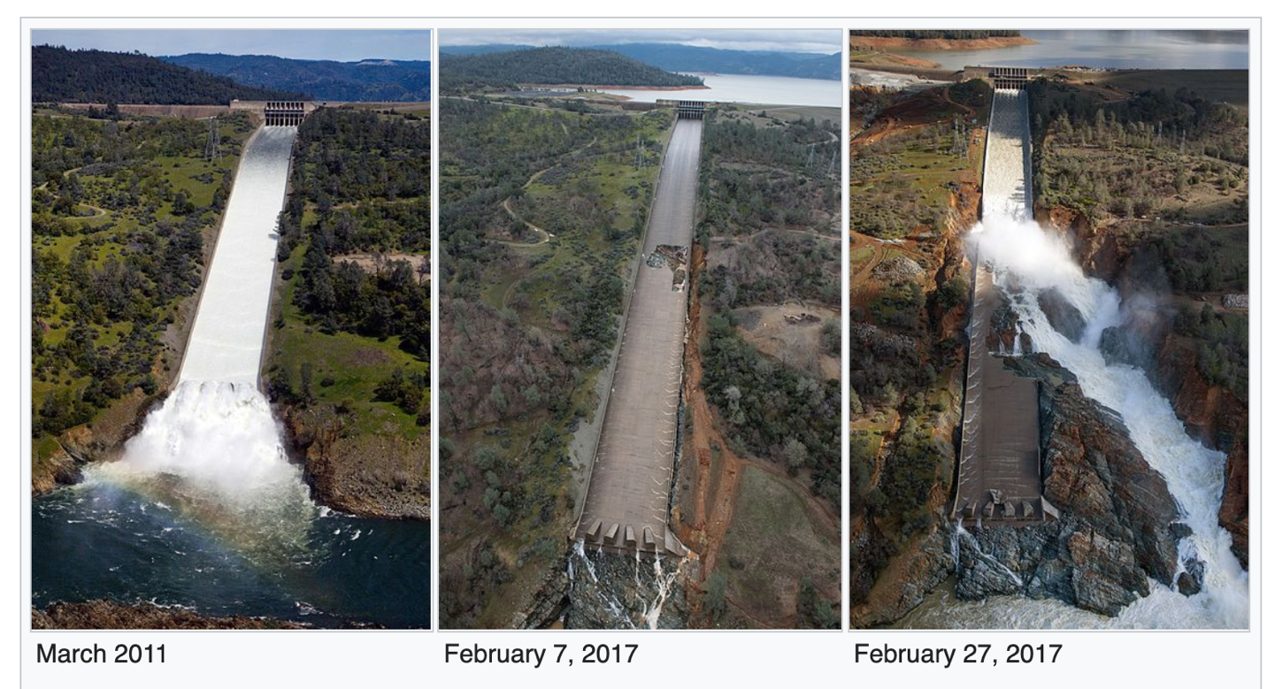
The above three pictures show the main spillway and where it drains into the Feather River. The middle shows the sinkhole that developed in the spillway on February 7, 2017.

Lake Oroville is the second largest reservoir in CA and is impounded by the tallest dam in the US!

During the period February 6-10, 2017 the Feather River Watershed received over 10 inches of precipitation, caused by two nearly overlapping atmospheric rivers (ARs):
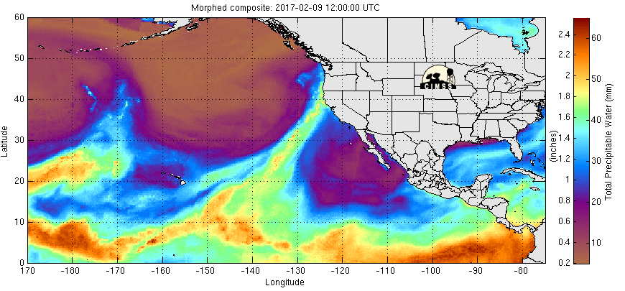
This picture shows the second AR making landfall in Northern CA near 12 UTC on 9 Feb, 2017 by its IWV (mm - same variable as “Total Precipitable Water”) from microwave satellite sensors.
Note that there are areas within the AR where IWV exceeds 50 mm. This is a value not typically seen outside the tropics.

The largescale weather pattern, its extratropical cyclones, fronts and atmospheric river pathways (green arrows) are summarized on the below schematic produced by the California-Nevada River Forecast Center:

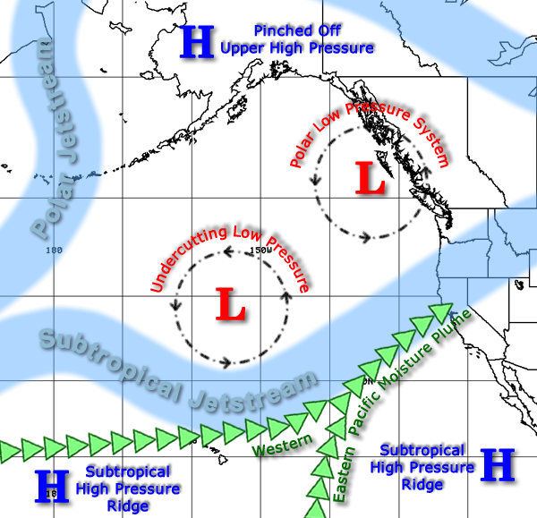

Potential for Dangerous Weather:
The Feather River Watershed is shown in the image below. This entire watershed drains into Lake Oroville behind the dam. The watershed encompasses more than 2 million acres and is a very rugged part of the northern Sierra Nevada mountains. Elevations in the watershed range from approximately 1000 feet to approximately 10,000 feet. The spillway failure coinciding with this powerful AR posed a critical emergency management scenario for the operators of Lake Oroville Dam. When the spillway failed, the level of the reservoir was 848 feet. This is the maximum safe operations level in the wintertime, when extra ‘flood capacity’ space must be kept in the reservoir to prevent floods from reaching the lower Feather River. More than 200,000 residents live downstream of the dam. These residents are in harm’s way if the dam is no longer able to control the amount of water spilling into the river from the reservoir. When the reservoir level is at 848 feet, the available room to store additional water is 750,000 acre-feet (a measure of volume). This means that if all the precipitation falling on the Feather River Watershed were to run-off into the reservoir, just 4.3 inches of precipitation would fill the available room and the reservoir would be over capacity. Another way to say that: 4.3 inches of rain falling on the surface area of the Feather River Watershed is equal to 750,000 acre-feet.

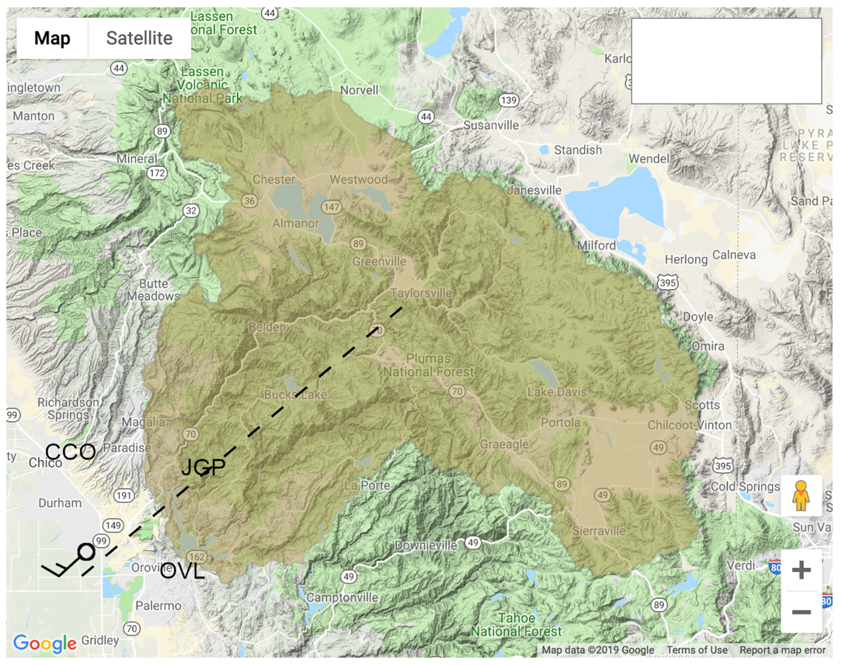
Map of the Feather River Watershed with Lake Oroville and the measurement locations you will use in this assignment. Brown shading shows boundaries of watershed, the reservoir is next to the HWY ‘162’ sign near the SW corner of the watershed. The “upslope” wind for the local mountain range flows along the dashed line from SW to NE. A hypothetical upslope wind barb with speed = 15 knots is depicted just to the south of the town of Durham. See Table 1 for a list of helpful parameters about the Watershed. See Table 2 for a list of instruments and their measured variables.

Table 1
Parameter | Value | Definition
Lake Orovile Flood Space | 750,000 ac-ft | The volume of extra space held in reserve for potential floods created by heavy rain the watershed.
AW | 2,048,000 ac | The surface area of the watershed (brown shading)
zelevtop | 3,000 m | Highest elevation terrain in watershed
zelev95 | 2,100 m | 95% of the watershed surface is below this elevation. If the rain-snow transition altitude is zelev95, FR=0.95
zelev50 | 1,400 m | 50% of the watershed surface is below this elevation. If the rain-snow transition altitude is zelev95, FR=0.5
δup | 225 deg | Upslope wind direction. 225 degrees is directly from the southwest. The hypothetical barb in the watershed map shows wind moving from this direction.

Table 2
Instrument | Location | Measurement
915 MHz wind profiling radar | CCO | Horizontal wind speed and direction (kt) profiles every hour and every 100 m vertically
FMCW precipitation profiling radar | OVL | Vertical location of rain-snow transition (m) if raining
GPS receiver | OVL | IWV (cm)
Hygrometer | OVL | Water vapor mixing ratio (g kg⁻¹)
Rain-gauge | JGP | Accumulated precipitation (inch)

Helpful Formulas:
- BUF=IWV*uctl*cos⁡(δwind- δup)
Bulk Upslope Flux (AR strength), δwind is the direction (angle) of the controlling layer wind, uctl is the magnitude of the controlling layer wind.

- RMAX=Pr*AW*FR; Maximum potential runoff from watershed. P_{r} is the accumulated rain.

How to Find Wind Direction:
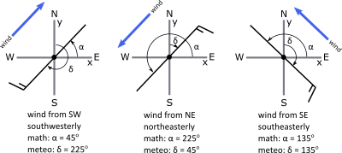
In Meteorology, δ = N = 0º refers to wind blowing from the North (from top of y axis). Directions increase clockwise from there: E = 90º, S = 180º, W = 270º.
Assignment:
- (2 points) Based on our definition of severe weather and the background section above, was the failure of the Oroville Spillway necessary to make this a severe weather event? Why or why not?

Part 1: Analyze the wind-profiling radar during the event to pick out the most problematic periods during this AR.

- Examine Figures 1a and 1b. The top panel of Figure 1a shows a sounding, every hour, of the horizontal winds measured by the 915 MHz radar at Chico, CA. Each horizontal wind measurement is shown using a wind barb, in standard notation, where the speed is in knots (kt). The x-axis is time, increasing from right to left beginning 00 UTC on Feb 6 and ending 00 UTC on Feb 8. The top panel of Figure 1b shows the same information beginning 00 UTC on Feb 8 and ending 00 UTC on Feb 9. Note that you could look at the contiguous time period 00 UTC on Feb 6 through 00 UTC on Feb 10 by placing Fig 1b next to Fig 1a and to its’ left. The middle panels of Fig 1a and Fig 1b show the controlling layer wind speed (kt): uctl, every hour, in brown bars. Note that an IWV measurement is usually also provided at CCO, but for this event the measurement was missing for the duration, so it will not appear in the middle panels. The lower panels of Fig 1a and Fig 1b show measurements from OVL of the water vapor mixing ratio in g kg⁻¹ and IWV in cm in light blue and dark blue, respectively. Each IWV and mixing ratio has its’ own scale located on opposite y-axes. You can assume that all weather conditions at CCO and OVL are identical. Note that if any hour from any figure in this assignment appears to be blank, this means the data was not collected because of an instrument issue.

- (3 points) Based on the definition we gave for an atmospheric river, identify the time the atmospheric river arrived in the Oroville area, identify the break period between the first and second AR, and identify the time of arrival of the second AR. You can use the following thresholds for moisture content and low-level movement of moisture: IWV must exceed 2.0 cm while controlling layer wind exceeds 30 kt. Write your answer in date / time (UTC)

  - AR1 arrival:
  - Interlude period between ARs:
  - AR2 arrival:

- (3 points) Based on our discussion of low-level jets and our definition of the term “jet”, use figures 1a and 1b to identify the periods when low-level jets are present over the CCO radar. You can exclude any periods where controlling layer wind speed does not exceed 30 kt. Write your answer in the same format as in question 3.

- (2 points) When did the strongest low-level jet occur? What non-meteorological event was also occurring during this time that made this timing especially dangerous?

- (3 points) Based on our discussion of the relationship between BUF and precipitation during ARs (July 24 lecture) and the formula for BUF given above, when do you expect the heaviest precipitation to occur in the Feather River Watershed? List the three 6 hour periods during which you expect the heaviest rain. Write your answer in the same format as question 3. Hint: cos (45 deg) = cos (-45 deg) = 0.7.

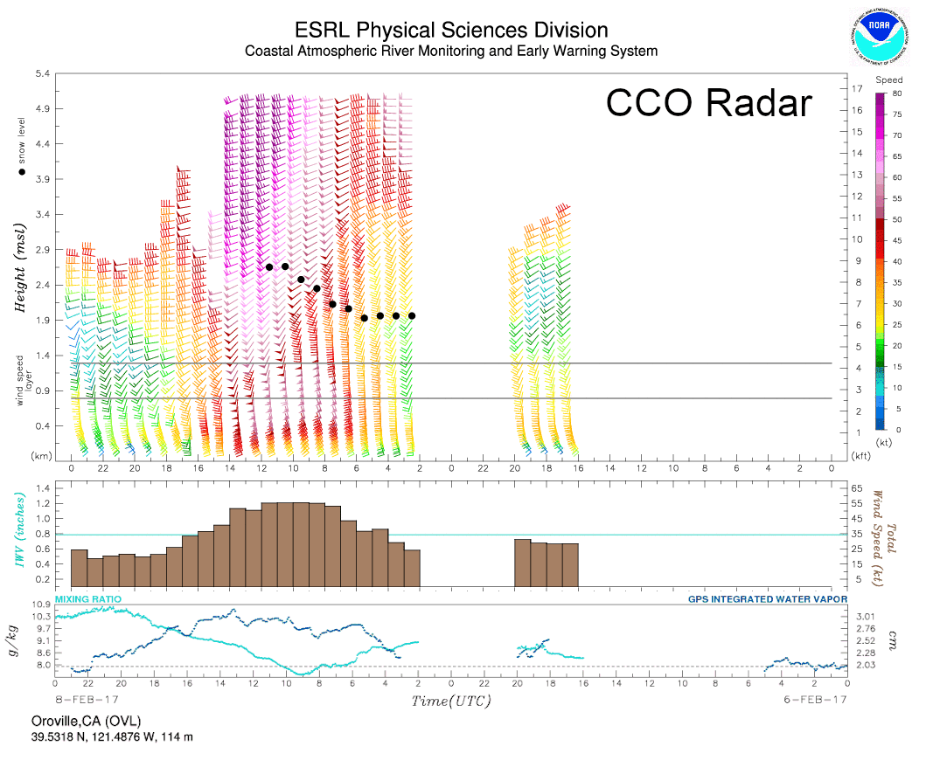
Figure 1a: Top displays the vertical profile of horizontal wind (kt), measured every hour by the 915 MHz wind profiling radar at CCO. The wind barbs are in standard station model notation. The vertical boundaries of the orographic controlling layer for the local mountains is shown by horizontal lines near 1 km altitude. You can ignore the black dots. Middle panel shows the average wind speed in the orographic controlling layer. The bottom panel shows the water vapor mixing ratio (humidity) in g kg⁻¹ and IWV in cm measured at the OVL site. This figure shows the period 00 UTC on 6 Feb, 2017 to 00 UTC on 8 Feb, 2017. Note that time increases from right to left!

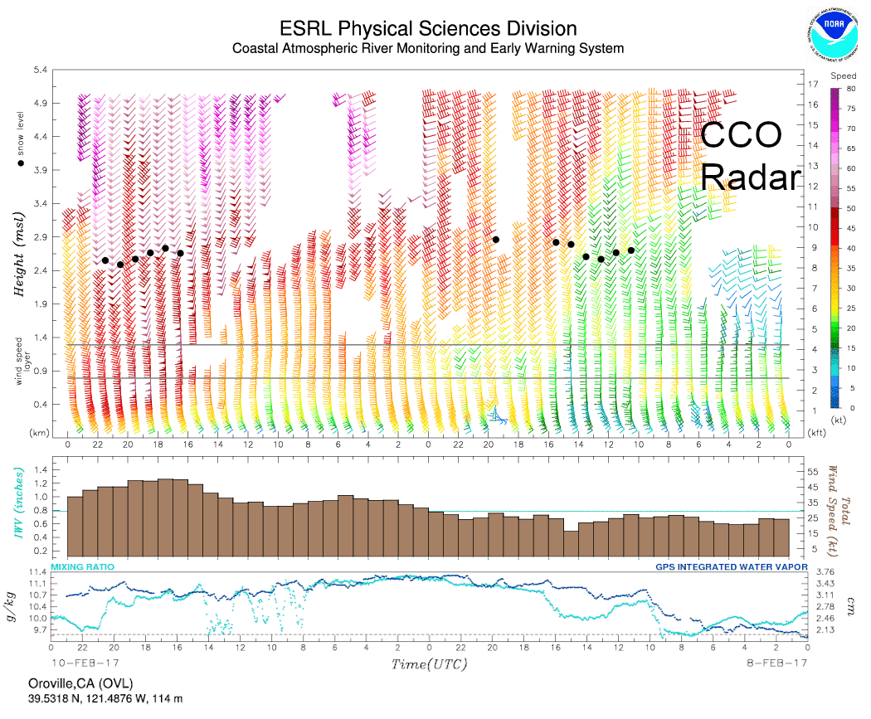
Figure 1b: Top displays the vertical profile of horizontal wind (kt), measured every hour by the 915 MHz wind profiling radar at CCO. The wind barbs are in standard station model notation. The vertical boundaries of the orographic controlling layer for the local mountains is shown by horizontal lines near 1 km altitude. You can ignore the black dots. Middle panel shows the average wind speed in the orographic controlling layer. The bottom panel shows the water vapor mixing ratio (humidity) in g kg⁻¹ and IWV in cm measured at the OVL site. This figure shows the period 00 UTC on 8 Feb, 2017 to 00 UTC on 10 Feb, 2017. Note that time increases from right to left!

Part 2: Analyze the precipitation that occurred and the rain-snow transition elevation to evaluate the risk of exceeding the flood space in Lake Oroville.

- Examine Figure 2. The figure shows the accumulated precipitation (inches) at JGP. The JGP gauge measures precipitation every hour. The location of JGP is shown on the watershed map. You can assume that the precipitation at JGP is representative of the precipitation everywhere in the watershed. Its elevation is approximately 750 m above mean sea level (MSL). Note that the time axis in this figure shows time in local standard time. To translate to UTC, add 8 hours to the value on the x-axis of Figure 2. You will need to do this to compare the rain-gauge measurement to the other measurements!

- Now examine Figures 3a and 3b. Each shows the time-altitude graph of the doppler speed of falling hydrometeors sensed by the precipitation radar at OVL. Falling hydrometeors speed up considerably after melting from snow to rain. Thus, the transition altitude from slowly falling hydrometeors to fast falling hydrometeors is approximately the altitude of transition from rain to snow. The exact location of the rain-snow transition (“snow level”) is shown by black dots. The measurement is impossible if rain is not falling, so there are several missing data periods. Just like with any storm, ARs include periods of light or no rain interspersed with heavy rain. This type of radar is also known as a “snow level radar”. Note time increases from left to right in this figure. This is the opposite direction compared to Figures 1a and 1b. Figure 3a covers the period 00 UTC on 6 Feb, 2017 to 00 UTC on 8 Feb, 2017 and Figure 3b covers the period 00 UTC on 8 Feb, 2017 to 00 UTC on 10 Feb, 2017.

- (4 points) Use Figure 2 to find the 3 six-hour periods (in UTC) of heaviest precipitation. Write down the time boundaries of each period and the accumulation in inches during each period.

- (Bonus: 2 points) Are the periods from question 9 approximately the same as what you wrote down for question 6? If not, what factors does BUF not take into account that may have caused a difference in precipitation in the watershed compared to what you expected?
- (1 point) Use figures 3a and 3b to determine when the largest change in F_{R}, the fraction of the watershed receiving liquid precipitation, will occur. Write the time down in date / time (UTC).

- (Bonus: 2 points) Which periods from question 9 will pose the greatest danger based on the situation at Lake Oroville? Use the equation for maximum potential watershed runoff (R_{MAX}) and the available storage space at the time of spillway damage to inform your answer. Write a sentence or two supporting your logic.

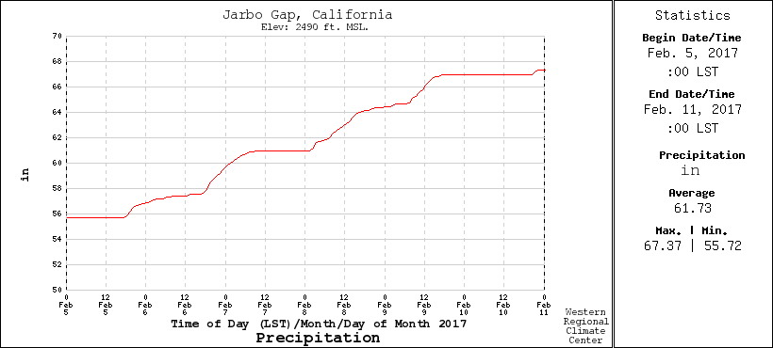
Figure 2: Accumulated precipitation (inches) at the JGP rain-gauge during the period 00 LST on 5 Feb, 2017 through 00 LST on 11 Feb, 2017.

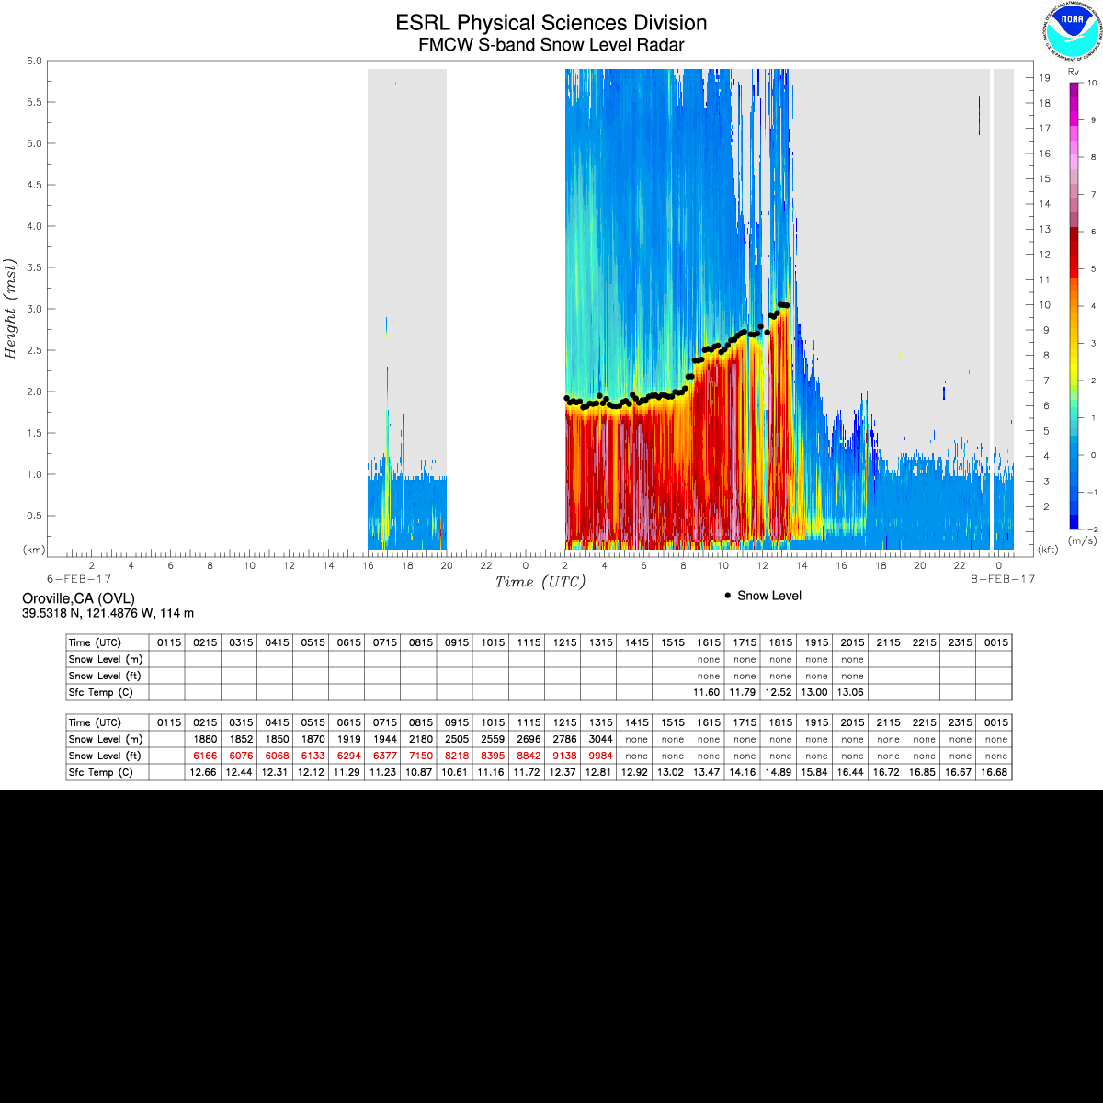
Figure 3a: Snow-level radar figure from OVL during the period 00 UTC on 6 Feb, 2017 to 00 UTC on 8 Feb, 2017. Note time increases from left to right in this figure. This is opposite from Figures 1a and 1b.

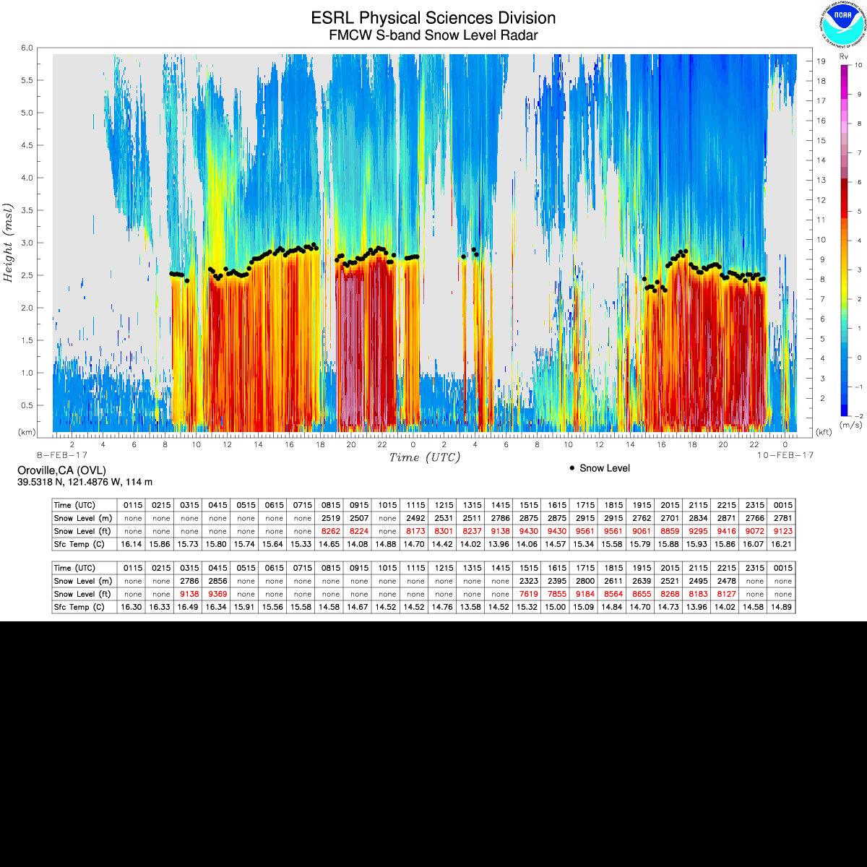
Figure 3b: Snow-level radar figure from OVL during the period 00 UTC on 8 Feb, 2017 to 00 UTC on 10 Feb, 2017. Note time increases from left to right in this figure. This is opposite from Figures 1a and 1b.

