Diagnosing Rainfall Variability Within A Series of Atmospheric Rivers over Northern California in February 2017
Parker Malek

Introduction
High intensity precipitation events are described by their unusually high rates of precipitation over a given duration of time. However, these events can also be distinguished by the various impacts that result from them. As known drivers of rapid and potentially hazardous changes in landscape through flash flooding, erosion, snow melting, landslides, and debris flows (IPCC, 2022), extreme high intensity precipitation (HIP) events can lead to high socioeconomic costs through their ability to simultaneously affect drinking water supplies, fishery health, and transportation infrastructure over short time periods. As studies have suggested that these kinds of precipitation events are likely to increase in intensity as the climate warms (Kunkel et al., 2013), understanding the synoptic and mesoscale physical characteristics of HIP events is critical for the development of future mitigation strategies and infrastructure improvements.
Previous research has investigated spatial and temporal patterns of high intensity precipitation along the West Coast of the US. For example, Ralph et al. (2006) and Neiman et al. (2011) used radar and streamflow data to analyze and document extreme precipitation events in California’s Russian River and Washington’s Olympic and Cascade Mountains. Guan et al. (2010) similarly analyzed precipitation data from the Sierra Nevada Mountain Range in California and found that the largest precipitation events were associated with atmospheric rivers (ARs), synoptic-scale (1000 km or larger) narrow bands of water vapor that can transport large amounts of moisture out of the tropics to the mid-latitudes. Atmospheric rivers account for a significant proportion of high impact hydrological events in the state of California (Young et al. 2017).
Within these large-scale systems, smaller mesoscale characterizations of HIP events have also been described. Because of California’s unique water resource dependencies on a few extreme precipitation events during the winter season, numerous studies have utilized the state’s topographic variability and large spatial extent to describe HIP events in relation to orographic drivers and AR storm-level summary analyses (Lamjiri et al. (2018); Cannon et al. (2017)). Additional work has been done to describe smaller scale meteorological features embedded within ARs that contribute to HIP events. Convective narrow cold frontal rainbands (NCFRs) are a characteristic of particularly sharp frontal boundaries and are often accompanied by strong gusty winds and brief but intense precipitation. Studies have shown that the “precipitation cores” formed within NCFRs are associated with high surface convergence and some of the highest rates of precipitation in storms where the phenomena are observed (Houze et al., 1976; Hobbs & Persson, 1982; Koch & Kocin, 1991). These systems have additionally been associated with many costly and destructive debris flow and landslide events in Southern California (Cannon et al., 2018; Oakley et al., 2017; Sukup et al., 2016, de Orla-Barile, 2022).
As the hydroclimate of California is dominated by wild swings in drought and non-drought years, similar annual extreme events within the state often impact the hydrologic and geomorphic response to precipitation by changing the physical relationships among rainfall, runoff, erosion, and hillslope stability. HIP events that trigger these landscape responses increase the risk of simultaneous disasters where water and emergency managers face increasingly dire tradeoffs between water quality, transportation networks, community safety and flood prevention. Recent studies (Agilan, et al., 2017; Chanaud et al., 2021) have found that precipitation intensity-duration-frequency (IDF) relationships have changed from the historical curve in many regions, with many of these changes found in higher intensity, shorter duration events. Because these curves are oftentimes used to design water control infrastructure, and the design of long-lifetime infrastructure is that the curves represent a stationary climate, non-stationarity implies risk to infrastructure and socioeconomic health.
Previous scholarly research has identified two distinct challenges associated with the current state of high intensity precipitation research:
- Poor understanding of processes that cause high intensity precipitation.
It is known that the highest precipitation rates on earth are found in deep convective cells. However, the details of how convective elements organize or how strong rising motion embeds within larger precipitating systems (e.g. cyclones or fronts) are poorly understood and are critical for understanding how high rates persist long enough to cause significant impact (Poujol et al. 2021, Fowler et al. 2021). Furthermore, numerical climate models partially rely on the parameterization of these high resolution moist processes within storms, and it has been found that biases in storm track position and intensity are likely linked to uncertainties associated with these kinds of meso-scale processes (Shaw et al., 2016).
- Poor understanding of the landscape responses to high intensity precipitation.
Rainfall intensity is known to affect land surface processes such as infiltration, runoff efficiency, erosion, and runoff/liquid water retention during rain-on-snow events and sensitivity to HIP has been well-studied via laboratory and computational experiments. However, landscape scale processes are less understood (I.E. flash flooding, debris flow and landslide initiation, mass erosion, stream network sediment loading, and snowpack loss) and may become exacerbated when events occur within disturbed regimes. Sequencing of intra-event HIP is known to modulate the above impacts, but little work has been performed to link the sequencing of HIP in real events to hydrological and geomorphic outcomes (Dunkerley et al., 2021).
Notable events have illustrated the socioeconomic impact of HIP. In 2017, the Oroville Dam Crisis in the state of California was in part triggered by a series of atmospheric river events that affected the region in early February. The pulses of high intensity precipitation within these AR events caused heavy damage to the primary and emergency spillway of the Oroville Dam, leading to the evacuation of 188,000 people and around $1 billion in damage-related repairs (Henn et al., 2020; Vano et al., 2018; White et al., 2019). Previous studies have characterized the meteorological events surrounding the crisis with the intent of improving station-based ensemble surface meteorological analyses, describing the runoff mechanisms that led to the crisis, and quantifying the effects of climate warming on increased precipitable water in AR systems, but the drivers of within-AR rainfall intensity has not been well-described for the event (Bunn et al, 2022; White et al, 2019; Michaelis et al., 2022).

Study Objectives
This case study will provide synoptic and mesoscale characterizations of a series of landfalling ARs that triggered the February 2017 Oroville Dam Crisis in the state of California. Rain gauge, satellite-based, and reanalysis data will be used to identify high intensity, short duration precipitation pulses embedded within these ARs, and the local and synoptic-scale forcing characteristics attributed to these pulses will be identified and statistically described. Results will provide insight into how short duration high intensity precipitation propagates within larger storm systems and will expand our understanding of the mechanisms that drive high intensity precipitation variability from within-storm events.
Developing an understanding of the mesoscale features of HIP that occur within the events surrounding this crisis will address the above challenges by improving the ability to accurately project these events in future climates through dynamical and statistical means, highlighting critical uncertainty in detection and prediction, providing gains in predictive skill and scientific insight into the impact of HIP on changing landscapes, and generating new decision-support information to assist water and environmental resource managers in developing the next generation of adaptive management practices.

Data and Methods

Study Region
The Oroville Dam is located near the city of Oroville California. The city is on the geographic edge of the Yuba-Feather watershed region in Northern California. The watershed region consists of river systems that have a long history of catastrophic flooding, with five major floods resulting in 41 deaths since 1950 (FIRO). The region has the climatological propensity to be affected by extreme precipitation events that often lead to high socioeconomic impacts, with the Oroville Dam crisis being one of these high impact events. For this study, the Oroville municipal airport is used as an approximate location for the dam, with the dam being location around miles from the airport.
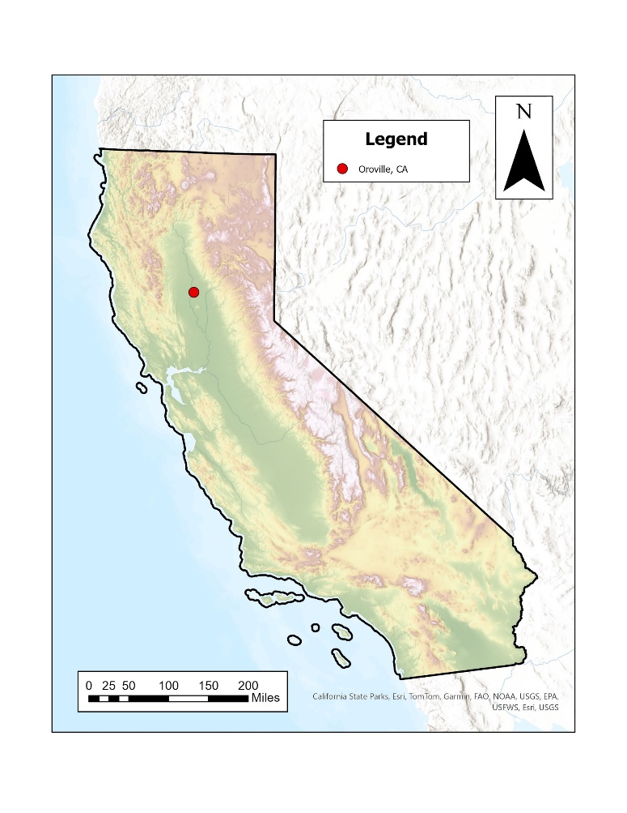
Figure 1. Location of Oroville, California

MesoWest Station Data
This study utilizes rain gauge data to approximate precipitation around the Oroville Dam. The University of Utah’s MesoWest project provides access to archived weather observations across the United States, with extensive records of hourly precipitation available for many airport-based stations across the country. The station located at the Oroville Municipal Airport has an extensive record of hourly precipitation data and was used to pull precipitation records for February 2017. Raw precipitation data from MesoWest required resampling to consolidate precipitation values to the nearest hour. Data with multiple time stamps per hour were resampled using the mean value across each respective hour. Additional time series were constructed from California Data Exchange Center weather gaging stations within the watershed region to confirm the presence of similar synoptic-level pulses across the study region during the events flagged with the resampled airport time series. (Figure 1).

Watershed Region Name | Station Name | Station Code | Years of Data Available
Yuba-Feather | Oroville | kove | 24
Table 1. MesoWest sites selected for analysis
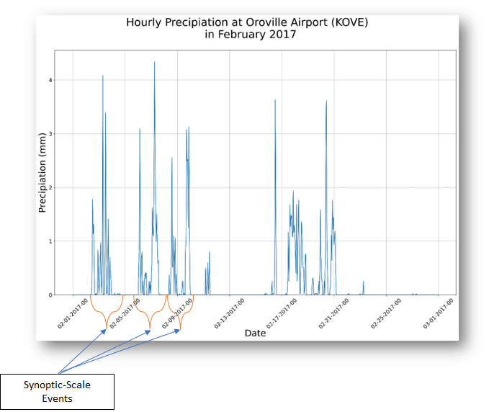

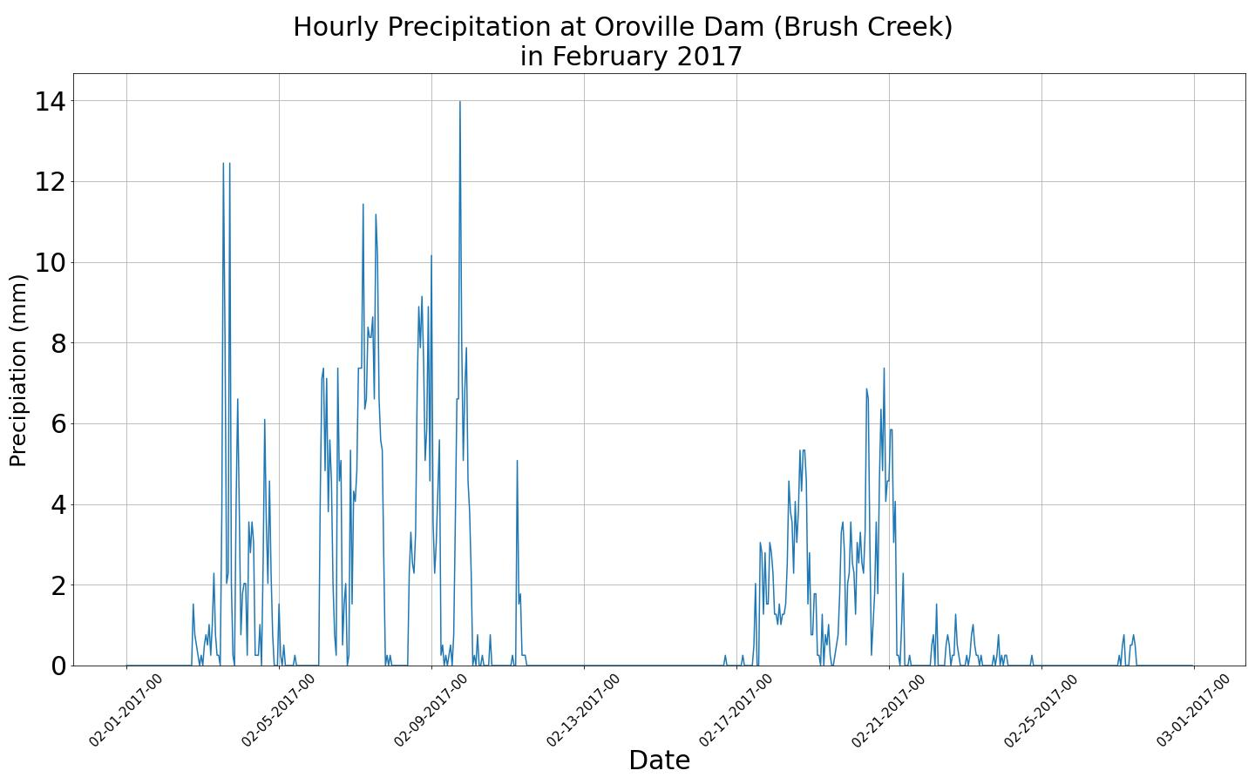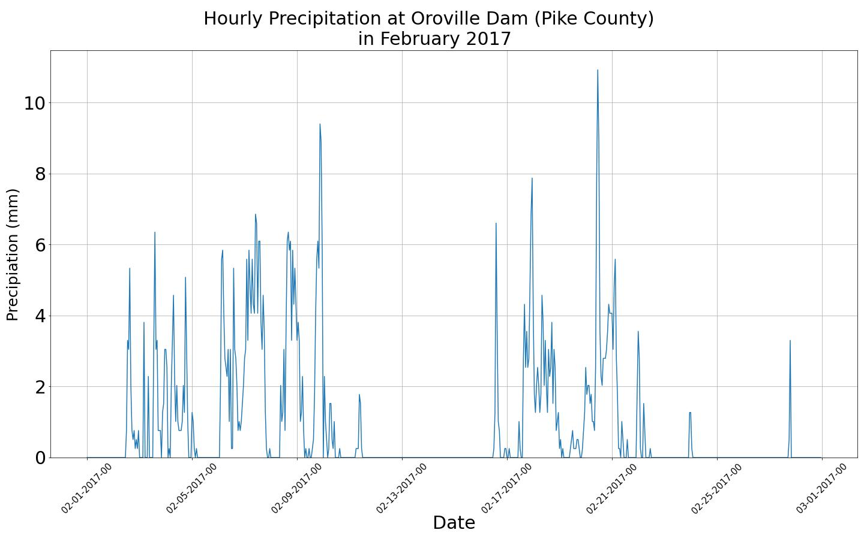
Figure 1a. Resampled hourly precipitation time series for Oroville Airport, California for February 2017. Example of synoptic scale events identified.

Synoptic and Mesoscale Pulse Identification
A two-pronged approach is used to categorize pulses of precipitation for the study. Longer-duration synoptic scale events are first identified visually from the hourly time series of rainfall events at Oroville Municipal Airport in February 2017. These larger scale events are identified through visually selecting groupings of precipitation that have a distinct peak followed by a period of reduced rainfall. This process identified 7 separate synoptic-level events. Within each of these synoptic level events, individual mesoscale pulses are identified through a similar visual identification process. Because distinct peaks in precipitation can occur multiple times within the same synoptic level pulse event, multiple pulses are identified within the same synoptic level event. This methodology identified 8 notable mesoscale pulses within the study time period. Pulses in vary temporally from 7 hours to 2 days, with precipitation totals ranging from 6 to 22 mm. (Table 1).

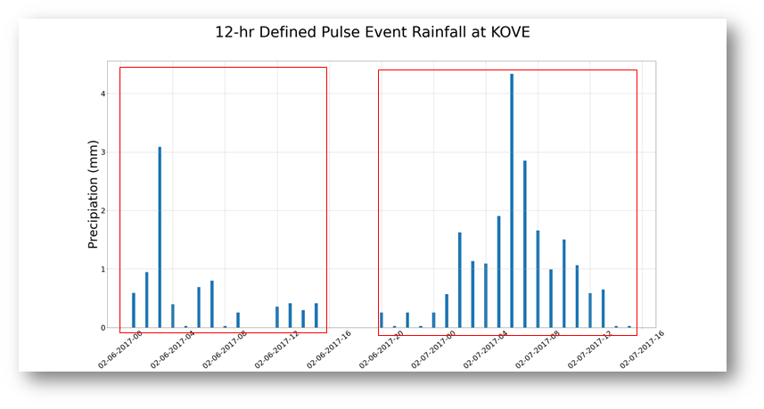

Figure 2. Example of “multimodal” pulses found within synoptic level event at Oroville Airport in February 2017
d
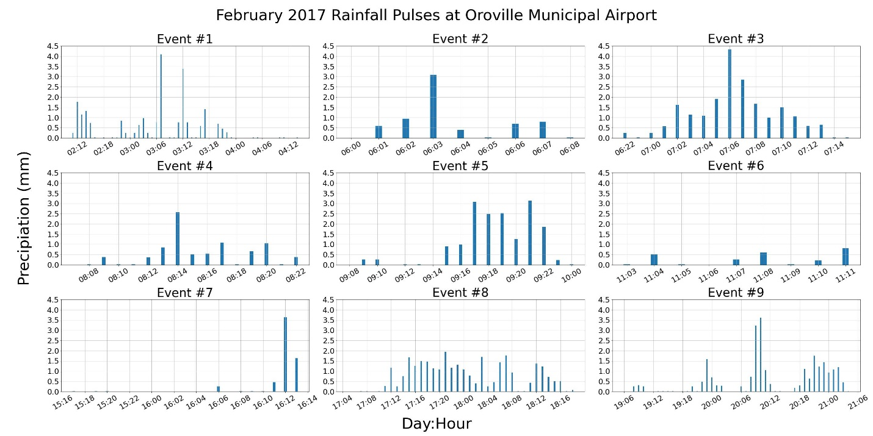
Figure 3. Pulses found within synoptic level event at Oroville Airport in February 2017

Synoptic Event  # | Pulse Event  # | Event start date  (mm-dd-hh) | Event end date  (mm-dd-hh) | Total  Precipitation  (mm) | Average  Precipitation  (mm) | Maxmium  Precipitation  (mm) | Day  Difference
1 | 1 | 02-02-11 | 02-04-14 | 22.02 | 0.42 | 4.08 | 2 days 3 hours
2 | 2 | 02-06-00 | 02-06-08 | 6.56 | 0.82 | 3.09 | 8 hours
2 | 3 | 02-06-22 | 02-07-15 | 20.55 | 1.14 | 4.34 | 17 hours
3 | 4 | 02-08-07 | 02-08-22 | 8.51 | 0.57 | 2.56 | 15 hours
3 | 5 | 02-09-08 | 02-10-00 | 17.03 | 1 | 3.13 | 16 hours
5 | 6 | 02-16-06 | 02-16-13 | 6.06 | 0.76 | 3.63 | 7 hours
6 | 7 | 02-17-05 | 02-18-18 | 28.76 | 0.8 | 1.94 | 1 day 13 hours
7 | 8 | 02-19-06 | 02-21-04 | 24.28 | 0.52 | 3.61 | 1 day 22 hours

Table 1. Pulse statistics at Oroville Airport in February 2017

Methods and Data

NEXRAD Doppler Radar
The Next Generation Weather Radar (NEXRAD) is a network of 160 high-resolution Doppler radar sites that detects precipitation and atmospheric movement and disseminates data in approximately 5-minute intervals from each site. NEXRAD enables severe storm prediction and is used by researchers and commercial enterprises to study and address the impact of weather across multiple sectors. The NEXRAD radar stations located at Beale Air Force Base in Yuba City, California and Sacrament’s NWS office were used to identify sub-hourly mesoscale features associated with each precipitation pulse identified in this study.

MERRA II Reanalysis
Synoptic-scale characterizations of the storm systems that affected the region in February 2017 was used to describe the large-scale patterns influencing the precipitation pulses identified with the above methodology. Reanalysis data from the Modern-Era Retrospective analysis for Research and Applications, Version 2 (MERRA-2, 0.5° x 0.625° grid resolution) was used as a diagnostic tool to describe the flow of moisture into the region during these events. The direction and magnitude of this high-level moisture profile will provide information on which locations within the region are more affected by pulses of high intensity rainfall. Because the directionality and intensity of moisture is the primary driver at the synoptic-scale, MERRA-2’s integrated water vapor transport was used for this characterization effort. In addition to IVT, 850 hPa temperature and sea level pressure from MERRA II was also used to detect frontal passages and centers of low pressure moving over the region during these precipitation pulses.

ERA5 Reanalysis
Wind magnitude derived from ECMWF Reanalysis v5 (ERA5, 0.25° x 0.25° grid resolution) 10-meter U and V components were used to represent surface level winds during the pulse events. Directionality of surface level winds provided information on system locations during the time of the heaviest precipitation for each pulse. Wind quivers are overlayed over SLP and 850 hPa temperatures from MERRA II.

Characterization Results:
Several meteorological drivers of the rainfall pulses during the AR events were identified for the pulses identified in this study. Primary drivers of precipitation include frontal passages and mesoscale convective systems and prolonged lows over the region.

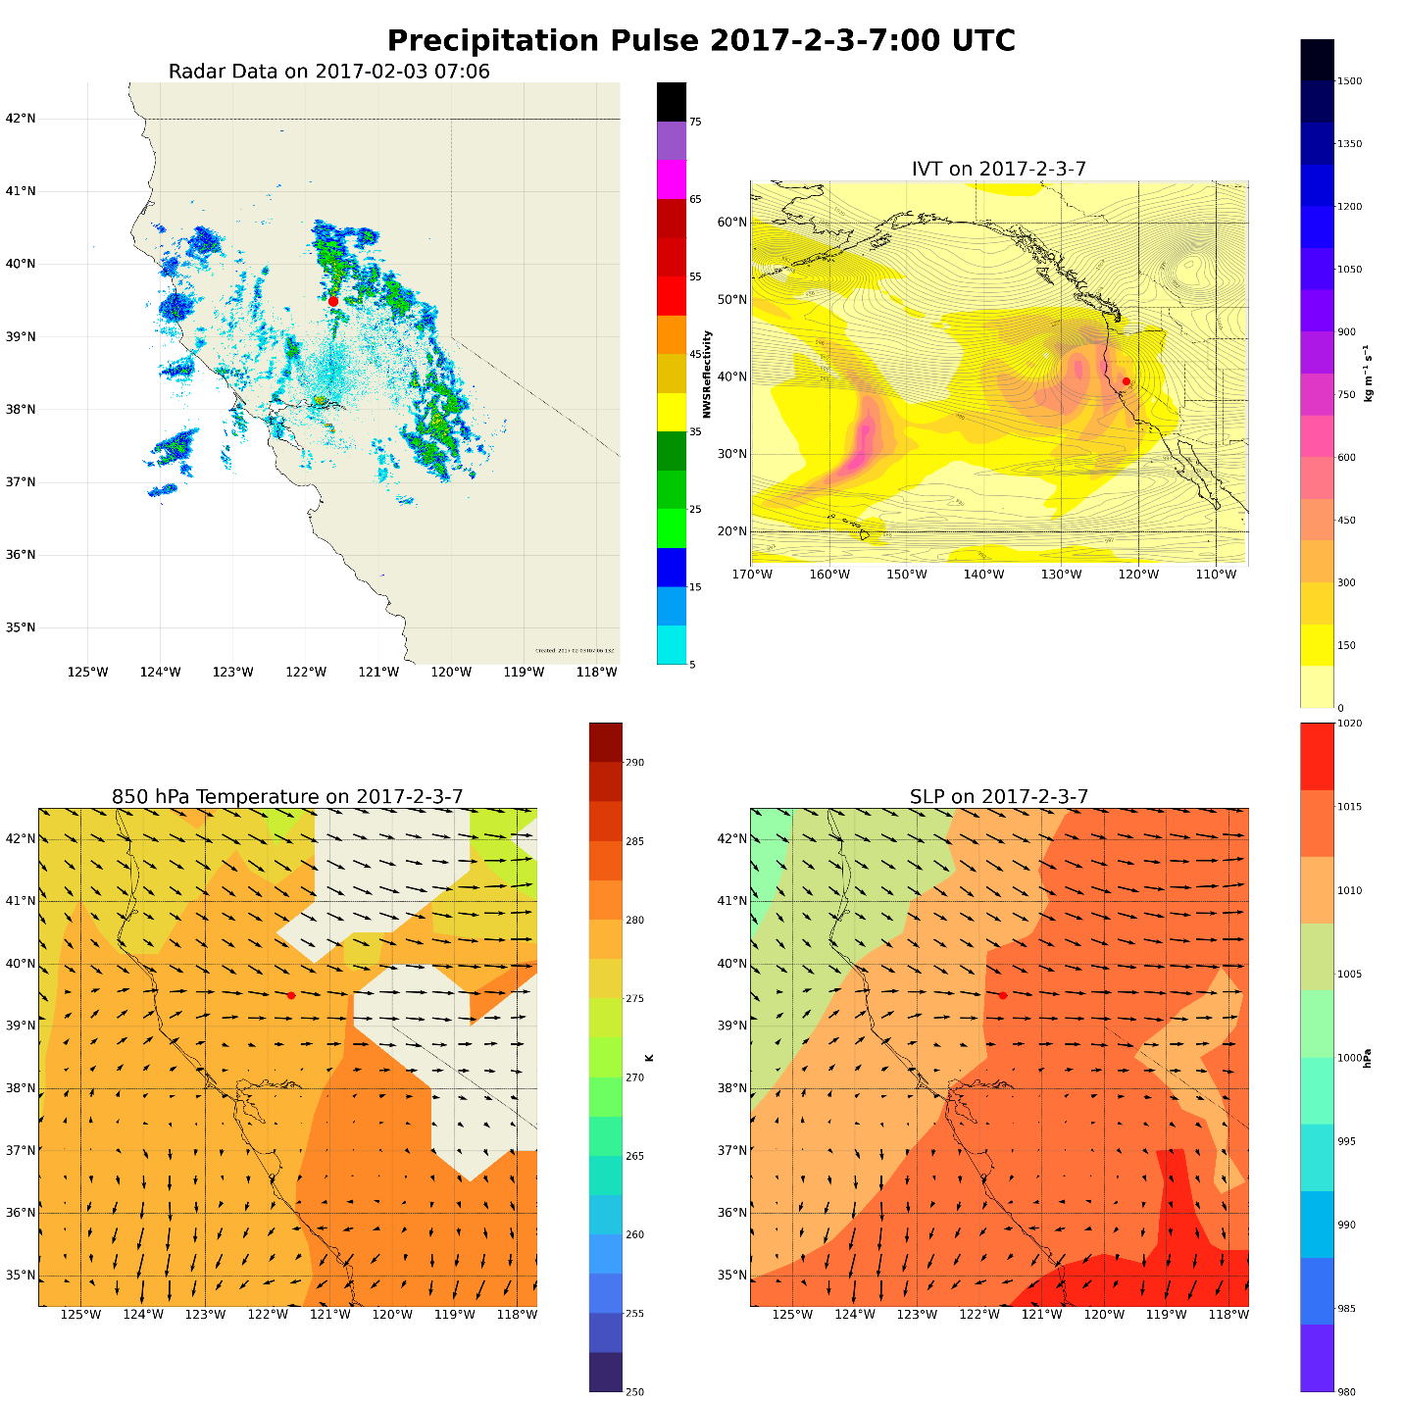

The system that contributed to this pulse was prolonged, lasting over 2 days. Starting on February 2nd, a strong convective system associated with a low pressure system moved ashore, leading to an initial pulse of precipitation at 12:00 UTC. Smaller scale convection followed for a few hours. A second and stronger round of convective precipitation started at 22:00 UTC as the low continues to propagated over land. The peak of precipitation occurred during this pulse at 7:00 UTC on February 3rd. This peak was followed by residual precipitation starting at 11:00 UTC and lasting until 00:00 UTC on February 4th. The lack of nonzero precipitation gaps occurring for the duration of the event along with singular maxima of hourly precipitation has led to the classification of entire synoptic level event as a pulse event.
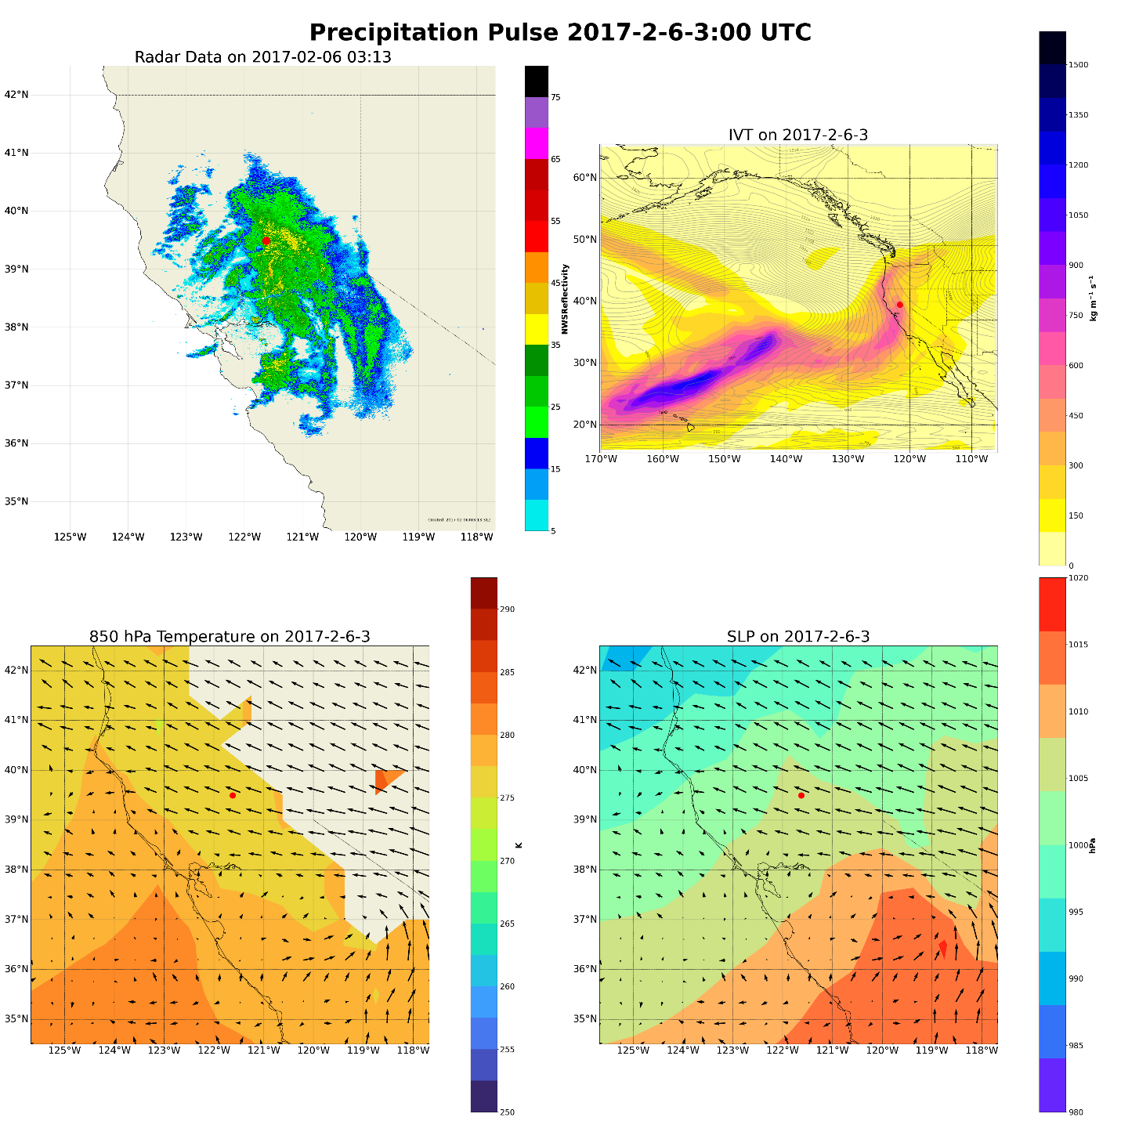
The system constitutes the first portion of a synoptic level event. The collection of mesoscale pulses found within this event occurred during February 6th and 7th. These events constitute the arrival of one of two atmospheric rivers over California and coincide with the failure of the Oroville Dam on the 7th. The first pulse maxima is associated with a vertically oriented band of heavy precipitation that peaks on 03:00 UTC on the 6th and quickly dissipates by 08:00 that same day. Relatively strong northwesterly flow at the surface along with a warm conveyor belt of IVT that originates in the tropics primarily drives this pulse.
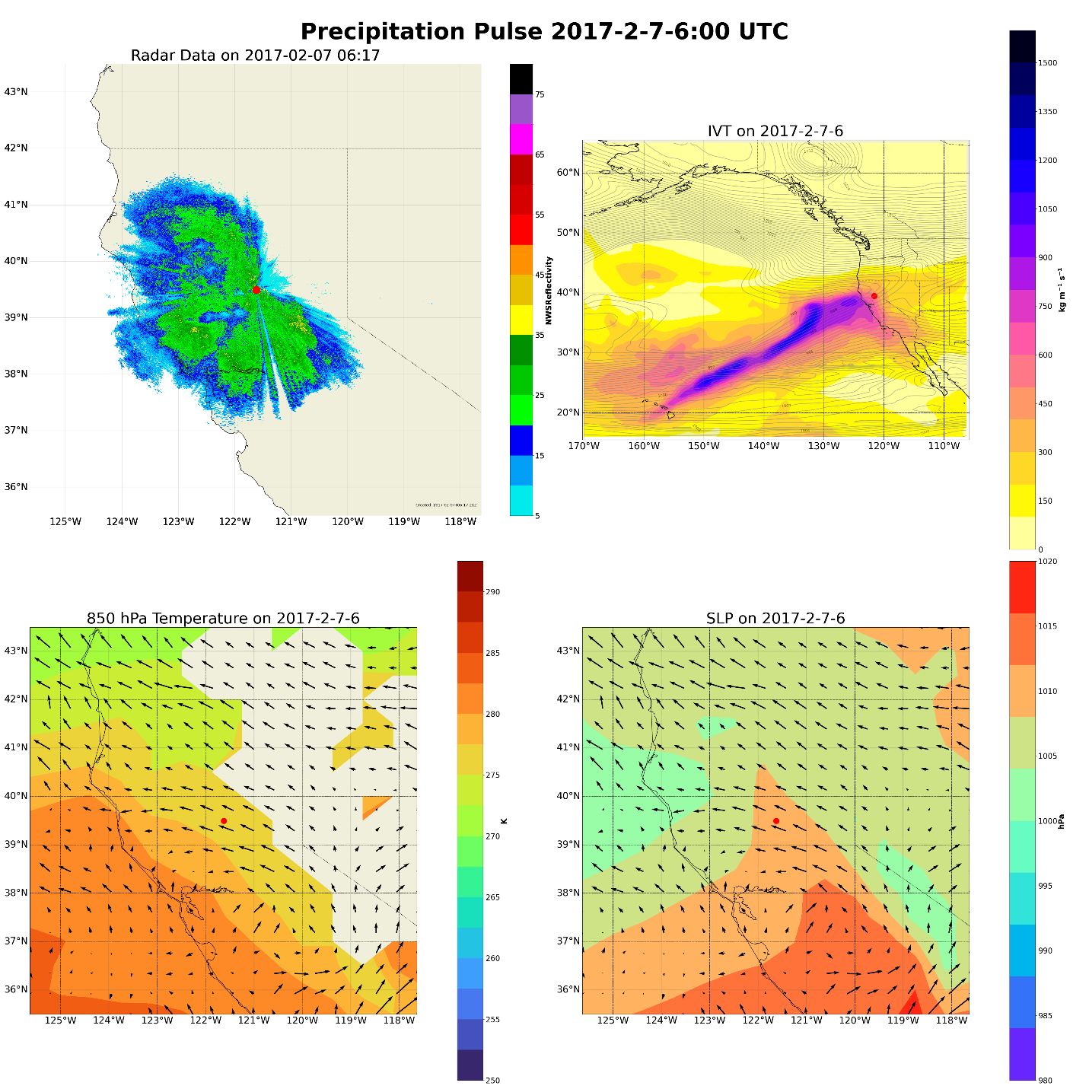

The second pulse within this synoptic system lasts twice as long as the first pulse and is associated with more than triple the total rainfall compared to the first pulse. Precipitation during this pulse is more broadform with a gradual increase in precipitation rate starting in 22:00 UTC on the 6th, peaking at 06:00 UTC on February 7th, and a gradual decrease in precipitation rate that ends at 14:00 UTC on the 7th. Driving this pulse is a suspected mesoscale frontal wave that develops off the coast of California at 18:00 UTC on the 6th. As the frontal wave approaches, and strong pressure gradient forms pushing more precipitation into the region. Because of the warm air moving onshore during this period, this type of atmospheric river system is colloquially known as a “Pineapple Express”.
Show sea level pressure zoomed out to show development of mesoscale frontal wave that likely contributed to enhance rainfaill during this event. Overlay contours of SLP over IVT (fairly tight: 1 mb). This type of atmospheric river system is colloquially known as a “Pineapple Express”.
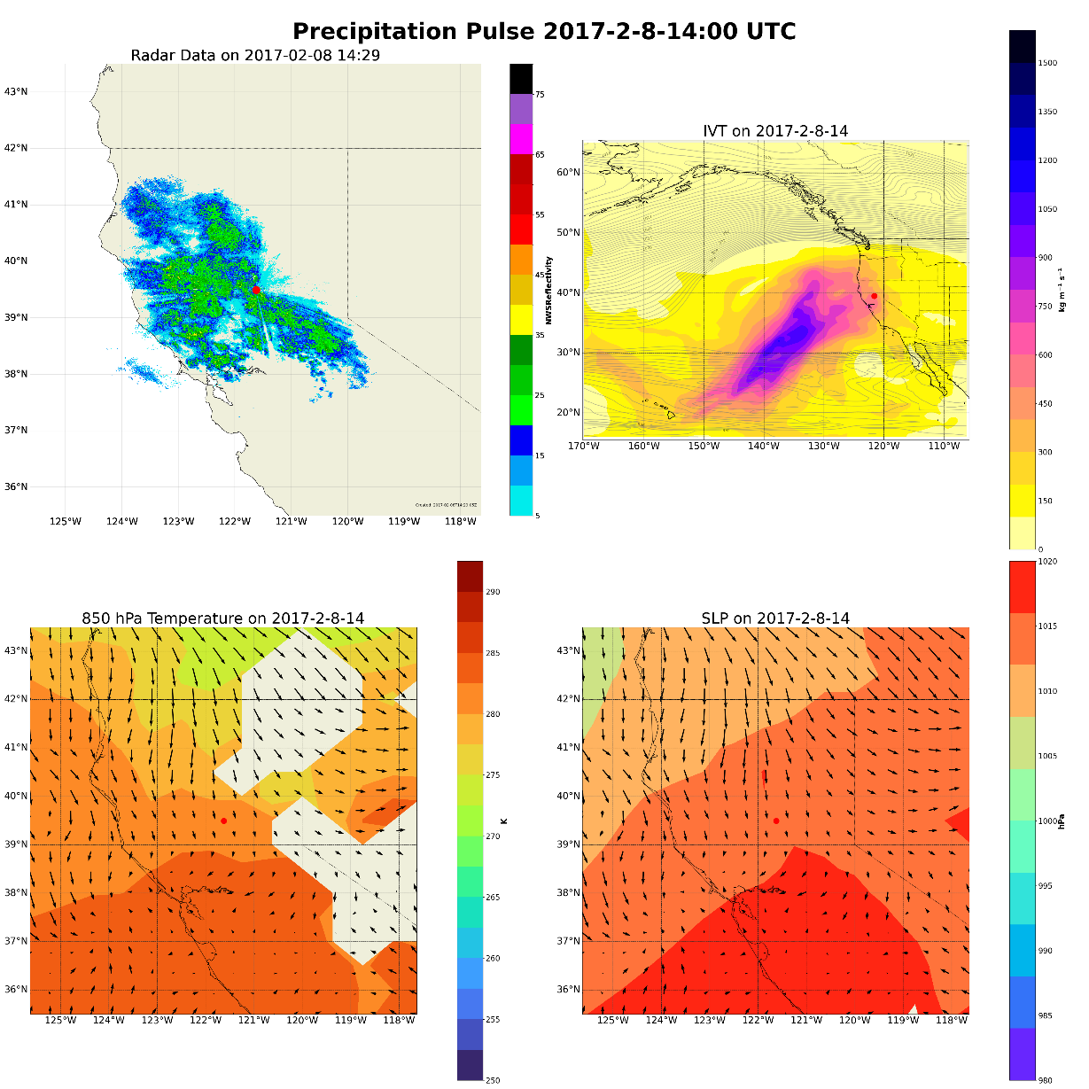
This pulse is associated with another pairing of pulses from a single synoptic level event. Similar to the first pairing, this first pulse produces less than half the amount of total precipitation compared to the second pulse. Beginning at 08:00 UTC and lasting until 22:00 UTC on February 8th, the convective system that produces the precipitation from this pulse occurs prior to the arrival of a larger system of IVT off the coast. This larger system of IVT is associated with the
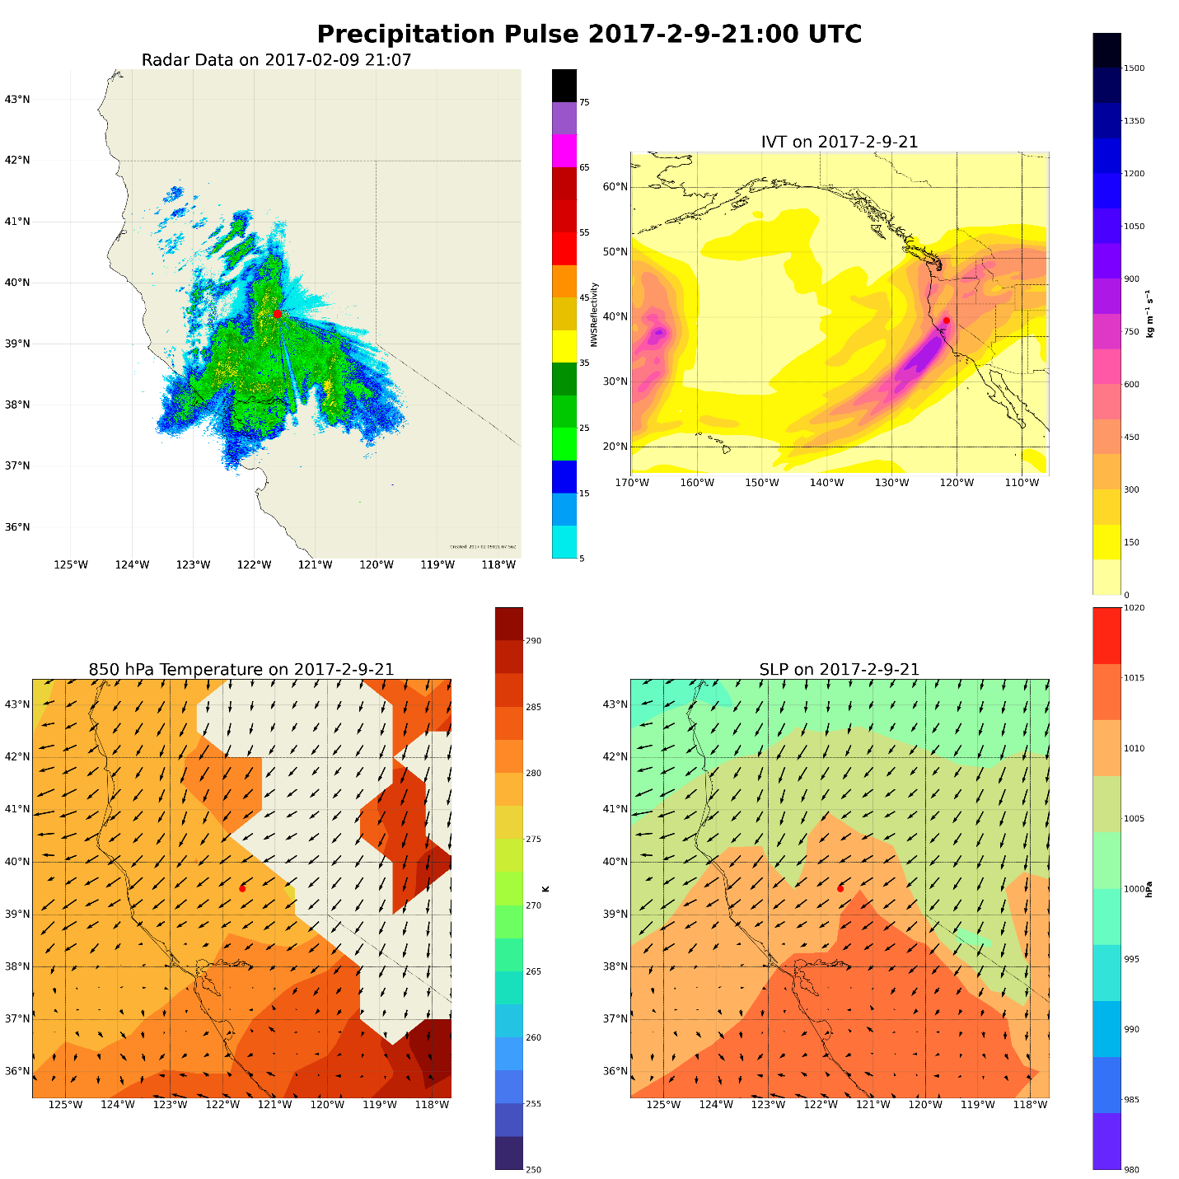

This pulse is the second of a pairing of synoptic level events. This is the primary pulse associated with the second landfall of the AR pulse. As the systems moves onshore, a strong cold front (will need to check) moves through the area, dropping a considerable amount of precipitation in the region starting at primarily on 15:00 UTC on February 9th. Prolonged ratefall rates over 2 mm/hr are observed from 17:00 – 19:00 UTC, with a smaller but significant rainfall rates occurring for 3 hours afterwards.

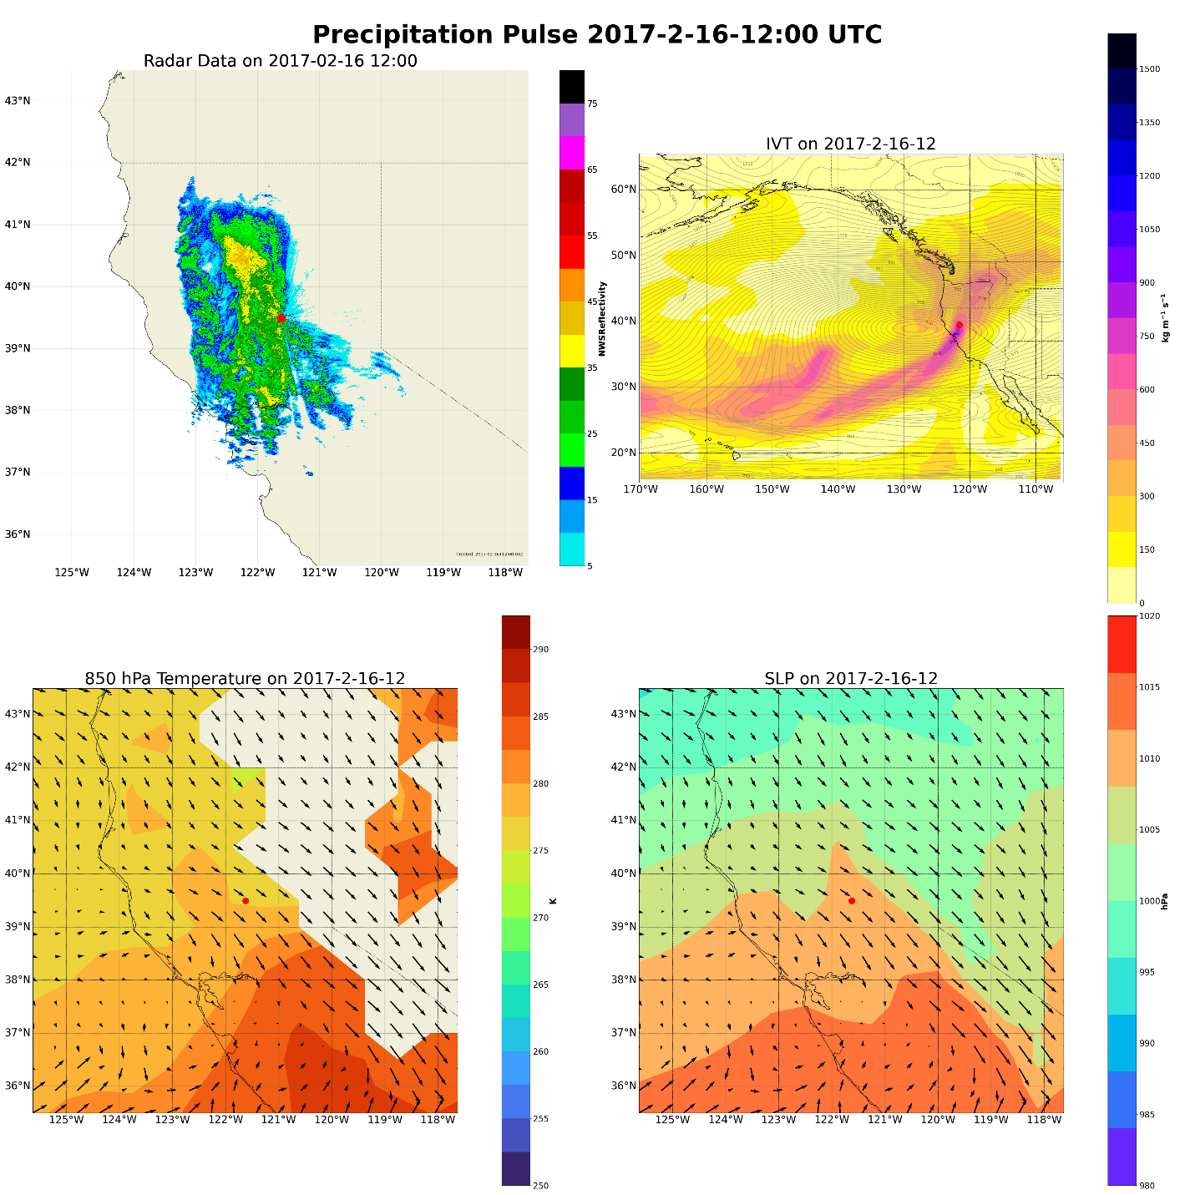
This pulse occurred primarily over 3 hours, from 11:00 UTC to 13:00 UTC on the 16th. The peak of precipitation at 12:00 UTC occurred as a cold front moves over the region. Given that this band of precipitation is relatively localized, producing heavy periods of precipitation (over 45 dbz at times), and is associated with a cold front, the pulse of rainfall produced from this system over the region is likely caused by a narrow cold frontal rainband.
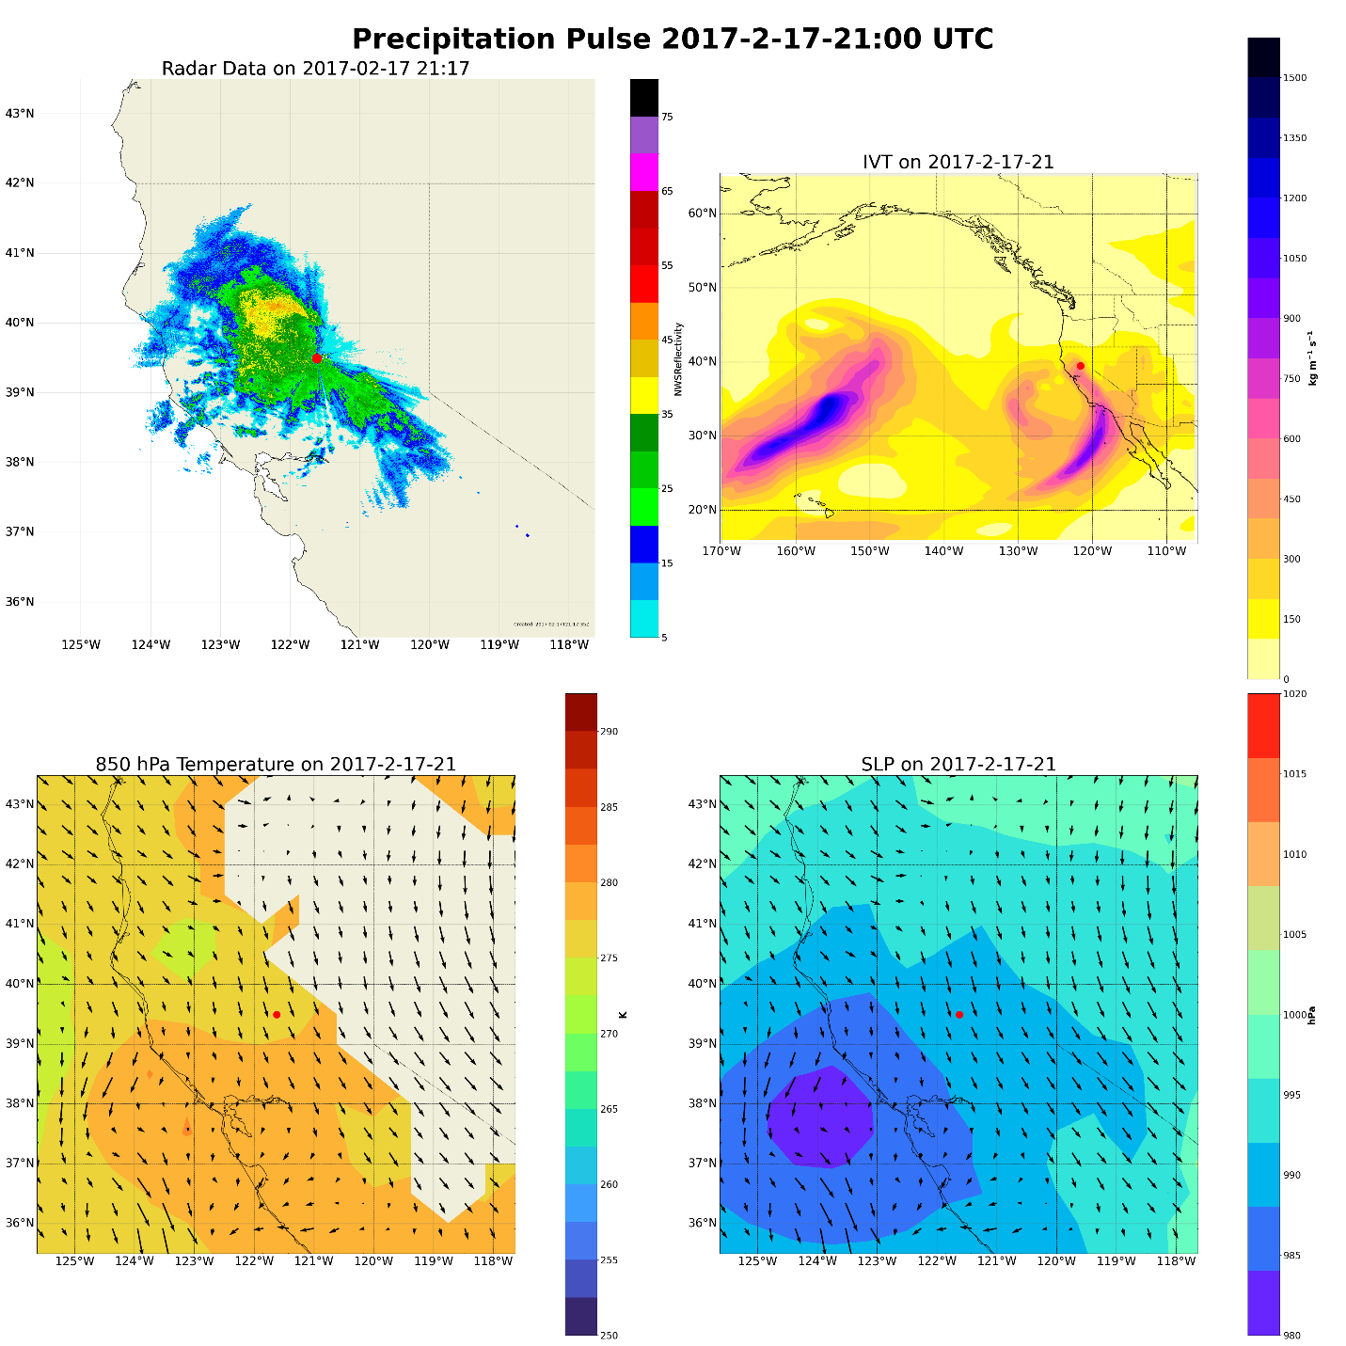
Broadform long lasting precipitation attributed to low pressure moving ashore and feeding study are with constant albeit less intense rainfall.
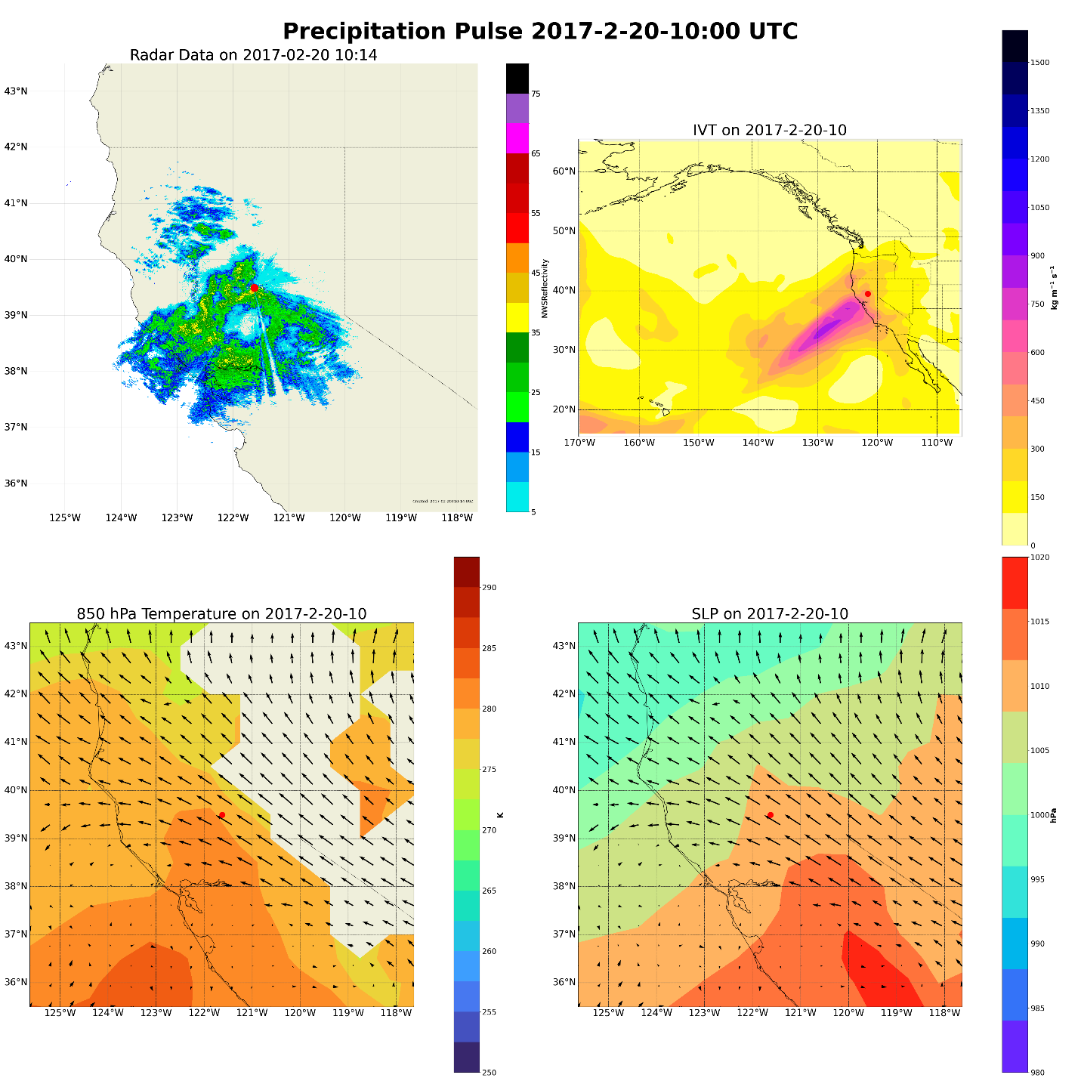
This pulse is associated with a smaller system that moves through the region.
Several meteorological drivers were identified for the pulses identified in this study. Primary drivers of precipitation are categorized into convective, frontal, and narrow cold frontal rain bands. Pulses 1,4,6,and 8 exhibit….

Pulse | Primary driver of precip  Mesoscale features  No mesoscale categorize  Start categorize whether there are mesoscale features that are identifiable.  Convective features NCFR/ non-organized.  Whether mesoscale frontrol wave.  Look to see if AR’s have mesoscale frontal wave.
1 | Convective/NCFR
2 | NCFR
3 | frontal
4 | convective/frontal
5 | NCFR/Frontal
6 | convective/none
7 | NCFR
8 | convective
9 | frontal

Discussion and Broader Implications

The characterization of mesoscale within-event precipitation pulses have implications for the advancement of both numerical weather forecasting and increased quality of climate model parameterization. The Center for Western Weather and Water Extremes Forecast Informed Reservoir Operations will be able to use these results to help develop more informed strategies for efficiently managing reservoir levels throughout California during extreme rainfall events. As high intensity precipitation is not well understood in numerical models and poorly represented in longer-term climate data (Stephens et al., 2019, Martin et al., 2018, Suzuki et al., 2015, Dunkerley et al., 2010), the characterization of these pulses will advance our understanding of the meteorological mechanisms that drive short-term, high intensity precipitation and contribute knowledge to the high resolution hydrometeorological processes that are required as inputs into many climate models. The public will also see benefits from the research proposed as understanding the local mechanisms underlying these extreme events will allow for the improvement of warning systems in vulnerable communities and can assist in the development of preemptive mitigation strategies to save property and lives.
There are opportunities for future research with this proposed project. All data being used is available for the full spatial extent of the United States. A geographic expansion of the pulse identification methodologies presented in this study would shed light on how these high intensity precipitation pulses change across the country. The characterizations described in this study have the potential to provide the groundwork for an algorithmic approach to identifying within-storm precipitation pulses.
Below is a proposed timeline for the project, based on credits needed and deliverables expected:
MS in Geography  objective timeline | Fall 2024 | Winter 2024  (Defend Thesis Proposal) | Spring 2024 or Fall 2025  (Defend Thesis)
Action Items | Continue developing Thesis Proposal | Continue research/Masters Thesis | Defend Thesis

Table 3. Proposed research timeline

References:
Kunkel, K.E., Karl, T.R., Easterling, D.R., Redmond, K., Young, J., Yin, X. and Hennon, P., 2013. Probable maximum precipitation and climate change. Geophysical Research Letters, 40(7), pp.1402-1408.
IPCC, 2022: Climate Change 2022: Impacts, Adaptation, and Vulnerability. Contribution of Working Group II to the Sixth Assessment Report of the Intergovernmental Panel on Climate Change [H.-O. Pörtner, D.C. Roberts, M. Tignor, E.S. Poloczanska, K. Mintenbeck, A. Alegría, M. Craig, S. Langsdorf, S. Löschke, V. Möller, A. Okem, B. Rama (eds.)]. Cambridge University Press. Cambridge University Press, Cambridge, UK and New York, NY, USA, 3056 pp., doi:10.1017/9781009325844.
Ralph, F. M., Neiman, P. J., Wick, G. A., Gutman, S. I., Dettinger, M. D., Cayan, D. R., & White, A. B. (2006). Flooding on California’s Russian River: Role of atmospheric rivers. In Geophysical Research Letters (Vol. 33, Issue 13). American Geophysical Union (AGU). https://doi.org/10.1029/2006gl026689
Neiman, P. J., Schick, L. J., Ralph, F. M., Hughes, M., & Wick, G. A. (2011). Flooding in Western Washington: The Connection to Atmospheric Rivers*. In Journal of Hydrometeorology (Vol. 12, Issue 6, pp. 1337–1358). American Meteorological Society. https://doi.org/10.1175/2011jhm1358.1
Neiman, P. J., Ralph, F. M., Wick, G. A., Lundquist, J. D., & Dettinger, M. D. (2008). Meteorological Characteristics and Overland Precipitation Impacts of Atmospheric Rivers Affecting the West Coast of North America Based on Eight Years of SSM/I Satellite Observations. In Journal of Hydrometeorology (Vol. 9, Issue 1, pp. 22–47). American Meteorological Society. https://doi.org/10.1175/2007jhm855.1
Kim, J., Waliser, D.E., Neiman, P.J. et al. Effects of atmospheric river landfalls on the cold season precipitation in California. Clim Dyn 40, 465–474 (2013). https://doi.org/10.1007/s00382-012-1322-3
Guan, B., Molotch, N. P., Waliser, D. E., Fetzer, E. J., & Neiman, P. J. (2010). Extreme snowfall events linked to atmospheric rivers and surface air temperature via satellite measurements. In Geophysical Research Letters (Vol. 37, Issue 20, p. n/a-n/a). American Geophysical Union (AGU). https://doi.org/10.1029/2010gl044696
Dettinger, M.D. 2011. Climate change, atmospheric rivers and floods in California—a multimodel analysis of storm frequency and magnitude changes. Journal of the American Water Resources Association. 47: 514–523. de Orla-Barile, M., Cannon, F., Oakley, N. S., & Ralph, F. M. (2022). A climatology of narrow cold frontal rainbands in Southern California. Geophysical Research Letters, 49, e2021GL095362. https://doi.org/10.1029/2021GL095362
Swain, D. L., Langenbrunner, B., Neelin, J. D., & Hall, A. (2018). Increasing precipitation volatility in twenty-first-century California. In Nature Climate Change (Vol. 8, Issue 5, pp. 427–433). Springer Science and Business Media LLC. https://doi.org/10.1038/s41558-018-0140-y
Agilan, V. and Umamahesh, N.V., 2017. Modelling nonlinear trend for developing non‐stationary rainfall intensity–duration–frequency curve. International Journal of Climatology, 37(3), pp.1265-1281.
Chagnaud, G., Panthou, G., Vischel, T., Blanchet, J. and Lebel, T., 2021. A unified statistical framework for detecting trends in multi-timescale precipitation extremes: application to non-stationary intensity-duration-frequency curves. Theoretical and Applied Climatology, pp.1-22.
Dunkerley, D.L., 2010. How do the rain rates of sub‐event intervals such as the maximum 5‐and 15‐min rates (I5 or I30) relate to the properties of the enclosing rainfall event?. Hydrological Processes, 24(17), pp.2425-2439.
Dunkerley, D., 2021. Rainfall intensity in geomorphology: Challenges and opportunities. Progress in Physical Geography: Earth and Environment, 45(4), pp.488-513.
Martin, A., Ralph, F.M., Demirdjian, R., DeHaan, L., Weihs, R., Helly, J., Reynolds, D. and Iacobellis, S., 2018. Evaluation of atmospheric river predictions by the WRF Model using aircraft and regional mesonet observations of orographic precipitation and its forcing. Journal of Hydrometeorology, 19(7), pp.1097-1113.
Stephens, G.L., Christensen, M., Andrews, T., Haywood, J., Malavelle, F.F., Suzuki, K., Jing, X., Lebsock, M., Li, J.L.F., Takahashi, H. and Sy, O., 2019. Cloud physics from space. Quarterly Journal of the Royal Meteorological Society, 145(724), pp.2854-2875.
Suzuki, K., Stephens, G., Bodas-Salcedo, A., Wang, M., Golaz, J.C., Yokohata, T. and Koshiro, T., 2015. Evaluation of the warm rain formation process in global models with satellite observations. Journal of the Atmospheric Sciences, 72(10), pp.3996-4014.
de Orla-Barile, M., Cannon, F., Oakley, N. S., & Ralph, F. M. (2022). A climatology of narrow cold-frontal rainbands in Southern California. Geophysical Research Letters, 49, e2021GL095362. https://doi.org/10.1029/2021GL095362
Zhang, J., Howard, K., Langston, C., Kaney, B., Qi, Y., Tang, L., Grams, H., Wang, Y., Cocks, S., Martinaitis, S., Arthur, A., Cooper, K., Brogden, J., & Kitzmiller, D. (2016). Multi-Radar Multi-Sensor (MRMS) Quantitative Precipitation Estimation: Initial Operating Capabilities. In Bulletin of the American Meteorological Society (Vol. 97, Issue 4, pp. 621–638). American Meteorological Society. https://doi.org/10.1175/bams-d-14-00174.1
Guan, B., & Waliser, D. E. (2019). Tracking Atmospheric Rivers Globally: Spatial Distributions and Temporal Evolution of Life Cycle Characteristics. In Journal of Geophysical Research: Atmospheres (Vol. 124, Issue 23, pp. 12523–12552). American Geophysical Union (AGU). https://doi.org/10.1029/2019jd031205
Horel, J.; Splitt, M.; Dunn, L.; Pechmann, J.; White, B.; Ciliberti, C.; Lazarus, S.; Slemmer, J.; Zaff, D.; Burks, J. MesoWest: Cooperative Mesonets in the Western United States. Bull. Am. Meteorol. Soc. 2002, 83, 211−225
Cannon, F., Hecht, C. W., Cordeira, J. M., & Ralph, F. M. (2018). Synoptic and mesoscale forcing of Southern California extreme precipitation. Journal of Geophysical Research: Atmospheres, 123, 13,714– 13,730. https://doi.org/10.1029/2018JD029045
Lamjiri, M. A., Dettinger, M. D., Ralph, F. M., and Guan, B. (2017), Hourly storm characteristics along the U.S. West Coast: Role of atmospheric rivers in extreme precipitation, Geophys. Res. Lett., 44, 7020– 7028, doi:10.1002/2017GL074193.
Sukup, S., Laber, J., Sweet, D., & Thomson, R. (2016). Analysis of an intense narrow cold frontal rainband and the Springs Fire burn area debris flows of 12 December 2014. NWS Technical Attachment 1601s. National Weather Forecast Office. Retrieved from https://www.weather.gov/media/wrh/online_publications/TAs/TA1601.pdf
Oakley, N. S., Lancaster, J. T., Kaplan, M. L., & Ralph, F. M. (2017). Synoptic conditions associated with cool season post-fire debris flows in the Transverse Ranges of southern California. In Natural Hazards (Vol. 88, Issue 1, pp. 327–354). Springer Science and Business Media LLC. https://doi.org/10.1007/s11069-017-2867-6
Hobbs, P. V., & Persson, P. O. G. (1982). The Mesoscale and Microscale Structure and organization of Clouds and precipitation in Midlatitude Cyclones. Part V: The Substructure of Narrow Cold-Frontal Rainbands. In Journal of the Atmospheric Sciences (Vol. 39, Issue 2, pp. 280–295). American Meteorological Society. https://doi.org/10.1175/1520-0469(1982)039<0280:tmamsa>2.0.co;2
Houze, R. A., Jr., Hobbs, P. V., Biswas, K. R., & Davis, W. M. (1976). Mesoscale Rainbands in Extratropical Cyclones. In Monthly Weather Review (Vol. 104, Issue 7, pp. 868–878). American Meteorological Society. https://doi.org/10.1175/1520-0493(1976)104<0868:mriec>2.0.co;2
Koch, S. E., & Kocin, P. J. (1991). Frontal contraction processes leading to the formation of an intense narrow rainband. In Meteorology and Atmospheric Physics (Vol. 46, Issues 3–4, pp. 123–154). Springer Science and Business Media LLC. https://doi.org/10.1007/bf01027339
Young, A. M., K. T. Skelly, and J. M. Cordeira (2017), High-impact hydrologic events and atmospheric rivers in California: An investigation using the NCEI Storm Events Database, Geophys. Res. Lett., 44, 3393–3401, doi:10.1002/2017GL073077.
Henn, B., Musselman, K. N., Lestak, L.,Ralph, F. M., & Molotch, N. P. (2020).Extreme runoff generation from atmospheric river driven snowmelt during the 2017 Oroville dam spillways incident.Geophysical Research Letters,47, e2020GL088189. https://doi.org/10.1029/2020GL088189
Vano, J. A., Miller, K., Dettinger, M. D., Cifelli, R., Curtis, D., Dufour, A., et al. (2018). Hydroclimate extremes as challenges for the water management community: Lessons from Oroville dam and hurricane Harvey. Bulletin of the American Meteorological Society, 100(1), S9–S14. https://doi.org/10.1175/BAMS-D-18-0219.1
White, A. B., Moore, B. J., Gottas, D. J., & Neiman, P. J. (2019). Winter storm conditions leading to excessive runoff above California’s Oroville Dam during January and February 2017. Bulletin of the American Meteorological Society, 100(1), 55–70. https://doi.org/10.1175/BAMS-D-18-0091.1
Poujol, B., Mooney, P. A., & Sobolowski, S. P. (2021). Physical processes driving intensification of future precipitation in the mid- To high latitudes. Environmental Research Letters, 16(3). https://doi.org/10.1088/1748-9326/abdd5b
Fowler, H. J., Wasko, C., & Prein, A. F. (2021). Intensification of short-duration rainfall extremes and implications for flood risk: Current state of the art and future directions. In Philosophical Transactions of the Royal Society A: Mathematical, Physical and Engineering Sciences (Vol. 379, Issue 2195). Royal Society Publishing. https://doi.org/10.1098/rsta.2019.0541
Shaw, T. A., Baldwin, M., Barnes, E. A., Caballero, R., Garfinkel, C. I., Hwang, Y. T., Li, C., O’Gorman, P. A., Rivière, G., Simpson, I. R., & Voigt, A. (2016). Storm track processes and the opposing influences of climate change. In Nature Geoscience (Vol. 9, Issue 9, pp. 656–664). Nature Publishing Group. https://doi.org/10.1038/ngeo2783
Michaelis, A. C., Gershunov, A., Weyant, A., Fish, M. A., Shulgina, T., & Ralph, F. M. (2022). Atmospheric River Precipitation Enhanced by Climate Change: A Case Study of the Storm That Contributed to California’s Oroville Dam Crisis. Earth’s Future, 10(3). https://doi.org/10.1029/2021EF002537
Bunn, P. T. W., Wood, A. W., Newman, A. J., Chang, H.-I., Castro, C. L., Clark, M. P., & Arnold, J. R. (2022). Improving Station-Based Ensemble Surface Meteorological Analyses Using Numerical Weather Prediction: A Case Study of the Oroville Dam Crisis Precipitation Event. https://doi.org/10.1175/JHM-D-21
White, A. B., Moore, B. J., Gottas, D. J., & Neiman, P. J. (2019). Winter storm conditions leading to excessive runoff above California’s Oroville dam during January and February 2017. Bulletin of the American Meteorological Society, 100(1), 55–69. https://doi.org/10.1175/BAMS-D-18-0091.1

