Machine Learning Final Project

Peter Malmgren

## Project idea

My proposed project is to design a classifier which effectively distinguishes images of dogs from images of cats. This task is relatively easy for humans but [literature](http://xenon.stanford.edu/~pgolle/papers/dogcat.pdf) suggests that computers can only succeed in distinguishing cats from dogs about 83% of the time. Most of the proposals in this area involve learning a discriminative classifier. Since I believe this approach ignores the relative similarity in visual appearance between cats and dogs, my approach would be to learn a model which can handle the wide variety of appearance in either animal. The algorithm I plan to implement and extend is outlined in detail [here](http://www.computer.org/csdl/trans/tp/2013/10/ttp2013102484.html). The basic idea is for a training set of images, assumed to be representative, from one class (in this case, the goal was to detect faces at various rotations) learn feature correspondences and model it as an undirected multi graph, called a constellation or correspondence map. Given a new image and all the features from a constellation, the probability is computed that the new image contains a face based on the prior feature information from the constellation.

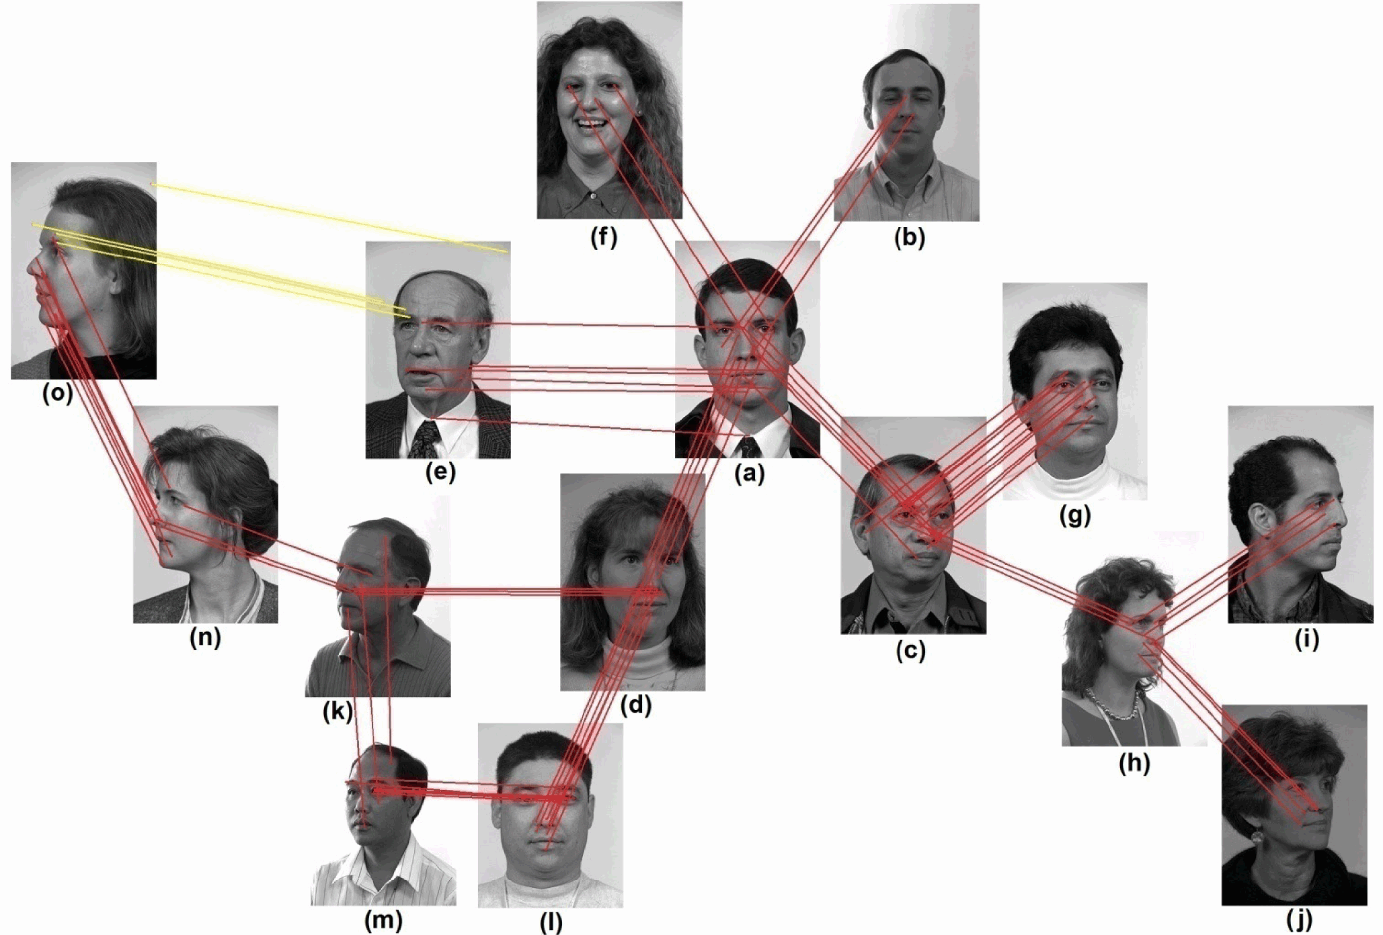

Figure 1: Face constellation. Links between images represent feature correspondence.

The proposed algorithm only works for face detection, not discriminative classification. I have two ideas to extend the approach. The first is to train two constellations and for novel input images, compute the probabilities that they belong to either constellation and return the class which had the highest probability. The second is to train a single constellation using all the training images from cats and dogs, and divide the constellation into sub regions (based on animal) using clustering. Given a new image, compute the probability that the image belongs to each cluster, and use the probabilities as votes. This approach has an added benefit of flexibility: if there is some heterogeneous region containing cat-like dogs and dog-like cats, some other ‘specialist’ classifier could be used.

## Data set description

I plan to use the ASIRRA (Animal Species Image Recognition for Restricting Access) public corpus dataset provided by Microsoft. URL: <http://research.microsoft.com/en-us/projects/asirra/corpus.aspx>

The dataset has 30,000 labeled images of cats and dogs. I plan to subdivide it into cross-validation, testing, and training sets. Ultimately, I will submit an entry to the [Kaggle competition](http://www.kaggle.com/c/dogs-vs-cats) using their testing set.

## Expected challenges

While certain things are implemented: SIFT feature extraction, Lowe’s matching algorithm, and clustering techniques, most of the code will have to be developed from scratch. A big challenge will be implementing their algorithm to find distinctive correspondence points and reference points given a pair of images.

## Evaluation criteria and baselines

While my ultimate goal would be to get on the leaderboard (top 10) at Kaggle, I view the 83% accuracy achieved in state of the art classifiers as my optimistic target (something I could publish a paper on), and anything above 60% as promising. If this approach fails to be discriminative, I at least want to be able to use it to detect cats or dogs in images. To my knowledge, this algorithm has yet to be implemented by anyone except the paper authors.

## Other details

I plan to use MATLAB and VLFeat for implementation. I will work by myself on this project.