Cluster Analysis:

cophenetic correlation = 0.9269

Spearman's rank correlation = 0.6700

TotalCorrect lowestCorrectCluster, linkVal, clusters

56.486, 4.167, 0.0000, (p|b|m|f|v|T|D|w|r|C|j|s|Z|t|d|s|z|k|g|n|l|h|a)

59.312, 4.167, 0.3627, (s|Z|r|l|T|z|f|v|s|D|k|g|t|d|h|m|a|p|b|Cj|w|n)

61.630, 4.167, 0.4352, (r|l|T|z|f|v|s|D|k|g|t|d|h|m|a|p|b|Cj|sZ|w|n)

64.312, 4.167, 0.4792, (T|z|f|v|s|D|k|g|t|d|h|m|a|p|b|Cj|sZ|w|rl|n)

65.217, 10.000, 0.4894, (f|v|s|Tz|D|k|g|t|d|h|m|a|p|b|Cj|sZ|w|rl|n)

66.413, 10.000, 0.5071, (s|Tz|D|k|g|t|d|h|fv|m|a|p|b|Cj|sZ|w|rl|n)

68.297, 10.000, 0.5183, (D|Tsz|k|g|t|d|h|fv|m|a|p|b|Cj|sZ|w|rl|n)

70.362, 29.167, 0.5705, (k|g|t|d|h|fv|m|a|TDsz|p|b|Cj|sZ|w|rl|n)

72.138, 29.167, 0.5927, (t|d|h|fv|m|a|TDsz|p|b|Cj|sZ|kg|w|rl|n)

73.768, 29.167, 0.6384, (h|fv|m|a|TDsz|p|b|Cj|sZ|kg|td|w|rl|n)

75.580, 43.333, 0.6419, (m|a|TDsz|fvh|p|b|Cj|sZ|kg|td|w|rl|n)

77.138, 45.000, 0.6686, (TDsz|fvh|p|b|Cj|sZ|kg|td|ma|w|rl|n)

81.087, 53.333, 0.7494, (p|b|Cj|sZ|fvTDszh|kg|td|ma|w|rl|n)

81.884, 60.952, 0.8289, (Cj|sZ|fvTDszh|pb|kg|td|ma|w|rl|n)

83.478, 60.952, 0.8363, (fvTDszh|pb|kg|td|ma|w|rl|n|CjsZ)

**88.007, 76.019, 0.8715, (kg|td|ma|pbfvTDszh|w|rl|n|CjsZ)**

88.732, 76.019, 0.9272, (ma|pbfvTDszh|w|rl|n|tdkg|CjsZ)

90.543, 82.045, 0.9285, (w|rl|n|pbmfvTDszha|tdkg|CjsZ)

90.833, 82.045, 0.9480, (n|pbmfvTDszha|tdkg|CjsZ|wrl)

93.080, 87.847, 0.9554, (tdkg|pbmfvTDsznha|CjsZ|wrl)

96.667, 95.729, 0.9611, (CjsZ|pbmfvTDtdszkgnha|wrl)

97.862, 97.583, 0.9850, (wrl|pbmfvTDCjsZtdszkgnha)

100.000, 100.000, 0.9891, (pbmfvTDwrCjsZtdszkgnlha)

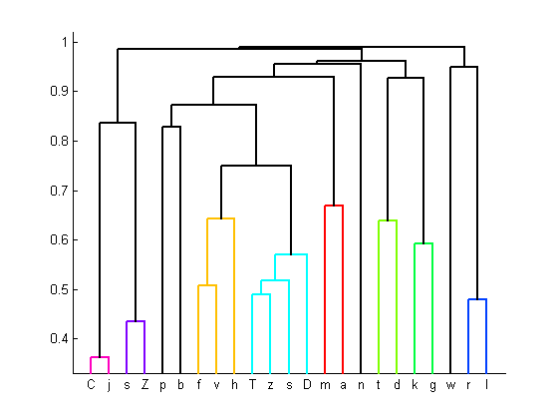

Cluster Analysis:

cophenetic correlation = 0.9818

Spearman's rank correlation = 0.8364

TotalCorrect lowestCorrectCluster, linkVal, clusters

81.333, 46.667, 0.0000, (i|I|e|A|E|R|@|a|c|o|W|O|^|U|u)

85.000, 46.667, 0.4405, (o|u|E|@|^|ac|U|I|W|i|e|O|A|R)

88.111, 56.667, 0.4493, (E|@|^|ac|U|ou|I|W|i|e|O|A|R)

91.333, 63.333, 0.5990, (^|ac|U|ou|I|E@|W|i|e|O|A|R)

**94.333, 76.667, 0.7108, (U|ou|I|E@|W|ac^|i|e|O|A|R)**

96.444, 90.000, 0.8179, (I|E@|W|oUu|ac^|i|e|O|A|R)

97.778, 93.333, 0.8976, (W|oUu|ac^|i|e|O|A|IE@|R)

98.556, 97.083, 0.9624, (ac^|oWUu|i|e|O|A|IE@|R)

99.556, 98.333, 0.9750, (i|e|O|acoW^Uu|A|IE@|R)

99.667, 98.333, 0.9835, (O|acoW^Uu|A|IE@|ie|R)

99.889, 99.444, 0.9904, (A|IE@|acoWO^Uu|ie|R)

100.000, 100.000, 0.9945, (acoWO^Uu|IAE@|ie|R)

100.000, 100.000, 1.0000, (ie|IAE@acoWO^Uu|R)

100.000, 100.000, 1.0000, (R|iIeAE@acoWO^Uu)

100.000, 100.000, 1.0000, (iIeAER@acoWO^Uu)

