Part A: Conceptual Understanding (Theory)
Brief Answers (2–4 Lines Each) with Related Images

1. What is Logistic Regression and why is it suitable for classification?
Answer: Logistic Regression is a supervised machine learning algorithm used to predict the probability of a class, usually 0 or 1. It uses the sigmoid function to convert output into a value between 0 and 1. It is suitable for classification because a probability threshold can be used to assign class labels.
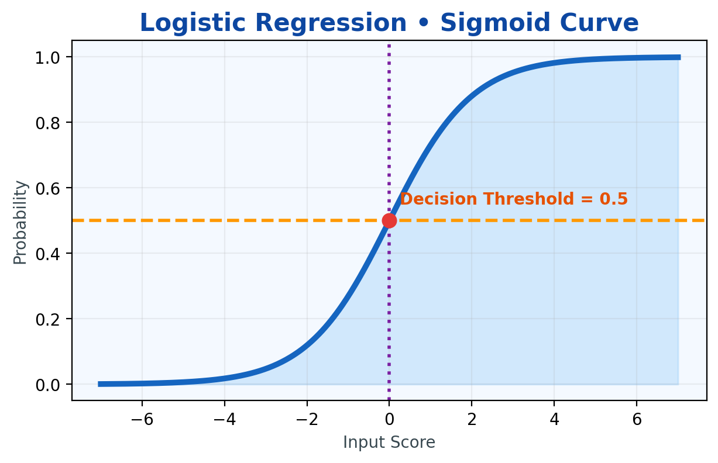

2. Explain classification performance metrics and why accuracy alone is insufficient.
Answer: Classification metrics include Accuracy, Precision, Recall, F1-Score, TPR and FPR. Accuracy shows overall correct predictions, but it can be misleading when classes are imbalanced. For example, predicting the majority class may give high accuracy while failing to detect important minority cases.
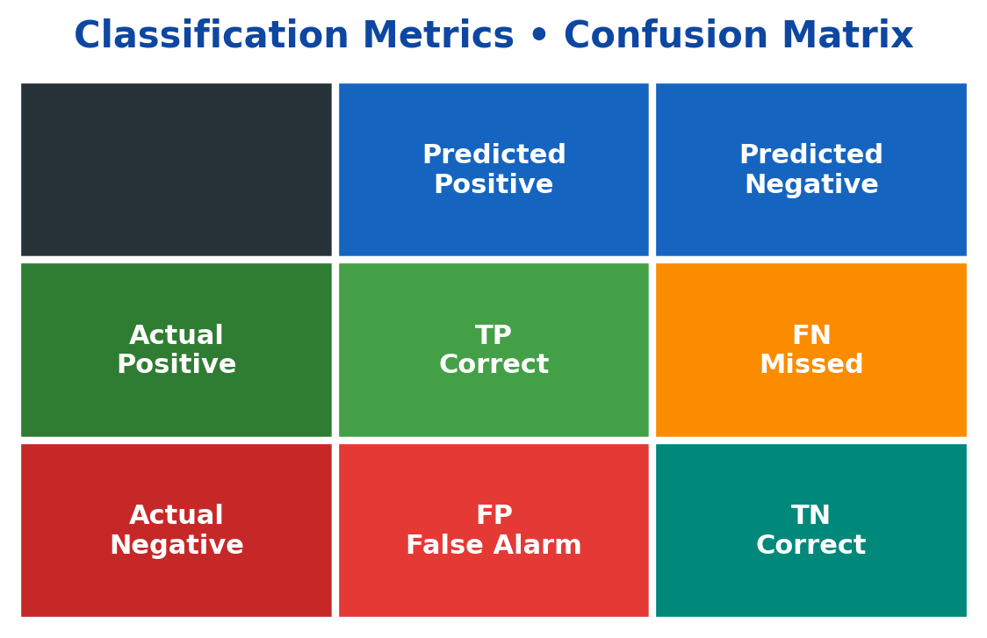

3. Define Type-I Error and Type-II Error in the context of risk prediction.
Answer: Type-I Error (False Positive) means predicting risk when the case is actually not risky. Type-II Error (False Negative) means predicting no risk when the case is actually risky. In risk prediction, false negatives can be especially dangerous because real risky cases may be missed.
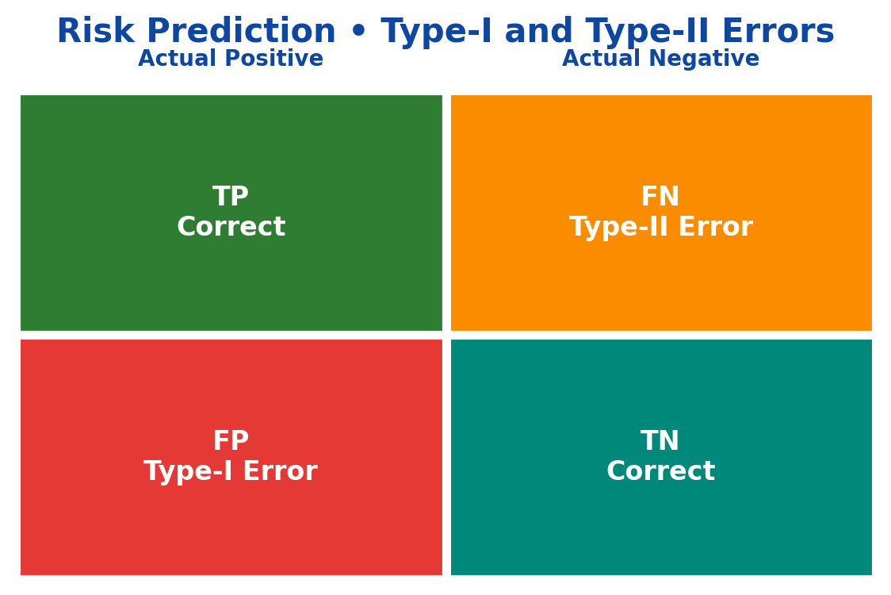

4. Explain Precision, Recall, F1-Score, TPR, and FPR.
Answer: Precision is the proportion of predicted positives that are truly positive, while Recall/TPR is the proportion of actual positives correctly identified. F1-Score balances Precision and Recall using their harmonic mean. FPR is the proportion of actual negatives incorrectly predicted as positive.
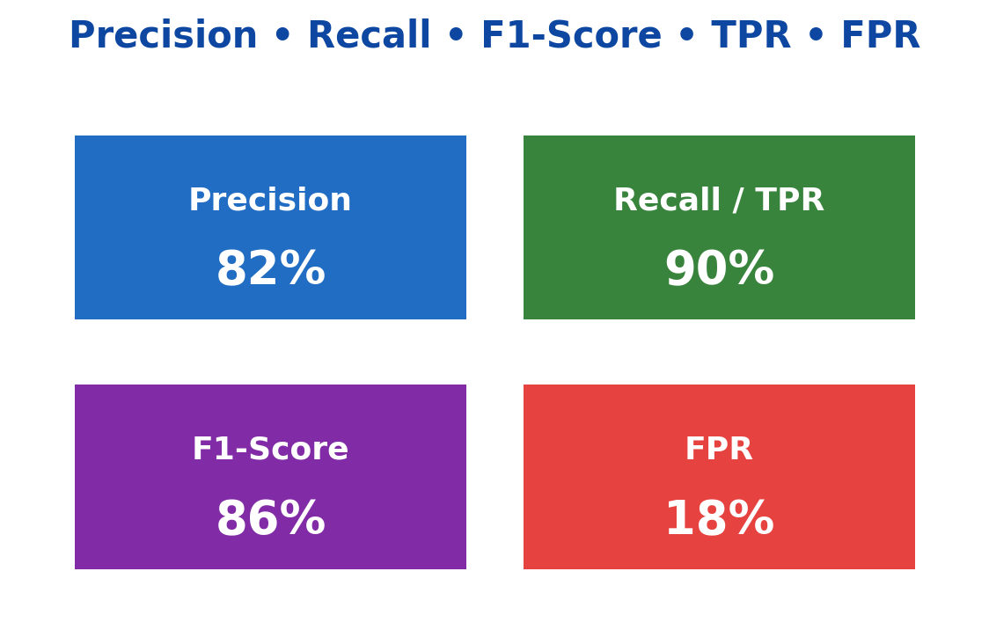

5. What is AUC-ROC and how does it help in evaluating classifiers?
Answer: The ROC curve plots True Positive Rate against False Positive Rate at different classification thresholds. AUC is the area under this curve and summarizes the model's ability to separate classes. A higher AUC generally indicates better discrimination, while 0.5 is close to random performance.
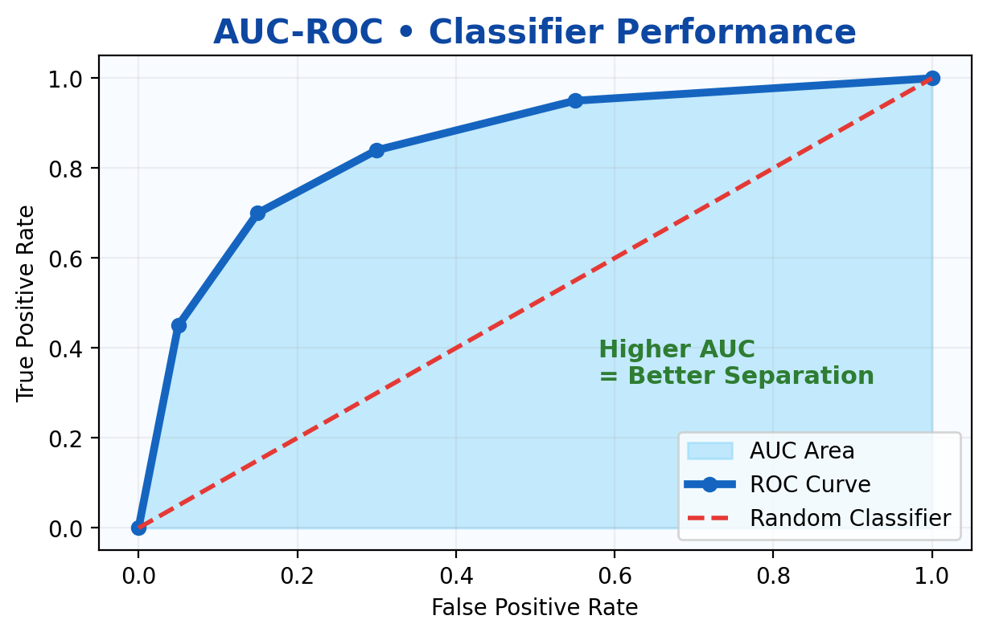

6. Why does imbalanced data create problems in classification models?
Answer: Imbalanced data means one class has many more examples than the other. A model may become biased toward the majority class and still achieve high accuracy. Therefore, metrics such as Precision, Recall, F1-Score, ROC-AUC and suitable resampling methods are often important.
