Project # 2

Hadoop Administration

Project/Assignment Solution



Project # 2: Hadoop Administration

Table of Contents

1. Introduction 3

2. Problem Solution 3

3. Output 4

# Introduction

You need to use VMWARE player or any virtualization tool to set up the environment

CentOS 6.5 is preferred

You need to create a regular user in CentOS

You may either configure a DNS server or have the appropriate entries in hosts file

# Problem Solution

Create a 3 node Hadoop cluster with Hadoop 2.6.0 installed. Please make a note of the following points

1. The block size needs to be 128 MB.
2. Resource Manager should run in port 60300.
3. Enable High Availability on the cluster so that we have one Active Namenode, one active Resource Manager, One standby Namenode and One Standby Resource Manager.
4. Two nodes should have Namenode and Resource Manager processes.
5. One node should act as slave for Namenode and Resource Manager.
6. Install and Configure Zookeeper on Namenode1, Namenode 2 and Datanode.
7. Use Quorum Journal Manager concept to enable High Availability.
8. All the shared edits must be stored in a directory called **SharedEdits** **in user’s home folder**.
9. There should be no secondary Namenode in the set up.
10. Verify that Zookeeper Failover controller is up and running.
11. Test the set up by killing the active Namenode. Paste the logs of standby Namenode to prove that it has taken over successfully.

RESULT

**Host Configuration**

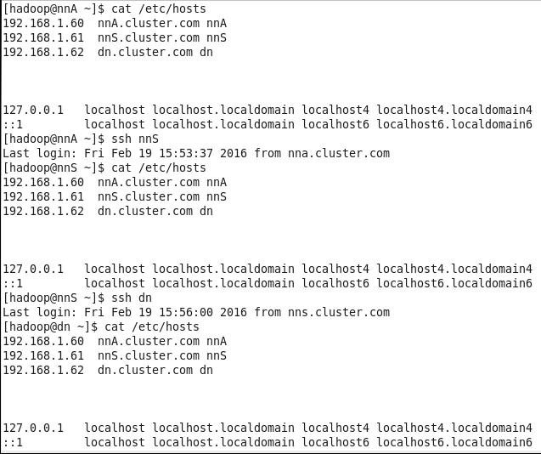

**hdfs-site.xml (specific setting as per requirements)**

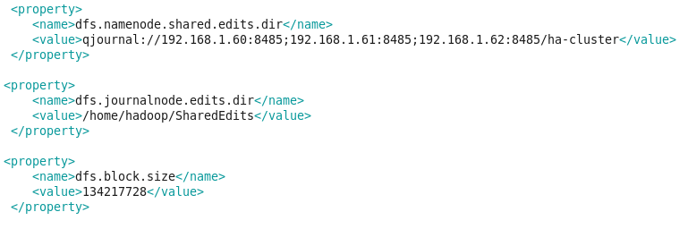

**Available Clusters:**

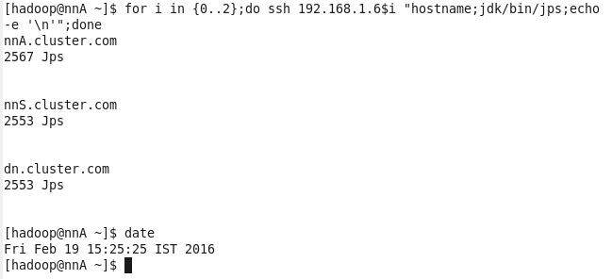

**Active Namenode Format:**

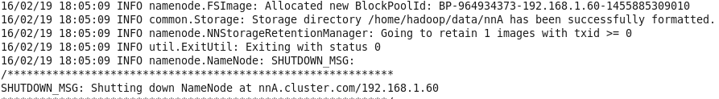

**Standby Namenode Format:**

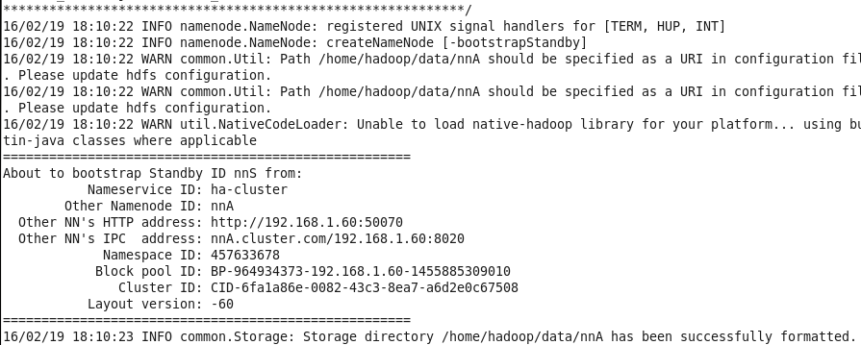

**Up & Running Nodes:**

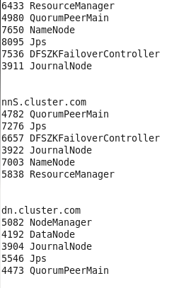

**Web Interface: Active**

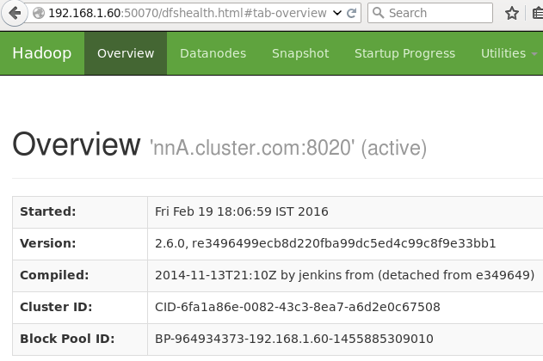

**Web Interface: Standby**

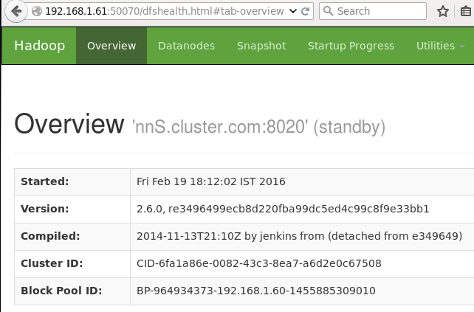

**Namenode State:**

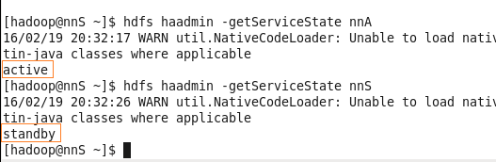

**Forced to fail the Active namenode - Proved that Standby Namenode bacame Active automatically**

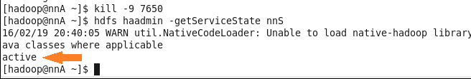

WebInterface

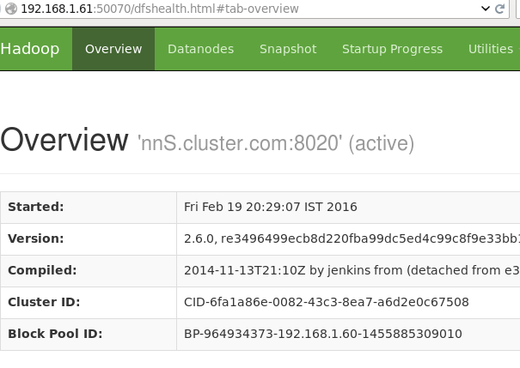

**Resource Manager Port:**

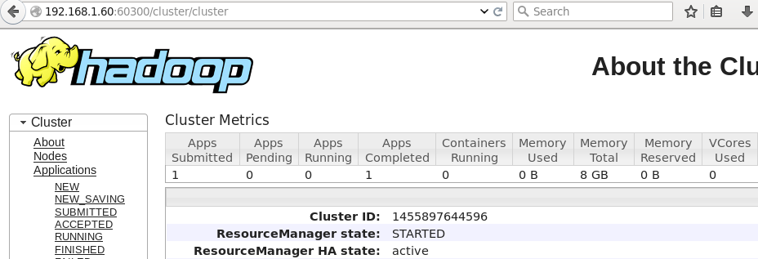

**Job Executed after making nnA as Active mode & nnS as Standbymode**

