Que 1 → ● Create one IAM user and one IAM Group using Terraform.

● Make sure you will use variables for names of IAM users and Group.

● Note :- Below files are required. - main.tf - variables.tf - your_name_custom.tfvars

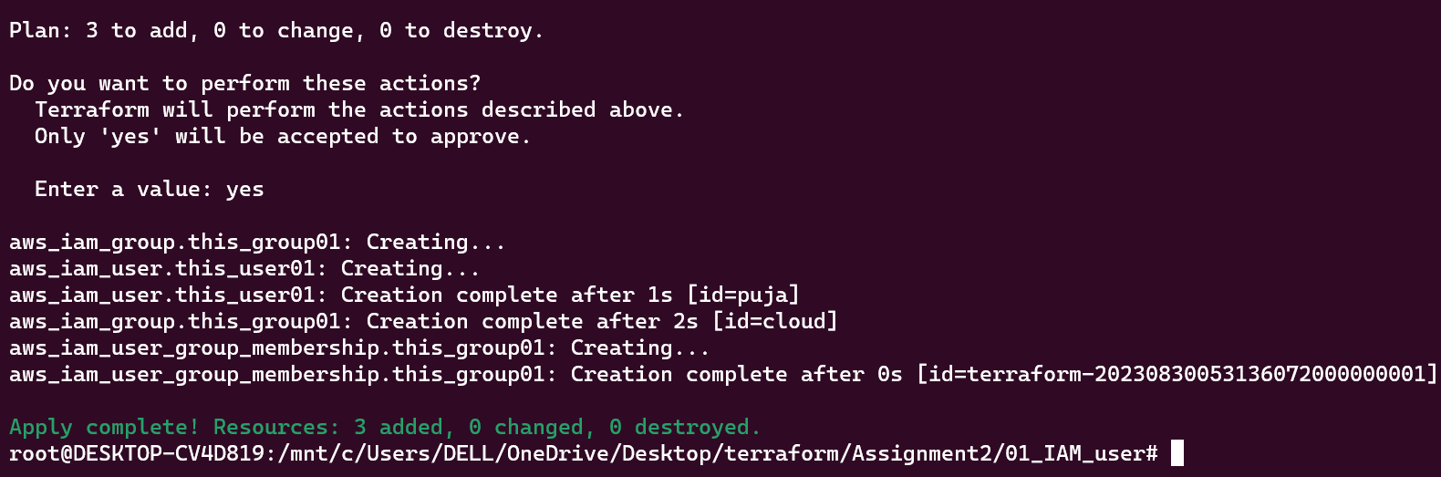

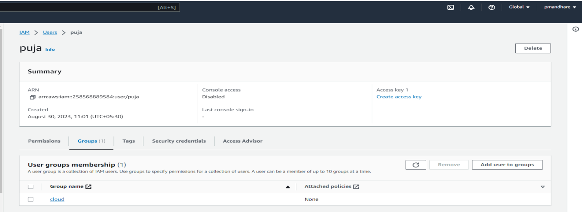

Que 2 → ● Create one EC2 Instance and Elastic IP using Terraform and Map elastic IP with EC2 instance.

● Also please make sure you will use a combination of both variables in the main.tf file. ○ i.e. local and variable from variables.tf and custom.tfvars file.

● Also use output values to print EC2 instances Public DNS name , Private DNS name , Private IP and Public IP.

● Note :- ○ Here you will require one locals in the main.tf file. ○ Also four output values in the main.tf file

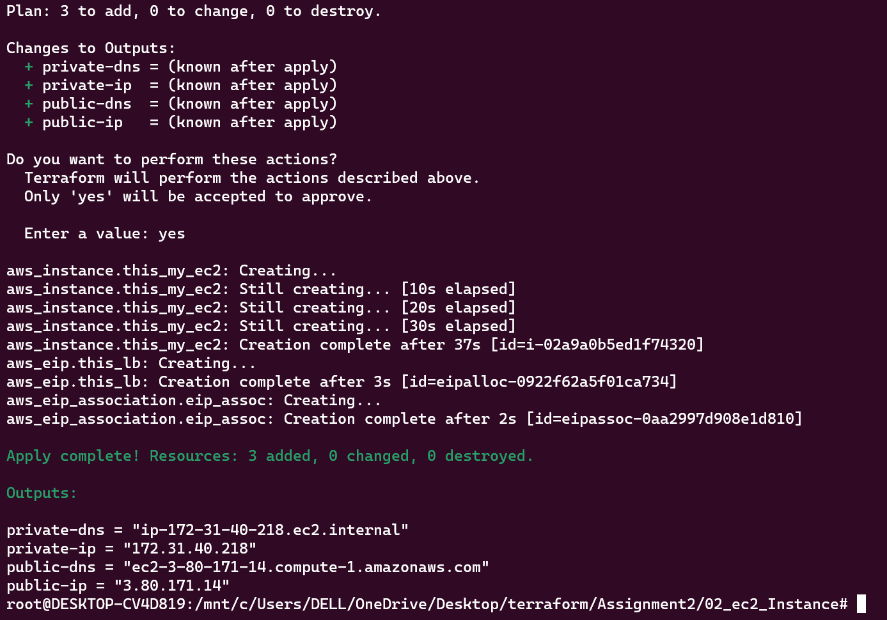

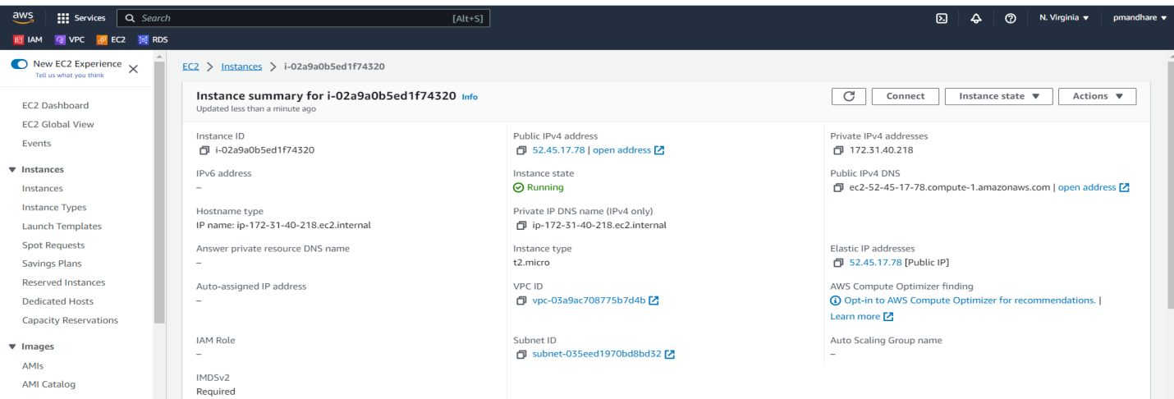

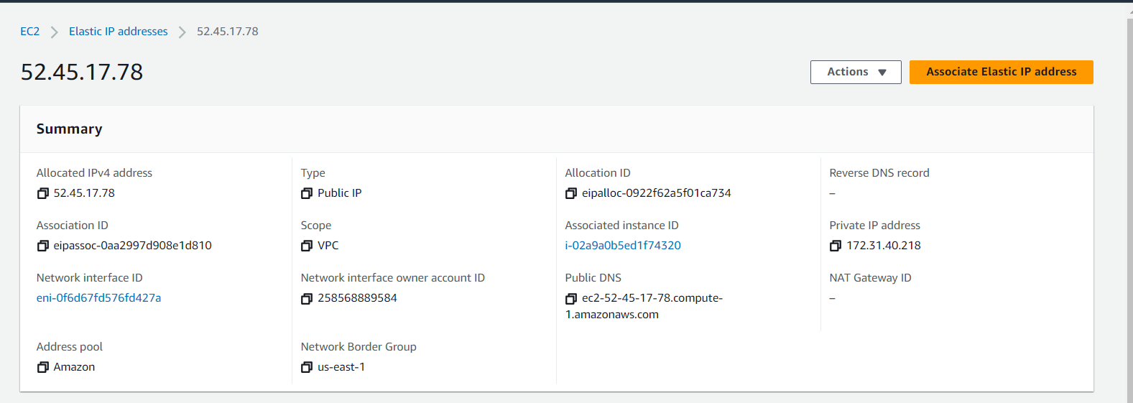

Que 3 → ● Create AWS VPC with Terraform.

1. Create a VPC 2. Create

2 Public Subnet & Create 2 Private Subnet

3. Create IGW (Internet Gateway) & Attach to the VPC

4. Create Public and Private Route Table

5. Add IGW in Public Route table (0.0.0.0/0)

6. Add Public Subnet (1a & 1b) in Route table

7. Create a NAT Gateway in Public Subnet

8. Add NAT GW into the Private Route Table

9. Add Private Subnet in Private Route Table

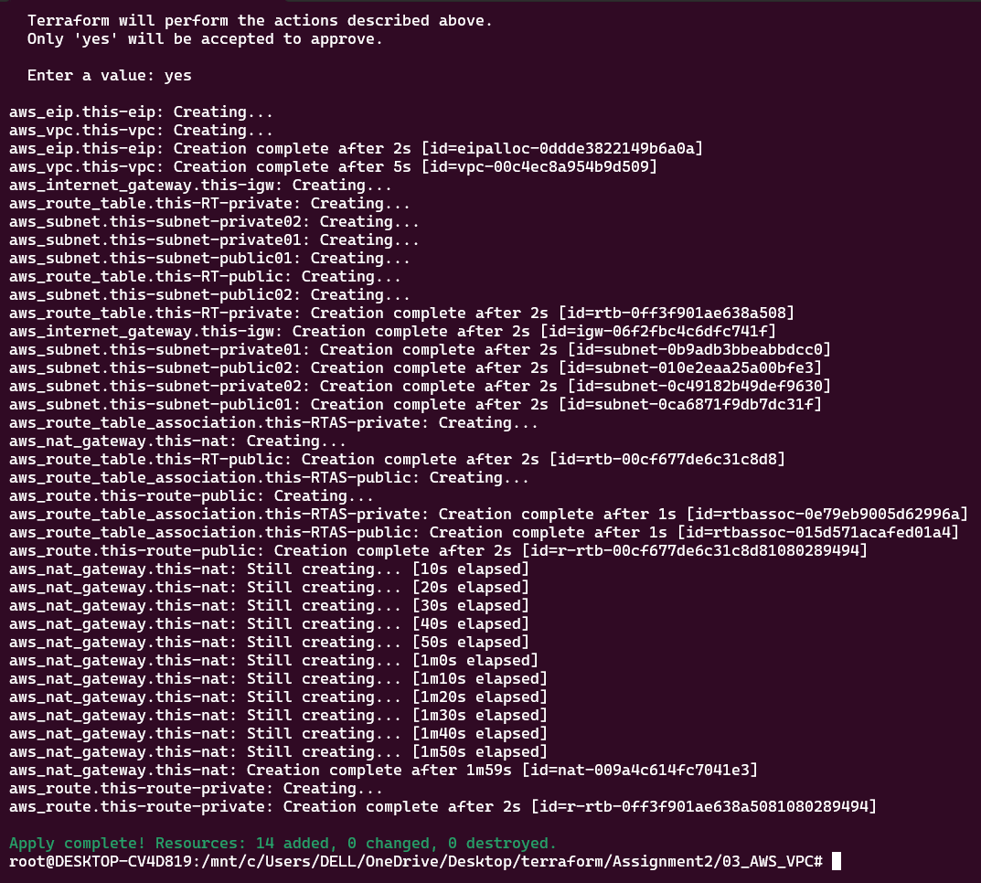

VPC CREATION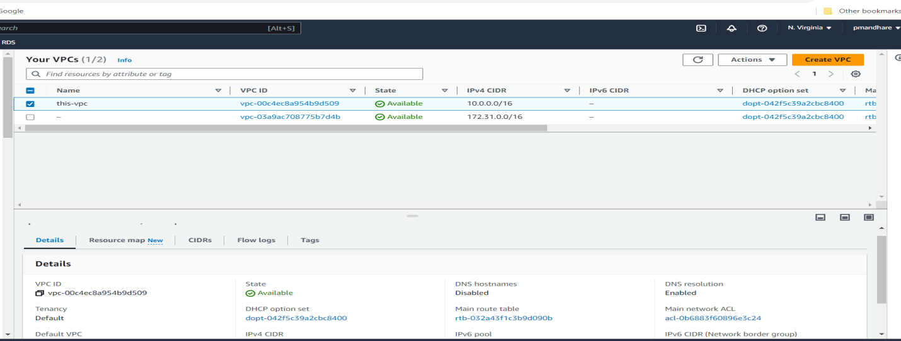

CREATE private/public subnets

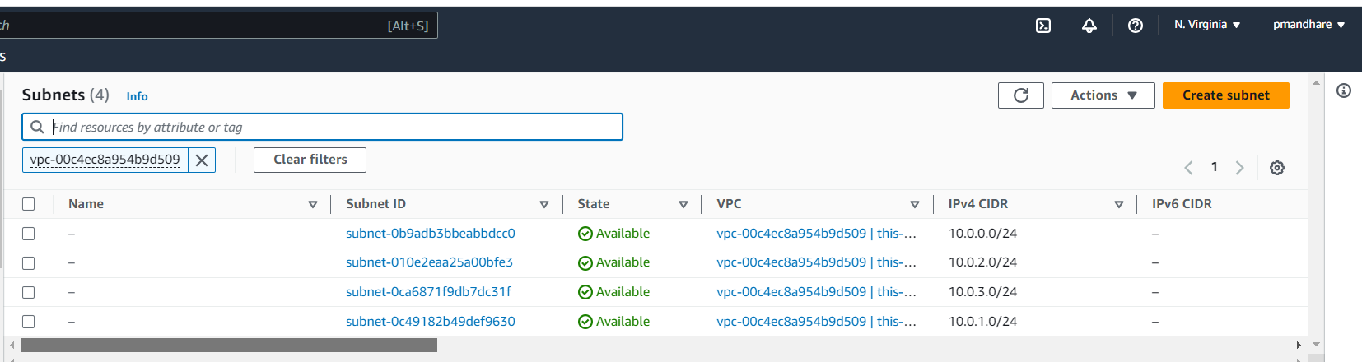

CREATE IGW

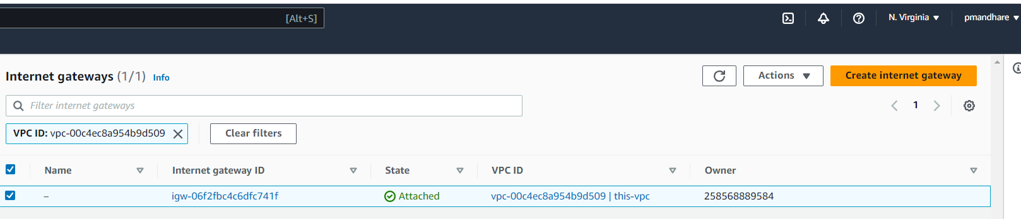

CREATE NAT

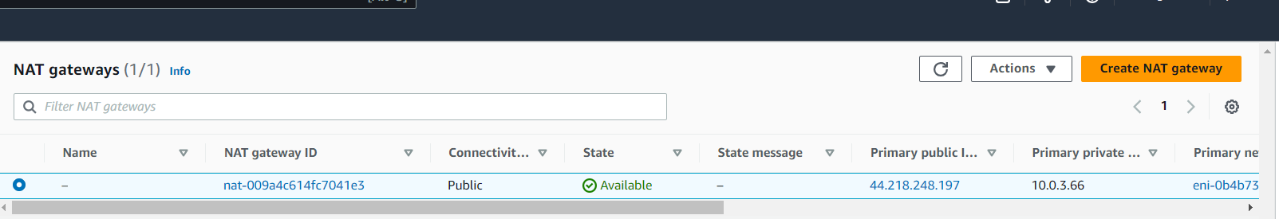

**PRIVATE/PUBLIC ROUTE TABLES**

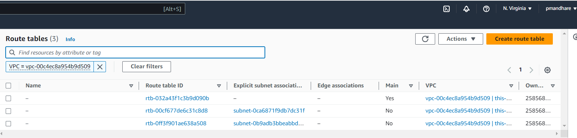

Que Q4

● Create EC2 instance one of the public Subnets of VPC that you have created & Validate your Connection using ssh.

● For this You need to create below AWS resources using Terraform. 1. EC2 Instance. 2. SSH Key 3. Security Group.

● Note :- ○ Attach SSH key and Security Group to EC2 Instance using attribute reference.

○ Then try to access it from an EC2 instance using the SSH key that you have created.

