1. Resource Provisioning: **Write Terraform code to provision a basic Amazon Linux 2 EC2 instance with the instance type t2.micro.**

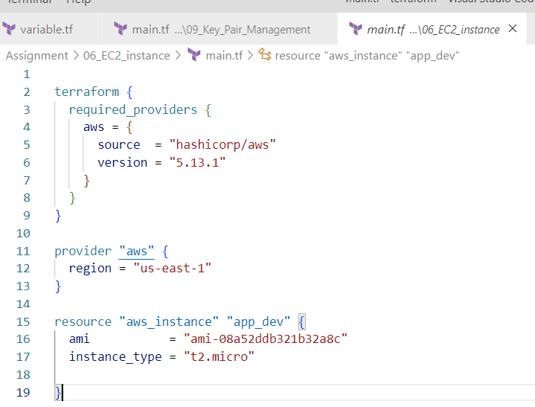

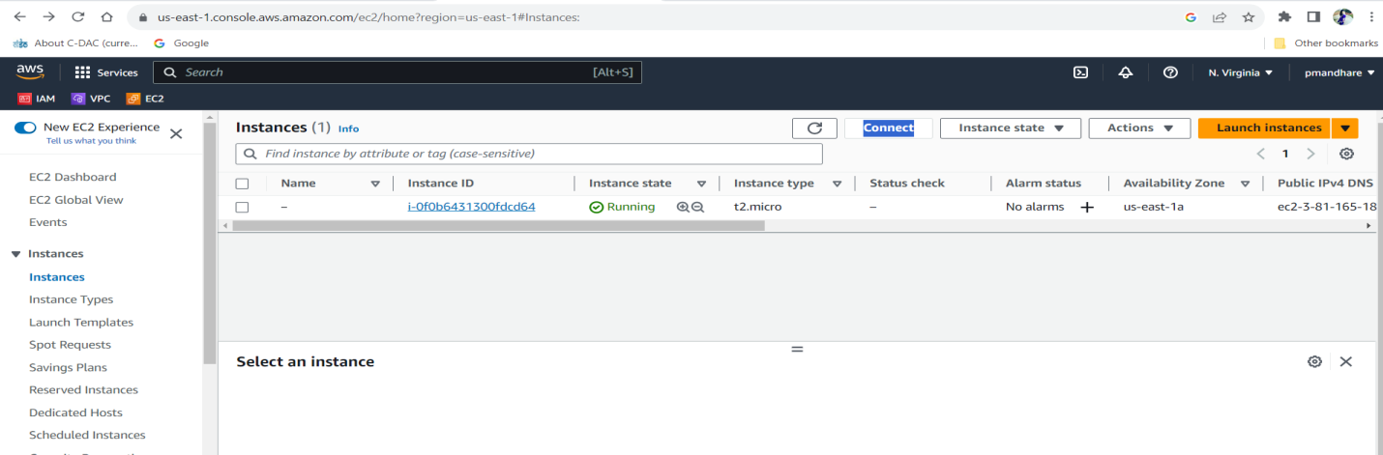

**2.  Instance Tagging:  
 Extend the previous Terraform code to add tags to the new EC2 instance.**

**Tags should include "Name" with the value "WebServer" and "Environment" with the value "Production".**

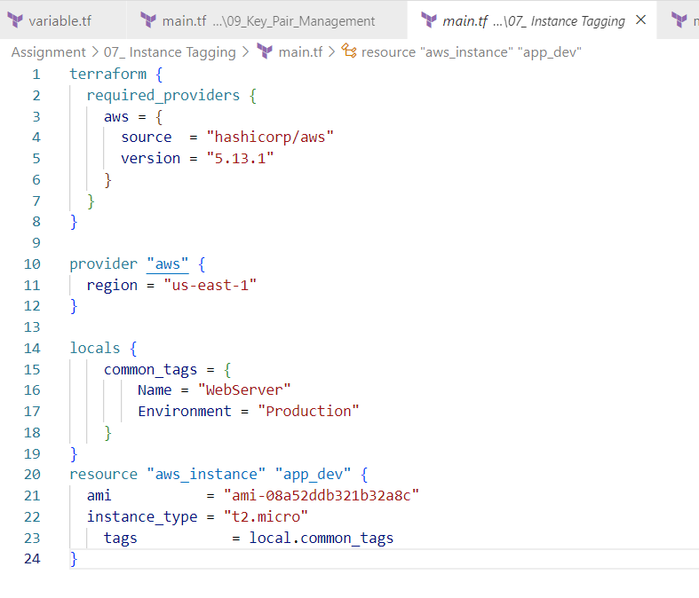

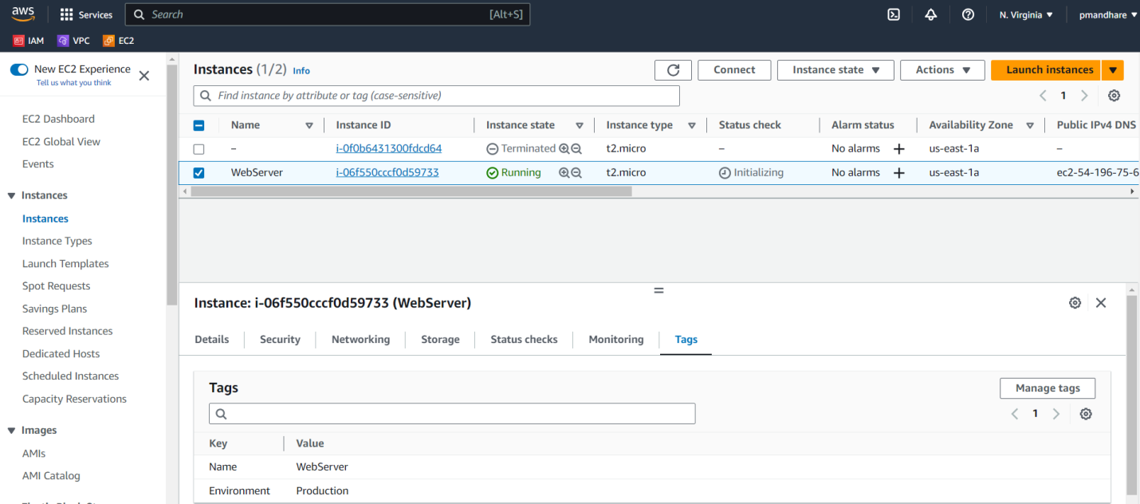

**3.  Security Group Creation:  
Create a security group using Terraform that allows incoming HTTP (port 80) and SSH (port 22) traffic. Attach this security group to the new EC2 instance.**

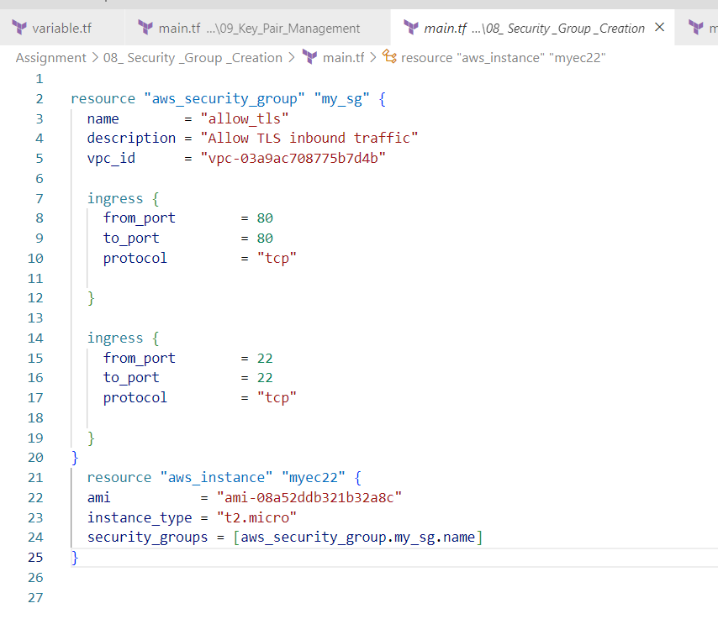

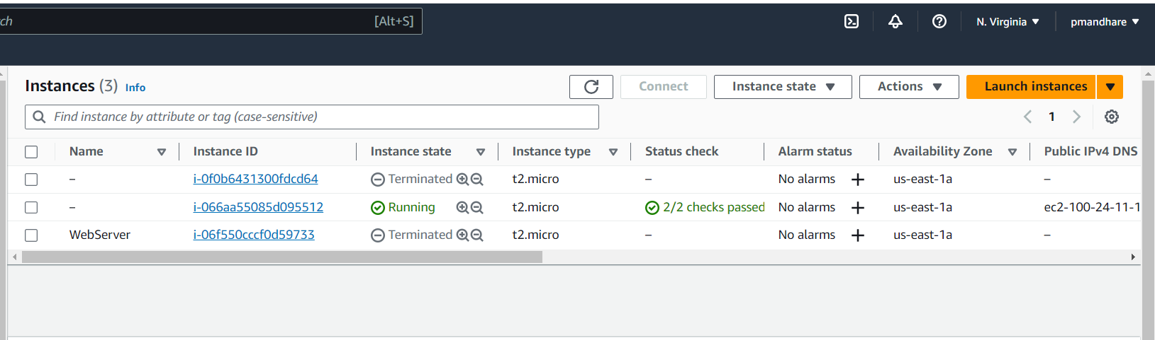

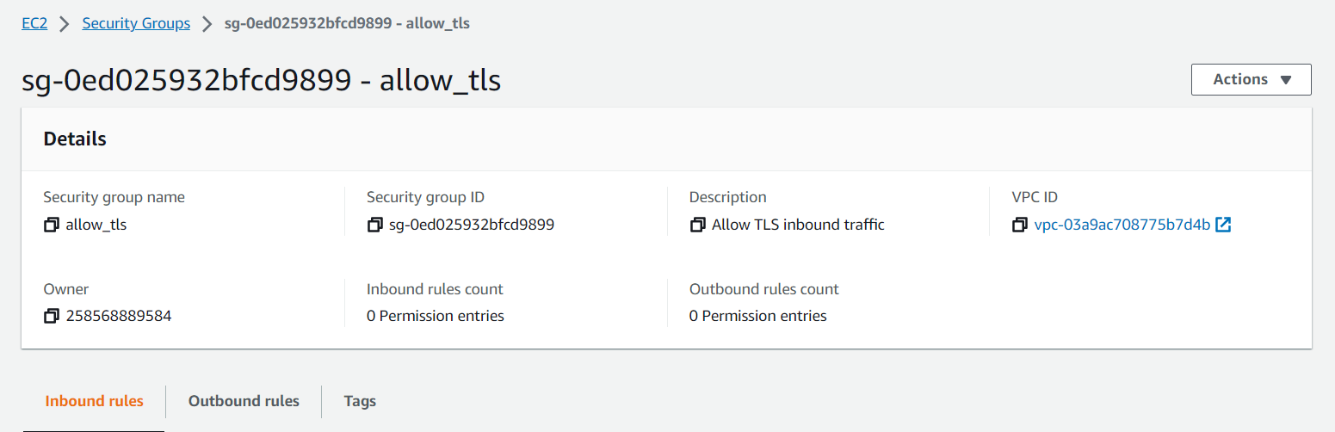

**4.  Key Pair Management:  
 Incorporate Terraform code to create an AWS key pair named "my-key-pair". Associate this key pair with the new EC2 instance.**

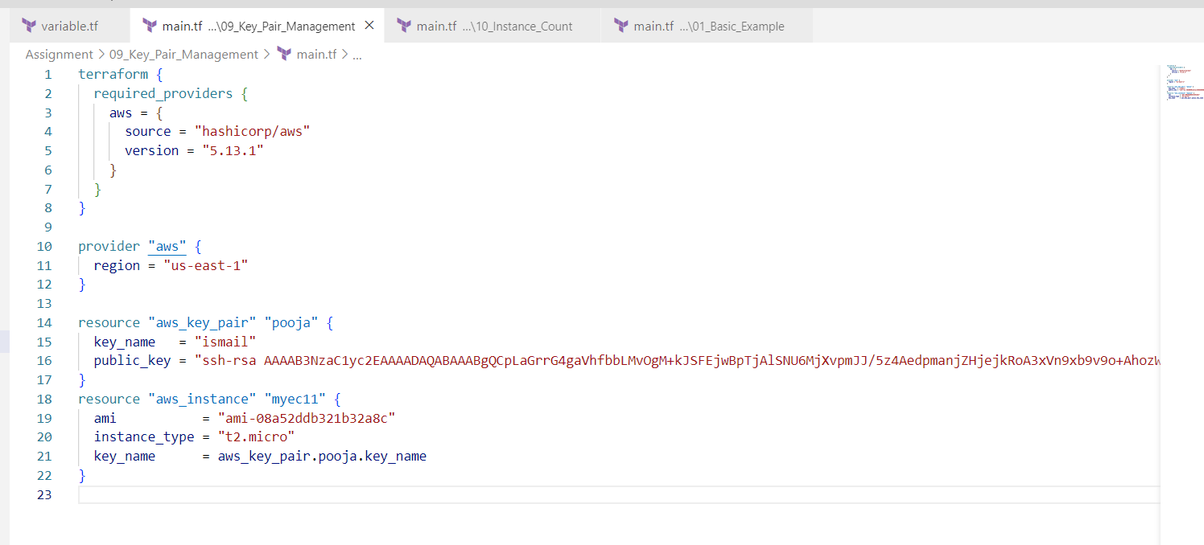

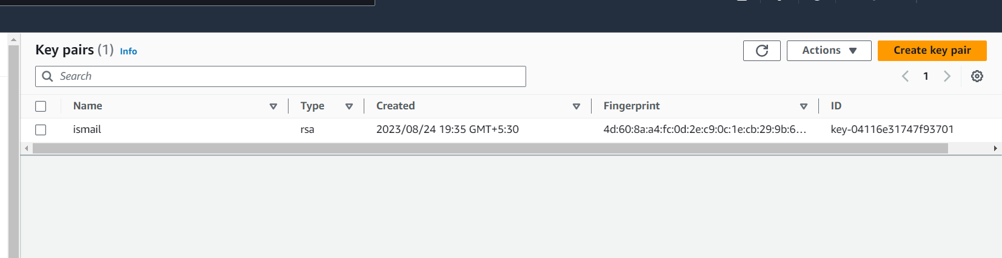

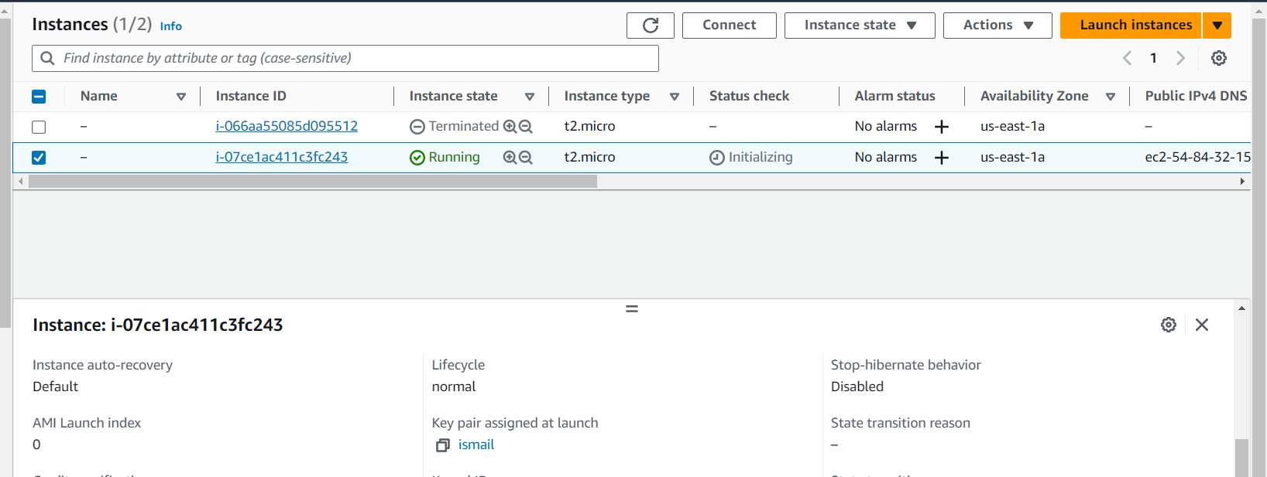

**5.  Instance Count:Modify the existing code to provision 3 Ec2 instances of the same type and associate new key pair with those instances.**

