Traditionally, Morphological chart is used for problem decomposition, seeking solution fragments and random connection. Interactive Cascading Evolutionary Morphological Charts (ICEMC) are being developed to support Reframing, Restructuring, Provocative stimuli, Analogies and Experiential Transfer. Humans and computer work together to structure and manipulate the problem and solution concepts.

The term morphology comes from classical Greek (morphe) and means shape or form. Thus morphology is the study of the shape and arrangement of parts of an object, and how these parts "conform" to create a whole or Gestalt. The "objects" can be physical objects (e.g. an organism or an ecology), social objects (a social system of organisation) or mental objects (e.g. word forms, concepts or systems of ideas).

Provide a structured approach to concept generation to widen the area of search for solutions to a defined design problem. Can help the team generate a complete range of alternative design solutions for a product through a systematic analysis of the form/configuration that a product or machine might take.

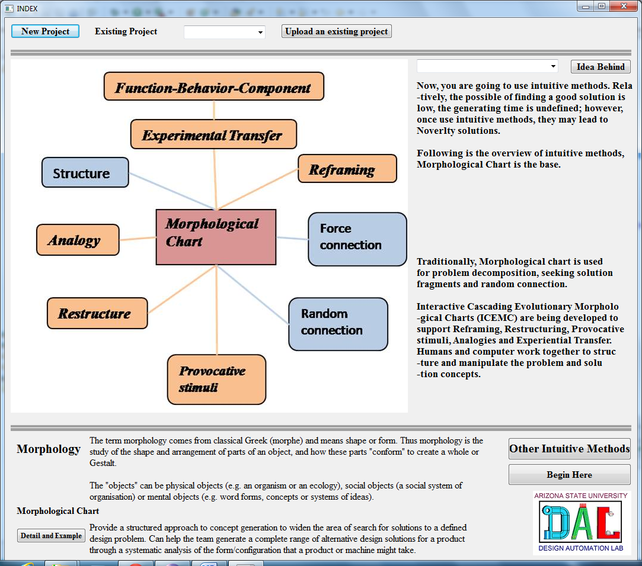

1. List the features or functions that are essential to the product.

The items in the list should all be at the same level of generality, and they should be as independent of each

other as possible. They must comprehensively cover the necessary features or functions of the product to

be designed.

The purpose of this list is to try and establish those essential aspects that must be incorporated in the product

or that it must be capable of doing. These are therefore usually expressed in rather abstract terms of

product requirements or function.

2. For each feature or function list the means by which it might be achieved.

For example, if one of the functions identified in stage one is ‘motive power’, then the different means that

compose this list will be things such as petrol, gas, diesel, electricity etc.

The lists of means can include not only the existing, conventional components or sub-solutions of the

particular product, but also new ones that you think might be feasible.

3. Draw up a chart containing all the sub-solutions.

The morphological chart is constructed from the previous lists. First form a grid of empty squares. Down the left hand side list the essential functions of

the product. Then across each row of the chart enter the appropriate secondary list of sub-solutions.

There is no relationship within the columns; the squares are just convenient locations. There may be two means of achieving the first function, five

of achieving the second and so on.

4. Identify feasible combinations of sub-solutions.

Take one solution from each row to combine a principal solution.

Some solutions will be existing feasible solutions, some will be new feasible solutions and others will be totally infeasible solution.

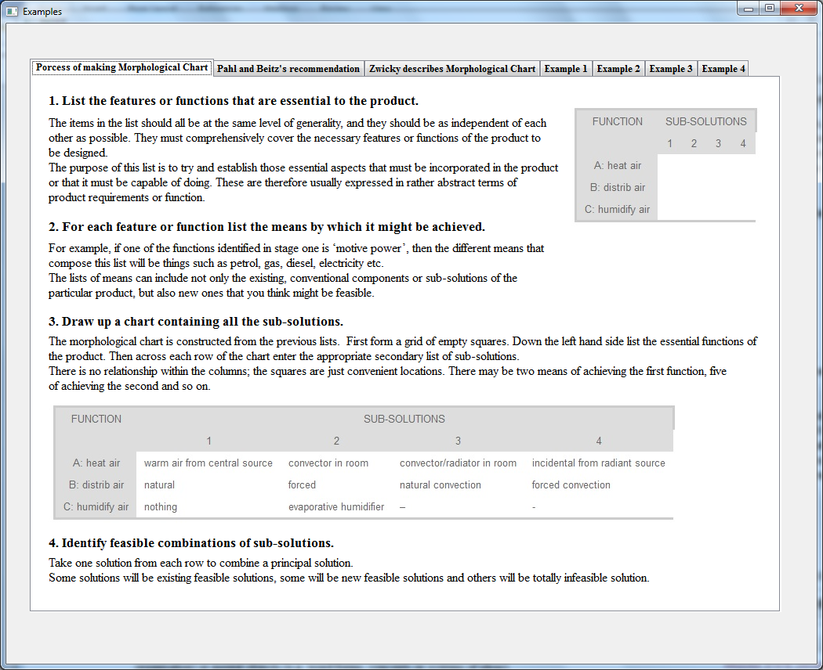

Pahl and Beitz recommend the following:

1. Build first a rough function structure from still complex sub-functions and then work it out step by step by splitting up the sub-functions. Often the analysis of a first design concept helps to find the essential sub-functions.

2. Start with the main function which is the most determining for the design. Add auxiliary functions – such as energy transmission, control functions etc. – at a later stage.

3. Certain sub-functions appear in almost all function structure. Knowledge of the elementary or general functions helps in seeking product-special functions.

4. A function structure may be optimized by developing variants. Variation possibilities are: (a) the splitting or combining of functions, (b) the changing of the arrangement of sub-functions, and (c) the shifting of the system boundary.

5. Function structure should be kept as simple as possible. The integration of various functions into one component (function carrier) often is a useful means in this respect.

6. Block diagram of functions should remain conveniently arranged; use simple and informative symbols.

7. A function structure is not an end in itself; it should support the finding of useful solutions. The designer’s experience and the task – adjusting a design to new requirements (redesign), or a really new design – determine the degree of detail which is to be looked for.

8. The development of a function structure is an iterative process. There is nothing against starting by analyzing an existing design or with a first outline of an idea for a new solution.

Pahl, G. & W. Beitz, Konstruktionslehre; Handbuch fur Studium und Praxis, 2nd edition. Berlin: Springer, 1986,

pp.96-99

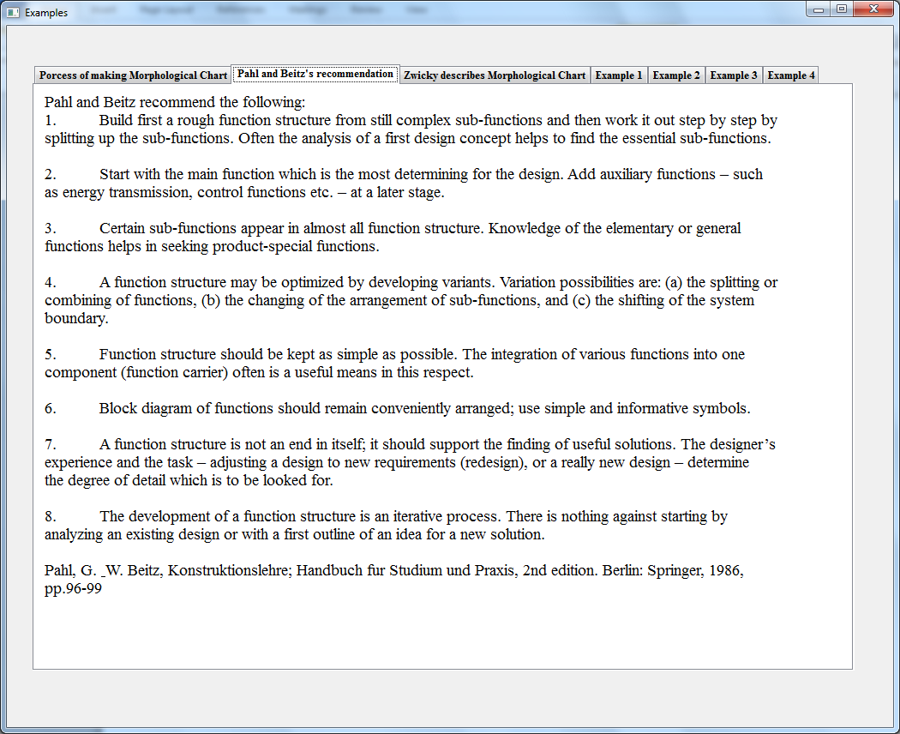

The inventor of Morphological Charts, Zwicky describes

Step one: The problem to be solved must be formulated as accurately as possible.

Step two: all parameters which might occur in the solution are identified and characterized.

Step three: A morphological chart or multidimensional matrix is constructed, which contains all solutions to the problem.

Step four: All solutions are carefully analyzed and evaluated with regard to the objectives to be attained.

Step five: the best solutions are chosen and implemented, in so far as the means to do so are available; the practical application may require another morphological study.

Zwicky himself has discovered new principles for jet engines and made a study of the existence of celestial bodies not yet discovered, with this method.

Zwicky, F., The morphological approach to discovery, invention, research and construction. In: F. Zwicky & A. G. Wilson (eds.), New methods of Thought and Procedure; Symposion on Methodologies, Pasadena, May 1967. Berlin: Springer, 1967, pp.316-317

