Centrel-Tendency

[Type the document subtitle]

Centrel-Tendency

[Type the document subtitle]

# [Type sidebar title]

[Type the sidebar content. A sidebar is a standalone supplement to the main document. It is often aligned on the left or right of the page, or located at the top or bottom. Use the Drawing Tools tab to change the formatting of the sidebar text.]

# 1.Mean

Up To Tenth Std To Degree Pass Mark Every One Are In A same Range Of Avg Range.

# 2.Median

Allone They Got 72% as an Avg So I Found Outlayer Median Salaery

Part.

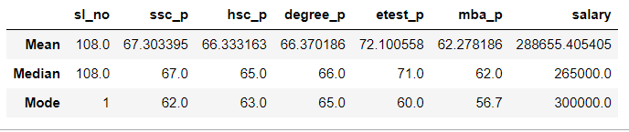

# 3.Mode

So Repeated Mode Of All This.